Human Resources Advisory Committee
Report to Advisory Committee
From the Chief Human Resources Officer
October 17, 2022
Informational Updates from the Office of Human Resources
Human Resources Operational Updates
In September, Human Resources said farewell to Erika Ziolkowski, one of our HRIS Analysts, who was accepted to pursue one of her dreams as an educator in Spain. We also received notice of the separation of Beth Peternell, another one of our HRIS Analysts, who will leave HR on October 28, 2022.
With the separations, Human Resource utilized our talent pipeline by Ellie Zwiefel to the role of HRIS Analyst.
We were able to hire a new HR Associate, Hailey Herbst, who will begin on October 17, 2022 and now will post for the vacated, second HR Assistant position.
New Employee Onboarding Experience
Beginning in January 2023, Human Resources will be launching a New Employee Onboarding (NEO)Experience. This fully immersive program will bring together a cohort of new employees every quarter year, (of the calendar year). Participating campus departments will provide an overview of their services and provide any training for employees on compliance related areas for which they will need to be informed. The NEO will also include:
- Welcome and introductions by campus leadership
- Ensuring that Directory Photographs are taken for all employees
- Creating lasting relationships between each cohort participant
- Provide a inviting welcome to the university community
Ticketing System Migration to Ivanti
UWL Human Resources has been using a ticketing system called Zendesk to track and manage all inquiries or questions to the office. The program was installed in 2019 to ensure that UWL HR Staff members were quickly responding to employee’s requests and concerns and providing follow up. The results were improved efficiency and decreased response time. See the below graphs for information about how HR does in just one month time, (September 2022).
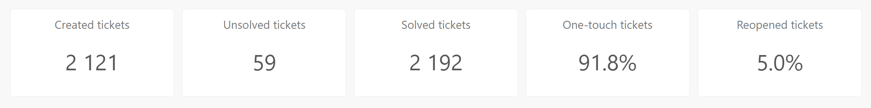
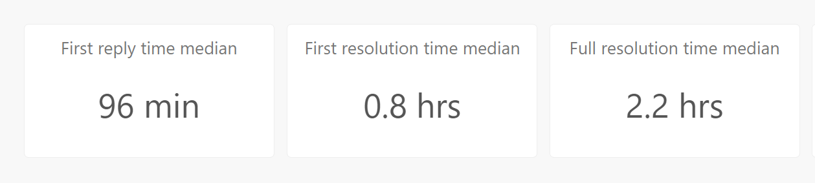 | 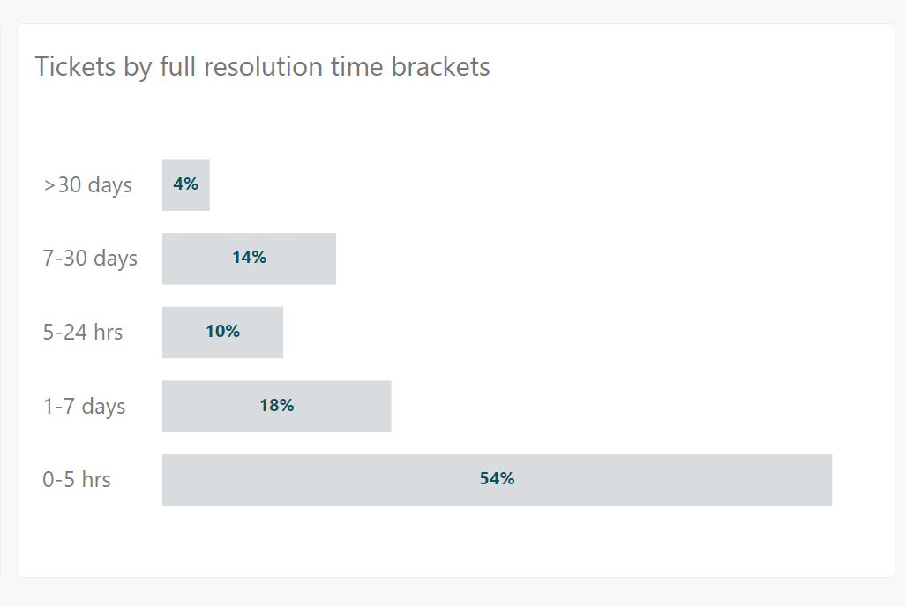

On November 1, 2022, HR will migrate to a new program, called Ivanti. Ivanti links together all of the UW System family of service units, including UW Service Operations, Procurement, and Financial Services. This new tool will continue to provide the same level of timely support to our employees, but now also link directly with UW System for more expedited results, tracking, and updates. Employees will also be able to log into their own service portal to view the status of the requests, or to add/modify information within their request.
Administrative Transformation Program
July 1, 2024 is the target “Go Live” date for the replacement to the current HRS System under the project banner name of the Administrative Transformation Program (ATP). Workday is the new program which has been selected to replace the current PeopleSoft product. UWL has prepared a “ATP Readiness Team” which is part of the larger UW System ATP Readiness Team. This group is meeting monthly to learn about the updates, assist with pulling in camps stakeholders to provide input, and to provide overall communication to the campus about the transition to Workday.
These groups are just now establishing themselves, so employees can begin to expect more communication on the topic in January of 2023.
The UWL Group is comprised of Leanne Vigue, Kristin Koepke, Kyle Farris, Mark Haakenson, David Kim, and John Acardo.
BP Logix Development
UWL Human Resources continues to move forward with automating current paper-based forms using the workflow automation tool, “BP Logix”.
The Student Employee Action Form was automated in August of 2022 and the Employee Action Form, (to request and record approvals for employment changes), is scheduled to be launched in November of 2022.
Career Progression
As of the last CHRO meeting on October 13 and 14, 2022, UWL Human Resources continues to wait for the finalized guidance from UW System Human Resources.

Recruitment Metrics for September
Please note, reporting of demographic metrics is optional for candidates. Report includes open and active recruitments from the period of September 1, 2022 through September 30, 2022.
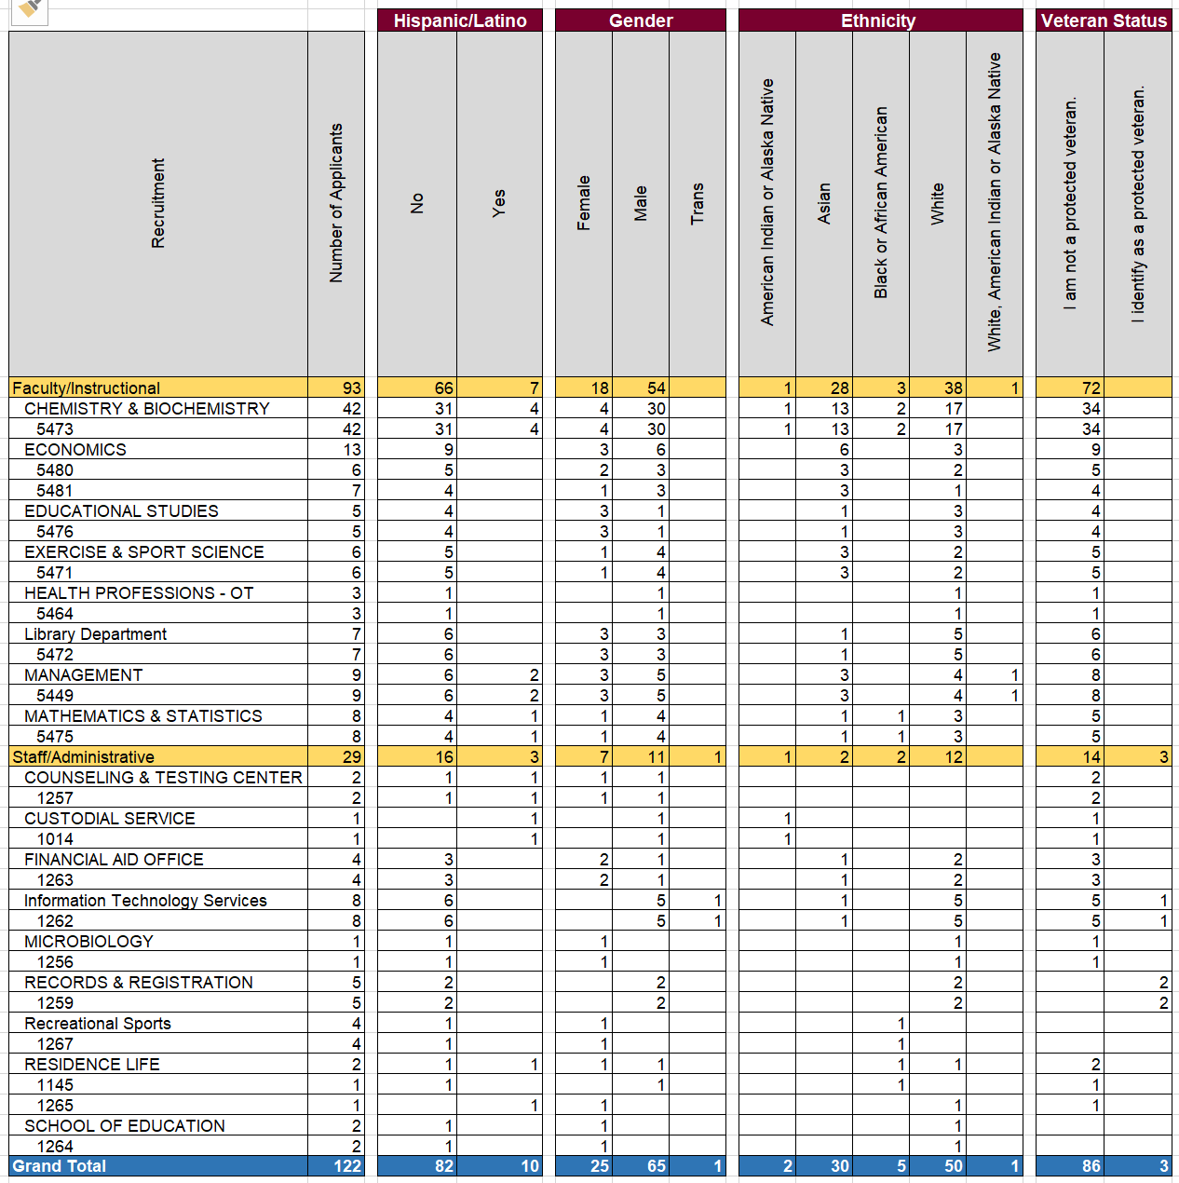

Employment Metrics for September
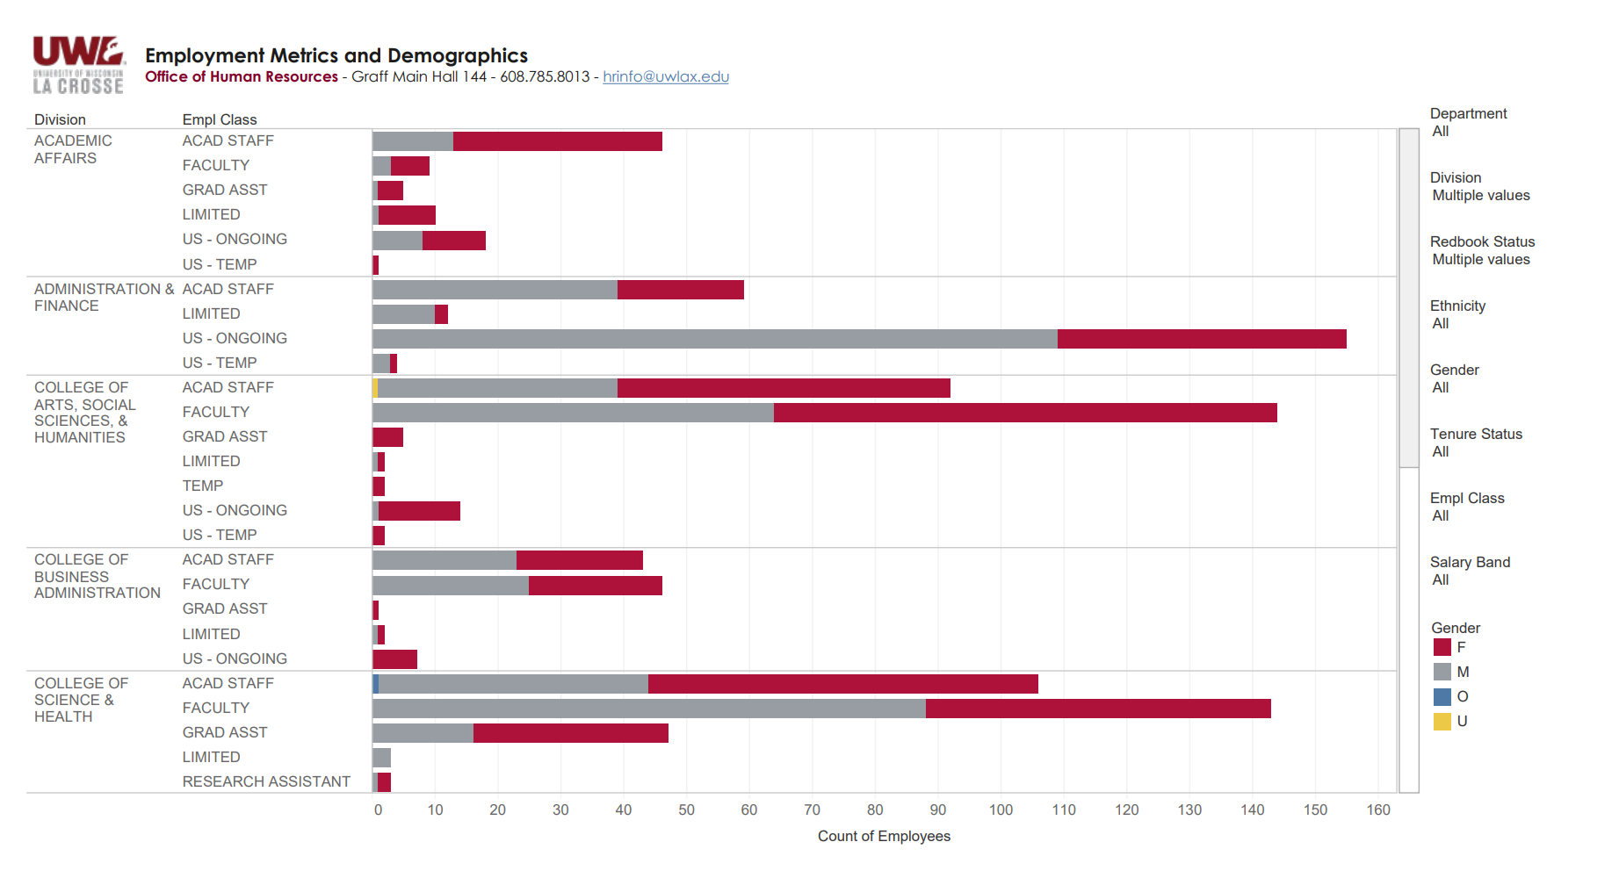
Partial Image Displayed…
John to display the dashboard to HRAC: https://tableau.wisconsin.edu/#/site/LAC/views/EmployeeDemographicMetrics/ActiveEmployeeInformation?:iid=1

