Manager Current Documents

Ability for manager to see a list of existing and active (not canceled or completed) documents where they are the evaluating manager. These are document’s the manager can update. There are two navigation options.

HRS Navigation #1 (fluid): NavBar icon (top right near home icon) > Navigator > Manager Self Service > Performance Management > Performance Documents > Team Performance > Current Documents

- Select the row of the employee/document you wish to review and/or update.

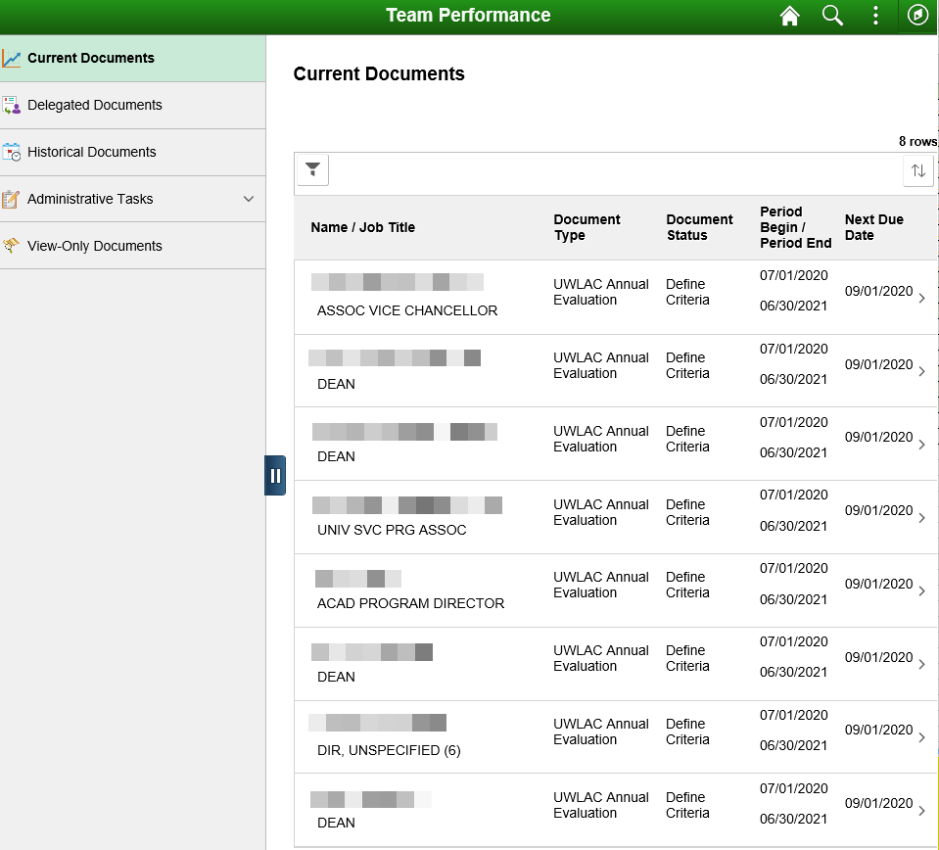

HRS Navigation #2 (classic): NavBar icon (top right near home icon) > Navigator > Manager Self Service > Performance Management > Performance Documents > Current Documents

- Select the name hyperlink to open the document you wish to review and/or update.

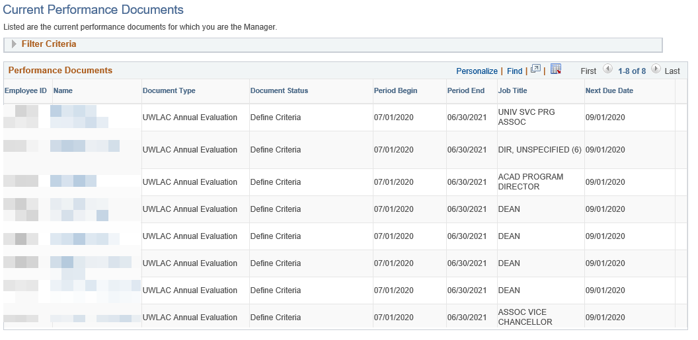

Manager View-Only Documents

Ability for manager to see a list of their direct report employees and indirect report employees (if applicable), and their documents (if applicable). Documents accessed here cannot be updated. Employee list is based on Reports To.

HRS Navigation: NavBar icon (top right near home icon) > Navigator > Manager Self Service > Performance Management > Performance Documents > View-Only Documents

- Leave As of Date alone and Select Your Group ID blank
- If direct report has employees that report to them, a plus button will appear next to their name; select it to expand and display indirect reports.
- Select the Select button next to the employee name to look at that employee’s documents. The View Performance Documents page will open with a list of the employee’s documents.

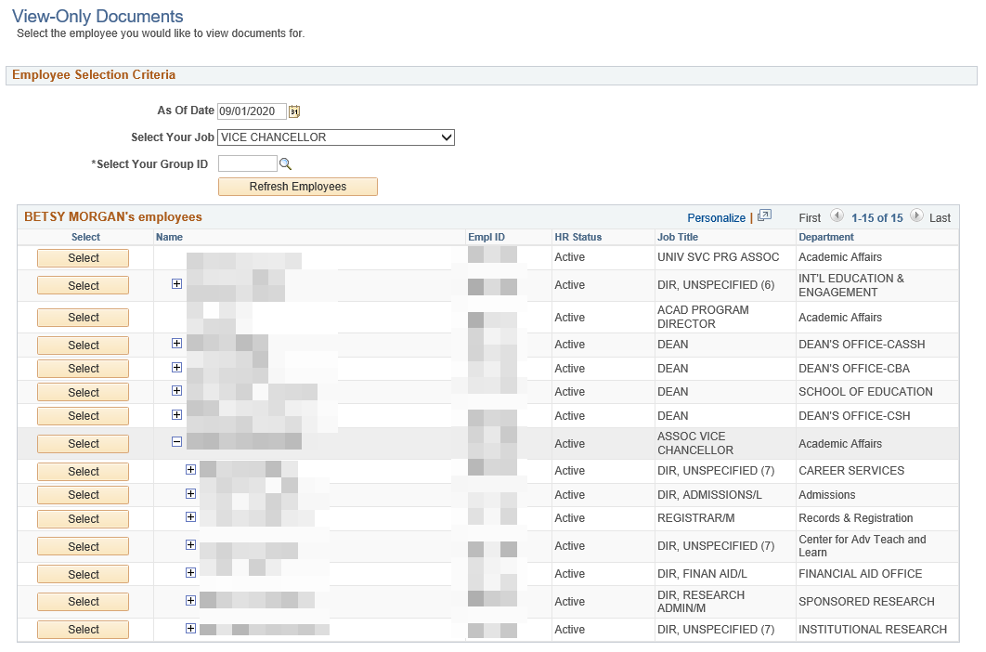

Select the Document Type hyperlink to open the View-Only document (cannot make updates).

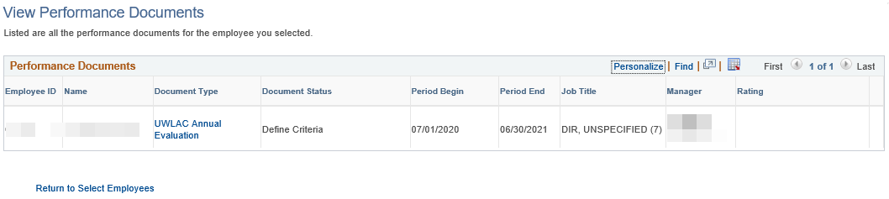

Note: View-Only Documents that appear on the Team Performance page is dependent on documents existing and tied to TL Approver, and does not display documents for indirect reports.

