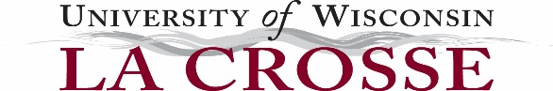

Degree Waiver Request Form

University of Wisconsin-La Crosse Degree Waiver Policy provides the ability for an employee to be considered for an Academic Staff or University Staff promotion or reclassification who may lack the necessary degree requirements. Complete form below and submit to Chief Human Resources Officer.

Employee Name:

Position:

Department:

Justification:

Attach the resume/vita of the employee and the position description

Submitted by:

HR Review:
Reviewed By:
Date:

