- Green Fund -
___________________________________________

University of Wisconsin-La Crosse
Application for Environmental Sustainability Reserve

Fall 2020

Application must be received by November 6th, 2020

____________________________________________________________

Please send completed applications to greenfund@uwlax.edu. You will be sent a confirmation e-mail verifying that the proposal was received.

For more information about the Green Fund or the application process please refer to the following; Green Fund Bylaws, Green Fund webpage or email us at greenfund@uwlax.edu.

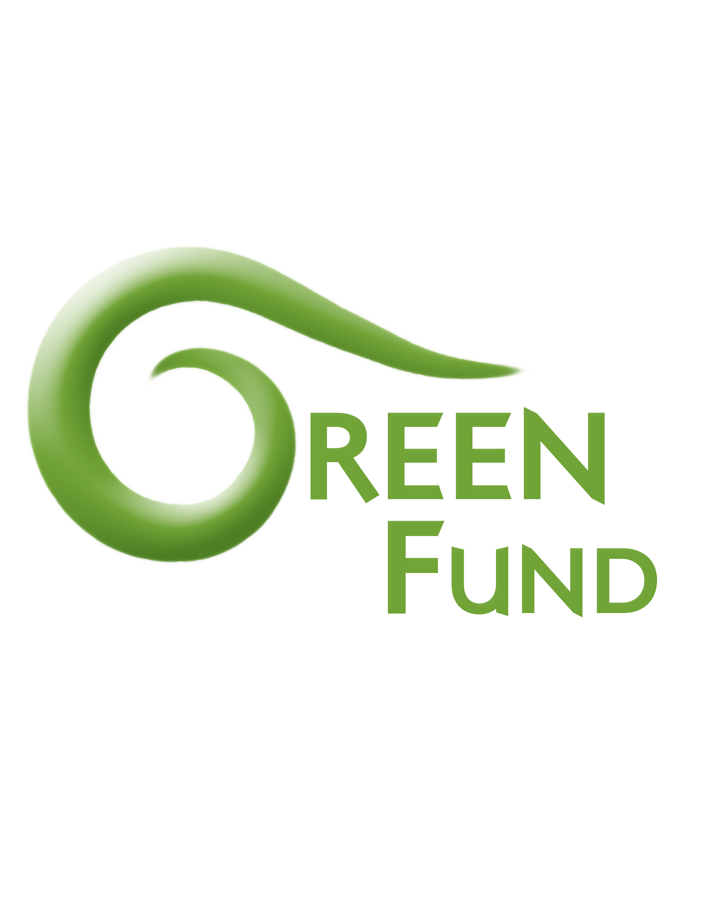

Application Checklist
- Have you reviewed the Green Fund bylaws?
- Have you meet with a Green Fund coordinator?
- Have you reached out/received approval from the appropriate campus offices i.e. Office of Residence Life, University Centers, Facilities Planning & Management?
- Have you had your application proofread i.e. by professors, Green Fund coordinators, Writing Center, etc.?

Eligibility for Funding
The Environmental Sustainability Reserve, or “Green Fund” can be used to fund projects
for non-GPR facilities, including, but not limited to:
• Residence halls
• Student Union
• Recreational Eagle Center
• Whitney Center
• Veteran’s Memorial Stadium
The fund cannot go towards:
• Trees, landscaping not related to gardens, rain gardens, and green roofs
• Items typically included in other entities’ ongoing budgets
• Faculty or staff salaries

Evaluation Criteria for Proposed Projects
Highest Priority
- Impact on the student population at UW-La Crosse
- Impact on carbon footprint: including reduced energy usage through efficiency and renewable energy
- Collaboration with other organizations: through funding matches, joint planning, or in the execution of the project
- Visibility: projects that are conspicuous and noticeable
- Able to demonstrate a quantifiable return on investment
- Innovation: new initiatives not typically funded by other entities
Medium Priority:
- Size of project: projects with greater magnitude preferred
- Interdisciplinary, and engaging multiple stakeholders
- Educational value: increasing student understanding of environmental issues or actions
- Possibility for future expansion: growth from a pilot into a standing program
Other Important Considerations:
- Purchasing ethics: considerations such as fair trade, sustainable equivalent products, sustainable production
- Community outreach and support of local/sustainable businesses

Include the following with this application:
- At least 3 price comparisons of the item(s) or project. (if applicable)
- Budget Sheet
- Other supporting documentation
- __________________________________________________________________

Contact Information
Name:
Phone:
Email:
Unit/Organization/Department (optional):
____________________________________________________________

Please provide a short title for you proposed project:

Provide an Abstract for your project. What changes/additions do you propose? What is are the basic impacts that you anticipate? What is your expected timeline?

Provide a detailed explanation of the environmental impact of your project on the UWL carbon footprint, water usage or electrical consumption. Be as specific and quantitative as possible.
If impacts are indirect, please explain.

How will this increase student understanding of environmental issues? Will it be visible to students? This is an important aspect of the Green Fund. If your proposed project isn’t visible to students have you added signage, informational materials or promotion to your request?

What does this proposed project look like in 5 years, 10 years, etc.? Are there ongoing maintenance costs, will this need to be replaced, will ongoing costs be absorbed by another UWL entity or will this project rely on the Green Fund?

How much funding are you requesting overall?

Is this a project that would typically be funded through another budget?

If yes, explain in detail why this project is going through the Green Fund.

Are you receiving additional funding from other university or non-university entities?

If yes, please state the other sources of funding that you are receiving, and the amount received.

Do you think this is a responsible use of Student Segregated Fees? Explain

Large and complex projects require UWL Staff member(s) to be involved. Please list relevant personnel who are or will be involved in the proposed projects, who can evaluate project viability as it affects their department or unit.

Do you plan to collaborate with other entities? This would include students, organizations, university departments/offices.

When the project is completed, what is your reporting plan (i.e., how will your accomplishments be advertised to the campus community)?

Anything else you would like to add?

