Class Permissions thru 5th Day
prorated for shorter classes
a.k.a. Electronic Overrides

Before you begin, please note:
- Classes shorter than a full semester class have prorated add/drop deadlines. Check with the ADA or the Records office if you aren't sure what the deadline is.
- Once permission is added, student must go into their own account and enroll. If class is closed, it will still look closed to the student. He/she will still be able to enroll if the class permission was placed correctly. Students must enroll before the expiration date expires.
- Classes in the DYN session (dated with unique start/end dates, otherwise known as dynamically dated classes) must use the paper drop/add form. The electronic permissions do not work on those specially dated classes.

- WINGS navigation: Records and Enrollment> Term Processing> Class Permissions

- On the search page, put in:
Academic Institution: UWLAC
Term: 2186 (Winter 2018) or 2187 (Spring 2018) or 2191 (Summer 2018) or 2194 (Fall 2018)
Subject: CHM (prefix of course you are teaching)
Catalog Nbr: 103 (course number of course you are teaching)

- Click Search. When the course appears, make sure you are on the correct section of the class. If more than one section of a class is offered you will see 1of ? on the right side of the top blue bar. Click the arrow until you find the correct section. Verify you are the instructor of the course.

- For courses with lab components, it is the LAB that controls the enrollment. Make sure you put the override permission on the correct LAB section. Even if overriding a closed LECTURE section, put the permission on the LAB.

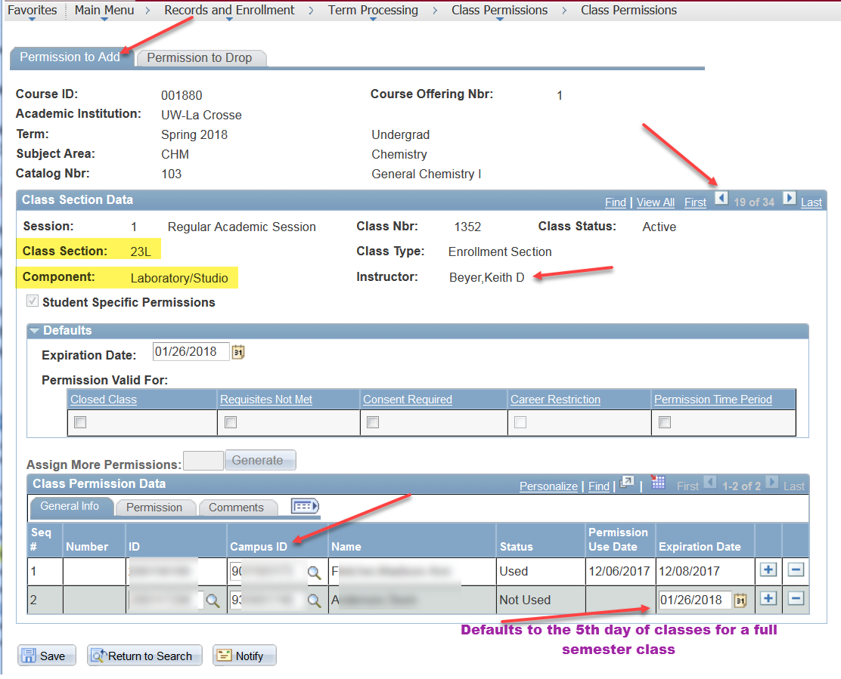

- Go to the bottom of the page and enter the student ID (Starts with 8 or 9) in the Campus ID field.

- Note the Expiration Date of the override and change it if you are limiting the time the student can use it. It automatically defaults to the last day students can add the class on WINGS for that term.

  - After the 5th class day (prorated for shorter classes), you will also need to check the Permission Time Period box on the Permissions tab and change the Expiration Date (on General Info tab) to no later than the 10th day (prorated for shorter classes.) After the 10th day, late adds require instructor, department, and dean's office approval in paper/hard copy format.

- On the Permission tab, click the box for the permission you are giving. Please note the Requisites Not Met permission will override ALL prerequisites. You need to be very careful with that box. Overriding admission to a specific program or class standing (sophomore standing, etc) must be given by the dean's office. Do not check that box unless you know the student is admitted to your program or has the necessary class standing. If a student does not have those prereqs you will still need to use the blue override form. Students also need the blue override form for audits, time conflicts, and/or overriding more than 18 credits.

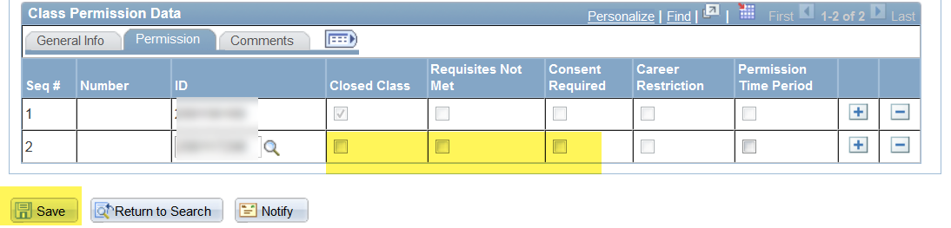

- If you would like to add a comment to track why an override was given, you can click the Comments tab and make an entry.

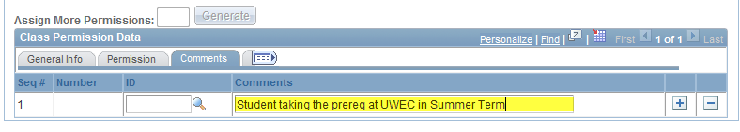

- Click at the bottom of the page. Please let the student know they still have to register. A class permission does not register the student; it only gives them permission to register.

- To give permission to another student, click the button on the bottom right to add another row.

- You can monitor the overrides given to see when the student used the override or if they dropped the class after they initially added it. The status of "Not Used" does not necessarily mean the student is not enrolled. It may mean the student didn't need the override to get in. For example, if the class was closed when the student got the override, but another student dropped it before your student registered, the class status may have been "open" and allowed them to register without using the override.

- Questions? Call Victoria Rahn at 785-8579.

Add with Permission, 6th - 10th Day
Electronic adds during the second week of the semester
Before you begin, please note:
- Classes shorter than a full semester class have prorated add/drop deadlines. Check with the ADA or the Records office if you aren't sure what the deadline is.
- Once permission is added, student must go into their own account and enroll. If class is closed, it will still look closed to the student. He/she will still be able to enroll if the class permission was placed correctly. Students must enroll before the expiration date expires.
- Classes in the DYN session (dated with unique start/end dates, otherwise known as dynamically dated classes) must use the paper drop/add form. The electronic permissions do not work on those specially dated classes.
- WINGS navigation: Records and Enrollment> Term Processing> Class Permissions > Class Permissions
- On the search page, put in
  - Academic Institution: UWLAC
  - Term: 2186 (Winter 2018) or 2187 (Spring 2018) or 2191 (Summer 2018) or 2194 (Fall 2018)
  - Subject: ENG (prefix of course you are teaching)
  - Catalog Nbr: 110 (course number you are teaching)
- Click Search. When the course appears, make sure you are on the correct section of the class. If more than one section of a class is offered you will see 1 of ? on the right side of the top blue bar. Click the arrow until you find the correct section. Verify that instructor of the section is correct.

- For courses with lab components, put the permission on the LAB component section that the student needs. This is because the lab component controls the enrollment. Even if overriding a closed LECTURE section, put the permission on the LAB component
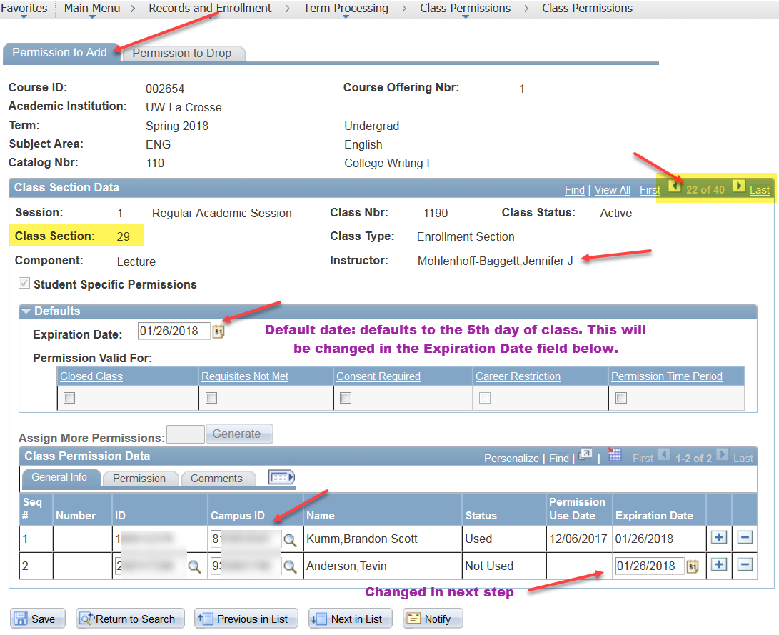

- Stay on the Permission to Add tab
- Go to the bottom of the page and enter the student ID (Starts with 8 or 9) in the Campus ID field under General Info tab.
- In the Expiration Date field, change the date to the 10th day of class at the latest.

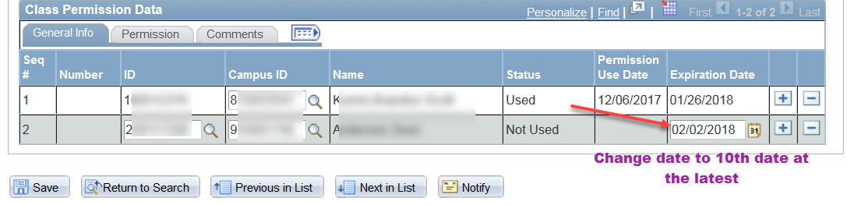
  - Please note that after the 10th day of class, the Add with Permission function doesn't work. Students who request late adds after the 10th day will need instructor, department, and dean's office permission and will have to be added in the Records Office.

- Go to the Permission tab, check the Permission Time Period box. This overrides the expiration date listed in the Default section above and allows you to put in the longer add date in the General Info tab.

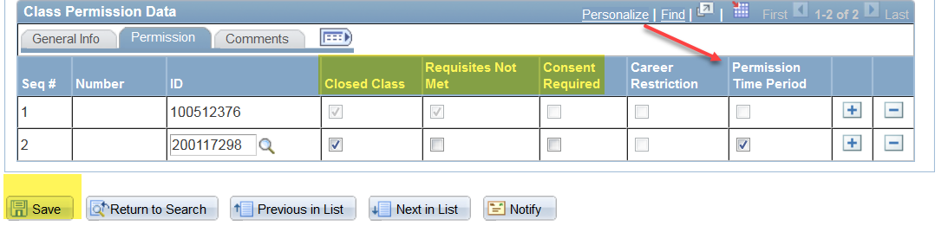
- Also check one or more of the boxes for the permissions you are giving (Closed Class, Requisites Not Met, Consent Required).
  - Please note the Requisites Not Met permission will override ALL prerequisites. You need to be very careful with that box. Some permissions like “admission to program” or overriding “class standing” must be given by the Dean's Office. Do not check that box unless you know the student is admitted to the appropriate program or has the necessary class standing. If a student has a time conflict or is auditing a class, you will still need to use the blue override form.

- Click Save. Please let the student know they still have to register. This does not register the student; it only gives them permission to register.
- To give permission to another student, click the on the bottom right to add another row.

- You can monitor the overrides given to see when the student used the override or if they dropped the class after they initially added it. The status of "Not Used" does not necessarily mean the student is not enrolled. It may mean the student did not need the override to get in. For example, if the class was closed when the student got the override, but another student dropped it before your student registered, the class status may have been "open" and allowed them to register without using the override.

Questions? Call Victoria Rahn at 785-8579.

Drop with Permission
Electronic permission to drop after the 10th day of class and through the last day to drop.
Before you begin, please note:
- Classes shorter than a full semester class have prorated add/drop deadlines. Check with the ADA or the Records office if you aren't sure what the deadline is.
- Once permission is added, student must go into their own account and drop. Students must drop before the expiration date expires.
- Classes in the DYN session (dated with unique start/end dates, otherwise known as dynamically dated classes) must use the paper drop/add form. The electronic permissions do not work on those specially dated classes.

- WINGS navigation: Records and Enrollment> Term Processing> Class Permissions > Class Permissions
- On the search page, put in
  - Academic Institution: UWLAC
  - Term: 2186 (Winter 2018) or 2187 (Spring 2018) or 2191 (Summer 2018) or 2194 (Fall 2018)
  - Subject: ENG (prefix of course you are teaching)
  - Catalog Nbr: 110 (course number you are teaching)
- Click Search. When the course appears, make sure you are on the correct section of the class. If more than one section of a class is offered you will see 1 of ? on the right side of the top blue bar. Click the arrow until you find the correct section. Verify that instructor of the section is correct.

- For courses with lab components, put the permission on the LAB component section that the student is in. Enrollment is controlled by the lab component, so if the permission is put on the lecture instead of the lab, the student won't be able to drop.
- Go to the Permission to Drop tab

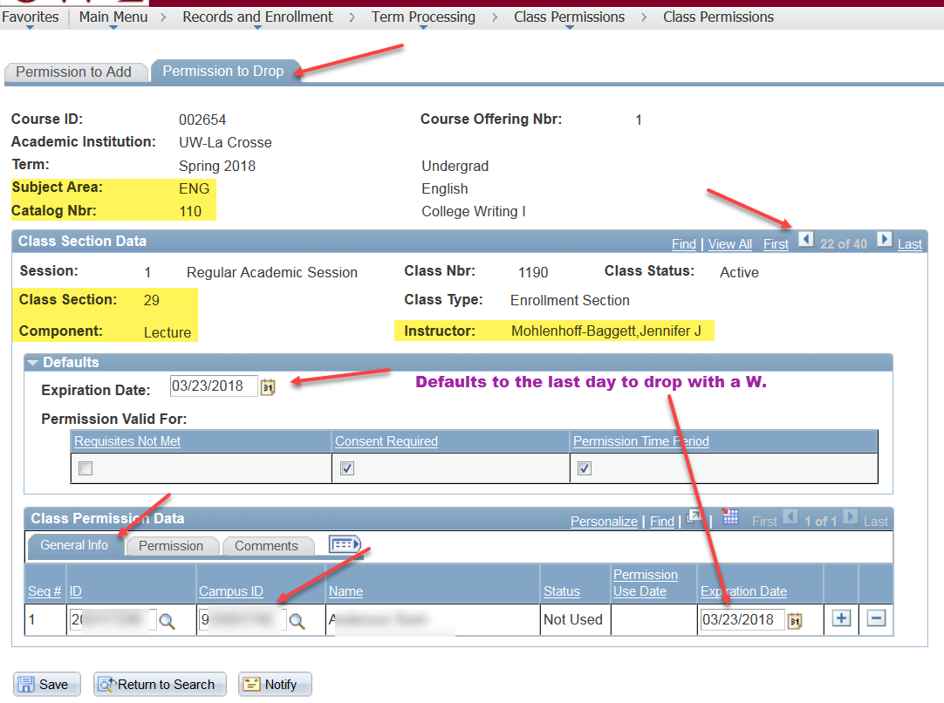
- Go to the bottom of the page and enter the student ID (Starts with 8 or 9) in the Campus ID field.

- Leave the Expiration Date at the bottom the same as the Default date listed above. This is the last day to drop the course. Students will receive a "W" on their transcripts when they drop.
- On the Permission tab at the bottom, verify that the Consent Required and the Permission Time Period boxes are checked.

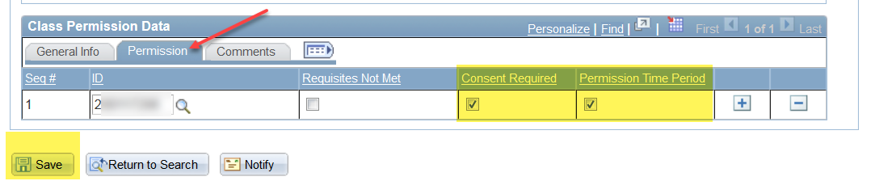
  - Please note the Requisites Not Met permission does not normally need to be checked. This only needs to be checked if the student is registered in two or more classes that are co-requisites with each other and the student is trying to drop one of the classes.
- Go back to the General Info tab and click Save. Please let the student know they still have to drop through their WINGS Student Center. This does not drop the student; it only gives them permission to drop.

- Students who use the permission to drop will receive a 'W' on their academic record.

- To give permission to another student, click the on the bottom right to add another row on the Permission to Drop tab.

Questions? Call Victoria Rahn at 785-8579.

