UW-La Crosse History Department

HIStory XXX

Class name
Class meeting times:

For questions, contact:

@uwlax.edu

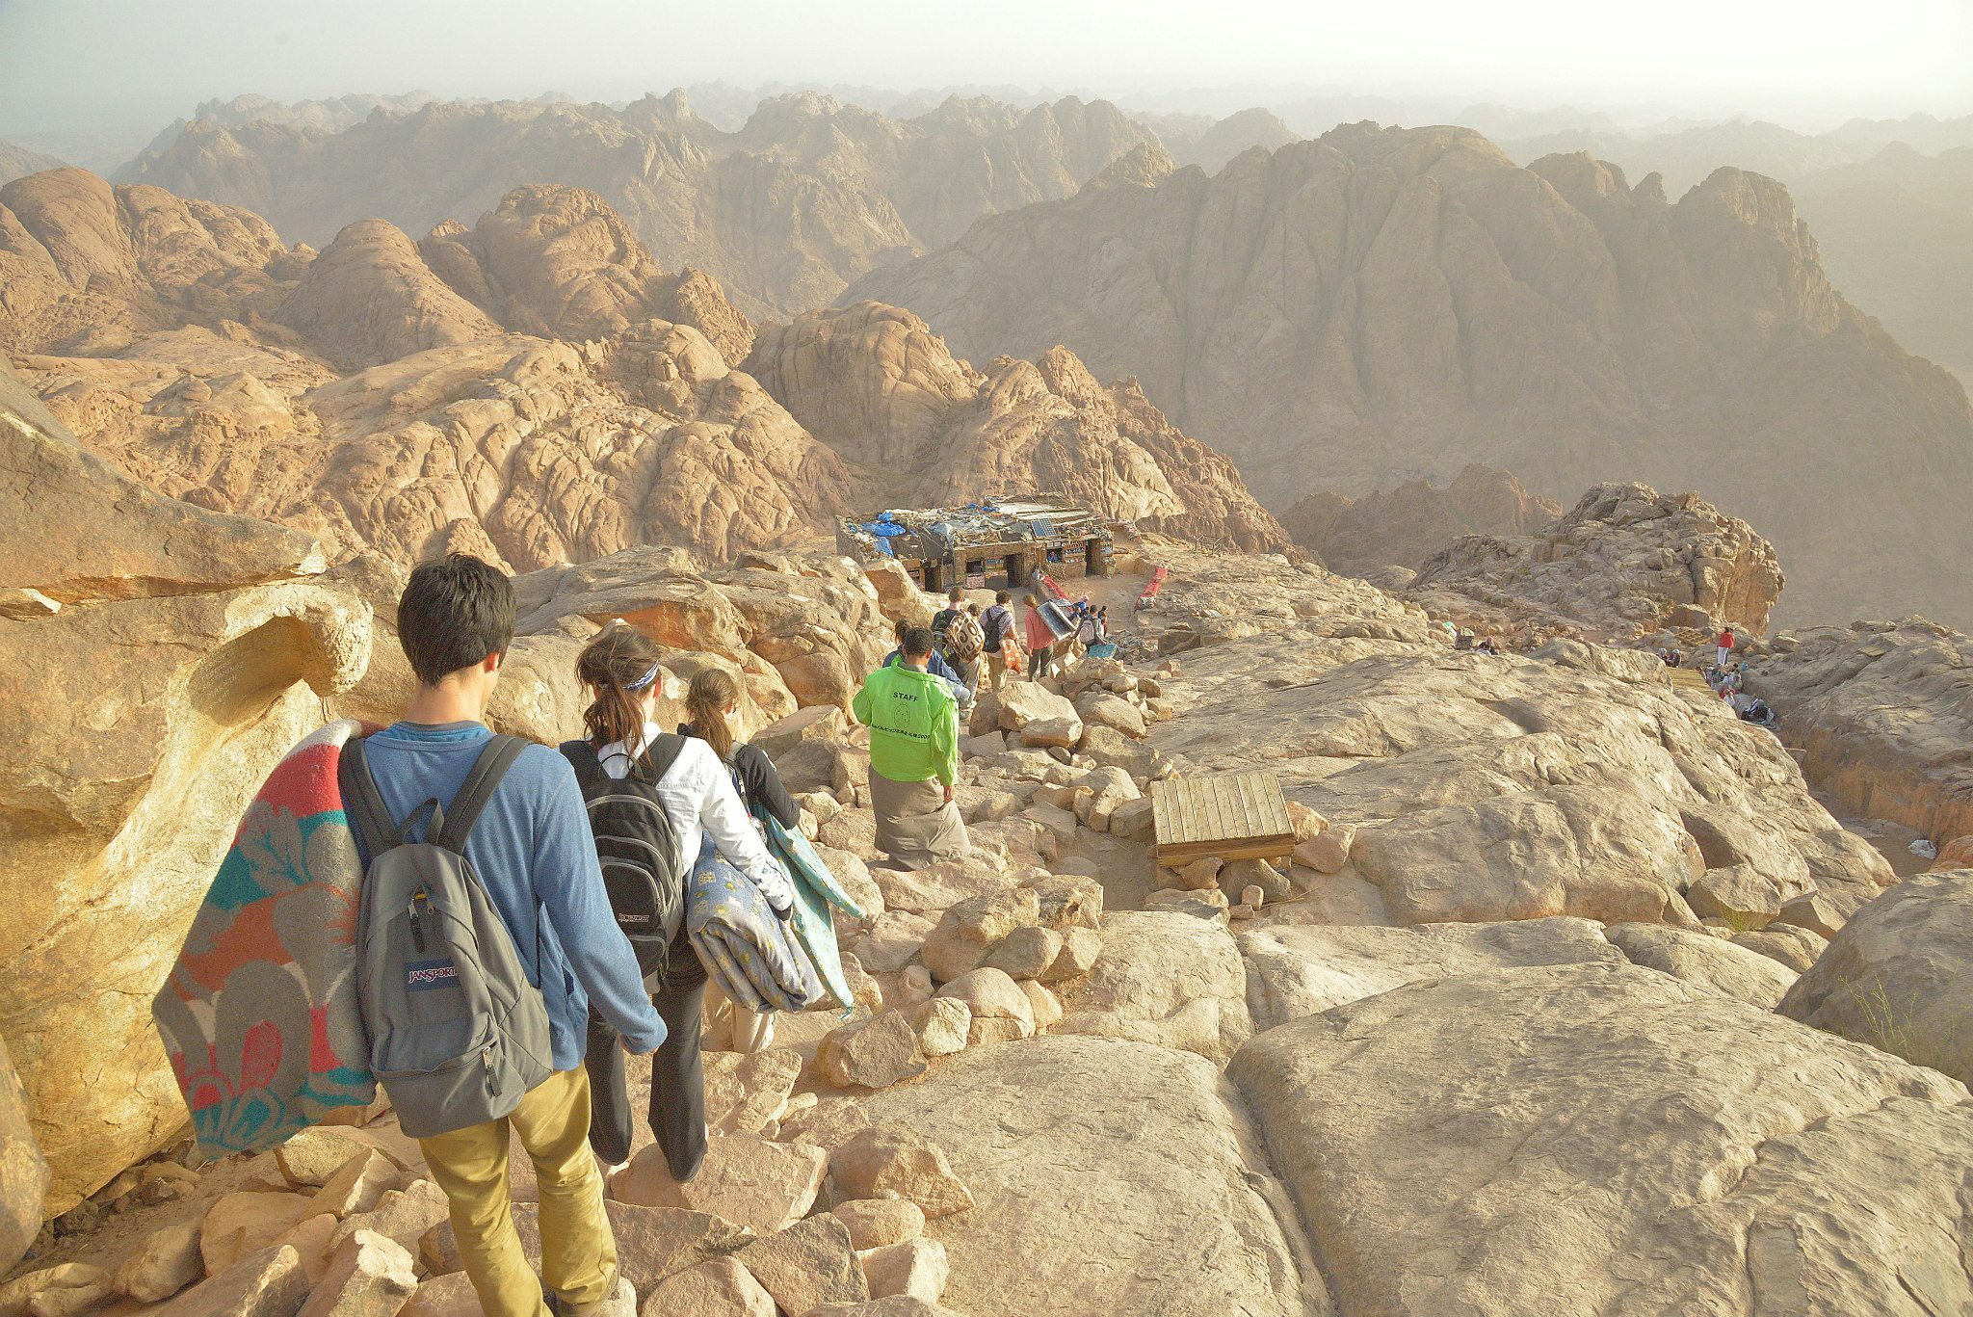
[Click here to add a caption]

Class description
You can just replace the sample text with your own.
Another paragraph describing the class to potential students.

“I know the Whites wish to kill me in order to take my country. But I find my country good just as it is. I have no need of them.” – King Wobogo of Mossi, 1895

other Relevant info
To replace a sample picture with your own, right-click it and then click Change Picture.
If your picture isn’t a perfect fit for the space provided, you can crop it in almost no time.
On the Picture Tools Format tab, click Crop.
Want to zoom in on the best part of your photo and make it stand out even more?
After you click Crop, just drag to resize the image inside the crop area.

