# Eagle Battalion Semester Newsletter

# Advanced Camp

• • •

**During this summer, eleven Cadets were sent to Fort Knox, KY to Advanced Camp. Everyone returned home upon completion of land navigation during the day and night, weapons qualification, two weeks of field training where they conducted multiple missions a day while staying in patrol bases at night. They conducted training for call for fire, confidence courses, rappelling, medical training, and ended with a timed 12-mile ruck march. It was a great experience to grow your leadership abilities and push yourself to your limits.**

* **Cadet Tori Richison**

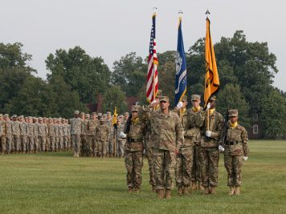

Eagle Battalion

|  |  |
| --- | --- |
| **Summer – Fall 2017** |  |

**The Cadets completed many schools over Summer 2017, including Airborne and Air Assault as well as internships through CTLT and NSTP. Cadets participated in advanced and basic camps, learning more about becoming a great Soldier and future Army Officer. Eagle Battalion reflects on its accomplishments and looks forward to continuing successes. This September Eagle Battalion participated in a fall FTX that emphasized the importance of land navigation and Cadets gained great confidence in their abilities. Many labs followed including rappelling off Cowley Hall, Drill and Ceremony lab and a Trauma/Medical Lab. Following the FTX, Ranger Challenge proved to be a true challenge and learning experience for those involved. Eagle Battalion is looking forward to coming back even stronger.**

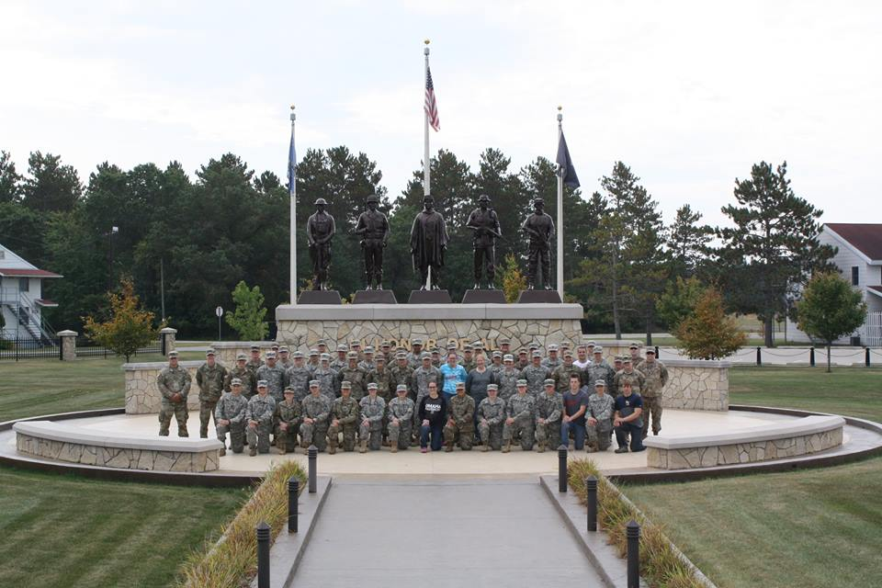

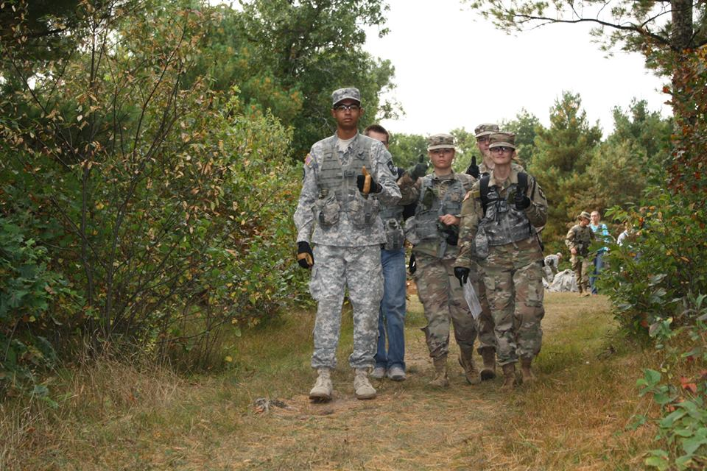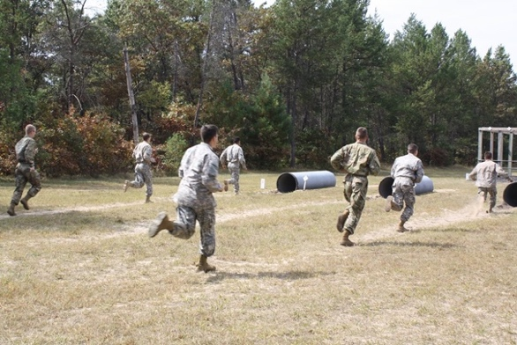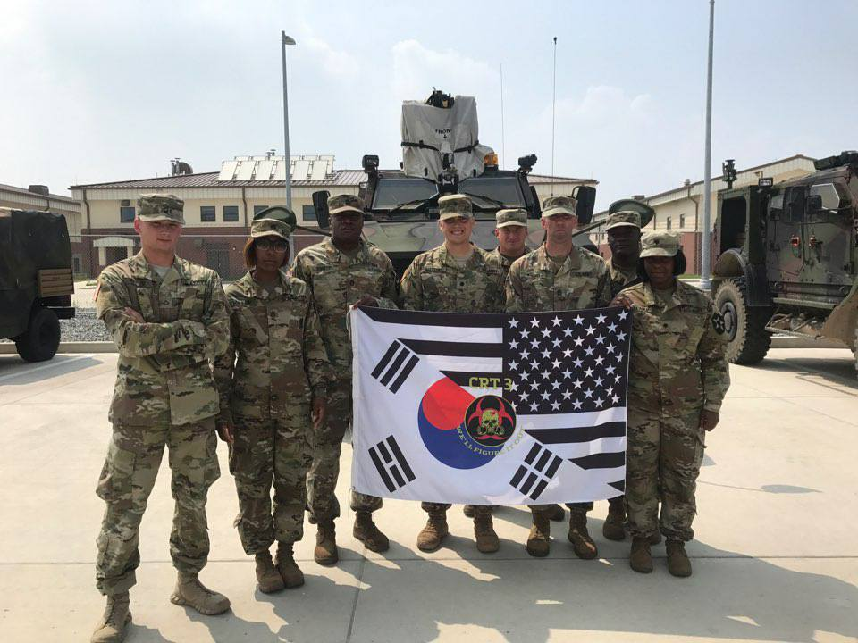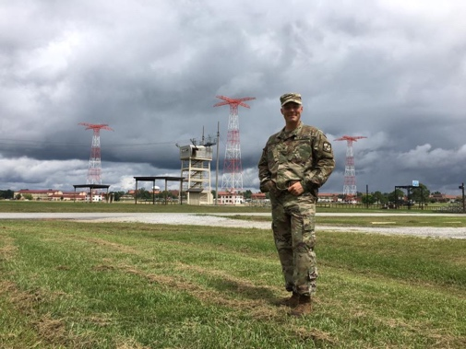

# Basic Camp

**I attended basic camp down in Fort Knox, Kentucky, this past summer transitioning from my MSI to my MSII year. It consisted of 30 days and lots of physical and mental training brought forth by the drill sergeants. Some of this includes weapons training, squad tactics, land navigation, and the gas chamber just to list a few. We were also tested on different events such as operating a radio, first aid, and disassembling/assembling an M16. Not only did I learn a lot of great information but I made some great friends that I am still in touch with today. Overall, I would highly recommend it for upcoming MSII’s or even MSIII’s because of the experience and knowledge you can gain.**

* **Cadet Trevor Quade**

# Cadet Troop Leading Training (CTLT)

**This summer after Advanced Camp I had the amazing opportunity to be able to shadow a Chemical Team SGT and stand in as a Team Leader for a Technical Escort team in South Korea. The experience to be able to go overseas and become immersed in a branch I knew little about was awesome. I also got the chance to train with chemical soldiers in the Republic of Korea Army. While stationed at Camp Humphreys I also experienced what it is like to be an American Soldier and immerse yourself in another culture, traveling around Seoul and even seeing the Korean War Museum. It was an amazing experience that definitely helped prepare me for life as an officer and an experience I will never forget.**

* **Cadet Abram Whitebird**

# Airborne

• • •

**Airborne School is a three-week course consisting of three phases. ground week, tower week, and jump week. Ground week starts with taking the APFT test, multiple company runs, training on how to don a parachute, practice exiting an aircraft, and exiting/jumping out of the 34 foot towers. Tower week consists of learning how to execute a proper parachute landing fall (PLF), mass exiting out of mock C-130s and C-17s as well as the 34 foot towers. This week is known for the multiple 5 mile runs. Then comes the week everyone has been longing for, jump week. During jump week, future paratroopers will complete five jumps, to include one night and one combat jump. Combat jumps require Paratroopers jumping with a ruck and weapons case and recovering their parachute in a tactical manner.**

**Airborne School was one of the most exciting and worthwhile experiences I have ever had, not just in Army ROTC but in life in general. The pride of joining the Airborne family and earning your jump wings is something you will take with you for the rest of your life.**

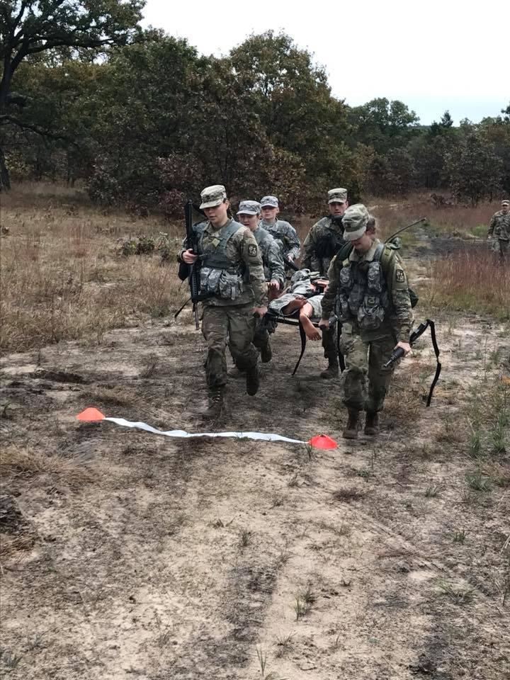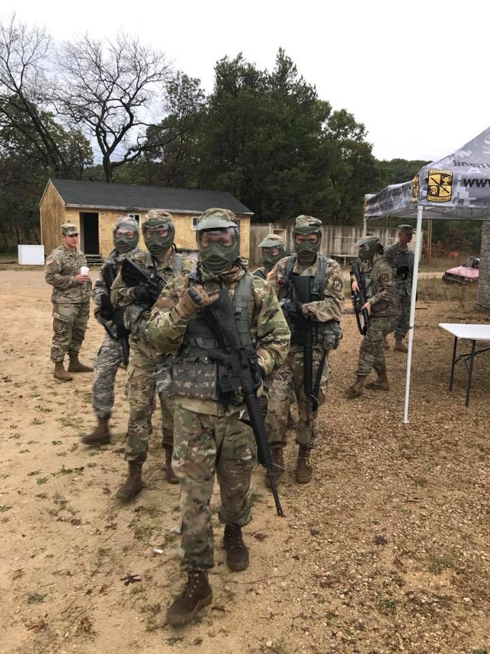

# Ranger Challenge

**Ranger Challenge helped bring out the best in all the cadets participating. It helped us band together and overcome great odds and embrace very unfavorable conditions. It also helped bring the leader out in each of us participating. Ranger Challenge was a growing experience and is something every Cadet should try and accomplish. The Cadets completed an obstacle course, confidence course, a ruck march, taking apart and putting together weapons for time, among many other things over the weekend.**

* **Cadet Stephano Fabiano**

# NSTP

**My clinical rotation was a night shift on the ICU floor at Landstuhl Regional Medical Center. During my time on the ICU, I learned a tremendous amount of information, skills, and assessments. Thankfully I had an excellent preceptor who made the long nights on the floor a wonderful learning opportunity. One of my favorite experiences I had was being able to participate in the Maroon Surge exercise. Maroon Surge was a mock-mass casualty exercise in which many different care facilities participated. The simulation began down range where the causalities were transferred to Poland, and then flown to Ramstein. Finally, the casualties were transferred to LRMC where the simulation ended in the ICU. I was later interviewed about my experience during the exercise. What an amazing opportunity for a Cadet to participate in!**

* **Cadet Klokow**

# Air Assault

• • •

**Air Assault School is a ten-day long training that teaches Soldiers the basics of aircraft-based missions, with an emphasis on air assault missions. There are three phases to complete as well as several physical requirements a soldier must meet. The three phases are the Combat Assault Phase, Sling Load Phase, and Rappel Phase. The physical requirements include completing an obstacle course, a two-mile run, a four-mile company run, a six-mile ruck, and a twelve-mile ruck. On graduation day, you receive your Air Assault Badge and are certified for Air Assault operations.**

* **Cadet Joseph Messer**

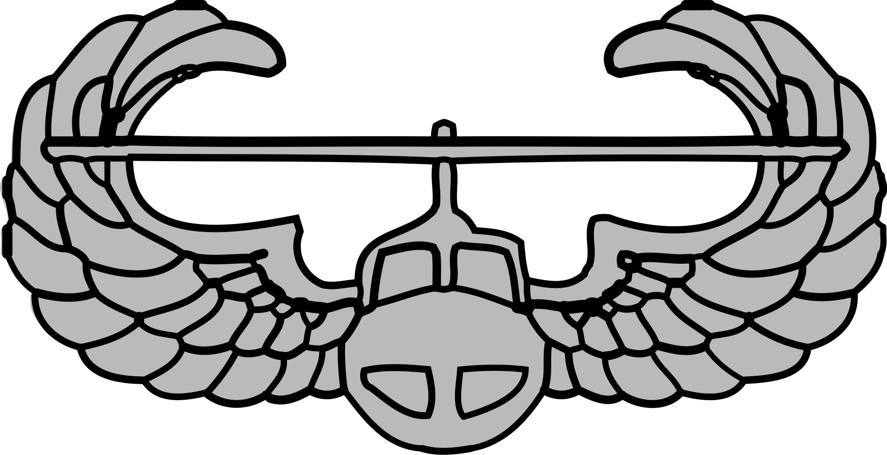

# 

# Upcoming in Eagle Battalion

**Eagle Battalion is looking forward to the Spring semester. The Battalion will conduct many labs involving tactics, allowing the MSIIIs to have platoon leader time in preparation for their time at Advanced Camp. There will be many competitions the Battalion is hoping to participate in, including Bataan Death March and Ranger Buddy. The Battalion is creating an Alumni Association that will allow for the alumni to stay in touch with what the Battalion is doing and is a way to support its future endeavors.**

# Commissioning December 2017

**Cadet Zeke Emerick**

**Cadet Emerick served Eagle Battalion as Spring 2017 Battalion Commander, over the course of his time in Eagle Battalion he competed in ranger challenge, northern warfare challenge, ranger buddy, received gold in his German Armed Forces Proficiency Badge and participated in project GO where he traveled to India and learned multiple languages. While accomplishing many things at Eagle Battalion, Cadet Emerick also played football at University of Wisconsin La Crosse and was a wide receiver. He will graduate Saturday December 17 with a degree in sociology and two minors in military science and criminal justice.**

**Donations to the Alumni Association can be mailed to the address below:**

**Military Science Department**

**1725 State St. La Crosse, WI 54601**

**#: 608-785-8404**

# Fall Photos

• • •

# More Photos:

