**A Guide for Managing a Department’s Financial Resources**

A good understanding of how to manage your department’s financial resources is important to maximizing the effectiveness of your unit in achieving its mission. To aid in this understanding, the Budget Office has developed this guide.

# Budget Process

The [Budget Office](http://www.uwlax.edu/Budget/) works with each department during the annual budget cycle to develop the department’s financial plan for the coming fiscal year. Standardized budget templates, like the examples below, are used to organize the information. The templates include summaries of a unit’s financial operations for the year, a listing of unit personnel, and detailed supplies & expense budgets. Units with self-supporting or dedicated revenue streams may also have additional pages containing projections for these revenue sources.

The budget that is finalized and approved by Stephanie Pope, Vice Chancellor for Administration & Finance, becomes the financial operating plan for that fiscal year. The plan that is developed becomes the unit’s official [Redbook](https://www.wisconsin.edu/budget-planning/annual-operating-budget/) budget and is loaded into the university budget system, becoming a permanent state record. At times, adjustments or transfers can be made through a request and review with the Budget Office. More information about the annual budget process can be found at: <http://www.uwlax.edu/Budget/>.

# Budget Office Contacts

Each division is assigned a budget planner in the Budget Office. The assignments are as follows:

|  |  |
| --- | --- |
| **Division** | **Budget Planner** |
| Executive (01XXXX), University-wide (70XXXX & 98XXXX) | Emily Roraff, Budget Director ([eroraff@uwlax.edu](mailto:eroraff@uwlax.edu)) |
| Academic Affairs (02XXXX), School of Education (03XXXX), and Graduate & Extended Learning (10XXXX) | Mandi McKinney, Budget Analyst ([mmckinney@uwlax.edu](mailto:mmckinney@uwlax.edu)) |
| Student Affairs (04XXXX) and Diversity & Inclusion (06XXXX) | Kristen Piske, Budget Analyst  ([kpiske@uwlax.edu](mailto:kpiske@uwlax.edu)) |
| Administration & Finance (07XXXX) and University Advancement (05XXXX) | Charles Mundinger, Budget Analyst  ([cmundinger@uwlax.edu](mailto:cmundinger@uwlax.edu)) |
| College of Business Administration (08XXXX), College of Arts, Social Sciences, and Humanities (28XXXX), and College of Science and Health (36XXXX) | Zach Lehnen, Budget Analyst  ([zlehnen@uwlax.edu](mailto:zlehnen@uwlax.edu)) |

The assigned budget planner is considered the primary point of contact regarding budget questions as well as a resource for general finance-related questions. If the budget planner is unable to answer a question, they will direct it to the appropriate individual in [Business Services](http://www.uwlax.edu/business-services/) or elsewhere on campus.

# Common Funding Sources

Budget resources come from a variety of different funding sources. The most common are listed here:

102 - General Purpose Revenue (GPR)

Budget authority granted and partially funded by the state. Considered the primary budget resource for many core academic and administrative units.

128, 136 - Auxiliary/Self-supporting/General Operations

Certain programs and activities have dedicated funding sources either through [segregated fees](http://www.uwlax.edu/sufac/), user fees, [special course fees](http://www.uwlax.edu/Budget/Special-course-fees/), or other miscellaneous revenue.

131 - Academic Student Fees (Tuition) - Self-Supporting

Certain academic programs are managed as self-supporting through the tuition generated by the program. For these programs tuition is not pooled centrally, but is instead held by the program to cover the cost of its operation.

131 - Academic Initiatives (AI)

Academic Initiatives is differential tuition that was implemented and approved in 2004. Students pay this differential tuition to fund a variety of student-focused programs on campus that are centered around advising, diversity, internationalization and research. Allocation of the Academic Initiatives differential tuition is done by the [Academic Initiatives Differential Allocation Committee (AIDAC)](http://www.uwlax.edu/studentassoc/student-senate/Committees/AIOC/aioc.htm).

131 - Growth, Quality & Access (GQA)

Beginning in the 2008-2009 academic year, UWL received approval to charge differential tuition to hire additional faculty and staff to lower the student to faculty ratio and fund instructional supplies and equipment.

131 - Excess Revenue (ER)

Certain departments identified with strategic needs receive funding from academic student fees. The Vice Chancellor for Administration & Finance and Provost and Vice Chancellor for Academic Affairs oversee the allocation of these funds.

104, 132, 189 - UW Extended Campus Funds

These funds are for Extension related activities on campus operated by the office of [Extended](http://www.uwlax.edu/conted/) Learning and the [Small Business Development Center](http://www.uwlax.edu/sbdc/). Fund 132 is for non-credit programming and 189 is for credit programming.

133, 144, 233 - Externally Funded Gifts, Grants and Contracts

Externally-funds gifts, grants, and contracts are funds that are given to the University from external sources for some kind of specific purpose. When UWL Foundation funds are used to reimburse University expenses, they are included in this category. Budgets and financials in these funds are managed by the Grant Accountant in Business Services. These accounts operate under the stipulations outlined in the grant and follow extramural fringe benefit rates. The [Office of Research & Sponsored Programs](http://www.uwlax.edu/grants/) provides information and support for seeking these kinds of funding opportunities. Faculty and staff are encouraged to seek out both internally and externally funded grants for programs that support the mission of the University.

# Foundation Funds

If a department or unit is to receive private donations, it is common practice to have the donations made to the [UWL Foundation](https://foundation.uwlax.edu/) instead of directly to the University. The Foundation will usually assist in setting up an account to track the donations and provide reports on the account to the department. Marcus Buchholz ([mbuchholz@uwlax.edu](mailto:mbuchholz@uwlax.edu)) UWL Foundation Director of Finance, can be contacted for further information.

Gift funds held at the Foundation that departments will use in support of the university should be incorporated into the University’s budgeting and accounting system by requesting the Foundation make a gift to the University. The Foundation disburses the gift to the University and it is deposited into a Fund 233 Gift Account. The use of these gift funds are governed by State of Wisconsin, University of Wisconsin System and university policies.

For more information on the UWL Foundation Requisition Guidelines please see these resources:

[Guidelines](https://www.uwlax.edu/globalassets/offices-services/business-services/policies/uwl-foundation-requisition-guidelines.pdf) and [Business Services Gift Funds website](https://www.uwlax.edu/business-services/our-services/gift-funds/#tab-policy).

# Budget Process Timeline

Budget (fiscal) years run from July 2 through June 30 of the following year. The fiscal year number is always the year that the date range ends in.

Examples: Fiscal year 2017 (FY2017 or FY17) runs from July 2, 2016 to July 1, 2017.

A typical fiscal year’s important events (such as for FY17) may look something like this:

July 2016

Beginning of the fiscal year. Redbook budgets are loaded into WISER.

October 2016 through March, 2017

Budget development meetings are held to plan out the next fiscal year’s budget.

February through March, 2017

Budget hearings are held with division leadership. Some units may not have a formal hearing every year.

May 2017

Year-end processing deadlines are announced.

June 2017

Most year-end deadlines, occur in mid to late June. Meetings will be held to review year-end account standing and clean-up transfers. Spend plans on program revenue balances are requested.

July 1, 2017

Fiscal year is closed.

A more detailed timeline of the budget process can be found [here](https://www.uwlax.edu/budget/budget-development/budget-timeline/).

# Fiscal Year-end Deadlines

It is important to be mindful of fiscal year-end processing deadlines when managing your budget and ensure that expenses planned for a given fiscal year are submitted to Business Services by the deadlines. In preparation to closing the fiscal year, Business Services provides a document outlining the deadlines for each kind of financial transaction that can be located by going to the [Business Services web site](http://www.uwlax.edu/business-services/) and clicking on “Fiscal year-end deadlines”. Business Services also sends a copy of this document out to all personnel.

# Budget/Funding String Structure

Budgets and their respective accounts can be identified using a funding string. A typical funding string will look as follows:

102-2-020100

For this example, the parts of this funding string are as follows:

**102**: Three-digit [*fund/appropriation*](https://www.wisconsin.edu/financial-administration/download/chart_of_accounts/appropriation_structure/Approp_Structure-FY15.xlsx) code, denotes the funding source

**1**: One-digit [*activity/program*](https://www.wisconsin.edu/financial-administration/accounting-and-budget-control/chart-of-accounts/) code. Denotes activity code: 0: Student Services, 1: Institutional Support; 2: Instruction; 4: Research; 5: Public Service; 6: Academic Support; 7: Physical Plant; 8: Auxiliary Enterprises; 9: Financial Aid. Sometimes written with a leading zero (02 instead of just 2).

**074000**: Six-digit *UDDS/department* code. Technically begins with a one digit letter but the letter is usually omitted since it is always “E” for UWL.

UDDS standards for “**U**nit, **D**ivision, **D**epartment, **S**ub-department” could can be broken down further due to how it’s structured,

(E)074000 -> E 07 40 00

The parts of this UDDS are as follows:

**E**: *Unit*, usually omitted. All of UWL’s UDDS numbers begin with E in the System-wide financial system but can be ignored for most internal purposes.

**02**: *Division*, in this example, Admin & Finance (**07**XXXX).

**01**:*Department*, in this example, the ITS (0740XX)

**00**:*Sub-department*, typically used sequentially and is for accounts within a department. The 00 account is usually the first used and denotes the department’s main account.

Every funding string and UDDS code are structured a similar way. Every UDDS code also has a corresponding name or description. For this example, 074000’s name or description is “Administration & Finance” and can thus be referred to as “Administration & Finance 102-1-074000” for added clarity. The UDDS is generally considered the most important code in the funding string as most UDDS’s only have a single fund and program code associated with them and are often simply referred to as an “account”.

In addition to a funding string, specific financial items (such as an expense, revenue deposits, and budget line) are identified by a four-digit class/account code that classifies the transaction. The Budget Office determines the appropriate class/account code for budget lines while Business Services provides the class/account coding for most expense and revenue transactions. More information about class/account codes can be found [here](https://pollux.uwsa.edu/PRODUCTION/acctcodes/index.php/acctcodes/acctcodeselection/2015).

# Understanding Budget Templates

The foundation of a unit’s financial plan is the budget. Budgets are provided to units using standardized templates listing planned expenditures arranged into specific categories.

A typical 102 or 131 budget summary shows budgeted expenditures, as well as actual expenditures, for each major category for the current fiscal year, along with the last three fiscal years:

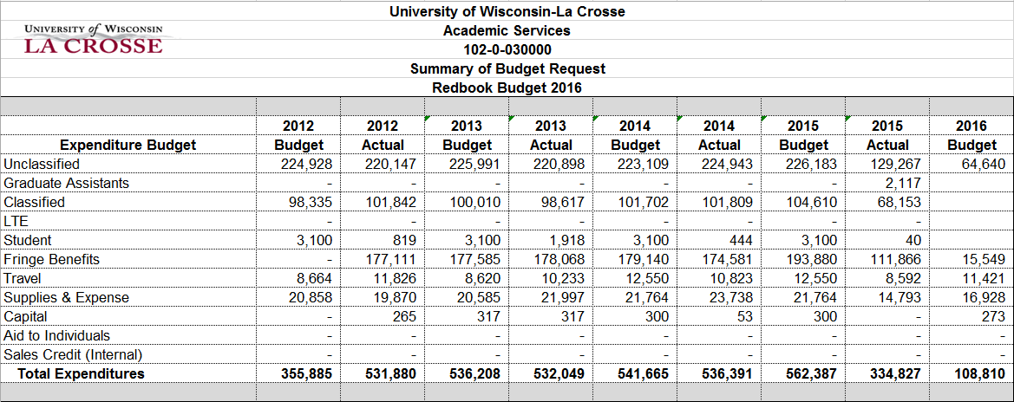

A summary of all individual budgets for each account within a unit is provided as well:

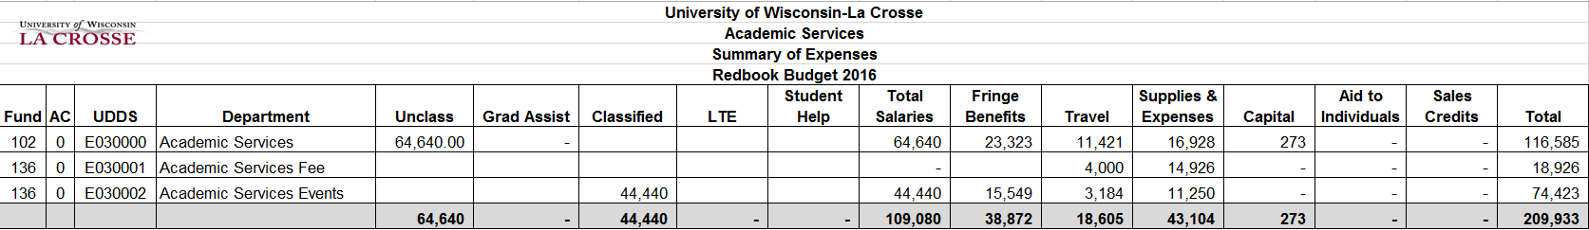

A listing of department personnel and their salary information, along with the prior year salary information is provided. Personnel included in this listing are considered to be in Redbook positions. Redbook positions are viewed as permanent and receive State pay plan, University-funded equity increases, and are eligible for career progression. Staff not in budgeted Redbook positions do not receive pay plan/equity and are not eligible for career progression.

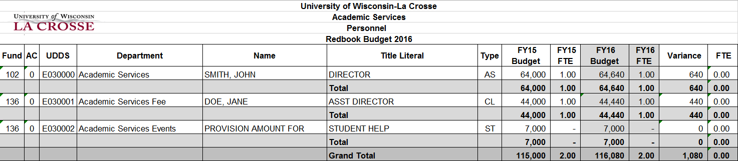

Detailed supplies & expense budgets by class code are developed during the budget cycle to provide a greater level of information on a unit’s spending plan for the year:

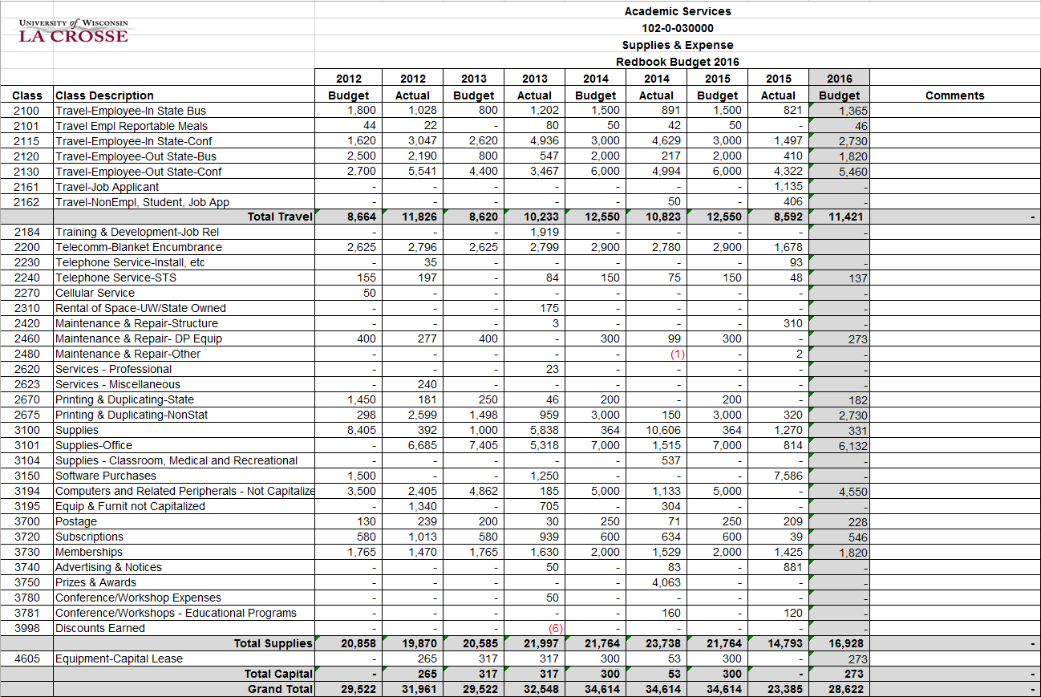

A variance report is also provided for each account to highlight any change in the budget from the prior year to the current year:

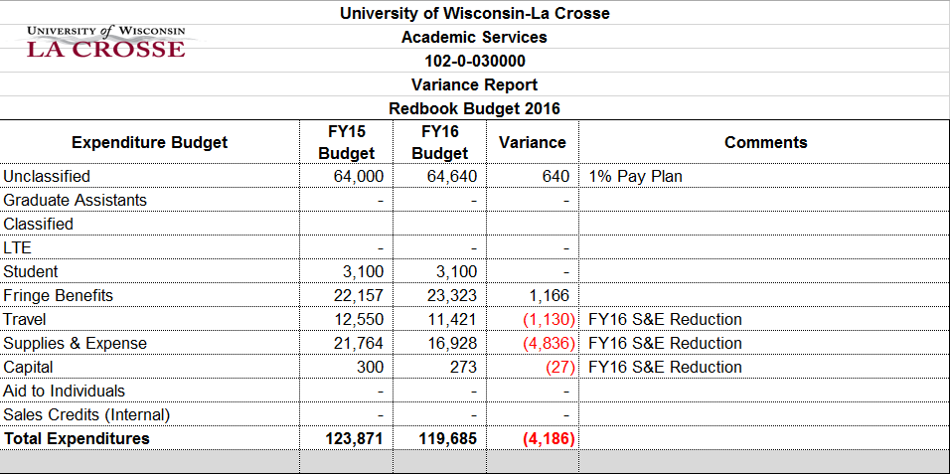

# Budget Transfers

Generally, budget resources should stay in the major expense category they were budgeted in during the Redbook development process (salary budget used for salaries, supplies & expense budget used for supplies & expense, etc.) for base-funded programs (102, 131 GQA, 131 AI, 131 ER). There are some exceptions to this rule, such as for Search and Screen costs (see “Search and Screen Costs” section below). Self-supporting programs (128, 136, 131 Self-supporting, etc.) usually have more flexibility to spend between expense categories.

Budget transfers that maintain the same category (salary/salary or supplies/supplies) and stay within the same fund, can generally be made between two UDDS accounts through a request to the Budget Office. In some circumstances, budget resources can be transferred between two funds within the same [State Block Grant Appropriation](https://www.wisconsin.edu/financial-administration/download/chart_of_accounts/appropriation_structure/Approp_Structure-FY18-Summary-and-Detail.xlsx) (e.g. 402 budget to 102 budget). Budget can generally not be transferred between two funds that are in different Block Grant Appropriations (e.g. 102 budget to 131 budget).

# Financial Reporting

[WISER](https://wiser.wisc.edu/) is our financial reporting application maintained by UW System Administration and provides users access to view the activity in their accounts. The WISER system can be accessed using this link: <https://wiser.wisc.edu/> or it can be accessed via the campus quick links.

New users will need to fill out the WISER authorization form, located [here](http://www.uwlax.edu/uploadedFiles/Offices-Services/Business_Services/WISDM2AuthorizationRequest.pdf), in order to receive the proper access to view their budgets and accounts in WISER. The Budget Office can provide appropriate UDDS numbers needed for a user’s access, with division leadership providing approval and Business Services granting the access. Business Services provides training in using the WISER system. Spencer Green, Assistant Controller, ([sgreen@uwlax.edu](mailto:sgreen@uwlax.edu)) can be contacted to set up a training session. In addition to training, Business Services also provides a user’s manual, located [here](http://www.uwlax.edu/uploadedFiles/Offices-Services/Business_Services/WISDM_Manual.pdf).

In addition to WISER, custom financial reports and budget templates showing up-to-date revenues, expenses and remaining balances throughout the year can be provided by the Budget Office upon request.

**Salary and Wages**

In general, budget resources allocated for salary expense cannot be used for non-salary expenditures. There are some exceptions to this rule, such as covering search and screen costs and temporary help or backfill. The use of salary savings outside of those items should be discussed with the Budget Office. Additionally, certain instructional units are allowed to use salary budget resources for non-salary expenditures, as well as certain self-supporting units. Position or job overlap is not permitted and is not an approved use of vacancy savings or other university resources.

UWL is committed to attracting and retaining a highly qualified and diverse workforce. In collaboration with university leadership, the Budget Office oversees compensation related policies and procedures, including starting salaries and salary adjustments. UWL’s salary structure is aligned with the Universities of Wisconsin and provides a consistent, equitable framework for pay decisions. Compensation decisions are informed by market data, which is regularly analyzed by the Budget Office. The market data used in compensation analyses is proprietary and cannot be publicly disclosed due to data usage agreements with third-party vendors.

**Vacancy/Backfill Plans**

When there is a vacancy in a department, a backfill plan should be developed for covering duties that the vacated position was responsible for. Salary savings is also an appropriate use for these funds. Units must work with the Budget Office to confirm the level of salary savings available to fund the backfill plan and work with Human Resources to process any needed personnel paperwork.

**Search and Screen Costs (Non-Instructional Units)**

When there is a vacancy in a department,salary savings associated with the vacancy can be used to cover travel and supplies costs incurred from a search and screen process to fill a position. More information about budgeting for search and screen costs can be found [here](http://www.uwlax.edu/uploadedFiles/Offices-Services/Budget/Search%20Screen%20Budget%20Procedures%20(Non-GQA)%206.16.2015.pdf). Instructional units follow the process within the individual college or school.

**Overload Payments**

Overload payment refers to additional non-recurring work taken on by UWL employees outside of their regular work duties. Please contact the Budget Office for more information and further guidance on permissible overload activities. Overload payment request forms can be found [here](https://www.uwlax.edu/globalassets/offices-services/human-resources/overloadlumpform.pdf). All overload request forms must be completed prior to associated work commencing. Also note, overload payment requests must be turned in according to Human Resources payroll calendar deadlines, found [here](https://www.uwlax.edu/contentassets/45d5d2f41e3f46f6801751a297b395f9/2018-monthly-payroll-calendar.pdf).

**Fringe Benefits**

In general, base-funded programs (102, 131 AI, 131 GQA, 131 ER), fringe benefits are covered through central University funds. Budget resources for fringe benefits allocated to base-funded units can generally not be utilized for other purposes. Fringe expenses for self-supporting (128, 136, 131 Self-supporting, etc.) units and activities need to be covered through the revenue production of those units. If departments would like to utilize Supplies budget to cover a Salary budget line there is a fringe cost for that conversion of funds that amounts to 40.03% per UW System guidelines.

**Supplies & Expense and Capital Expenditure Budgets**

Supplies & Expense budgets should be expended for supplies and services that support the general operations of a unit. Capital Expenditures are for larger purchases that have a lifetime use of two years or greater and a cost of $5,000 or more. Spending categories within Supplies & Expense and Capital budgets are generally considered interchangeable.

**Revenue Collection & Tracking**

Payment collections from students (outside of the Cashier’s Office) should be minimized and should be centralized through the University billing process as much as possible. For most situations, charges should be applied to the students’ WINGS account, allowing them to pay in person at the Cashier’s Office or online through the Cashnet system. This mitigates risk associated with cash handling, allows for better tracking, and prevents duplicating resources associated with collecting payments.

**General Financial Processing**

Most expense and revenue processing (except payroll) is managed by [Business Services](http://www.uwlax.edu/business-services/). This includes processing of invoices for payment, travel expense reports, issue procurement cards, submitting requisitions for purchase orders, student billing, expense and revenue transfers, as well as contract approval. The Controller, Mark Haakenson ([mhaakenson@uwlax.edu](mailto:mhaakenson@uwlax.edu)), serves as the Director of Business Services. Below are the specific contacts for these areas:

|  |  |
| --- | --- |
| **Area/Transaction Type** | **Business Services Contact** |
| Account Payable - Payment of Invoices, Travel Expense Reports, Reimbursements, SFO’s | Spencer Green, Assistant Controller  ([sgreen@uwlax.edu](mailto:sgreen@uwlax.edu)) |
| Cashiers/Accounts Receivable - Student Billing & Payments and Non-Student Revenue Deposits | Carlena Goddeau, Accounts Receivable Manager ([cgoddeau@uwlax.edu](mailto:cgoddeau@uwlax.edu)) |
| Accounting - Expense/Revenue Transfers, Chargebacks, Banking, Grants, & Accruals | Amy Feuling, Accounting Manager ([afeuling@uwlax.edu](mailto:afeuling@uwlax.edu)) |
| Purchasing – Requisitions, Purchase Orders, Purchasing Cards & Corporate (Travel) Cards | Steve Dennis, Interim Procurement Director  ([sdennis@uwlax.edu](mailto:sdennis@uwlax.edu)) |
| Contracts Administration (non-personnel) | Aaron Camacho, Contract Administrator ([acamacho@uwlax.edu](mailto:acamacho@uwlax.edu)) |

**Financial Aid/Scholarship Disbursements**

Certain departments have financial aid/scholarship resources built into their budget. All disbursements of financial aid should go through the [Financial Aid Office](http://www.uwlax.edu/finaid/). Each type of disbursement should be set up with its own item type in the WINGS student system to allow for individualized tracking. Item types should have uniquely descriptive names to identify them. Departments should maintain a listing of the item types they utilize.

**Programs with Complex Financial Structures**

When proposing new programs with complicated financial structures, such as programs involving multiple revenue streams, international payments, foreign currency, student billing, taxable sales, invoicing, or contractual agreements, the Budget Office and Business Services should be consulted in the development stage so that an effective financial plan and budget structure can be provided for the program. Including these offices in the planning and development stages of the program will help ensure that these offices are able to help the unit manage these programs effectively throughout their operation.

**Resource Utilization & Control**

Unit directors are expected to utilize their budgetary resources effectively throughout the fiscal year to support the operations of their department and its programs. The Budget Office, Business Services, and Human Resources provide guidance and oversight over budget utilization, expense and revenue processing, and personnel-related transactions, respectively, in order to ensure units are in compliance with UW System and institutional policies. A complete listing of UW System Financial Policies can be found [here](https://www.wisconsin.edu/financial-administration/financial-administrative-policies-procedures/fppp/).

**Spend Plans & Cash Balances**

The management of cash balances in accounts across campus has become an institutional priority in recent years. Beginning in 2014, the Budget Office has worked with departments to develop spend plans for accounts that have balances over $10,000. The University policy states that balances should be managed within a 0% to 10% range of total year end expenditures and the spend plans are the tool to document the activity to bring the balances down to or below the 10% level over a 4-5 year time frame.

**Deficit Accounts**

According to University Policy, accounts are not allowed to be in a deficit position and must be balanced on a monthly and annual basis for each fiscal year. More information about this policy can be found [here](http://www.uwlax.edu/Budget/Deficit-Account-Policy/).

**New Accounts**

Occasionally when a department initiates a new activity or program, it is helpful to set up a new UDDS account to budget for and track the activity or program. New accounts can be requested from the Budget Office. For some grants and awards, such as Academic Staff Professional Development Grants and Faculty Research Grants, new accounts are created automatically by the Budget Office and then closed out at the end of the award timeline or fiscal year. When a new account is set up, a notification is sent out with the account number and paperwork for the account to the WISDM for the department, the division budget lead, ADA for the department, and possibly others.

**Carryover**

Carryover is generally not permitted for 102, 131 (GQA, AI, PIR or ER) accounts. All accounts with those fund series (aside from 131 Self-Supporting) are closed out at fiscal year-end. Internal grants must be expended in the year the funds were awarded. Any request exceptions for carryover must have approval by the Vice Chancellor of Administration & Finance. The funding for certain startup accounts are typically permitted to carry over for two fiscal years. Other departmental PR accounts in Fund 131 Self-Supporting, 132, 128, 136, and 189 allow cash balances to carry over from year to year.

**Year-end Encumbrances**

Funds to cover expenses encumbered at year-end will carry over (or reloaded into the account) the next fiscal year.

Last update December 22, 2024.