---Go to Finances>other financial section
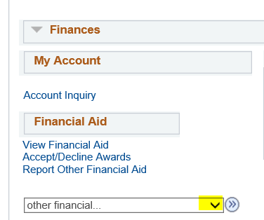
---Click on the drop down arrow.

It will bring up the choices of

Account Activity
Charges Due
Payment
Pending Financial Aid
View 1098-T
other financial

---Select View 1098-t and click on the arrow (right most arrow)

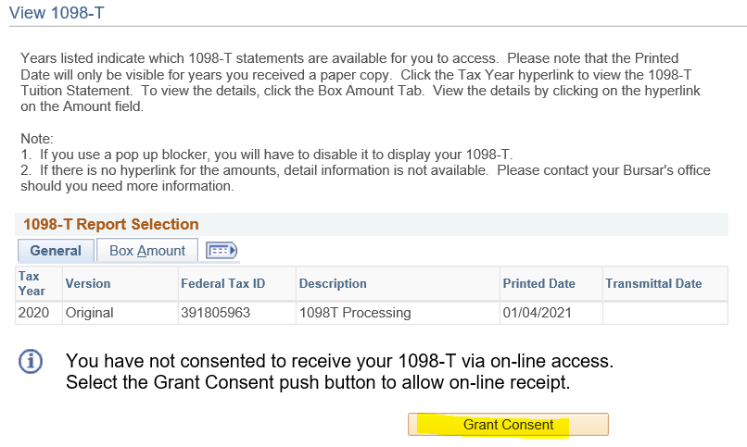
---Click on Grant Consent
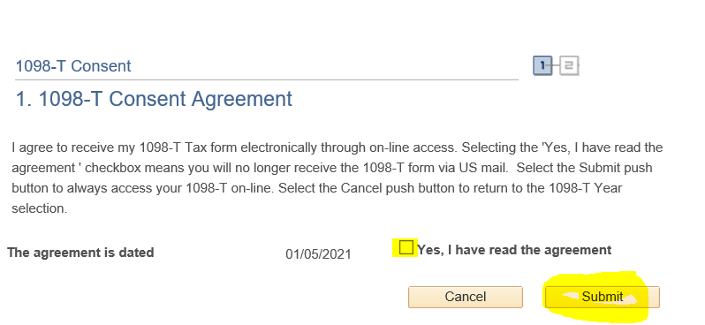
---Check and read the agreement
---Click on Submit

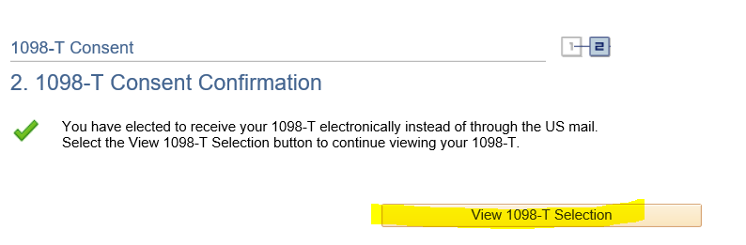
---Click on View 1098-T Selection

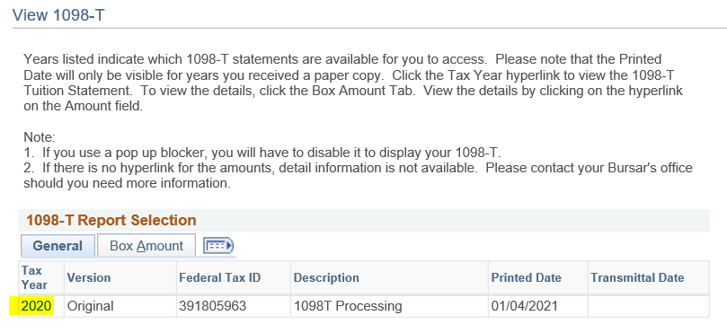
--- Click on 2020

Make sure to print the form. Once the form is viewed, you will not receive a paper form.

