Youth Protection and Compliance

UWL Process Guide

Obtain Approval: The Youth Activity Acknowledgement Form (YAA)

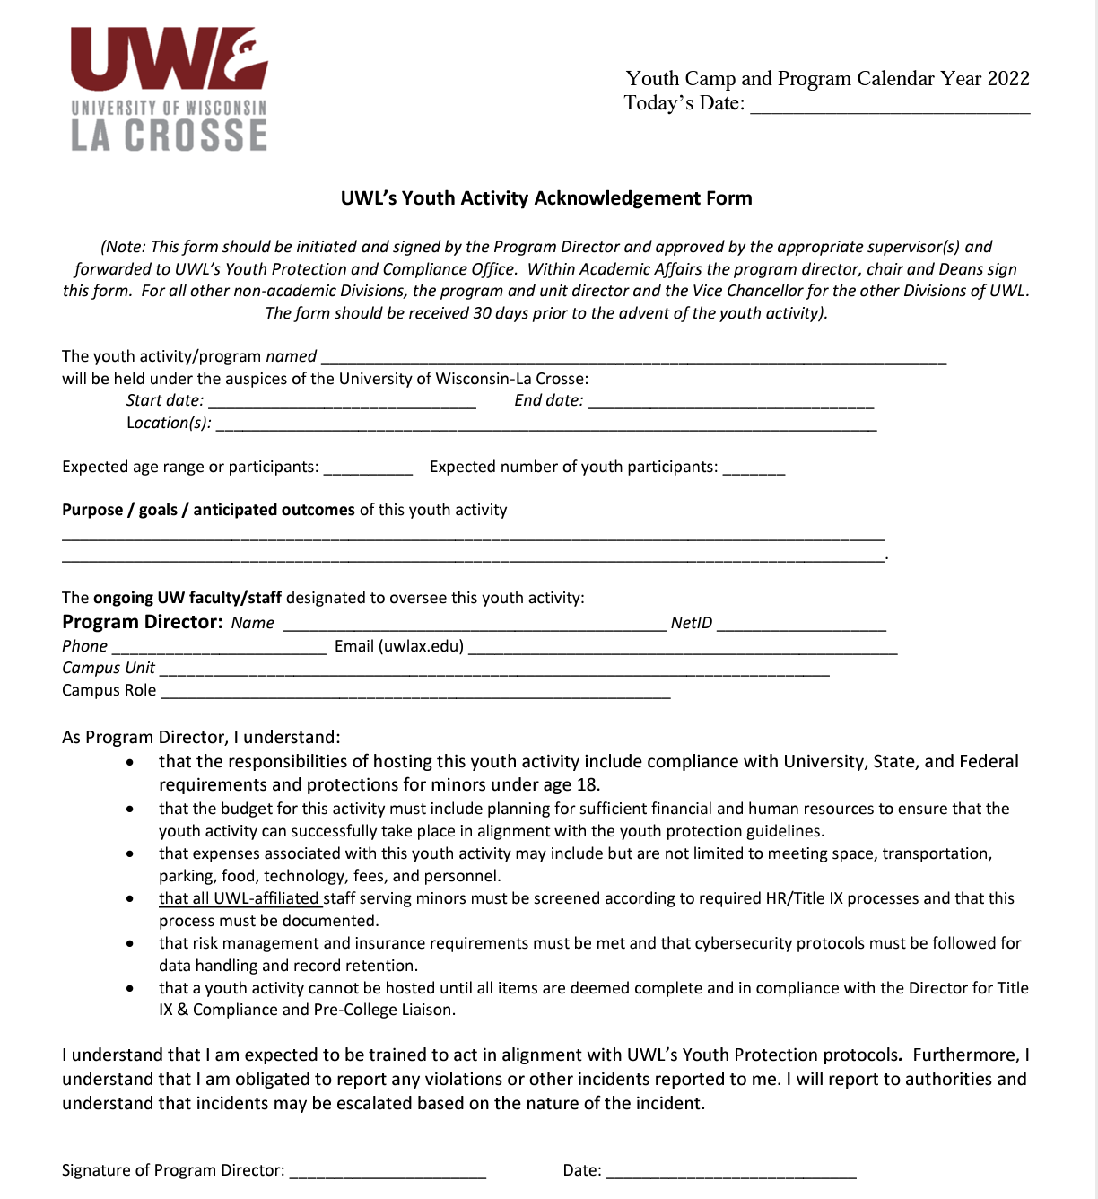
The Youth Activity Acknowledgement Form (YAA) is a signed form that outlines the risks and the responsibilities that the highest-level dean or director in a university unit, is willing to assume on behalf of a program. The YAA letter shows that the executive level dean or director in your unit is aware of your program, understands the risks involved in your program, agrees to accept ultimate responsibility, and supports your ability to run your program. The YAA letter also demonstrates that sufficient financial resources are available to cover an unexpected budgetary shortfall.

Program Directors will upload the YAA form during program registration (Section 2).

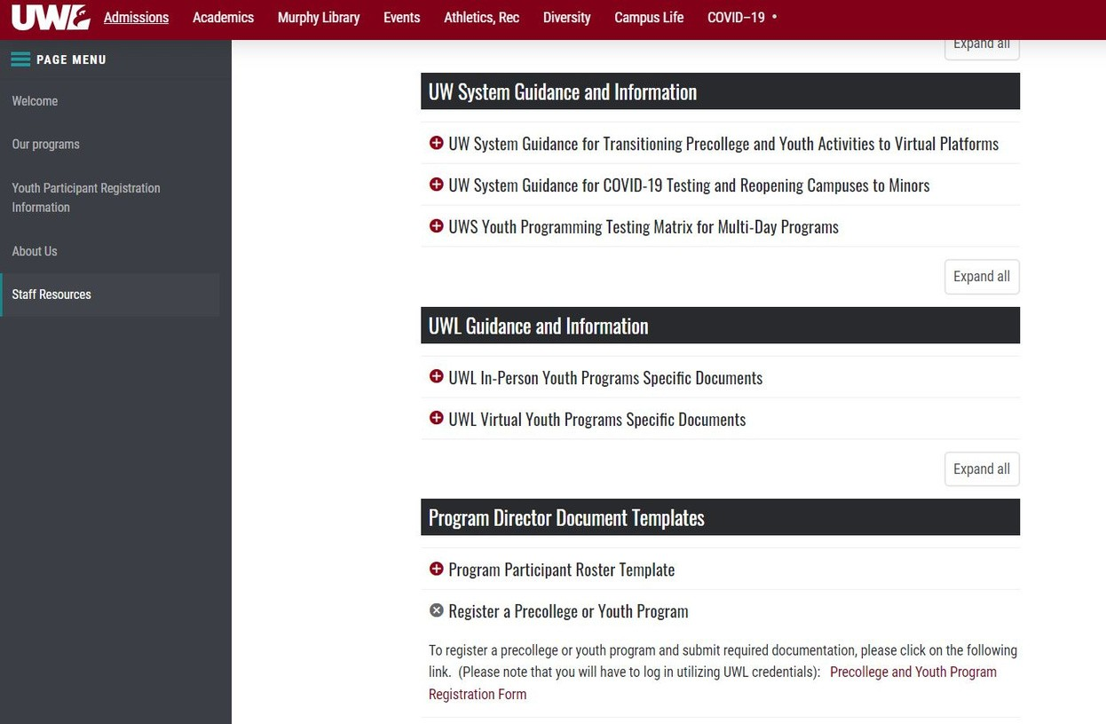

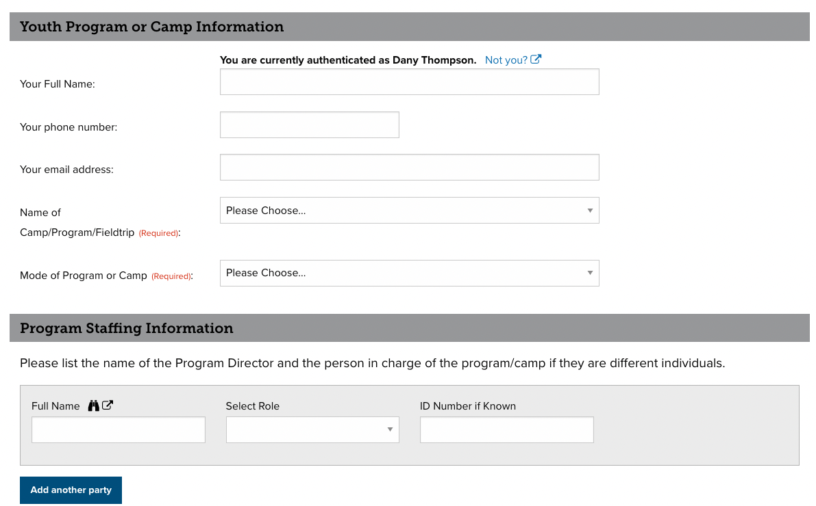

Program Information

Name of Program Director

The Registration Form is on the UWL Youth Programs Website under Staff Resources

Individuals will be directed to Maxient and must enter UWL credentials to access the form.

Program Information and submit the
Youth Acknowledgement Form

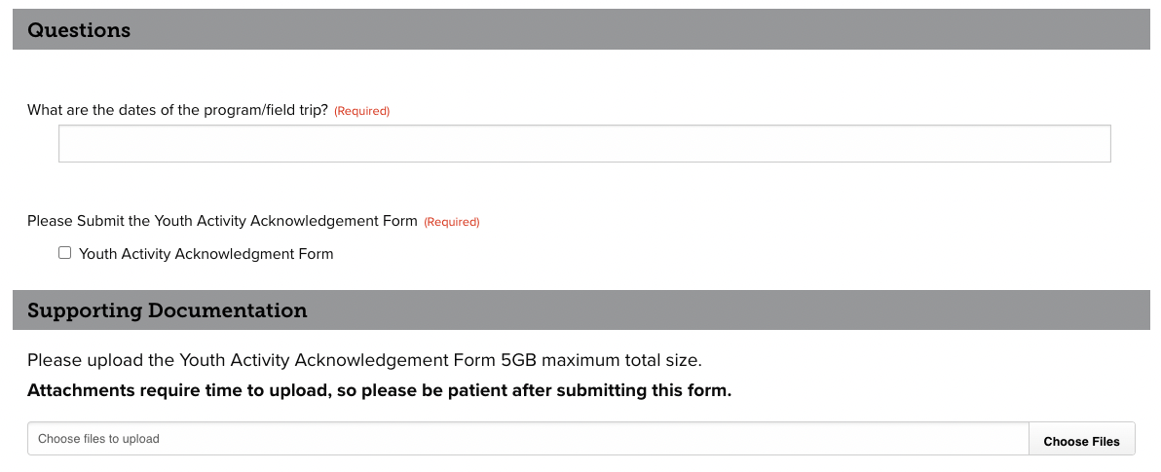

After Program Directors have hired staff (both paid and volunteers) and completed reference checks, they should connect with Human Resources (HR) to start the screening process, which includes the criminal background check and sex offender registry check.
All paid staff will need Employee Action Forms (EAF - non-students) or Student Employee Action Forms (SEAF - students) completed. To ensure paid staff receive a criminal background check, please complete the following:
EAF Form
Please check the "Position of Trust with Vulnerable Population" box SEAF Form
Please check the "Criminal Background Check (CBC) needed" and "Check here if there are applicable position of trust responsibilities" boxes
Volunteers will need to complete a Volunteer Agreement form. Program Directors will send a list of volunteer names to Human Resources to complete CBC's as a batch.
*An email from HireRight will be sent to all staff to start the CBC process. Please note that staff need to initiate this process after receiving this email. Program Directors should follow up with all staff to ensure they have received an email. Delays in start dates will occur if staff do not start the CBC process as soon as possible. Staff cannot interact with minors until the CBC is cleared.
Program Directors should submit names to HR at least 2-3 weeks before the start of a program to provide sufficient lead time. Once CBC's are completed/cleared, HR will notify Program Directors (name of individual listed as supervisor on the EAF or SEAF) when a staff can start working. Current UWL employees who have not worked with minors should connect with their supervisors and HR to ensure proper screening prior to interacting with youth.
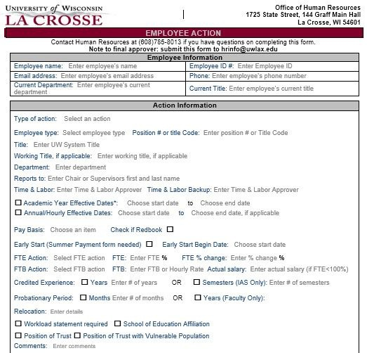
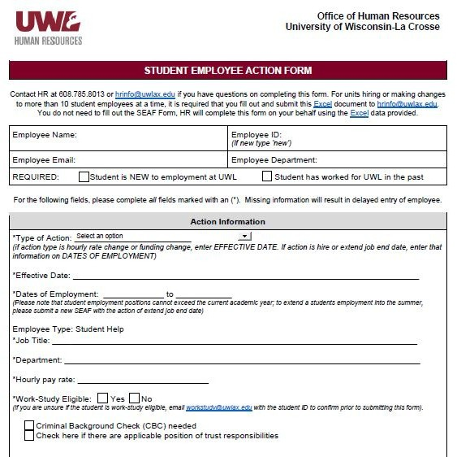
EAF SEAF

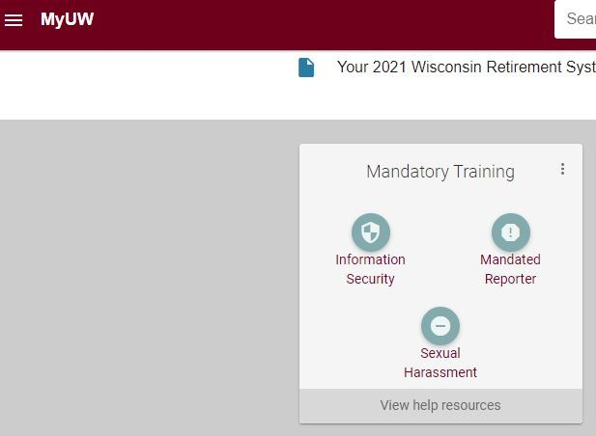
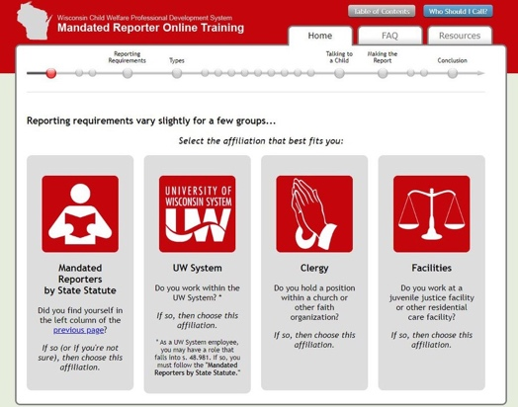
Program Directors must train program staff identified as Authorized Adults on the following content, at minimum, prior to interaction with youth:
\

Mandated Reporter and Sexual Harassment Current UWL employees can access these modules
in their HRS portal. For volunteers and UWL students, Program Directors should contact the Title IX Director for links to these modules.

Executive Order 54 (EO54)
Program staff can access this training module on the Wisconsin Child Welfare Professional Development System website. Staff should click on the "UW System" module and download a copy of the certificate after completion.

All certificates should be gathered by the Program Director and stored on SharePoint or OneDrive for audits. Dates of completion for each training should be included in the Staff Roster and uploaded as part of program registration (see Section 2).

*Designated individuals must receive additional training on Institutional youth protection best practices, including
prohibited behaviors, (as part of staff orientation/onboarding). Additional resources on best practices will be added to the UWL Youth Programs website.

Optional training for staff: First Aid/CPR and Youth Mental Health First Aid

Authorized Adult: Individuals, age 18 and over, paid or unpaid, who are authorized to interact with youth participants as part of a covered activity following completion of screening and training requirements. This includes, but is not limited to, faculty, staff, volunteers, graduate and undergraduate students, student- athletes, interns, and individuals associated with Third Parties. Authorized adults cannot have unsupervised access to minors.

Designated Individual: An authorized adult who is counted in the supervision ratio for a covered activity. Designated individuals are responsible for ensuring the care and safety of youth participants in covered activities. Additional training is required for authorized adults serving as designated individuals.

Program Directors must complete the following documents to finalize the registration process. Documents should be uploaded to Maxient . You will receive an email with the link to upload these documents.

Required Documents
- Youth Activity Acknowledgement Form
- General Health and Safety Plan
- Staff Roster
- Reporting Protocols
- Emergency Plan
- Field Trip Form (if needed)
- Volunteer Agreement (if using volunteers)

Templates are available on the UWL Youth Program website under Staff Resources
Staff Roster
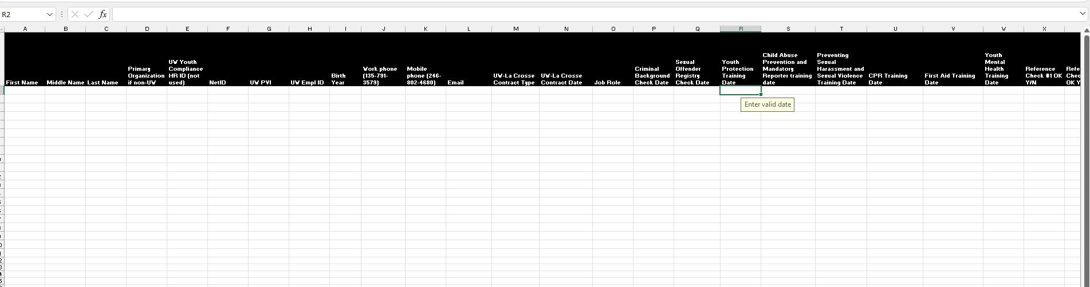
All staff names should be added to the roster. Fields highlighted in black are required.
Participant Roster
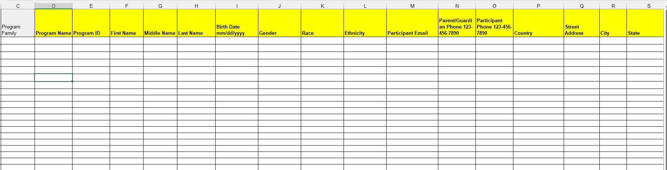
All participant names should be added to the roster. Fields highlighted in yellow are required.

Youth Supervision Plan
UWL must require that supervision ratios meet the minimum standards, with the exception of classroom settings, which allow for a 1:18 Adult to Youth Participant ratio. A minimum of two adults is required for all field trips. Designated individual status is required for all adults serving in supervision ratios.

Institutions must prohibit one-on-one interactions between adults and youth participants, unless the adult is a designated individual in a setting where one-on-one instruction occurs. In such settings, activities must be observable and interruptible. Institutions must designate an employee or department with knowledge of youth safety to review and approve requests to grant exceptions. Exceptions can also be made where a familial relationship exists and in emergency situations.

Health/Safety and Emergency Plans
The Health and Safety plan outlines response protocols in place to address mitigation/quarantine/isolation incidents. In addition, all residential programs must have a communicable disease protocol.

The Emergency Plan documents minimum emergency preparedness protocols based on the program's level of risk and as advised by the institution’s risk management authority or other relevant Institution stakeholders.

Links to the Health/Safety and Emergency plan templates are on the UWL Youth Program Website under Staff Resources. Templates should be modified to fit program needs.

Reporting Protocols Plan
Institutions must adopt an Reporting Protocols Plan to guide decision-making around incidents that violate institutional policy or trigger a reporting obligation as defined by the following:

Reporting Obligations
Institutions must require adults covered under this policy immediately report any suspected physical abuse, neglect, or sexual abuse of a minor pursuant to the institution’s EO54 reporting procedures.
Institutions must also require adults covered under this policy to report the following incidents that occur within a covered activity to the institution through procedures established by the Institution:
Sexual harassment or sexual violence as defined by the institution’s Title IX policy; Incidents resulting in serious physical harm requiring professional medical attention; and
Incidents of illegal or unauthorized drug use.
Institutions may identify additional reportable incidents.

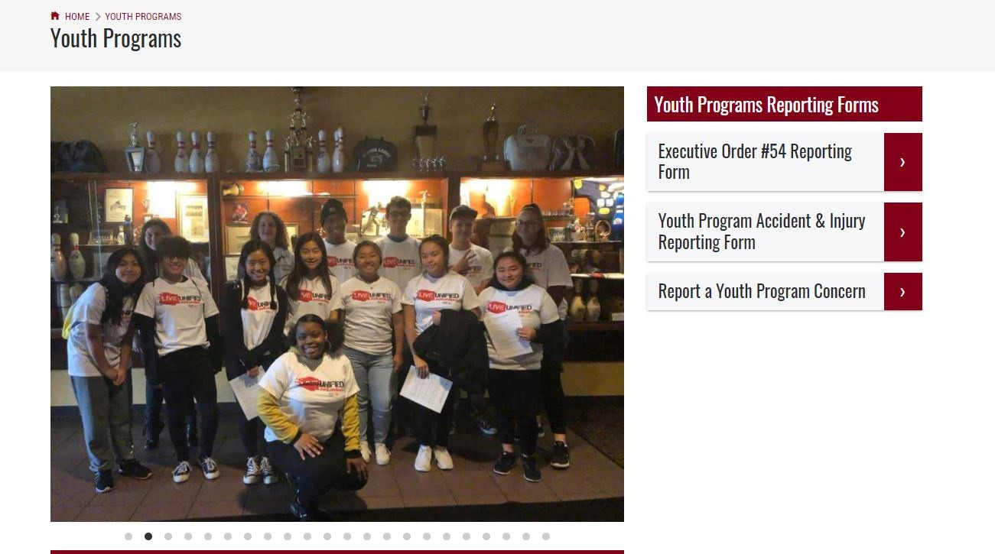
Program Directors need to include the how, when, where, and who as part of the reporting protocols. Links to make a youth program report are on the UWL Youth Programs website.

Other Helpful Program Documents (for program use)
Parental Waiver/Liability Form Media Release Form
Youth Health Form

What Comes Next?
Approval to Host a Youth Activity

The Director for Title IX & Compliance and Pre-College Liaison will
- review the initial program registration form
- send an email with list of documents and the link where to upload them
- follow up submission of staff screening/training requirements and required documents

The Director for Title IX & Compliance and Pre-College Liaison will communicate with Program Directors of any missing or outstanding items during this process to avoid delays.

Once all items are deemed complete and in compliance, the Pre-College Liaison will notify Program Directors of approval to operate their program.

