
Student
Supervisor and
Student
Process
Coordinator
Training



Agenda
•
Hiring a Student
o
ESO and Sup Org Review
o
Direct Hire of a UW Student
o
How to Cancel a Hire
–

In Progress
•
Onboarding requirements
o
How to Update a Position of Trust status
o
Onboarding and Form I
-
9
•
Add Job
•
Direct Hire of a Student Not Enrolled at UW

Student Hourly
Hiring and Add Job
Once you decide to hire a student, the supervisor should provide the following:
- Onboarding information for Workday
- How to use clock in and out
- Mandatory employee trainings
- How to find and read pay slip
Hiring a Student Employee
Student supervisors are
accountable for ensuring that
student employees receive a
comprehensive onboarding
experience. Effective onboarding
has been demonstrated to support
retention and drive positive
performance outcomes
.
- Onboarding information for the Department
- Role Expectations
- Examples: attendance/ clock in and out, break times (if any), Key/ safety protocols, call in procedures, dress expectations

ESO and Sup Org
- Student Hires Can Be Initiated in Two Ways
- Hire Student Task
- Find External Students Task
- Whenever possible, initiate student hires using the student's External Student Object (ESO). ESOs provide student information directly from UW student systems, reducing manual entry, duplicate records, and administrative effort.
- External Student Object (ESO)
- An ESO represents a student who is enrolled at, or eligible to enroll in, a UW institution.
- If the individual being hired into a Student Hourly position does not have an ESO and there is no active student record in Workday, the Hire Employee task must be used instead of the Hire Student task.

- Non-UW students may still be hired into Student Hourly positions and assigned to a Student Hourly supervisory organization. However, the hiring process will require additional data entry that would normally be populated through an ESO, including:
- Personal information
- Government identification information
- Other onboarding details
- Student Hourly Sup Org
- When hiring a Student Hourly (SH) employee:
- A position is not required
- Verify that the employee is being hired into a SH job management sup org
- SH Sup Orgs can be identified by a name ending in “_SH.”
- If your department needs a new SH Sup Org created, please reach out to Vinny for assistance
Direct Hire of a
Universities of
Wisconsin Student

Find External Students
- From the Workday Home Page, search for and select the Find External Students report using the search bar.
- On the Find External
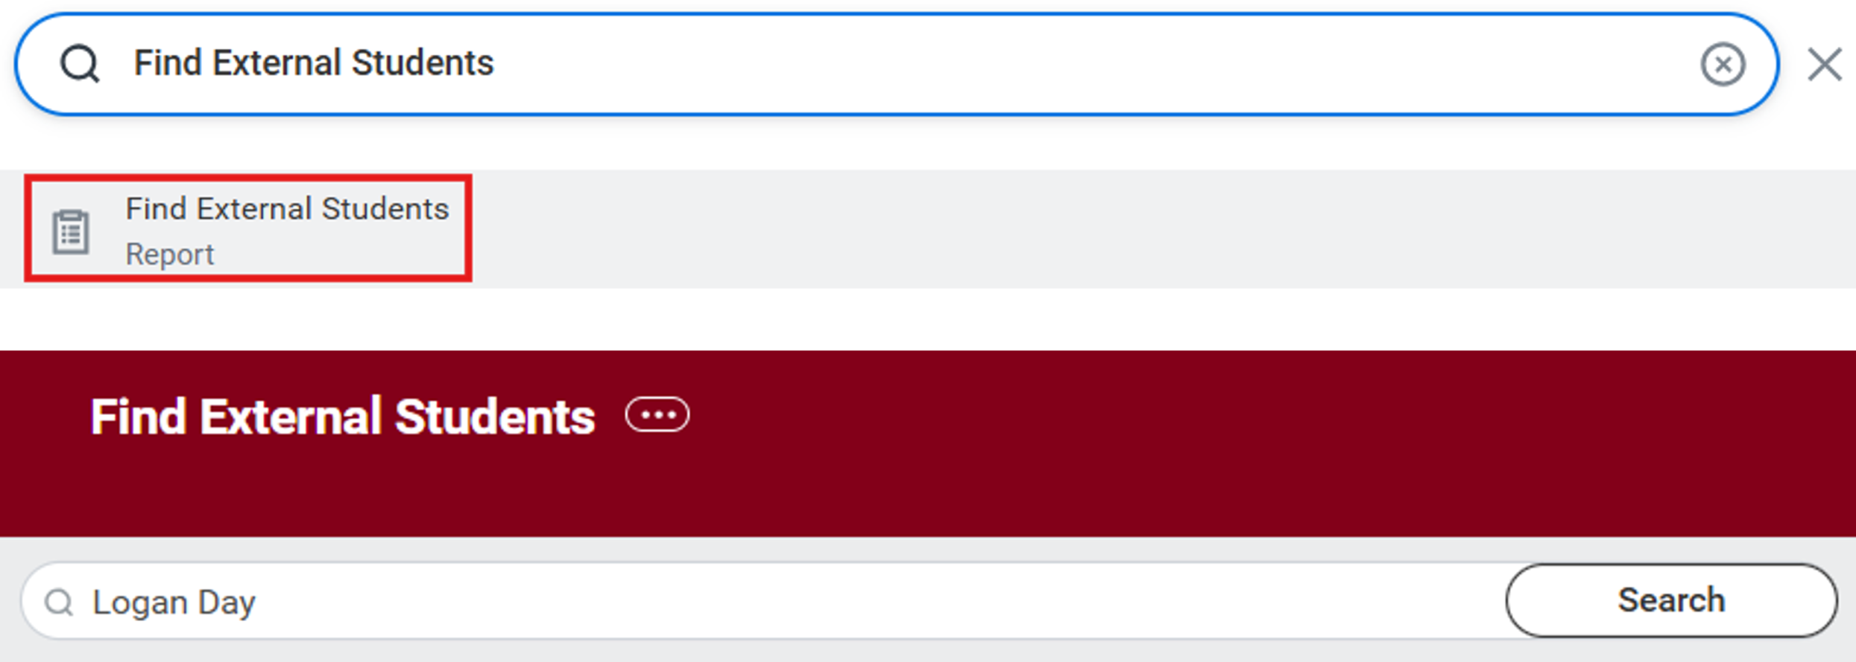
Students search bar, search for the student’s name.
- Use the legal name.
- In the Results section, click on the student’s name to bring up their External Student record.
- Confirm External Student Information to ensure correct student was selected.

Confirm Correct Student
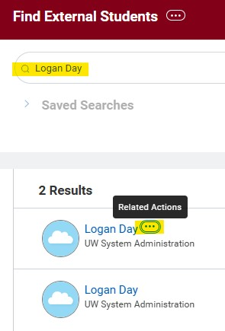
- Use the Related Actions button to verify and select the correct ESO before proceeding with the hire.
- Tip: Carefully review the student’s identifying information (such as email address and personal information) to ensure you are selecting the correct ESO and avoiding duplicate records.

Find Duplicates
- Navigate to Related Actions → Duplicate Management → Find Duplicates.
Key Reminders:
- Confirm the student appears with an Active status.
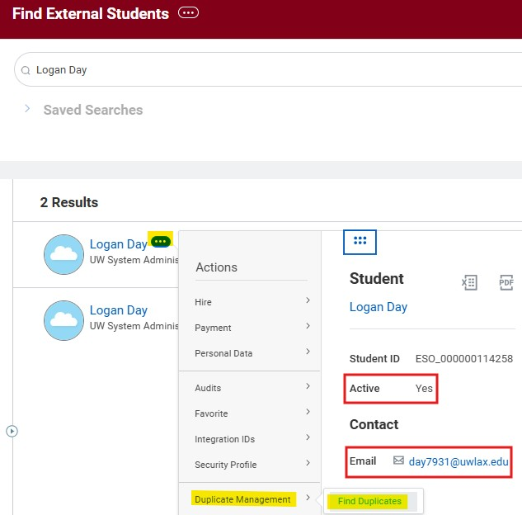
- If the student is not active, they may not yet be registered in WINGS. In these cases, you may need to:
- Wait until the student becomes active in WINGS, or
- Follow the Direct Hire of a Student Not Enrolled at a UW Institution process.
- Do not rely solely on the email address when identifying the correct student record. Students with the same or similar names may also have similar email addresses.
- Carefully review all available information to ensure you are selecting the correct student and avoiding the creation of duplicate records in Workday.

Hire Student
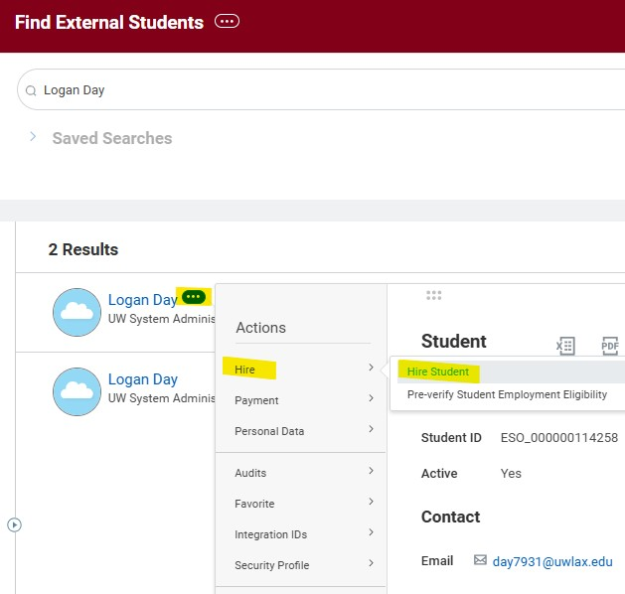
- After selecting Find Duplicates, review the student's information to verify you have identified the correct record. Available information may include the student's legal name, date of birth, home address, email address, and other identifying details.
- Once you have confirmed the correct student, proceed with the hire by selecting Related Actions () → Hire → Hire Student.
- If the record is not the correct student, use the Back button to return to the search results and review the other available External Student Objects (ESOs) until you locate the appropriate record.

Select SH Sup Org
- After selecting Hire Student, choose the appropriate Supervisory Organization (Sup Org) and click OK to continue.
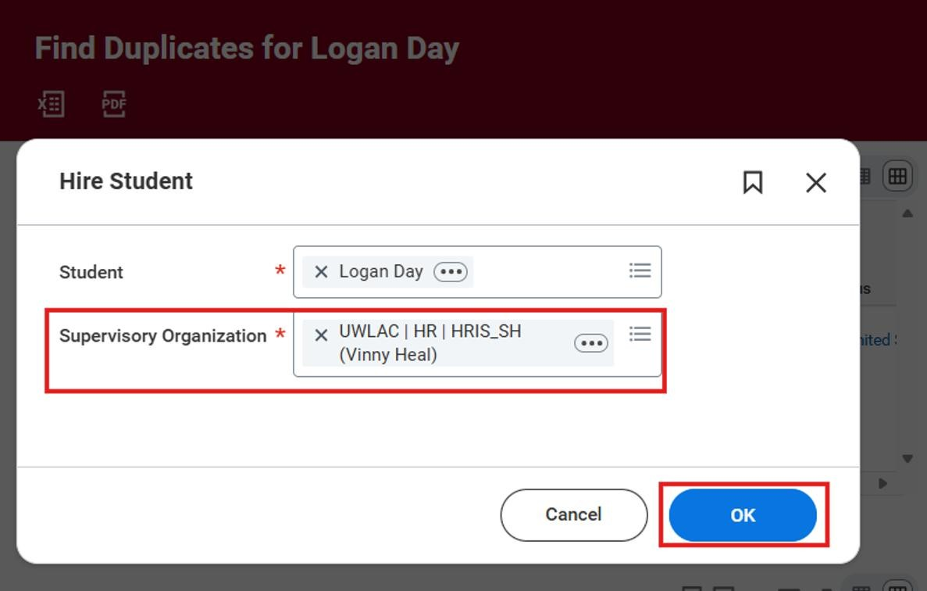
- Be sure to select a Student Hourly Supervisory Organization, which can be identified by a name ending in "_SH.“
- Selecting the correct Sup Org ensures the student is hired into the proper Student Hourly organization and follows the appropriate Workday business processes.

Launch Hire Process
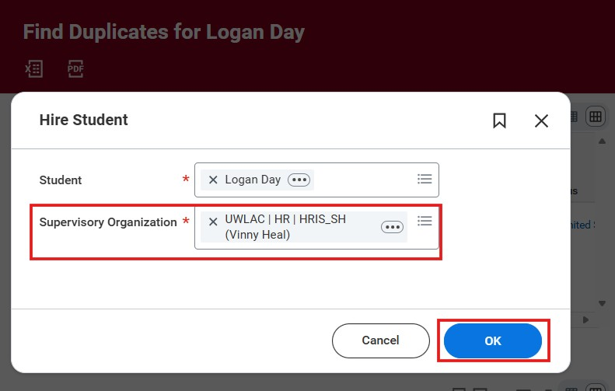
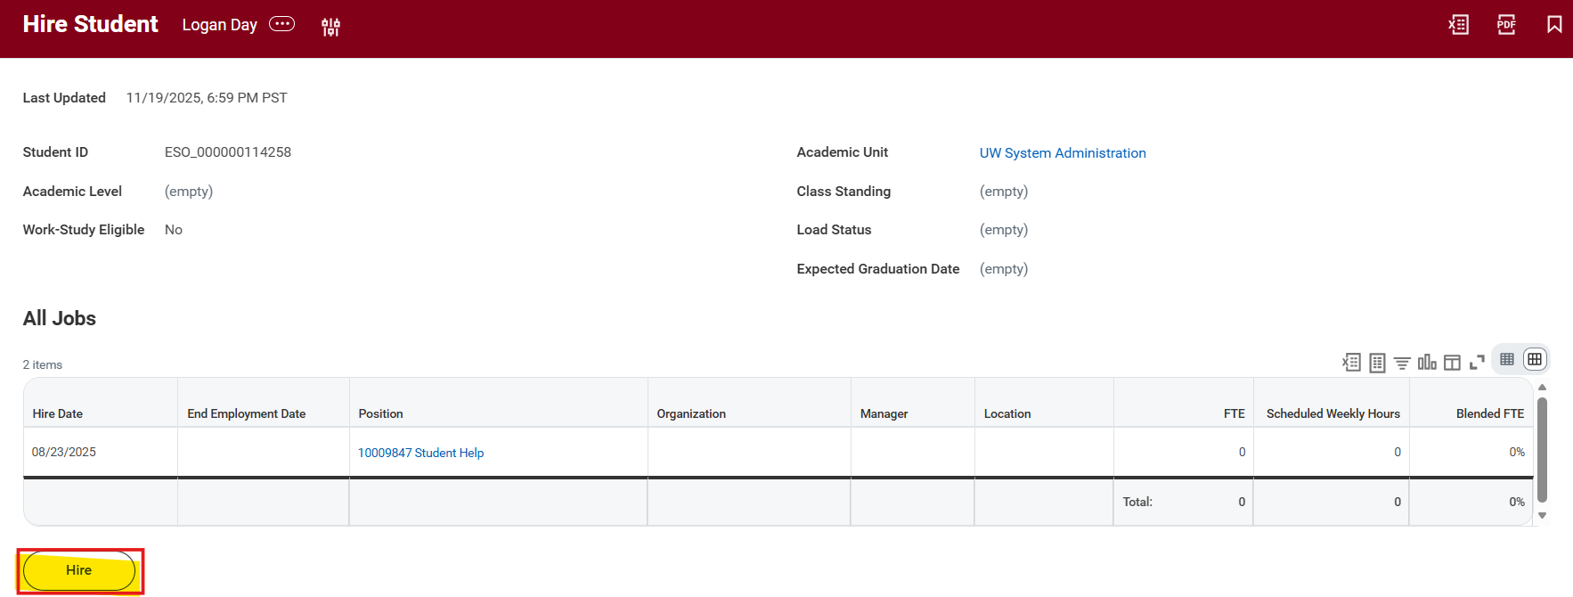
- After clicking OK, select Hire to proceed with the Student Hire process.
- Once the Hire button is selected, Workday will launch the hire business process and guide you through the remaining required steps.

Complete Details of Hire – Hire Date and Position
- Hire Date:
- Submit hires between 7 and 30 days before the student's start date to allow time for approvals and onboarding while minimizing the risk of conflicting hire actions.
- Reason: can use New Hire or Rehire
- Sup Org
- Verify that you selected the correct Sup Org before proceeding
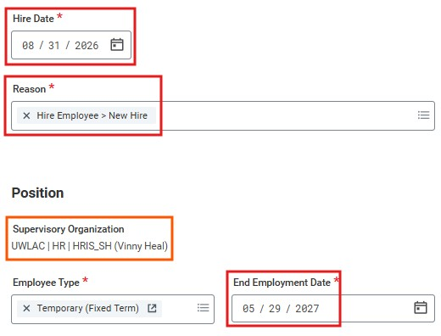
- The Sup Org cannot be changed from this screen
- If you selected the wrong Sup Org, you would need to cancel and restart the process through Find External Students
- Employee Type: leave as Temporary (Fixed Term)
- End Employment Date
- Enter the anticipated last day the student will work in this position. This can be extended later
- The End Employment Date should not extend beyond the last day of the pay period for the current academic year
- If FWS funding only, then the end employment date should reflect the last day of the FWS award period (ex: 5/15/27)
- Setting an accurate end date helps ensure timely job-end processing and reduces the need for future corrections

Appointment End Date Guidelines
- Fall hires: Use the last student hourly pay period of the academic year unless an earlier end date is known.
- Summer-only hires: Use the anticipated end date of the summer assignment.
- Ongoing employment into the next academic year: Use the first Friday in October of the following academic year.
- Expected Ongoing Employment – Spring to Fall
- If a student is expected to continue in the same position from Spring into Fall:
- The FTW process will be used to update the EJED to the first Friday in October
- This approach:
- Allows the position to carry into the Fall semester
- Triggers another FTW review in Fall to confirm continued employment • Student Hourly Eligibility and Appointment PDF

Complete Details of Hire - Location and Job Details
- Location and Job Details:
- Location: Select the primary place of work
- Work Space: Optional
- This field is not common for SH
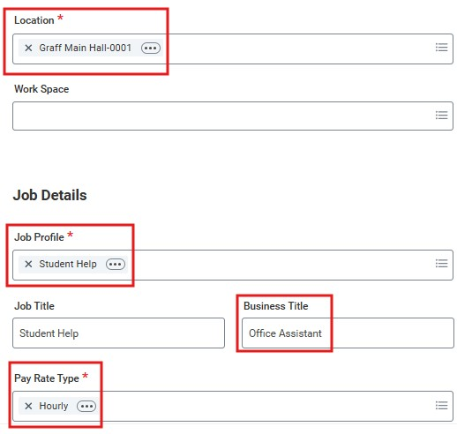
- Can enter assigned office, workstation, or room number
- Job Profile: Select Student Help
- Business Title: Enter a business title that accurately describes the student’s role and responsibilities
- The business title must be different from the Job Profile
- Ex: Office Assistant, Research Assistant, etc.
- Pay Rate Type: Leave as Hourly
- Leave the Annual Work Period and Disbursement Plan Period fields blank

Federal Work-Study - Part 1
As departments begin hiring Federal Work-Study (FWS) students for the 2026-27 academic year, please review the following reminders to ensure a smooth hiring and funding process. Hiring Process in Workday
During the Hire process in Workday, after entering the Job Category, please skip the optional "Additional Job Classification" step.
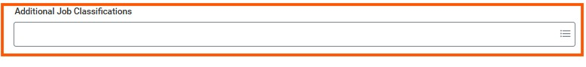
- This step should not be completed by the hiring department.
- The Additional Job Classification will be added by Financial Aid once:
o The department notifies Financial Aid that the hire process has been initiated, and o The student has reached the onboarding stage and is eligible for FWS processing.
When emailing Karen Deschepper to notify Financial Aid of a hire, please include confirmation of the student's start date. As a best practice, the hire date should match the student's actual start date.
Departments should only enter the appropriate Costing Allocation funding (Worker Position). Federal Work-Study Costing Allocation Funding (Worker Position Earning) will be added automatically after the Additional Job Classification has been applied.
Important: No FWS assignment notification = No FWS funding.
2026-27 Federal Work Study Dates
Federal Work-Study funding for the 2026-27 academic year covers the period of:
August 23, 2026, through May 15, 2027
Please use these dates when entering employment and funding information related to Federal Work-Study positions.

Federal Work-Study - Part 2
Department Responsibilities
Only students who have received an official Federal Work Study assignment for the current academic year are eligible for FWS funding approval.
Departments are responsible for:
- Retaining a copy of the student's FWS assignment notification email each academic year.
- Reviewing funding after the student's first posted payroll to ensure wages are charging to the correct FWS funding source.
- Identifying and resolving funding issues as early as possible by verifying payroll distributions promptly.
Returning Students
Some returning students may require a manual Federal Work-Study award before they can be hired. Before initiating a hire, please verify that the student:
- Has a Federal Work-Study award included in their 2026-27 Award Summary.
- Has accepted the award.
- Has completed the required FWS questionnaire to return to your department.
Please note that financial aid offers have been delayed for some students this summer, and manual awarding is still ongoing.
Thank you for your attention to these guidelines and for helping ensure timely and accurate processing of Federal Work-Study student employees.

Complete Details of Hire – Working Time
- Time Type: Select Part Time
- Scheduled Weekly Hours: Enter 0
- For Student Hourly (SH) employees, this field should always be set to 0, regardless of the number of hours the student is expected to work.

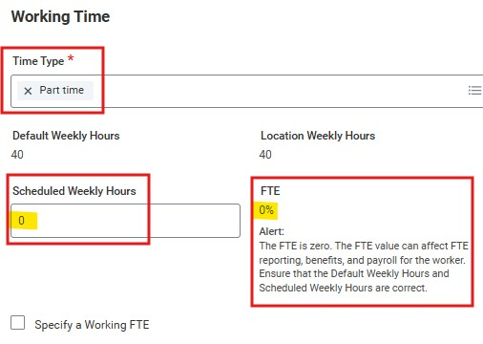
- Entering 0 ensures the employee's FTE is correctly calculated as 0%.
- Academic Section: Leave this section blank
- The Academic section applies only to 9-month academic employees and should not be completed for Student Hourly hires.
- Attachments and Comments: Optional
- Attach supporting documentation or enter comments if additional information would be helpful for approvers or future reference.
- Hit Submit


HR Policy - Student Employment - Student Employee Guidelines
- During the Academic Year o Student employees may work a maximum of 25 hours per week (Sunday through Saturday).
  - Hours are combined across all student jobs the student holds within the UW System.
Supervisors should not assume their department is the student's only employer. During Break Periods
- Students may work full-time when classes are not in session, including:
  - Summer break o J-Term
▪ This applies even if the student is enrolled in summer or J-Term classes. o Spring break
- Annual Hour Cap
  - Students may work a maximum of 1,559 hours in a rolling 12-month period.
- Federal Work Study (FWS) Students
  - Federal Work Study students are limited to 20 hours per week total. o FWS hours do not count toward Affordable Care Act (ACA) hour calculations.

Position of Trust Information
Student Hourly positions generally do not require a Criminal Background Check (CBC).
A CBC is required only when the position is designated as a Position of Trust based on:
- Access to vulnerable populations: Unsupervised or significant contact with minors (under 18 and not enrolled at a UW System school) or medical patients.
- Property access: Use of master keys or card access to offices, facilities, or worksites beyond the employee’s own, including residential housing.
- Financial or fiduciary duties: Primary responsibilities (50% or more) involving handling money or assets, approving or authorizing expenditures, maintaining or auditing accounts or records, or managing inventories or financial documentation.
- Executive roles: Top-level institutional leadership positions such as Chancellor, Provost, Dean, and all limited appointment roles, including movement between limited appointments.

Position of Trust Selection
When hiring a student employee, Student Process Coordinators should use the following decision-making process:
Step 1: Determine Access to Vulnerable Populations
Will the student employee work directly with anyone under the age of 18?
- Yes → Select Position of Trust – 4-Year Recheck.
- No → Proceed to Step 2.
Step 2: Evaluate Other Position of Trust Criteria
Does the position meet any of the following criteria?
- B. Property Access
- C. Financial/Fiduciary Responsibility
- D. Executive Position
- Yes to any criterion → Select Position of Trust – No Recheck.
- No to all criteria → The position is not a Position of Trust, and a CBC is not required.

Position of Trust Status
Moving Forward Guidelines
After further discussion, we are moving toward a standardized approach in which student employees will only be assigned one of the following Position of Trust (POT) statuses:
- Not a Position of Trust – CBC Not Required
- Position of Trust – No Recheck
- Position of Trust – 4-Year Recheck
- Important: If a student employee is in a Position of Trust, do not select "Position of Trust – 2 Year."
- Instead, select one of the following
- Position of Trust – No Recheck if the position does not involve access to vulnerable populations, or
- Position of Trust – 4-Year Recheck if the position does involve working with vulnerable population defined as minors and/or medical patients.
CBC Student Employees - Quick Guide Updated 7.22.26


CBC and POT Policy information
HR Policy

-

Background Checks and Positions of Trust or Access To Vulnerable

Population
s
Why It Matters
•
UWL requires criminal background checks to help maintain a safe environment for students,
employees, and visitors. Most new hires, including student employees in certain roles, are subject to
this requirement.
What is a "Position of Trust"?
o
Positions requiring additional screening include those with:
▪
Access to vulnerable populations

(
minors, medical patients
)
▪
Master key/card access

to facilities beyond their normal workspace
▪
Financial responsibilities

(
handling cash, approving expenditures, managing accounts
)
▪
Certain
executive or leadership roles

CBC and POT Policy information Reminders

Student Supervisor Responsibilities
- Identify if a student position may qualify as a position of trust.
- Ensure a background check is completed before employment begins unless specifically approved by HR.
- Notify HR when a conditional offer has been made and a background check is needed.
- Maintain confidentiality regarding background check information.

Important Reminders
- A criminal history does not automatically disqualify a candidate. UWL reviews each case individually and considers whether the offense is substantially related to the job duties.
- Employees and volunteers in positions with access to vulnerable populations undergo a background check every four years.
- Individuals at UWL must report certain arrests, charges, or convictions within 24 hours.

Compensation Basis and Position of Trust
- After clicking submit, you'll advance within the Hire BP to Organization Assignments
- Company, Cost Center, Fund, and Function:
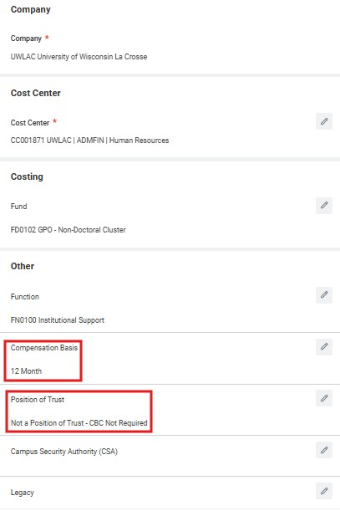
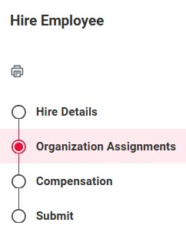
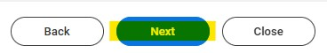
- These fields will automatically populate based on the defaults assigned to the selected Sup Org. These can be updated later through the Assign Costing Allocation step
- Organization Assignments do not impact how the student is paid
- This information is updated in the Assign Costing Allocations step
- Compensation Basis: always leave as 12 month
- Position of Trust
- Not a Position of Trust – CBC Not Required, or
- Position of Trust – No Recheck if the position does not involve access to vulnerable populations, or
- Position of Trust – 4-Year Recheck if the position involves unsupervised or significant access to vulnerable populations, including minors and/or medical patients.
- Click Next after completing the Organization Assignments section

- After clicking next within the Hire BP from Organization Assignments, you'll advance to Compensation.
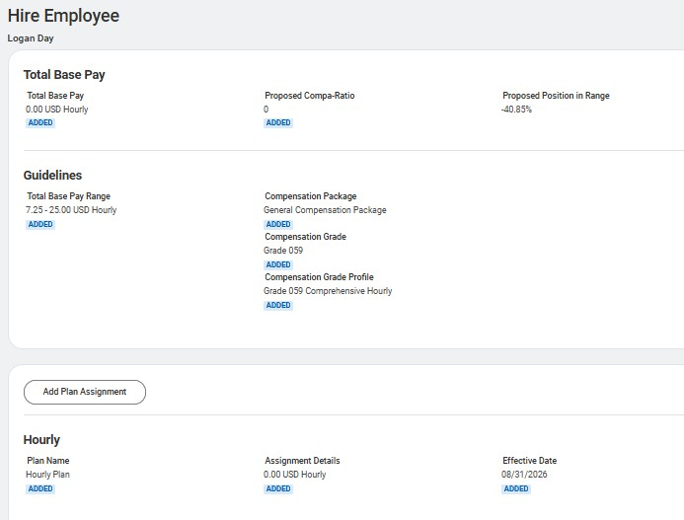
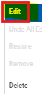
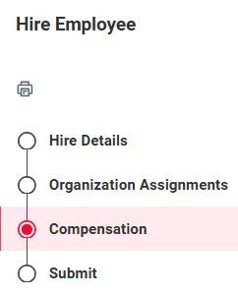
- Under the Hourly compensation plan, select Related Actions () → Edit or you can click within the Hourly section
- Do not use the "Add Plan Assignment" option, as it does not apply to Student Hourly (SH) employees and may result in an incorrect compensation setup.
- Enter the student’s hourly rate and click Save
- Verify that the compensation now displays as an Hourly Plan.
- If you accidentally selected Add Plan Assignment, the plan must be removed before proceeding.
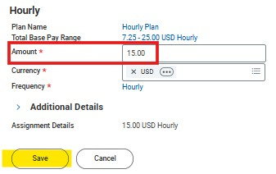
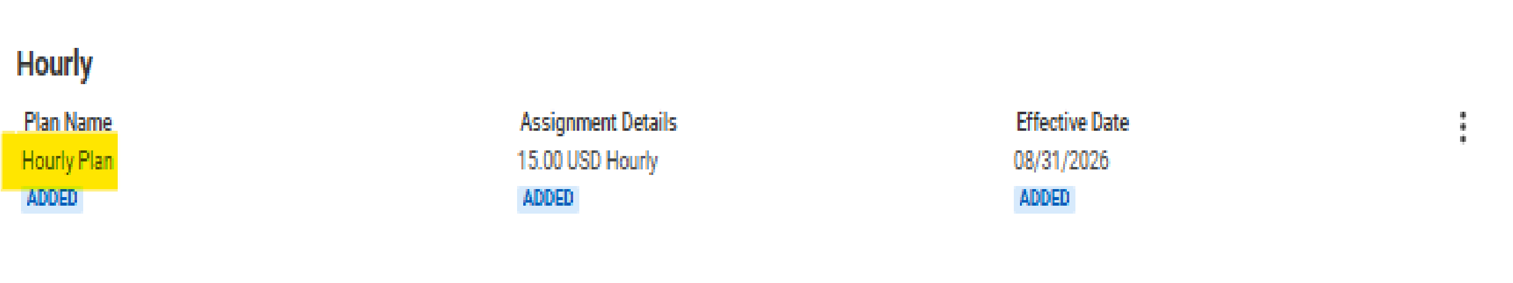
- Select the Related Actions (…) menu next to the incorrect plan.
- Click Delete.
- In the Delete Item confirmation window, click Delete again to confirm the removal.
- Once the compensation information is correct and only the
Hourly Plan remains, click Submit to continue the hire process.
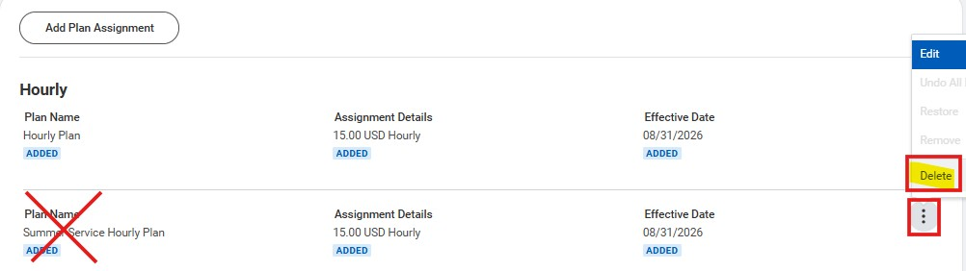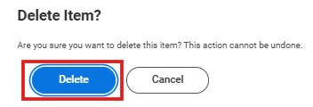
- After clicking Next from the Compensation step, you will advance to the final step of the Hire Business Process (BP).
- On this screen, you will see a summary of the hire details, including the:
- Sup Org
- Hire Date
- Hire Reason
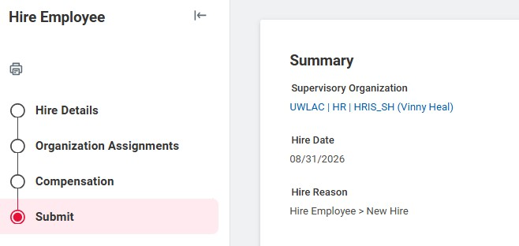

- If needed, you can return to any of the previous sections to review or update information:
- Hire Details
- Organization Assignments
- Compensation
- Important: The Sup Org cannot be changed once it has been selected from the Find External Students screen. If the wrong Sup Org was chosen, you must cancel the hire process and start over with the correct selection.
- After review, proceed with the hire by clicking Submit.

Next Steps
- Assign Costing Allocation
- The Assign Costing Allocation step is routed to the Cost Center Accounting Specialist (CCAS), who is often the department's HR Process Coordinator (HRPC).
- The CCAS is responsible for entering the appropriate Worker or Position Costing Allocation.
- Once completed, the costing allocation will route to the applicable Driver Worktag Manager(s) for approval.
- Best Practice: Send funding information to the CCAS immediately after submitting the hire to avoid processing delays.
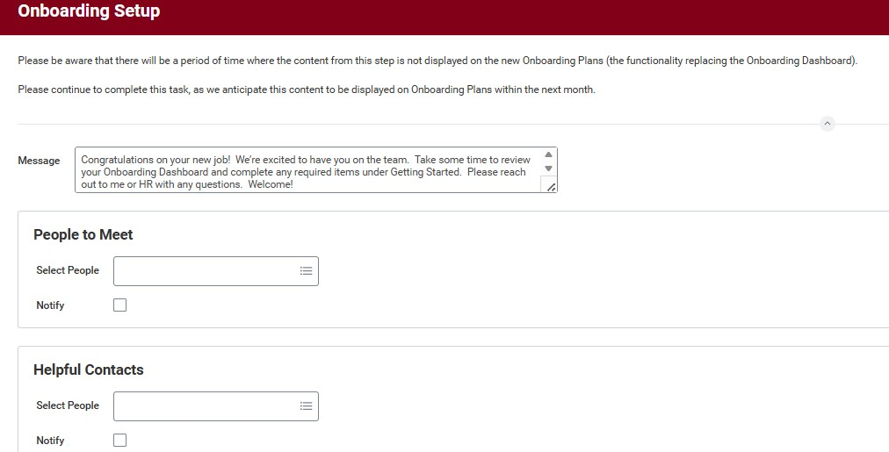
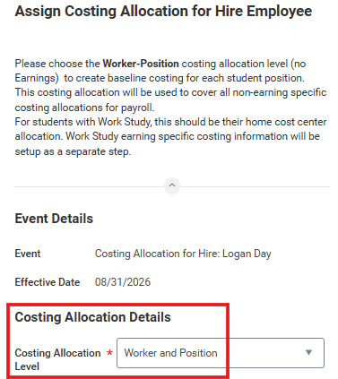
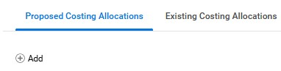
- Onboarding Setup
- The Onboarding Setup task can be completed by either the Manager or the Student Process Coordinator (SPC).
- This task allows you to configure onboarding messages and information that will be presented to the new employee.
- Important Timing Notes:
- If the Onboarding Setup task is not completed at least three days before the employee's hire date, the task will automatically complete.
- If the hire is entered after the hire date, the task will automatically advance at 8:00 a.m. on the day following task creation.
- With these auto-complete rules, it is recommended that onboarding information be reviewed and configured as soon as possible after the hire is initiated.
- Once the Onboarding Setup is submitted or manually advanced, the employee will begin receiving onboarding tasks.

Generate Document (Optional)
- This is an optional step that allows you to generate a document outlining the terms and conditions of employment for a Student Hourly hire.
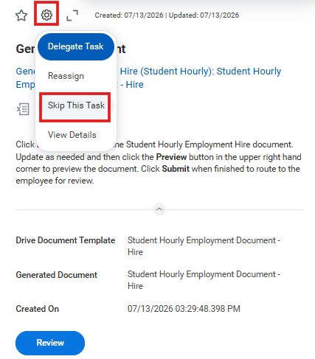
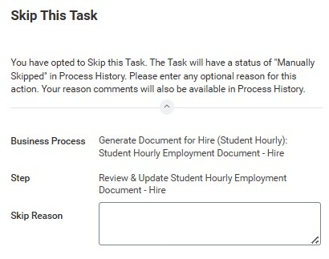

- Once submitted, the document will be routed to the new employee for review and acknowledgment in Workday.
- Generating the document is not required and may be skipped if your department does not use it.
- Any employment documents created outside of Workday can be uploaded manually to the worker's profile at any time.
- Best Practice: Skip this step by clicking on the wheel, then skip this task.
How to Cancel A Hire
–

In Progress

How to Cancel the Hire
- Navigate to Tasks in Workday
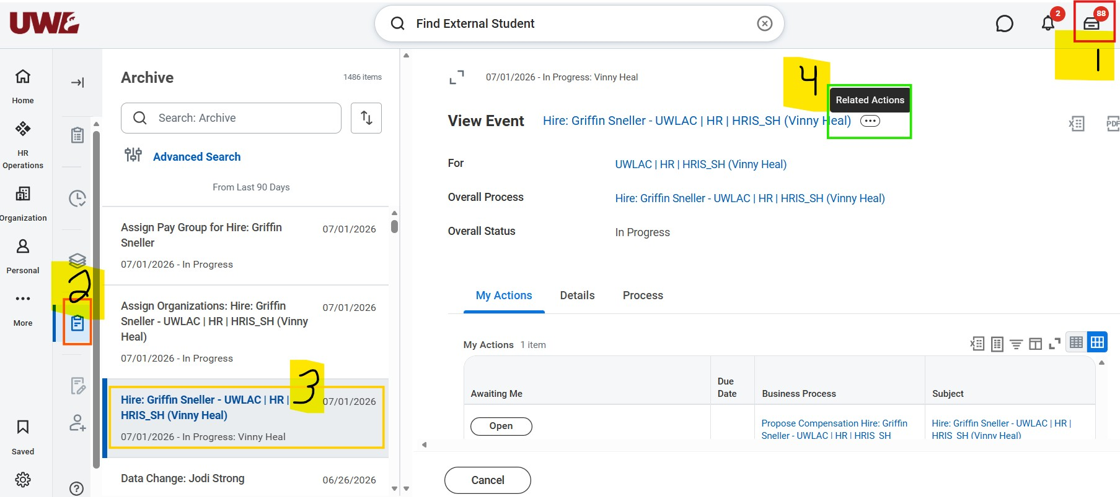

- Go to Archive
Canceling the Hire
- Locate the appropriate Hire Business Process (BP)
- Hover over the right side of the BP and select Related Actions (… icon)
How to Cancel the Hire (continued)
- From the pop-up menu: Select Business Process
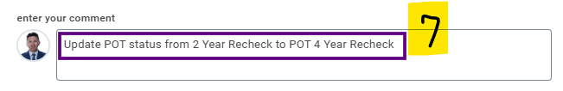

- Then click Cancel
Canceling the Hire
- Scroll to the bottom of the Cancel Business Process Screen and enter a comment
○ Example: Update POT status from 2 Year Recheck to 4-Year Recheck
- Click Submit
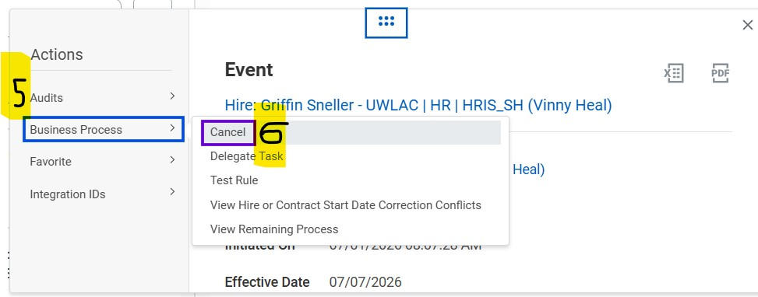
How to Update a
Position of Trust Status
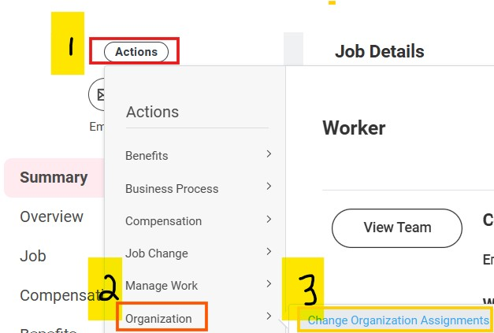
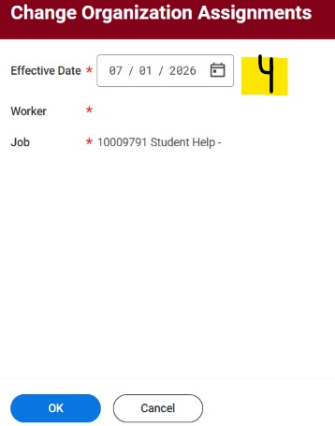
Update the Position of Trust Status
How to Update the
Position of Trust Status
1
. From the Worker Profile,
select Actions under the
employee's name
2
. Select Organization
3
. Select Change
Organization Assignments
4
. Leave the default effective
date and click OK

Update the Position of Trust Status
How to Update the Position of Trust Status
(continued)
- Scroll to the bottom of the Change
Organization Assignments screen and click the pencil within the Position of Trust field
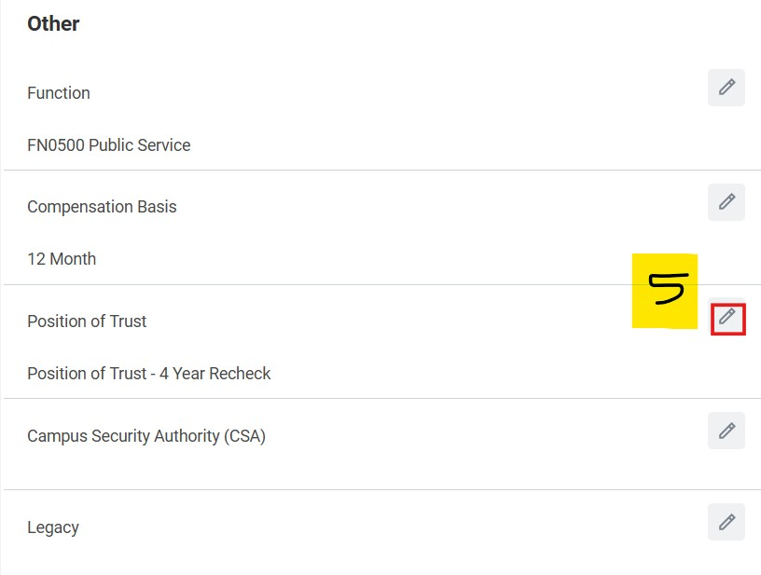
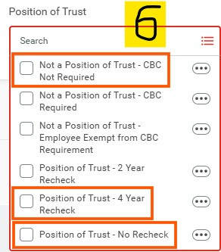
- Update the Position of Trust field accordingly to one of the following:
- If not a Position of Trust, choose 'Not a Position of Trust
- CBC Not Required’
- If Position of Trust, choose either:
- Position of Trust – No Recheck if the position does not involve access to vulnerable populations, or
- Position of Trust – 4-Year Recheck if the position does involve working with youth, minors, or other vulnerable populations.
7. Click Submit
Onboarding and Form I
-
9
Role Action Items
Supervisor - Hiring through Workday
Onboarding Student - Onboarding dashboard

Process for
Supervisor - Complete I9 Step 1 and 2 (if not already on file) and Student - Submit CBC Self-Report Portion (if needed and
not already on file)

It is the supervisor's responsibility to notify the student employee of the
tasks in Workday that must be completed.
- Enter Direct Deposit/Payment Elections in
Workday (recommended to avoid complications) - Students need to complete all required mandatory trainings in Workday Learning within 30 days of employment.
If Student is a Foreign National -Amy for specifics) Submit additional documentation (check with
- Miranda Panzer (International Education and Engagement) is the contact for foreign national processes outside of our office.

Onboarding Setup is a business process that delivers a task to the new hire’s Manager (the Student Process Coordinator assigned to the new hire’s supervisory organization also receives the task as back up for the Manager). The task includes three parts, which populate sections on the new hire’s Onboarding Plan:
1.Message
Default message: Congratulations on your new job! We’re excited to have you on the team. Take some time to review your
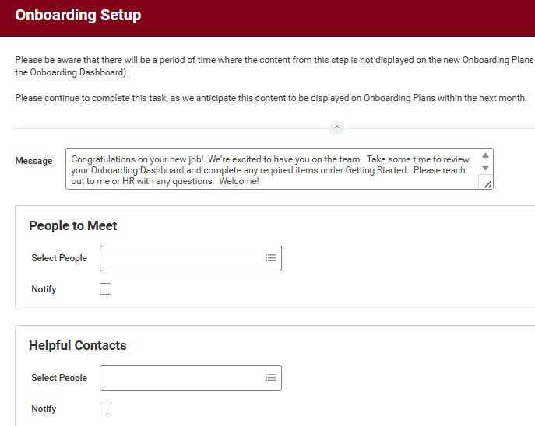
Onboarding Dashboard and complete any required items under Getting Started. Please reach out to me or HR with any questions. Welcome!
Onboarding Setup
2.People to Meet - optional, example: the new hire's coworkers from their supervisory organization
3.Helpful Contacts - optional, example HR
Each of these has default text and settings, which are the same for all institutions, and can be edited for each hire. Editing can only occur when the task is delivered.
NOTE: If the Onboarding Setup task is not completed by three days before the date of hire, it will automatically advance with the defaults.

Onboarding Tasks for Student Employee

Required Tasks:
- International ACH Transaction (IAT) Acknowledgement
- Payment Elections
- Federal Tax Election
- State Tax Election
- Form I-9 - I-9 Instructions and Acceptable Documents
- Section 1 must be completed before Section 2 can be finalized.
- Employees do not receive a separate Workday task/notification for Section 2, but still required.
- Human Resources will send follow-up communications regarding the document verification process.
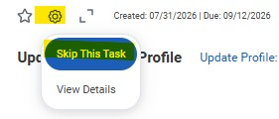
- Important: Both Sections 1 and 2 of the Form I-9 must be completed no later than the employee's third day of employment.
•
Photo Update
•
Disability Self
-
Identification
•
Veteran Status Identification
- If the I-9 process is not completed within this timeframe, the employee must immediately cease all work activities until acceptable documentation is provided and verified.
- Failure to complete the I-9 process in a timely manner may result in termination of employment.
Review Required Documents:
- Employee Handbook
- FERPA
- Acceptable Use of Information Technology
- Several Policies and Required notices
Optional Tasks (Can Be Skipped):
- Public Profile Preferences

Add Job

Find External Students
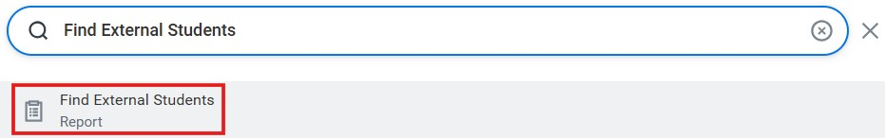
- From the Workday Home Page, search for and select the Find External Students report using the search bar.
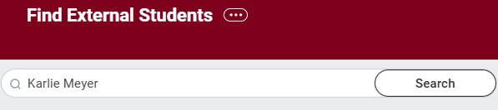
- On the Find External Students search bar, search for the student’s name.
- Use the legal name.
- In the Results section, click on the student’s name to bring up their External Student record.
- Confirm External Student Information to ensure correct student was selected.

Confirm Correct Student
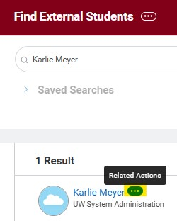
- Use the Related Actions button to verify and select the correct ESO before proceeding with the hire process.
- Tip: Carefully review the student’s identifying information (such as email address and personal information) to ensure you are selecting the correct ESO and avoiding duplicate records.

Find Duplicates
- Navigate to Related Actions → Duplicate Management → Find Duplicates.
- Key Reminders:
- Confirm the student appears with an Active status.
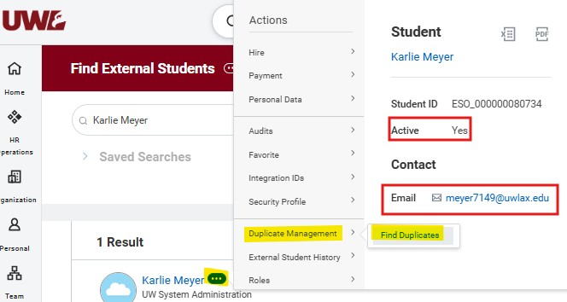
- If the student is not active, they may not yet be registered in WINGS. In these cases, you may need to:
- Wait until the student becomes active in WINGS, or
- Follow the Direct Hire of a Student Not Enrolled at a UW Institution process.
- Do not rely solely on the email address when identifying the correct student record. Students with the same or similar names may also have similar email addresses.
- Carefully review all available information to ensure you are selecting the correct student and avoiding the creation of duplicate records in Workday.

Add Job
- After selecting Find Duplicates, review the student's information to verify you have identified the correct record. Available information may include the student's legal name, date of birth, home address, email address, and other identifying details.
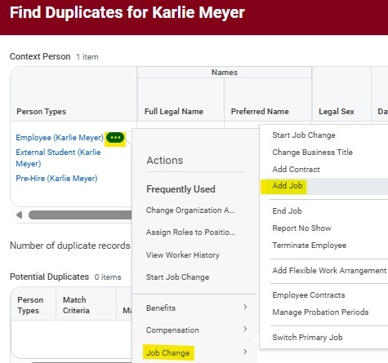
- Once you have confirmed the correct student, proceed with the hire by selecting Related Actions () → Job Change → Add Job.
- If the record is not the correct student, use the Back button to return to the search results and review the other available External Student Objects (ESOs) until you locate the appropriate record.

Select SH Sup Org
- After selecting Add Job, choose the appropriate Supervisory Organization (Sup Org) and click OK to continue.
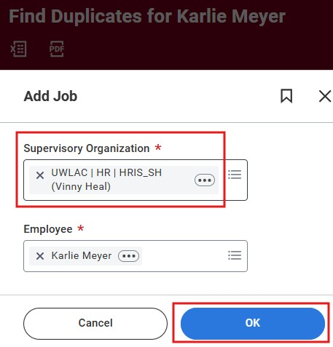
- Be sure to select a Student Hourly Supervisory Organization, which can be identified by a name ending in "_SH.“
- Selecting the correct Sup Org ensures the student is hired into the proper Student Hourly organization and follows the appropriate Workday business processes.

Date, Reason, and Job Details
- Sup Org
- Verify that you selected the correct Sup Org before proceeding
- The Sup Org cannot be changed from this screen
- If you selected the wrong Sup Org, you would need to cancel and restart the process through Find External Students
- Hire Date:
- Submit student hires no more than 30 days before the employee’s start date.
- This helps prevent conflicts and reduces the need for rework if another department tries to hire with an earlier start date
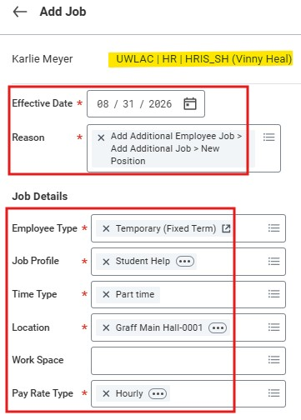
- Submit hires at least 7 days before the employee’s start date • This allows sufficient time for approval and onboarding activities
- Reason: Select New Position
- Employee Type: leave as Temporary (Fixed Term)
- Job Profile: Select Student Help
- Time Type: Leave as Part Time
- Location: Select the primary place of work
- Work Space: Optional
- This field is not common for SH
- Can enter assigned office, workstation, or room number
- Pay Rate Type: Leave as Hourly

Working Time
- Working Time
- Scheduled Weekly Hours: Enter 0
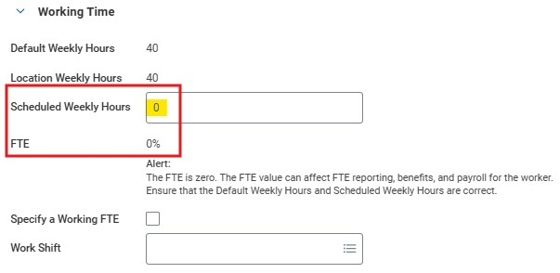
- For Student Hourly (SH) employees, this field should always be set to 0, regardless of the number of hours the student is expected to work.
- Entering 0 ensures the employee's FTE is correctly calculated as 0%.

Additional Details
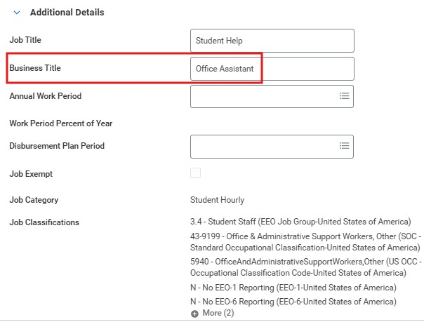
- Business Title: Enter a business title that accurately describes the student’s role and responsibilities
- The business title must be different from the Job Profile
- Ex: Office Assistant, Research Assistant, etc.
- Leave the Annual Work Period and
Disbursement Plan Period fields blank

Federal Work-Study - Part 1
As departments begin hiring Federal Work-Study (FWS) students for the 2026-27 academic year, please review the following reminders to ensure a smooth hiring and funding process. Hiring Process in Workday
During the Hire process in Workday, after entering the Job Category, please skip the optional "Additional Job Classification" step.
- This step should not be completed by the hiring department.
- The Additional Job Classification will be added by Financial Aid once:
o The department notifies Financial Aid that the hire process has been initiated, and o The student has reached the onboarding stage and is eligible for FWS processing.
When emailing Karen Deschepper to notify Financial Aid of a hire, please include confirmation of the student's start date. As a best practice, the hire date should match the student's actual start date.
Departments should only enter the appropriate Costing Allocation funding (Worker Position). Federal Work-Study Costing Allocation Funding (Worker Position Earning) will be added automatically after the Additional Job Classification has been applied.
Important: No FWS assignment notification = No FWS funding.
2026-27 Federal Work Study Dates
Federal Work-Study funding for the 2026-27 academic year covers the period of:
August 23, 2026, through May 15, 2027
Please use these dates when entering employment and funding information related to Federal Work-Study positions.

Federal Work-Study - Part 2
Department Responsibilities
Only students who have received an official Federal Work Study assignment for the current academic year are eligible for FWS funding approval.
Departments are responsible for:
- Retaining a copy of the student's FWS assignment notification email each academic year.
- Reviewing funding after the student's first posted payroll to ensure wages are charging to the correct FWS funding source.
- Identifying and resolving funding issues as early as possible by verifying payroll distributions promptly.
Returning Students
Some returning students may require a manual Federal Work-Study award before they can be hired. Before initiating a hire, please verify that the student:
- Has a Federal Work-Study award included in their 2026-27 Award Summary.
- Has accepted the award.
- Has completed the required FWS questionnaire to return to your department.
Please note that financial aid offers have been delayed for some students this summer, and manual awarding is still ongoing.
Thank you for your attention to these guidelines and for helping ensure timely and accurate processing of Federal Work-Study student employees.

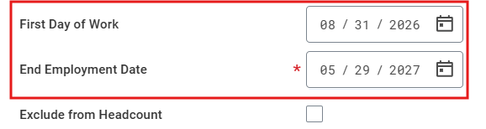
Complete Details of Add Job – Employment Dates
- Students hired during the fall semester should be assigned an EJED corresponding to the last student hourly pay period of the academic year, unless an earlier end date is known.
- Students hired during the spring semester solely for summer employment

should be assigned an EJED that aligns with the anticipated end of their
summer work assignment. •
- Students hired during the fall or spring semester who are expected to continue in the same position into the following academic year should be assigned an EJED of the first Friday in October of the next academic year •
- Expected Ongoing Employment – Spring to Fall
- If a student is expected to continue in the same position from Spring into Fall:
- The FTW process will be used to update the EJED to the first Friday in October
- This approach:
- Allows the position to carry into the Fall semester
- Triggers another FTW review in Fall to confirm continued employment
First Day of Work: should default to the effective date
End Employment Date
- Enter the anticipated last day the student will work in this position. This can be extended later
- Setting an accurate end date helps ensure timely job-end processing and reduces the need for future corrections

- Student Hourly Eligibility and Appointment PDF

Position of Trust Information
Student Hourly positions generally do not require a Criminal Background Check (CBC).
A CBC is required only when the position is designated as a Position of Trust based on:
- Access to vulnerable populations: Unsupervised or significant contact with minors (under 18 and not enrolled at a UW System school) or medical patients.
- Property access: Use of master keys or card access to offices, facilities, or worksites beyond the employee’s own, including residential housing.
- Financial or fiduciary duties: Primary responsibilities (50% or more) involving handling money or assets, approving or authorizing expenditures, maintaining or auditing accounts or records, or managing inventories or financial documentation.
- Executive roles: Top-level institutional leadership positions such as Chancellor, Provost, Dean, and all limited appointment roles, including movement between limited appointments.

Position of Trust Selection
When hiring a student employee, Student Process Coordinators should use the following decision-making process:
Step 1: Determine Access to Vulnerable Populations
Will the student employee work directly with anyone under the age of 18?
- Yes → Select Position of Trust – 4-Year Recheck.
- No → Proceed to Step 2.
Step 2: Evaluate Other Position of Trust Criteria
Does the position meet any of the following criteria?
- B. Property Access
- C. Financial/Fiduciary Responsibility
- D. Executive Position
- Yes to any criterion → Select Position of Trust – No Recheck.
- No to all criteria → The position is not a Position of Trust, and a CBC is not required.

Position of Trust Status
Moving Forward Guidelines
After further discussion, we are moving toward a standardized approach in which student employees will only be assigned one of the following Position of Trust (POT) statuses:
- Not a Position of Trust – CBC Not Required
- Position of Trust – No Recheck
- Position of Trust – 4-Year Recheck
- Important: If a student employee is in a Position of Trust, do not select "Position of Trust – 2 Year."
- Instead, select one of the following
- Position of Trust – No Recheck if the position does not involve access to vulnerable populations, or
- Position of Trust – 4-Year Recheck if the position does involve working with vulnerable population defined as minors and/or medical patients.
CBC Student Employees - Quick Guide Updated 7.22.26

CBC and POT Policy information
HR Policy

-

Background Checks and Positions of Trust or Access To Vulnerable

Population
s
Why It Matters
•
UWL requires criminal background checks to help maintain a safe environment for students,
employees, and visitors. Most new hires, including student employees in certain roles, are subject to
this requirement.
What is a "Position of Trust"?
o
Positions requiring additional screening include those with:
▪
Access to vulnerable populations

(
minors, medical patients
)
▪
Master key/card access

to facilities beyond their normal workspace
▪
Financial responsibilities

(
handling cash, approving expenditures, managing accounts
)
▪
Certain
executive or leadership roles

CBC and POT Policy information Reminders

Student Supervisor Responsibilities
- Identify if a student position may qualify as a position of trust.
- Ensure a background check is completed before employment begins unless specifically approved by HR.
- Notify HR when a conditional offer has been made and a background check is needed.
- Maintain confidentiality regarding background check information.

Important Reminders
- A criminal history does not automatically disqualify a candidate. UWL reviews each case individually and considers whether the offense is substantially related to the job duties.
- Employees and volunteers in positions with access to vulnerable populations undergo a background check every four years.
- Individuals at UWL must report certain arrests, charges, or convictions within 24 hours.

Complete Details of Add Job – Organization Assignments
- Organization Assignments do not impact how the student is paid
- This information is updated in the Assign Costing Allocations step
- Compensation Basis: always leave as 12 month
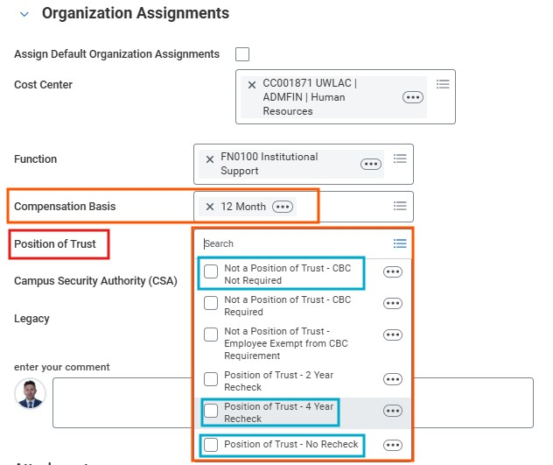
- Position of Trust
- Not a Position of Trust – CBC Not Required, or
- Position of Trust – No Recheck if the position does not involve access to vulnerable populations, or
- Position of Trust – 4-Year Recheck if the position does involve working with vulnerable population defined as minors and/or medical patients.
- Attachments and Comments: Optional
- Attach supporting documentation or enter comments if additional information would be helpful for approvers or future reference.
- Hit Submit

Propose Compensation Hire
- After completing the details for the add job step, the process will advance to the Propose Compensation Hire step.
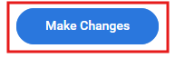
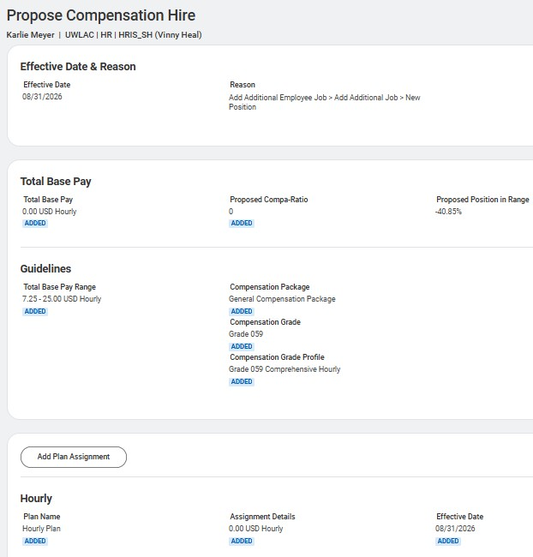

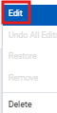
- Click Make Changes to enter compensation details.
- Under the Hourly compensation plan, select Related Actions () → Edit.
- Do not use the "Add Plan Assignment" option, as it does not apply to Student Hourly (SH) employees and may result in an incorrect compensation setup.

Propose Compensation Hire
- Enter the student’s hourly rate and click Save
- Verify that the compensation now displays as an Hourly Plan.
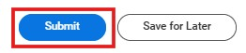
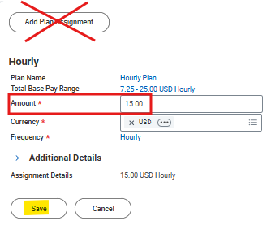
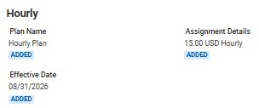
- If you accidentally selected Add Plan Assignment, the plan must be removed before proceeding.
- Select the Related Actions (…) menu next to the incorrect plan.
- Click Delete.
- In the Delete Item confirmation window, click Delete again to confirm the removal.
- Once the compensation information is correct and only the Hourly Plan remains, click Submit to continue the hire process.
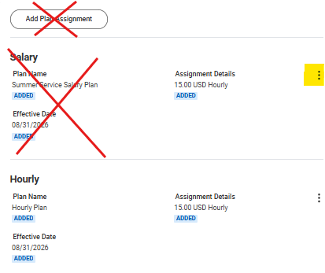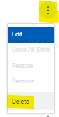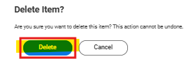

Next Steps
- Assign Costing Allocation
- The Assign Costing Allocation step is routed to the Cost Center Accounting
Specialist (CCAS), who is often the department's HR Process Coordinator (HRPC).
- The CCAS is responsible for entering the appropriate Worker or Position Costing Allocation.
- Once completed, the costing allocation will route to the applicable Driver Worktag Manager(s) for approval.
- Best Practice: Send an email to the CCAS with the funding information as soon as the hire is submitted to help avoid delays in processing.
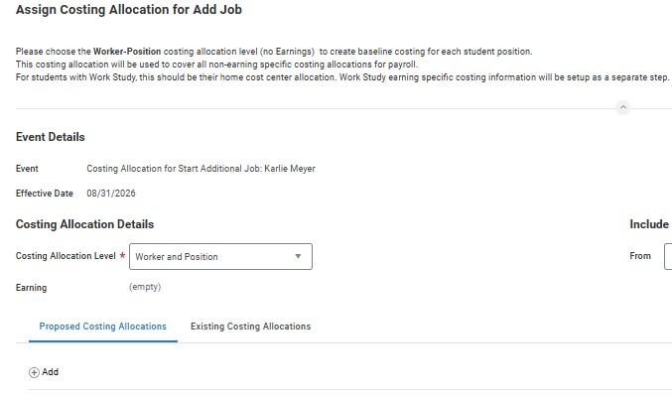
- Onboarding Setup
- The Onboarding Setup task can be completed by either the Manager or the Student Process Coordinator (SPC).
- This task allows you to configure onboarding messages and information that will be presented to the new employee.
- Important Timing Notes:
- If the Onboarding Setup task is not completed at least three days before the employee's hire date, the task will automatically complete.
- If the hire is entered after the hire date, the task will automatically advance at 8:00 a.m. on the day following task creation.
- With these auto-complete rules, it is recommended that onboarding information be reviewed and configured as soon as possible after the hire is initiated.
- Once the Onboarding Setup is submitted or manually advanced, the employee will begin receiving onboarding tasks.

Complete Details of Add Job – Generate Document (Optional)
- This is an optional step that allows you to generate a document outlining the terms and conditions of employment for a Student Hourly hire.
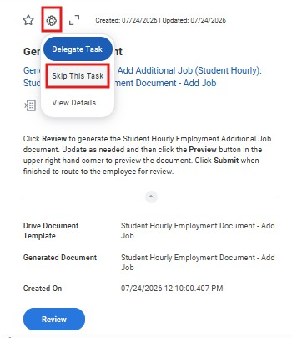
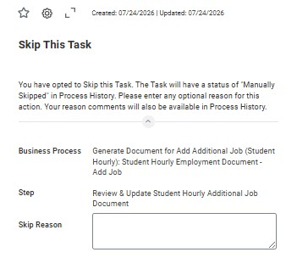
- Once submitted, the document will be routed to the new employee for review and acknowledgment in Workday.
- Generating the document is not required and may be skipped if your department does not use it.
- Any employment documents created outside of Workday can be uploaded manually to the worker's profile at any time.
- Best Practice: Skip this step by clicking on the wheel, then skip this task.
Direct Hire of a Student
Not Enrolled at UW

Direct Hire of a Non-UW Student-
Hire Employee
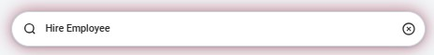
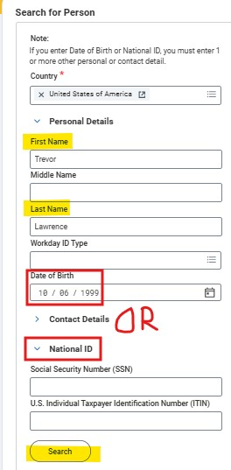
- From the Workday Home Page, search for and select the Hire Employee task using the search bar.
- Search for the new hire to ensure they are not a former worker.
- Use the legal name.
- Optional: Enter DOB or
SSN to narrow the search

Direct Hire of a Non-UW Student-
Hire Employee
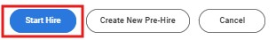
- If there is not a former worker record, click Create New Pre-Hire:
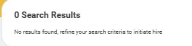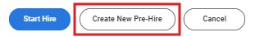
- If there is a former worker record, select that record and click Start Hire:
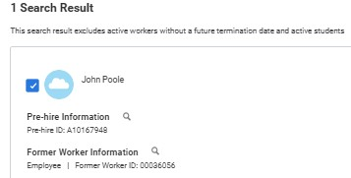

Direct Hire of a Non-UW Student Create New Pre-Hire
- After confirming there is not a former worker record and clicking Create New Pre-Hire, enter or confirm Legal Name and Contact Information.
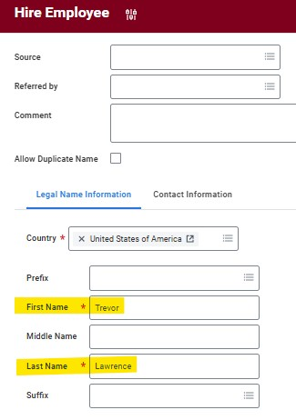
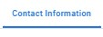
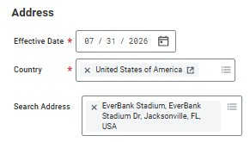
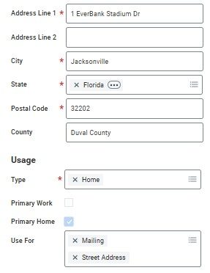
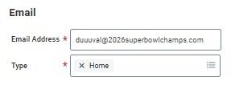
- Click the Contact Information tab and enter the new hire’s contact information. At least one form of contact must be entered to proceed.
•
NOTE: It is highly recommended to enter a home address on the Pre-Hire record before beginning the Hire. The I-9 Questionnaire step on the Hire is configured to trigger if a hire is not a
Student Hourly or Student Assistant AND their home address is outside of Wisconsin. Workday interprets no home address the same as one outside of Wisconsin and will send the questionnaire to the HR Process Coordinator.

UW Student Select Sup Org and Hire Date
- After completing the Contact Information and clicking OK, be sure to select the appropriate SH Sup Org.
- Click OK and advance to the Hire Details
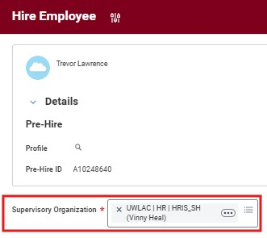
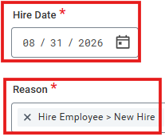
- Hire Date:
- Submit student hires no more than 30 days before the employee’s start date.
- This helps prevent conflicts and reduces the need for rework if another department tries to hire with an earlier start date
- Submit hires at least 7 days before the employee’s start date
- This allows sufficient time for approval and onboarding activities
- Reason: Hire Employee > New Hire

UW Student -
Position and Job Details
- Sup Org
- Verify that you selected the correct Sup Org before proceeding
- The Sup Org cannot be changed from this screen
- If you selected the wrong Sup Org, you would need to cancel and restart the process through Find External Students
- Position:
- Employee Type: leave as Temporary (Fixed Term)
- End Employment Date - Student Hourly Eligibility and Appointment PDF
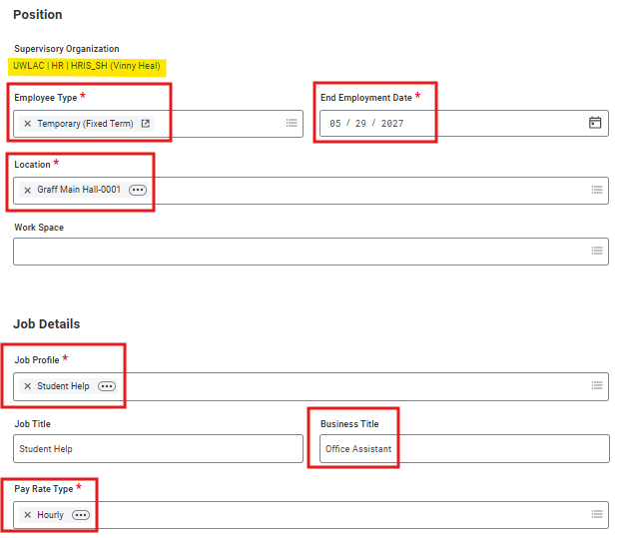
- Enter the anticipated last day the student will work in this position. This can be extended later
- The End Employment Date should not extend beyond the last day of the pay period for the current academic year
- Setting an accurate end date helps ensure timely job-end processing and reduces the need for future corrections
- Job Details:
- Location: Select the primary place of work
- Work Space: Optional
- This field is not common for SH
- Can enter assigned office, workstation, or room number
- Job Profile: Select Student Help
- Business Title: Enter a business title that accurately describes the student’s role and responsibilities
- The business title must be different from the Job Profile
- Ex: Office Assistant, Research Assistant, etc.
- Pay Rate Type: Leave as Hourly

UW Student -
Position and Job Details
- Sup Org
- Verify that you selected the correct Sup Org before proceeding
- The Sup Org cannot be changed from this screen
- If you selected the wrong Sup Org, you would need to cancel and restart the process through Find External Students
- Position:
- Employee Type: leave as Temporary (Fixed Term)
- End Employment Date - Student Hourly Eligibility and Appointment PDF
- Enter the anticipated last day the student will work in this position. This can be extended later
- The End Employment Date should not extend beyond the last day of the pay period for the current academic year
- Setting an accurate end date helps ensure timely job-end processing and reduces the need for future corrections
- Job Details:
- Location: Select the primary place of work
- Work Space: Optional
- This field is not common for SH
- Can enter assigned office, workstation, or room number
- Job Profile: Select Student Help
- Business Title: Enter a business title that accurately describes the student’s role and responsibilities
- The business title must be different from the Job Profile
- Ex: Office Assistant, Research Assistant, etc.
- Pay Rate Type: Leave as Hourly

Federal Work-Study - Part 1
As departments begin hiring Federal Work-Study (FWS) students for the 2026-27 academic year, please review the following reminders to ensure a smooth hiring and funding process. Hiring Process in Workday
During the Hire process in Workday, after entering the Job Category, please skip the optional "Additional Job Classification" step.
- This step should not be completed by the hiring department.
- The Additional Job Classification will be added by Financial Aid once:
o The department notifies Financial Aid that the hire process has been initiated, and o The student has reached the onboarding stage and is eligible for FWS processing.
When emailing Karen Deschepper to notify Financial Aid of a hire, please include confirmation of the student's start date. As a best practice, the hire date should match the student's actual start date.
Departments should only enter the appropriate Costing Allocation funding (Worker Position). Federal Work-Study Costing Allocation Funding (Worker Position Earning) will be added automatically after the Additional Job Classification has been applied.
Important: No FWS assignment notification = No FWS funding.
2026-27 Federal Work Study Dates
Federal Work-Study funding for the 2026-27 academic year covers the period of:
August 23, 2026, through May 15, 2027
Please use these dates when entering employment and funding information related to Federal Work-Study positions.

Federal Work-Study - Part 2
Department Responsibilities
Only students who have received an official Federal Work Study assignment for the current academic year are eligible for FWS funding approval.
Departments are responsible for:
- Retaining a copy of the student's FWS assignment notification email each academic year.
- Reviewing funding after the student's first posted payroll to ensure wages are charging to the correct FWS funding source.
- Identifying and resolving funding issues as early as possible by verifying payroll distributions promptly.
Returning Students
Some returning students may require a manual Federal Work-Study award before they can be hired. Before initiating a hire, please verify that the student:
- Has a Federal Work-Study award included in their 2026-27 Award Summary.
- Has accepted the award.
- Has completed the required FWS questionnaire to return to your department.
Please note that financial aid offers have been delayed for some students this summer, and manual awarding is still ongoing.
Thank you for your attention to these guidelines and for helping ensure timely and accurate processing of Federal Work-Study student employees.

Direct Hire of a Non-UW Student Working Time
- Time Type: Select Part Time
- Scheduled Weekly Hours: Enter 0
- For Student Hourly (SH) employees, this field should always be set to 0, regardless of the number of hours the student is expected to work.
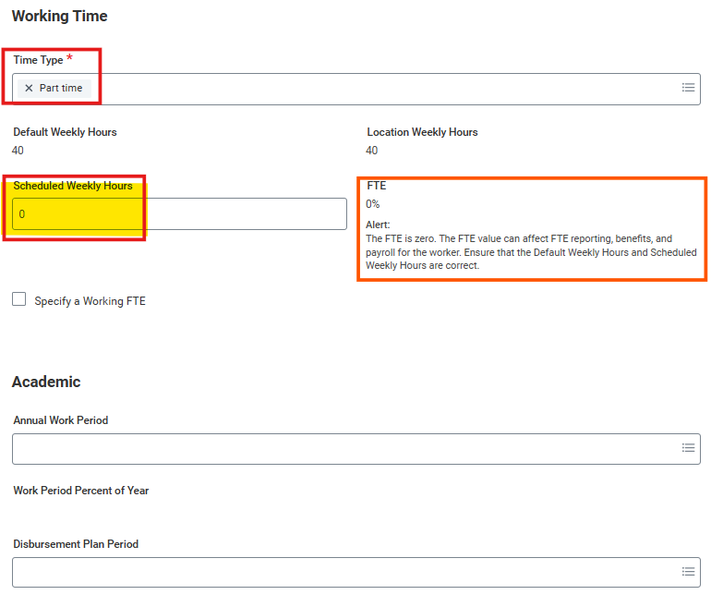
- Entering 0 ensures the employee's FTE is correctly calculated as 0%.
- Academic Section: Leave this section blank
- The Academic section applies only to 9-month academic employees and should not be completed for Student Hourly hires.
- Attachments and Comments: Optional
- Attach supporting documentation or enter comments if additional information would be helpful for approvers or future reference.
- Hit Submit

Direct Hire of a Non-UW Student Compensation Basis and Position of Trust
- Company, Cost Center, Fund, and Function:
- These fields will automatically populate based on the defaults assigned to the selected Sup Org. These can be updated later through the Assign Costing Allocation step
- Organization Assignments do not impact how the student is paid
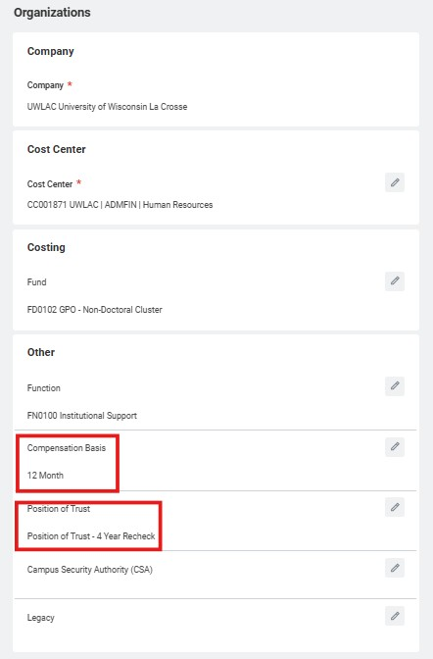
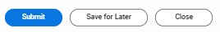
- This information is updated in the Assign Costing Allocations step
- Compensation Basis: always leave as 12 month
- Position of Trust
- Not a Position of Trust – CBC Not Required, or
- Position of Trust – No Recheck if the position does not involve access to vulnerable populations, or
- Position of Trust – 4-Year Recheck if the position does involve working with vulnerable population defined as minors and/or medical patients.
- Hit Submit after complete the task

Position of Trust Information
Student Hourly positions generally do not require a Criminal Background Check (CBC). A CBC is required only when the position is designated as one of the following:
- Position of Trust, or
- Position of Trust with Access to a Vulnerable Population
Reminder:
- A Position of Trust is determined by whether a role includes responsibilities in any of these areas:
- Access to vulnerable populations: Unsupervised or significant contact with minors (under 18 and not enrolled at a UW System school) or medical patients.
- Property access: Use of master keys or card access to offices, facilities, or worksites beyond the employee’s own, including residential housing.
- Financial or fiduciary duties: Primary responsibilities (50% or more) involving handling money or assets, approving or authorizing expenditures, maintaining or auditing accounts or records, or managing inventories or financial documentation.
- Executive roles: Top-level institutional leadership positions such as Chancellor, Provost, Dean, and all limited appointment roles, including movement between limited appointments.

Position of Trust Selection
When hiring a student employee, Student Process Coordinators should use the following decision-making process:
Step 1: Determine Access to Vulnerable Populations
Will the student employee work directly with anyone under the age of 18?
- Yes → Select Position of Trust – 4-Year Recheck.
- No → Proceed to Step 2.
Step 2: Evaluate Other Position of Trust Criteria
Does the position meet any of the following criteria?
- B. Property Access
- C. Financial/Fiduciary Responsibility
- D. Executive Position
- Yes to any criterion → Select Position of Trust – No Recheck.
- No to all criteria → The position is not a Position of Trust, and a CBC is not required.

Position of Trust Status
Moving Forward Guidelines
After further discussion, we are moving toward a standardized approach in which student employees will only be assigned one of the following Position of Trust (POT) statuses:
- Not a Position of Trust – CBC Not Required
- Position of Trust – No Recheck
- Position of Trust – 4-Year Recheck
- Important: If a student employee is in a Position of Trust, do not select "Position of Trust – 2 Year."
- Instead, select one of the following
- Position of Trust – No Recheck if the position does not involve access to vulnerable populations, or
- Position of Trust – 4-Year Recheck if the position does involve working with vulnerable population defined as minors and/or medical patients.

Direct Hire of a Non-UW Student – Compensation
- Under the Hourly compensation plan, select Related Actions () → Edit.
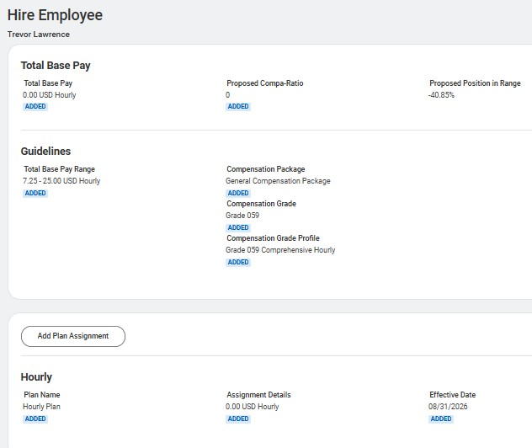
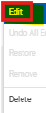
- Do not use the "Add Plan Assignment" option, as it does not apply to Student Hourly (SH)
employees and may result in an incorrect compensation setup.

Direct Hire of a Non-UW Student Compensation
- Enter the student’s hourly rate and click Save
- Verify that the compensation now displays as an Hourly Plan.
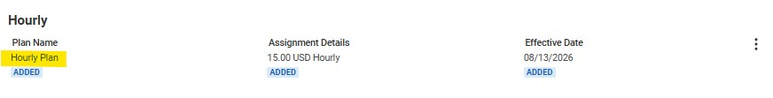
- If you accidentally selected Add Plan Assignment, the plan must be removed before proceeding.
- Select the Related Actions (…) menu next to the incorrect plan.
- Click Delete.
- In the Delete Item confirmation window, click Delete again to confirm the removal.
- Once the compensation information is correct and only the
Hourly Plan remains, click Submit to continue the hire process.

Direct Hire of a Non-UW Student Change Personal Information
- If chose ‘Create New Pre-Hire’, you’ll complete the required fields for the Change Personal Information Details
- Legal Sex
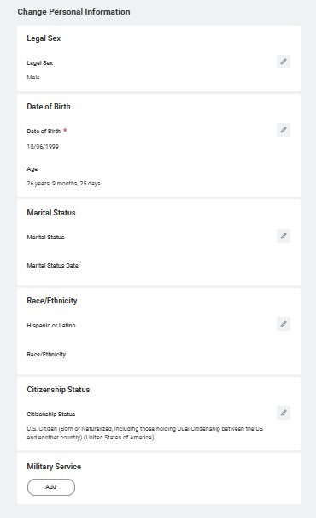
- Date of Birth
- Citizenship Status
- If found a former work record and initiated Start Hire, you’ll complete/confirm the required fields for the Change Personal Information Details
- Legal Sex
- Date of Birth (confirm)
- Citizenship Status

Direct Hire of a Non-UW Student Edit Government IDs
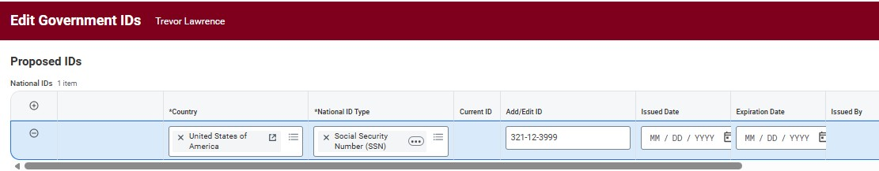
- If chose ‘Create New Pre-Hire’, you’ll be required to enter an SSN (if the employee is a US citizen) or ITIN.
- If found a former work record and initiated Start Hire, this step will not be included

Next Steps
- Assign Costing Allocation
- The Assign Costing Allocation step is routed to the Cost Center Accounting
Specialist (CCAS), who is often the department's HR Process Coordinator (HRPC).
- The CCAS is responsible for entering the appropriate Worker or Position Costing Allocation.
- Once completed, the costing allocation will route to the applicable Driver Worktag Manager(s) for approval.
- Best Practice: Send an email to the CCAS with the funding information as soon as the hire is submitted to help avoid delays in processing.
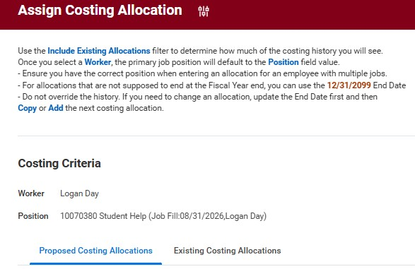
- Onboarding Setup
- The Onboarding Setup task can be completed by either the Manager or the Student Process Coordinator (SPC).
- This task allows you to configure onboarding messages and information that will be presented to the new employee.
- Important Timing Notes:
- If the Onboarding Setup task is not completed at least three days before the employee's hire date, the task will automatically complete.
- If the hire is entered after the hire date, the task will automatically advance at 8:00 a.m. on the day following task creation.
- With these auto-complete rules, it is recommended that onboarding information be reviewed and configured as soon as possible after the hire is initiated.
- Once the Onboarding Setup is submitted or manually advanced, the employee will begin receiving onboarding tasks.

Generate Document (Optional)
- This is an optional step that allows you to generate a document outlining the terms and conditions of employment for a Student Hourly hire.
- Once submitted, the document will be routed to the new employee for review and acknowledgment in Workday.
- Generating the document is not required and may be skipped if your department does not use it.
- Any employment documents created outside of Workday can be uploaded manually to the worker's profile at any time.
- Best Practice: Skip this step by clicking on the wheel, then skip this task.

Find Duplicates For Hire
- This task will only prompt if the hire is NOT from the External Student
Object
- Example: Create New Pre-Hire BP
- Click on Manage Duplicate Records
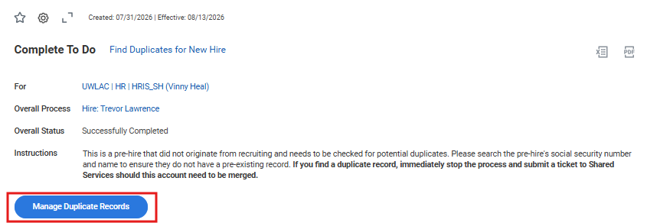
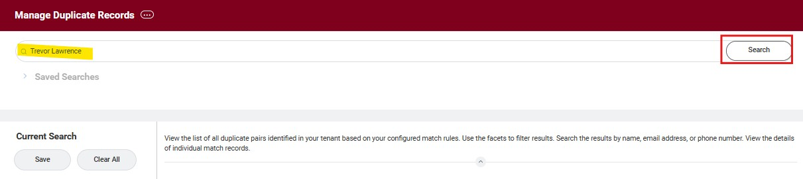
- Type in Legal Name of Student and click Search
- If no duplicate records, click back to original Find Duplicates task and click Submit
- If a potential duplicate record is identified, stop the hiring process and submit a UWSS ticket for review. Do not proceed until the duplicate has been evaluated and resolved.

Hiring/Add Job
Key Reminders
- Student Hourly Employees must be hired into a sup org that ends with _SH.
- Scheduled Hours must be entered as 0, which will result in an FTE of 0%.
- The Compensation Basis must be set to 12 Month.
- At this time, the Pay Rate Type should be Hourly (not Hourly - Timeclock).
- Note: This requirement may change for departments that choose to have student employees record time using a physical time clock.
Student Hourly Key Reminders
- A pilot of the physical time clock process is planned for later this fall with a limited number of departments. Additional guidance and information will be communicated as the pilot progresses.
- Do not update the Additional Job Classifications field with any FWS information
- Student Hourly Appointment Management Process Background.docx
- CBC Student Employees - Quick Guide Updated 7.22.26
Proper Behavior and
Professional Conduct
- Leadership and Guidance
- Skill Development

- Communication Hub
Supervisors are
Crucial
for Success
•
Monitoring Performance
•
Conflict Resolution
•
Resource Management
- Safety and Compliance
- Motivation and Morale
- Decision Making
- Continuous Improvement
- Succession Planning
Why is Professional Conduct Important?
•Sets a positive example.Supervisor
•Builds trust with peers and their superiors.
•Enhances workplace culture.actions have
•Builds our UWL community
impact!
Practical Tips:
•Encourage students to maintain punctuality.
•Role-model respectful communication.
•Remind students to demonstrate initiative and responsibility.
**Keep in mind this might be their first time in the working world!!
What is an Ethical Dilemma?
- Definition: A situation where there is a conflict between moral principles, often with no clear right or wrong answer.
Common Ethical Dilemmas in the Workplace:
- Conflicts of interest (e.g., favoritism).
- Handling confidential information.
- Reporting unethical behavior.

Scenario: A supervisor has a close relationship with one of the student employees and tends to assign them easier or more rewarding tasks, while others are given more challenging or menial work.
Resolution:

Supervisors should treat all students fairly, ensuring tasks are assigned
based on skills, learning opportunities, and team needs
.
Ethical Dilemma: favoritism
Scenario: A student employee is privy to sensitive information about a project or another employee’s personal situation (e.g., salary or health concerns). They accidentally overhear a conversation or come across a document that is not meant for their eyes.
Possible Resolution:

Supervisors should stress the importance of
confidentiality, and if a breach occurs, they should address the issue with
the employee to reinforce professional ethics and trust. Proper training
and understanding
Ethical Dilemma: Confidentiality
Scenario: A student employee is allowed to use the office computer for personal tasks during breaks but starts using it more frequently for non-work-related activities (e.g., shopping online or browsing social media) during work hours.
Possible Resolution:

Supervisors should set clear guidelines for the
acceptable use of company resources and address the issue directly if
personal use becomes excessive.
Ethical Dilemma: work ethic/ misconduct

Responsibility &

Accountability
- An individual's obligation to complete Responsibility The Basics tasks to achieve an outcome.

Delegating tasks and other responsibilities to others IS PART OF
YOUR RESPONSIBILITY

- Managers outline responsibilities in the job descriptions and then delegate tasks to the individuals on your team based on their competencies
- These set responsibilities can be individual or shared between a team.

Accountability The Basics
Accountability comes
after a person’s
responsibilities are
complete.
A person’s ownership
of a result,
experience, or task.

Accountability
•
Can’t be delegated
•
Comes in at the end
•
Accountability comes from Responsibility
•
It’s measured
•
Not about blame
It is YOUR RESPONSIBILITY to hold your team
accountable
Responsibility OR Accountability

Responsibility OR Accountability
Scenario 1:

A supervisor is overseeing several student
employees who are working on a group project. At the start, the
supervisor gives general goals of the project but does not
specify tasks or timelines.
Responsibility OR Accountability
Scenario 2:

One student employees makes a significant
mistake while performing a task that affects the overall team’s
progress (e.g., misplacing important documents, or entering
incorrect data into a system).

Responsibility OR Accountability
Scenario 3: A supervisor has a team of student employees working on a series of tasks. One student regularly volunteers to take on more responsibility, while others avoid taking on extra work, relying on the more proactive student to handle the bulk of the workload.

Training
Holding
Employees
Regular follow
-
ups
Set up clear expectations (YOUR
RESPONSIBILITY)
Coaching / Counseling
Termination
Accountable

Feedback &
Coaching
for your employees
Why do we provide our employees with Feedback and Coaching?
We provide feedback and coaching to…
Develop our employees, to assist in
Engagement, to help with their Success, and to meet the Goals of the University.
Providing Feedback and Coaching to your employees in a timely, clear, and consistent manner is one of the most IMPORTANT actions as a supervisor.
What is feedback?
What is
… coaching?
Feedback: developing your employee by providing commentary, either constructively or positively, on situations that have already occurred
Coaching: developing your employee by providing actionable information to help your employee reach their goals and to attain desired outcomes
How to provide your employee with Feedback:
- Be timely – as close to the event as possible
- Evaluate what went well and what could be improved upon
- Meet in a private setting
- Be respectful, calm, and clear manner
- Communicate expectations
- Follow-up (email)

Positive Constructive
Necessary
Feedback types
  Importance | Benefits
  Reinforces good performance | Boosts morale and motivation
  Recognizes achievements | Encourages continued excellence
  Builds trust and rapport | Strengthens team relationships
  Fosters a positive work environment | Increases job satisfaction
  Importance | Benefits
  Corrects errors and improves performance | Guides development and growth
  Provides specific guidance for improvement | Enhances skill development
  Identifies areas for  learning and development | Increases self-awareness and accountability
  Ensures alignment with goals and expectations | Improves overall team performance

How to Coach your employee:
❖
Be timely
–

don’t wait
❖
Meet in a private setting
❖
Be respectful, calm, and clear manner
❖
Be sure all expectations are communicated
❖
Follow
-
up with FEEDBACK
–

be sure to let them know
what they are doing well!
Resources you must provide to ANY and ALL employees
Disability Resource Center
Counseling and Testing center

Access, Belonging & Student Engagement

Questions?
Fixed Term Worker
Review Process

Fixed Term Worker Review Process
- As part of the monthly Student Hourly Fixed Term Worker (FTW) Review, departments review student employees with upcoming job end dates to determine whether their positions should be terminated or extended.
- Managers or designated reviewers use a provided spreadsheet to: o Identify each student position that is approaching its job end date. o Indicate whether the position should be terminated or remain active.
o Provide a new expected job end date for any position that will continue beyond the current end date.
- Completed spreadsheets are returned by the specified deadline and submitted to Shared Services, which will perform a mass update to extend employment end dates or process terminations as appropriate.
- If no action is taken for eligible employees whose job end dates have passed or are approaching, Shared Services may end the employee's job and/or process a termination through the Fixed Term Worker review process.
- Timely review and completion of the spreadsheet are essential to ensure student employee records remain accurate and active employees are not inadvertently terminated.

Sample Language – SH FTW Review mail
As part of the September Student Hourly Fixed Term Worker (FTW) Review, please review the spreadsheet ( UWLAC SH End Date Review Report 08.03.26.xlsx ) for student employees who have upcoming job end dates and may be subject to termination. Timely review is critical to ensure accuracy before Shared Services runs the process starting in October.
- For each student employee position listed:
- Column A (1) (Terminate):
- Select Yes - Terminate/No - Do Not Terminate from the dropdown to indicate if the position in Column G (7) should be terminated or extended.
- Column B(2) (Updated Expected Job End Date):
- If you selected No - Do Not Terminate in Column A(1), enter the new expected job end date with a date no later than 5/29/2027.
Key Dates:
- Employees who are not ongoing and have a job end date between September 30, 2026, or earlier (if they were missed on a previous FTW review), will have their job(s) ended and/or be terminated if no action is taken.
Action Required:
- Please review and complete the spreadsheet by the end of the day, Wednesday, August 26th.
- Step-by-step instructions are included below.
- On August 27th, or when the spreadsheet is complete, I will forward this to Shared Services, who will assist with a mass upload to update employment end dates or process employee terminations as needed.
Instructions
- Do not modify the layout of the spreadsheet, as it is shared for updates.
- Review end employment dates in Column K (11).
- Complete updates no later than Wednesday, August 26th.
- For each student employee position listed:
- Column A (1) (Terminate): Select Yes - Terminate/No - Do Not Terminate from the dropdown to indicate if the position (details in Columns G through I) should be terminated or extended.
- Column B(2) (Updated Expected Job End Date): If you selected No - Do Not Terminate in Column A(1), enter the new expected job end date.
- The spreadsheet is sorted by Column W (23) (Manager) in ascending order.
Please reach out with any questions. I'll plan on sending additional follow-up communication and reminders.
Report No Show /
Termination

Report No Show
• Report No Show
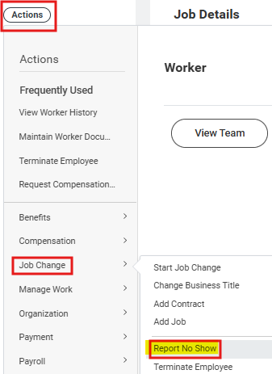
othe process of reporting a worker that does not show up for the first day of work. This business process can only be used if the worker has not already been processed in payroll and is not in the process of extending their hire date.
oCan only be initiated by HR Partner or Manager
- Would have to check the employee's pay to see if any payroll processed
- Recommended solution: email Vinny to assist instead
oReport No Show – Manager

Report No Show
- After selecting Report No Show, the next screen has you confirm the employee and position
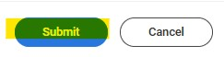
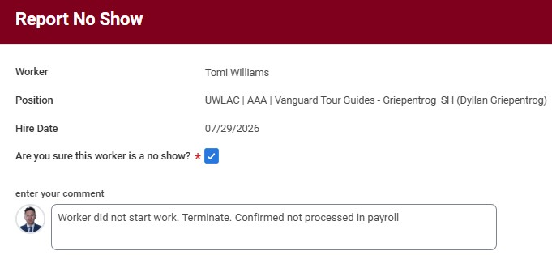
- Check the box next to 'Are you sure this worker is a no show?'
- Click Submit
- This routes to HR Partner for approval before being sent to UWSS for Review and Completion
- Terminate
  - Process of terminating a worker’s employment in Workday o Use this (instead of Report No Show) when employee has
had any payroll processed (even $0.00 payrolls)
  - Can be initiated by several roles including HR Partner, HRPC,
SPC, and Shared Services
▪ If Manager is not one of those roles, they are unable to initiate the termination
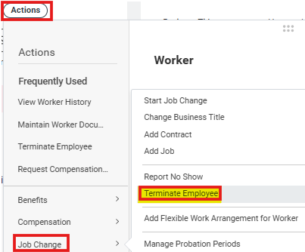
- Terminating a Worker’s Employment oTo terminate an employee with multiple positions,
utilize End Additional Job business process.
  - WARNING: This process can only be used to end an
additional job, not a primary job. Use the Switch Primary Job business process to change the primary job before ending the position. o Reference Termination and End Job Reasons as needed.
  - If an employee with multiple jobs is terminating/ending all
jobs. End any not absence eligible jobs first and then terminate the absence eligible job so the termination payouts are automated.
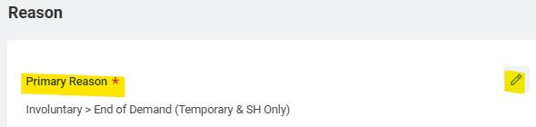
- After selecting Terminate, the next screen will be for completing the details
- Primary Reason: Most common reason to use is 'Involuntary > End of Demand
(Temporary & SH Only)
- Termination Date: Is the effective date of the termination. In Workday this often lines up with the last day worked.
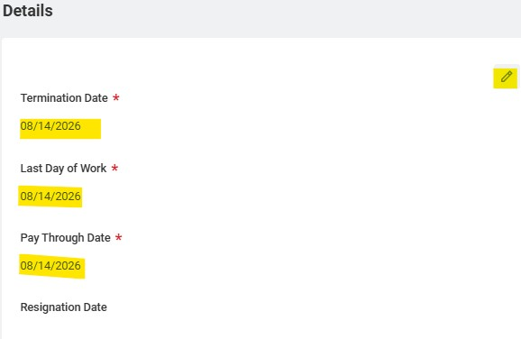
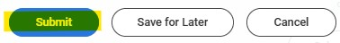
- Last Day of Work: The last day the employee worked for the company. This does not have to match the “Pay Through Date.”
- Pay Through Date: This date is used if the individual terminating employment continues receiving pay beyond their last day worked. An example of this is an individual approved to use remaining paid leave time prior to their retirement date.
- After submitting the Termination Business Process (BP), a Manage Business Processes for Worker task may route to the HR Process Coordinator (HRPC) if the student employee has any outstanding inbox tasks.
- The HR Process Coordinator is responsible for reviewing these outstanding tasks and determining whether they should be reassigned to another user or canceled. This step will be automatically skipped if the terminating employee has no remaining tasks in their inbox. oNote: UW Shared Services (UWSS) is currently developing a job aid for this process.
- Additionally, if a student employee's job end date has passed, the employee will not automatically terminate in Workday.
- While the Fixed Term Worker Process may identify and process some of these cases, the recommended best practice is to regularly monitor your sup org members or use the Current Workers and Jobs report as needed to ensure timely terminations are completed.

Role Action Items
    - Council/provide feedback to student employee about any issues

    - Contact HR with concerns especially if considering
-
Workday termination process starts after seeking HR
assistance and discussing with student employee
Student
-

Participate in discussions with supervisor/ actively
work to improve where applicable.
Process for Supervisor termination terminating/
offboarding a student employee
Manager Insights Hub
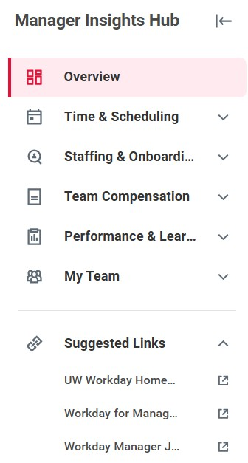
Manager Insights Hub
•
Single location where manager can:
o
Review and approve time and absences.
o
See in
-
progress staffing and onboarding transactions.
o
Review team compensation.
o
Review performance and learning information.
•
Manager Insights Hub Overview

–

Manage
r
o
Sections
▪
Overview
▪
Time & Scheduling
•
Time & Scheduling Overview
•
Team Absence Calendar
•
Edit and Approve Time
•
Scheduled vs. Actuals
•
Time and Absence Dashboard
▪
Staffing & Onboarding
•
Hiring and Staffing Overview
▪
Team Compensation
•
Team Compensation Summary
•
Compensation Reports
▪
Performance & Learning
•
Performance Overview
▪
My Team
▪
Suggested Links

Manager Insights Hub - Overview
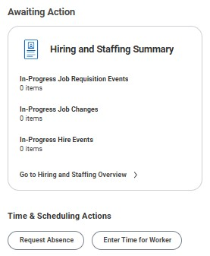
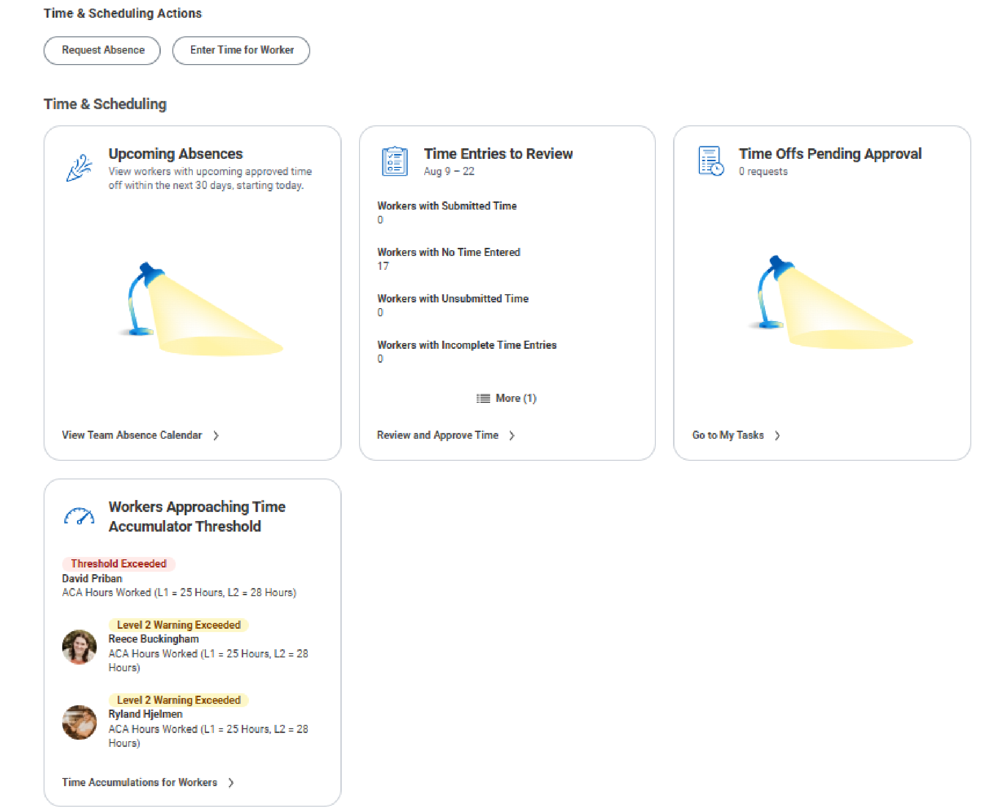
•
The overview page displays items awaiting actions, hiring and
staffing summary information, quick launch buttons for common time
& scheduling actions, and other time & scheduling related
information.
NOTE:
Some sections may not display for managers if they do not
have any data to display in a section.
•
Awaiting Action
Hiring and Staffing Summary
▪
Displays in
-
progress job requisition events, job changes, and hire events.
•
Time & Scheduling Actions
Has quick launch buttons for the Request Absence and Enter Time for
Worker tasks.
•
Time & Scheduling
Upcoming Absences
Time Entries to Review
Time Offs Pending Approval
Workers Approaching Time Accumulator Threshold
•
Team Career Highlights
Displays card for employees that show highlights such as overdue goals.
•
• • • •
•

Manager Insights Hub – Time and Scheduling
The Time & Scheduling Overview page serves as a central hub for managers to monitor and manage employee time entry, work schedules, and absences.
Key features include:
- Quick access to common tasks such as entering time, assigning work schedules, and reviewing team schedules.
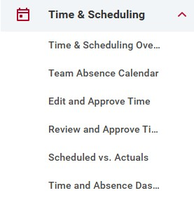
- Manager review items that highlight employees approaching time accumulator thresholds, missing or incomplete time entries, submitted time needing approval, and time-related alerts.
- Team status visibility through cards showing who is currently checked in or not checked in
- Reporting and approval tools that allow managers to review and approve time, compare scheduled versus actual hours worked, and access additional time and absence dashboards.
Overall, the page provides managers with a single location to efficiently oversee employee attendance, schedules, time entry, and absence management.
Time & Absence Dashboard (Time and Scheduling Hub)

Time Related Resources
- Entering Time - Employee
- Time & Scheduling Hub Overview
- Approving Time and Time Off
- Key Reports for Time Tracking
- Delegating Time and Absence Approval – Manager
- 2026 Pay Schedule - Employee and Manager

Manager Insights Hub – Staffing & Onboarding
•
•
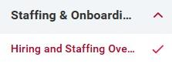
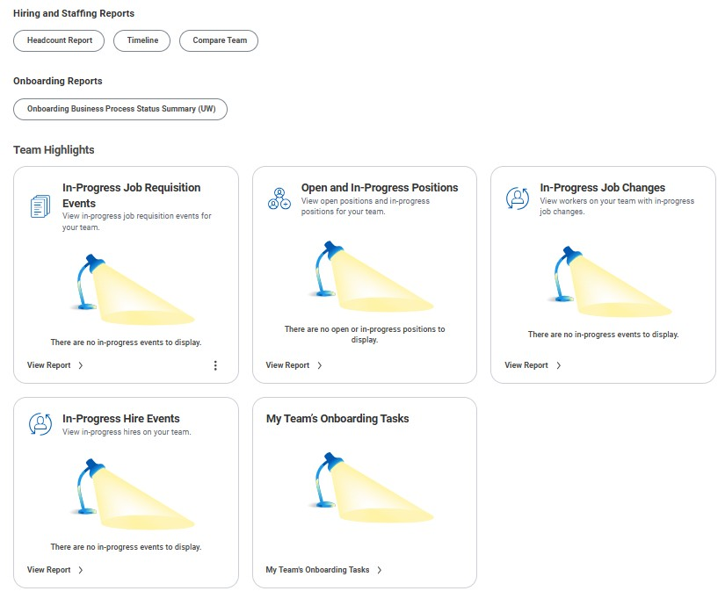
•
Staffing & Onboarding Overview
The Staffing & Onboarding Overview page includes buttons to quickly navigate to key tasks and reports and cards displaying sp
eci
fic
staffing, recruiting, and onboarding information for a manager's team.
Hiring and Staffing Reports
Displays buttons for launching key hiring and staffing reports.
Headcount Report
Timeline
Compare Team
Onboarding Reports
Displays buttons for launching key onboarding reports.
Onboarding Business Process Status Summary (UW)
Team Highlights
Displays cards showing staffing, recruiting, and onboarding information for a manager's team.
In
-
Progress Job Changes
Displays workers with in
-
progress job changes for a manager's team.
Links to the My Team's In
-
Progress Job Changes report.
In
-
Progress Hire Events
Displays in
-
progress hires for a manager's team.
Links to the In
-
Progress Hire Events report.
My Team's Onboarding Tasks
NOTE:
For more information on onboarding, see
Onboarding Overvie
w
and
Onboarding Setu
p
.
Displays onboarding tasks for a manager's team.
Links to the My Team's Onboarding Tasks report.
•
•
•
• •
•
•
•
•
•

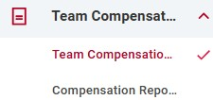
Manager Insights Hub – Team Compensation
Team Compensation Summary
Displays summary compensation information such as total
base pay and time in position for a manager's team broken
down by worker.
Compensation Reports
Links to key compensation reports such as Current Worker Allowance Plans (UW) and Compensation Spreadsheet.

Manager Insights Hub – Performance & Learning
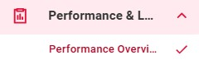
Learning Reports
- My Team's Learning Assignments (UW)
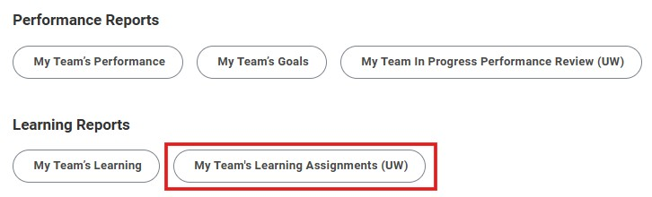
For more information on learning management, see:
- Enrolling Direct Reports in a Course – Manager
- Mandatory Employee Training - Manager • Viewing Team Learning Progress – Manager
.

Manager Insights Hub – My Team
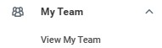
View My Team
Displays a button to quickly navigate to the team's organization chart. Also displays a card for each worker showing summary information.
Worker
Each worker on a manager's team will be listed in the navigation pane. Click on a worker's name to see a page with worker-specific information. Click the linked number on a worker's page to open a popup displaying their current performance goals.
Tabs
Additional worker information organized into tabs.
- Overview
- Displays suggested actions.
- Time & Scheduling
- Displays buttons to launch key tasks and reports.
- Assign Custom Work Schedule
- Request Absence • Manage Absence
- Card to view the work schedule calendar and launch the Assign Work Schedule task.
- Compensation
- Displays summary compensation information including base pay.
.

Centralized Support Hub
- GetHelpUW is the main platform for Workday support, offering easy access to help resources and ticket submission.​
- Virtual Assistant Features
- The GetHelpUW Virtual Assistant answers process-related questions efficiently, reducing the need for direct support tickets.​
Workday

Resources

Overview
•
Workday Websit
e
•
GetHelpU
W
- Ticket Escalation Process
- When necessary, issues can be escalated through ticket submission, ensuring routing to the right support team.
- GetHelpUW@support.wisconsin.edu
Centralized Training Access
- The dashboard serves as a single place for accessing required and optional Workday training courses.​
- Discover and Browse Features
- Users can search training by topic, role, or keyword to find relevant courses quickly.​
Workday

Learning
Dashboard
Workday Learning

Dashboar
d
- Just-In-Time Learning Support
- The dashboard enables users to find training when needed, promoting timely skill development.​
- Keeping Skills Current
- Regular use helps users stay updated with system changes and reinforces best practices for accuracy.
Centralized Update Hub
- The Information Hub consolidates updates on system issues, resolutions, and upcoming enhancements for Workday users.​
- Stay in the Know Subscription
- Users can subscribe to receive biweekly emails tailored to HR, Finance, Research, and Global update categories.​
Workday

Information
Hub and

Stay in the Know
Workday Information

Hub | Stay in the Kno
w
- Benefits of Staying Informed
- Regular updates allow users to anticipate changes, adjust workflows, and reduce confusion in daily operations.
Job Aid Library
- The Job Aid Library offers SOPs, how-to guides, and videos to help users navigate Workday processes effectively.
- WISC2 Testing Environment
- WISC2 is a non-production Workday sandbox where users can safely test transactions without affecting live data.​
Job Aid Library,
WISC2, and Resource
Hub
Workday Training

-

Launch Pag
e
•
Resources

-

Workday

KnowledgeBas
e

(
Job Aid Library
)
•
Wisc
2
No
n
-
Production Training

Tenan
t
•
Course Catalo
g
•
Resource Hub | Shared Service
s
- Resource Hub
- The Resource Hub provides essential pre-Workday tools, workshop materials, and ongoing learning resources.​

- Core Mobile Features
- Allows submitting time off requests, approving expenses, viewing payslips, and managing Workday tasks on mobile devices.​
- Accessibility and Convenience
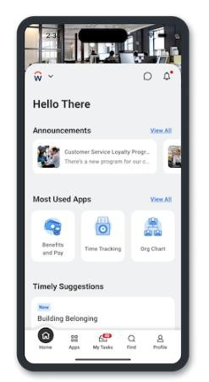
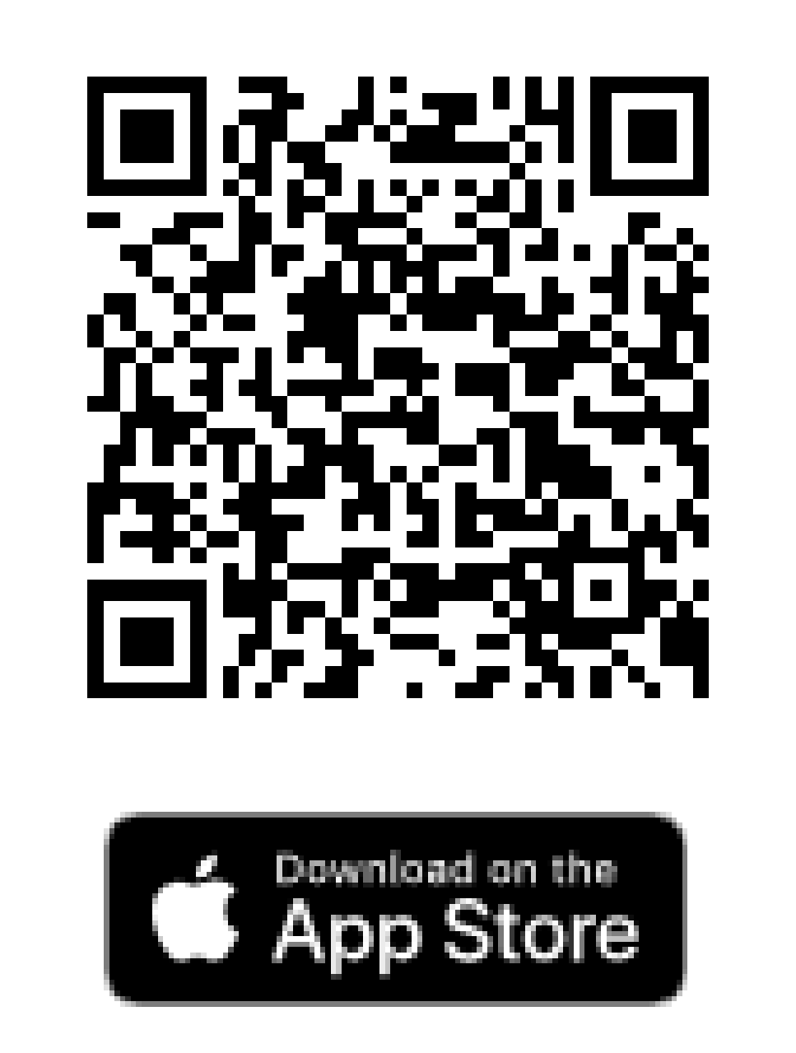
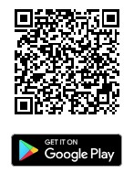
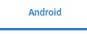
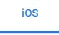

- Available on major app stores and enables managers to approve transactions remotely, reducing delays in processes.​
Workday Mobile
App
Job Aid: Installing

Workday on a Mobile

Device

–

Employe
e
- Security Features
- Supports biometric authentication like Face ID and Touch ID, ensuring security with periodic full authentication.
Questions?

