

Student Hourly
Updates
7.22.26

Success Stories
- Compliance and Auditing
- Streamlined I-9 Verification Process
- Enhanced Criminal Background Check (CBC) Process
- Does not slow down the hire process, but does require additional monitoring and communication
- Hiring
- Improved process to hire correct employee through ‘Find Duplicates’ functionality
- Faster, more efficient hiring process
- Removal of contracts for Student Hourly (SH) employees
- Use of Fixed Term Worker (FTW) process for extensions/continuous employment
- Time and Pay
- Student Employees independently enter and submit time
- Timely review and approval of timesheets by managers

Future Focus Points – Accurate Data
- Accurate Data
- Goal:
- Ensure the accuracy and integrity of Student Hourly (SH) job status data within Workday.
- What Happened:
- Current Workers and Jobs Audit – Spring 2026
- Current Workers and Jobs (UW) continues to identify SH that are showing FTE >0%
- Reminder: Regardless of the number of hours a student employee works, the scheduled weekly hours must be entered as 0 when completing a Hire or Add Job action.
- Revealed over 75 SH employees with Employee Job End Dates (EJED) beyond Fall 2027
- EJEDs established far into the future hinder the Fixed Term Worker (FTW) process from properly monitoring and managing job status.
- Mandatory Employee Training (MET) – Spring 2026
- Revealed many SH employees still active in Workday
- More than 35 of the employees had not worked in those positions for several months
- Impact:
- Inaccurate records (Verification of Employment, Unemployment inaccuracies)
- Increased compliance and reporting risk

– Scheduled Weekly Hours

• Reminder
- For Student Hourly (SH) employees:
- Scheduled Weekly Hours must be 0
- FTE must also be 0%
- Solution
- Implement a monthly review process to ensure compliance

• Process
- HR runs the “Current Workers and Jobs (UW)” report for Student Hourly employees
- Review the FTE column
- Identify SH employees with FTE greater than 0
- Review & Action
- HR submits a GetHelp ticket for UWSS assistance to correct/update FTE

– Standardize and Monitor SH EJED

• Solution
- Implement a monthly review process to monitor active Student Hourly and identify appointments that require extension or termination.
- Establish a new standard that Student Hourly appointments will be approved for one academic year at a time, with appropriate Expected Job End Dates (EJEDs).
- Appointment End Date Guidelines
- Students hired during the fall semester should be assigned an EJED corresponding to the last student hourly pay period of the academic year, unless an earlier end date is known.
- Students hired during the spring semester solely for summer employment should be assigned an EJED that aligns with the anticipated end of their summer work assignment.
- Students hired during the fall or spring semester who are expected to continue in the same position into the following academic year should be assigned an EJED of the first Friday in October of the next academic year (see additional details below)
- Process
- HR runs the “Current Workers and Jobs (UW)” report for SH
- Review “End Employment Date” column
- Identifies SH with EJEDs that extend beyond the one-academic year standard

• Review & Action
- HR updates EJEDs to align with the one academic year limitation
- This enables the Fixed Term Worker (FTW) process to:
- Monitor Job Status
- Prompt timely review
- Terminate or extend employment as appropriate

• Expected Ongoing Employment – Spring to Fall
- If a student is expected to continue in the same position from Spring into Fall:
- The FTW process will be used to update the EJED to the first Friday in October • This approach:
- Allows the position to carry into the Fall semester
- Triggers another FTW review in Fall to confirm continued employment
- Student Hourly Eligibility and Appointment PDF

– Quarterly Payroll Activity SH Review
- Solution
- Implement a review process to identify SH employees with no recent payroll activity over last 6 months
- Take action to terminate or retain based on Manager/Student Process Coordinator (SPC) review
- Process
- UWSS provides spreadsheet from the “Student Hourly Employment End Date Monitoring – UW” report
- Identifies SH with no payroll activity in the last 6 months
- HR distributes spreadsheet to managers/SPCs for review
- Review & Action
- Managers and SPC review each employee record and determine/update employment status
- Terminate – Yes Employee no longer in the position
- Termination processed by UWSS through mass upload EIB (similar to FTW) using ‘Payroll Inactivity” reason
- No Do Not Terminate – Employee is still actively in the position

Future Focus Points – Timely Hiring
Timely Hiring – No more than 30 days before the start date  - Reminder  - Best practice is to submit hires no more than 30 days before the start date.  - Why This Matters  - Initiating student hires (SH) too far in advance can create Workday system conflicts.  - This commonly occurs when a student is later hired by another department with an earlier start date.  - When a Conflict Occurs - Required Workaround  - Rescinding the later-dated hire  - Allowing the other department to complete their hire first  - Re-entering the original hire as an Add Job  - Best Practice  - Limiting hires to within 30 days of the start date:  - Prevents system conflicts  - Reduces rework  - Saves time for departments, HR, and student employees |  | Timely Hiring – At least 7 days before the start date  - Reminder  - Best practice is to submit a hire/add job at least 7 days prior to the employee’s start date.  - Why This Matters  - Allows sufficient time for the hire to move through the approval workflow  - Provides students adequate time to complete onboarding tasks, including Form I-9 - Sections 1 and 2  - Ensures enough time to complete Criminal Background  Checks (CBC) when the role is designated a Position of Trust (POT)  - If CBC is required  - SH must complete the CBC request within 5 days  - SH in a POT may not begin work until CBC results meet university standards  - Failure to complete the CBC request in a timely manner, or a CBC that does not meet university  standards, will result in termination

CBC – Position of Trust Information
Student Hourly positions generally do not require a Criminal Background Check (CBC). A CBC is required only when the position is designated as one of the following:
- Position of Trust, or
- Position of Trust with Access to a Vulnerable Population
Reminder:
- A Position of Trust is determined by whether a role includes responsibilities in any of these areas:
- Access to vulnerable populations: Unsupervised or significant contact with minors (under 18 and not enrolled at a UW System school) or medical patients.
- Property access: Use of master keys or card access to offices, facilities, or worksites beyond the employee’s own, including residential housing.
- Financial or fiduciary duties: Primary responsibilities (50% or more) involving handling money or assets, approving or authorizing expenditures, maintaining or auditing accounts or records, or managing inventories or financial documentation.
- Executive roles: Top-level institutional leadership positions such as Chancellor, Provost, Dean, and all limited appointment roles, including movement between limited appointments.

CBC – Position of Trust Status UPDATED
Moving Forward Guidelines
After further discussion, we are moving toward a standardized approach in which student employees will only be assigned one of the following Position of Trust (POT) statuses:
- Not a Position of Trust – CBC Not Required
- Position of Trust – No Recheck
- Position of Trust – 4-Year Recheck
- Important: If a student employee is in a Position of Trust, do not select "Position of Trust – 2 Year."
- Instead, select one of the following
- Position of Trust – No Recheck if the position does not involve access to vulnerable populations, or
- Position of Trust – 4-Year Recheck if the position does involve working with vulnerable population defined as minors and/or medical patients.

CBC – Position of Trust Decision Making Process
When hiring a student employee, Student Process Coordinators should use the following decision-making process:
Step 1: Determine Access to Vulnerable Populations
Will the student employee work directly with anyone under the age of 18?
- Yes → Select Position of Trust – 4-Year Recheck.
- No → Proceed to Step 2.
Step 2: Evaluate Other Position of Trust Criteria
Does the position meet any of the following criteria?
- B. Property Access
- C. Financial/Fiduciary Responsibility
- D. Executive Position
- Yes to any criterion → Select Position of Trust – No Recheck.
- No to all criteria → The position is not a Position of Trust, and a CBC is not required.

CBC – Position of Trust Audit
If “Position of Trust – 2 Year Recheck” Is Selected in Error
- If the hire is not yet complete:
- HR will not run the CBC and will reach out to the SPC.
- The SPC should cancel the hire and restart the hire process with the correct selection

• Reminder
- Three options we will use for Student Hourly (SH) employees:
- Not a Position of Trust – CBC Not Required
- Position of Trust – No Recheck
- Position of Trust – 4-Year Recheck
- Solution
- Implement a monthly review process to ensure compliance

• Process
- HR runs the “Current Workers and Jobs (UW)” report for Student Hourly employees
- Review the Position of Trust Column
- Identify SH employees with ‘Position of Trust – 2 Year Recheck’
- Review & Action
- HR submits a GetHelp ticket for UWSS assistance to correct/update POT status

CBC – Process Update
- No Limit on CBC Requests:
- The previous limit of two CBC requests for student employees has been removed after confirming that expired, uncompleted CBC invitations do not result in charges to the department.
- Additional Requests Allowed:
- CBC requests may be reissued as needed before the employee's start date.
- Start Date Requirement:
- Employees may not begin work until the required CBC has been completed.
- One-Time Extension:
- HR may approve a one-week start date extension and initiate a final CBC request.
- Termination:
- If the CBC remains incomplete by the revised start date, HR will proceed with termination of the hire.

Canceling the Hire
How to Cancel the Hire
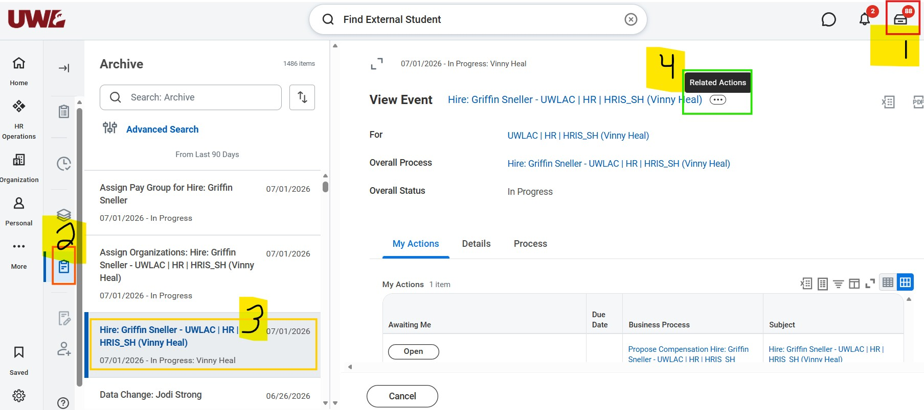
- Navigate to Tasks in Workday
- Go to Archive
- Locate the appropriate Hire Business Process (BP)
- Hover over the right side of the BP and select Related Actions (… icon)

Canceling the Hire
How to Cancel the Hire (continued)
- From the pop-up menu: Select Business Process
- Then click Cancel
- Scroll to the bottom of the Cancel Business Process Screen and enter a comment
○ Example: Update POT status from 2 Year Recheck to 4-Year Recheck
- Click Submit
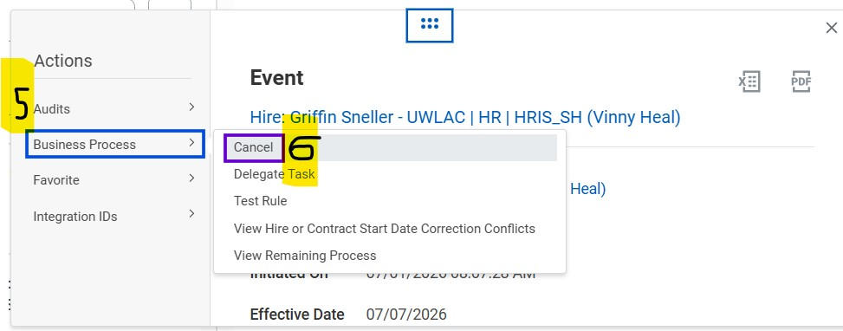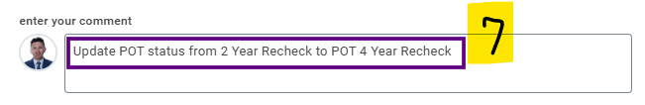

Update the Position of Trust Status
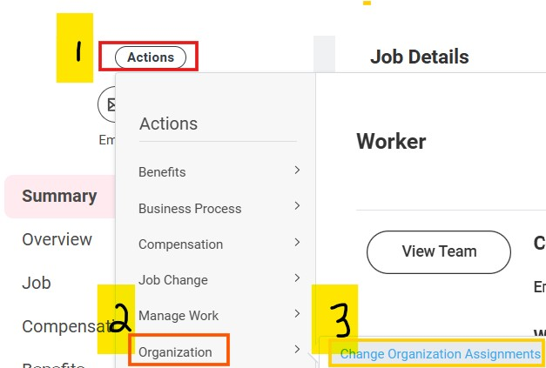
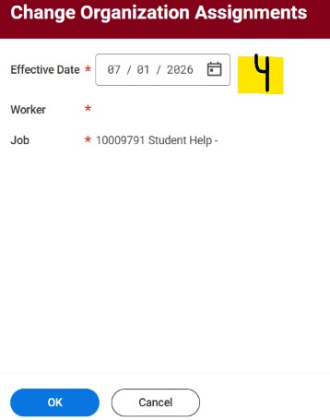
How to Update the Position of Trust Status
- From the Worker Profile, select
Actions under the employee's name
- Select Organization
- Select Change Organization Assignments
- Leave the default effective date and click OK

Update the Position of Trust Status
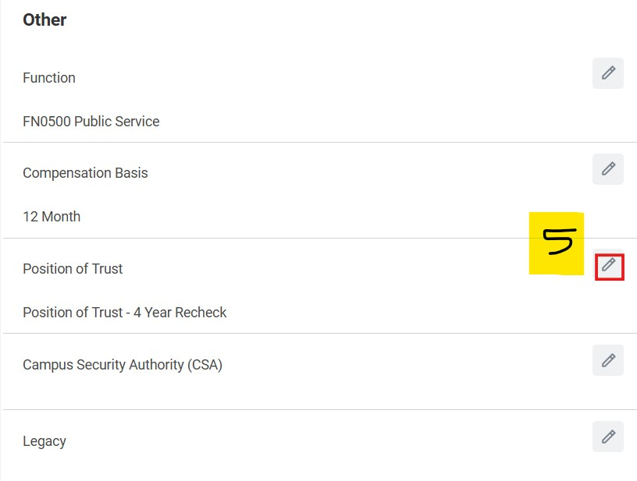
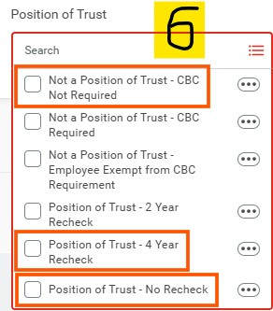
How to Update the Position of Trust Status
(continued)
- Scroll to the bottom of the Change Organization Assignments screen and click the pencil within the Position of Trust field
- Update the Position of Trust field accordingly to one of the following:
- If not a Position of Trust, choose 'Not a Position of Trust - CBC Not Required’
- If Position of Trust, choose either:
- Position of Trust – No Recheck if the position does not involve access to vulnerable populations, or
- Position of Trust – 4-Year Recheck if the position does involve working with youth, minors, or other vulnerable populations.
7. Click Submit

Upcoming Roadmap
Student Supervisor Training -
- August 18 and 20, 8:30 AM - 12:30 PM
- Will talk about Hiring/Add Job process, along with other Supervisor related training
- Will also cover the Hiring/Add job process on the August 19th SPC call
- Sign up link coming soon
- Launch the auditing processes outlined in previous slides, effective Fall 2026
- Create a Student Hourly webpage on the UWL HR website that:
- Centralizes key resources
- Provides relevant links and guidance for departments about student employees

Resources
• Student Hourly Staffing

