Hello Everyone!
Welcome to Cash Course! https://www.cashcourse.org/

- Register for a free account. Under the “Students” tab click the red link to register for a free account. (see below) Please select Wisconsin for state and University of Wisconsin-La Crosse for school.
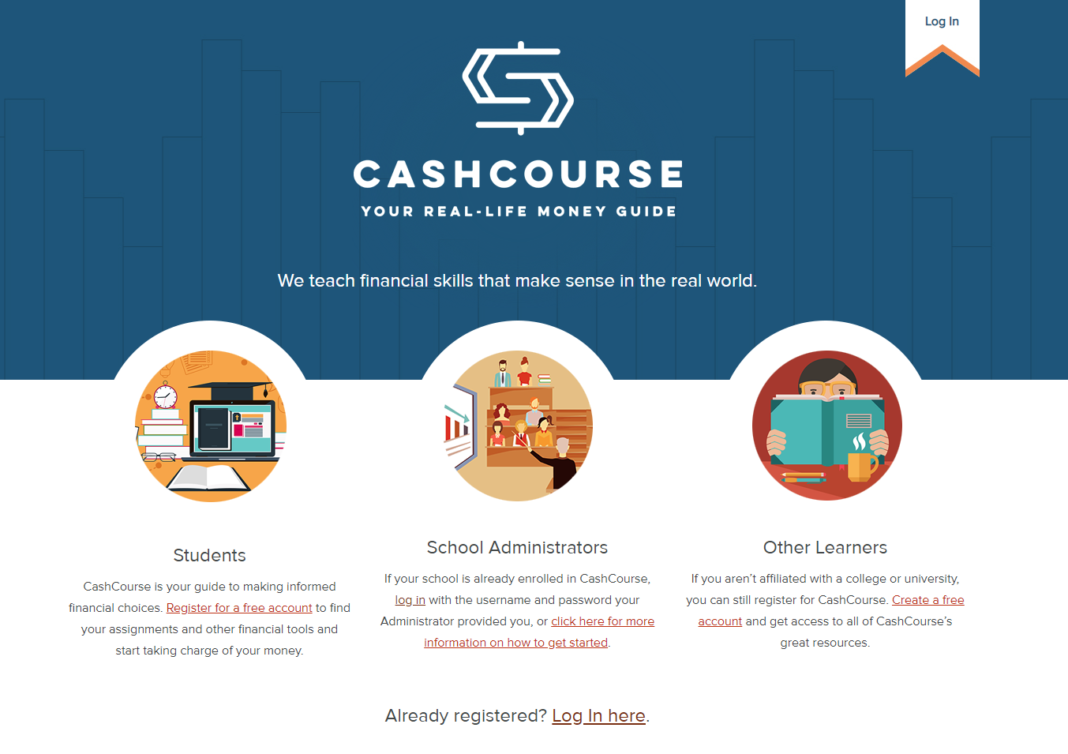

- Your Dashboard. This is what your dashboard will look like (below). You can find a selection of online modules by clicking the “My Assignments” button.
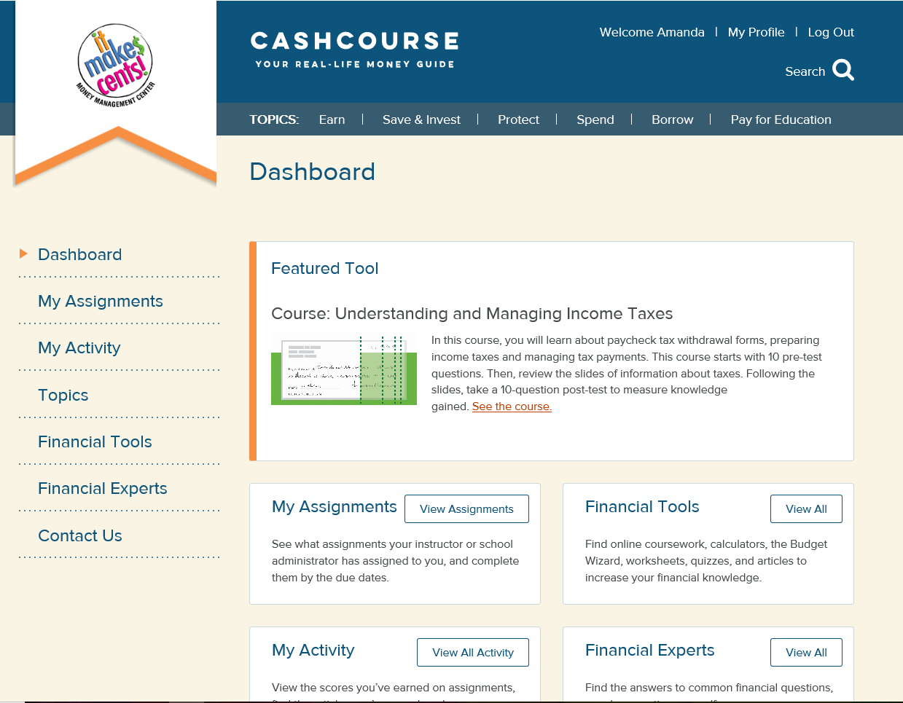

- Select Your School Administer. In the dropdown area, please select “Amanda Gasper” the It Make$ Cents! Coordinator as your school administer and push the submit button.

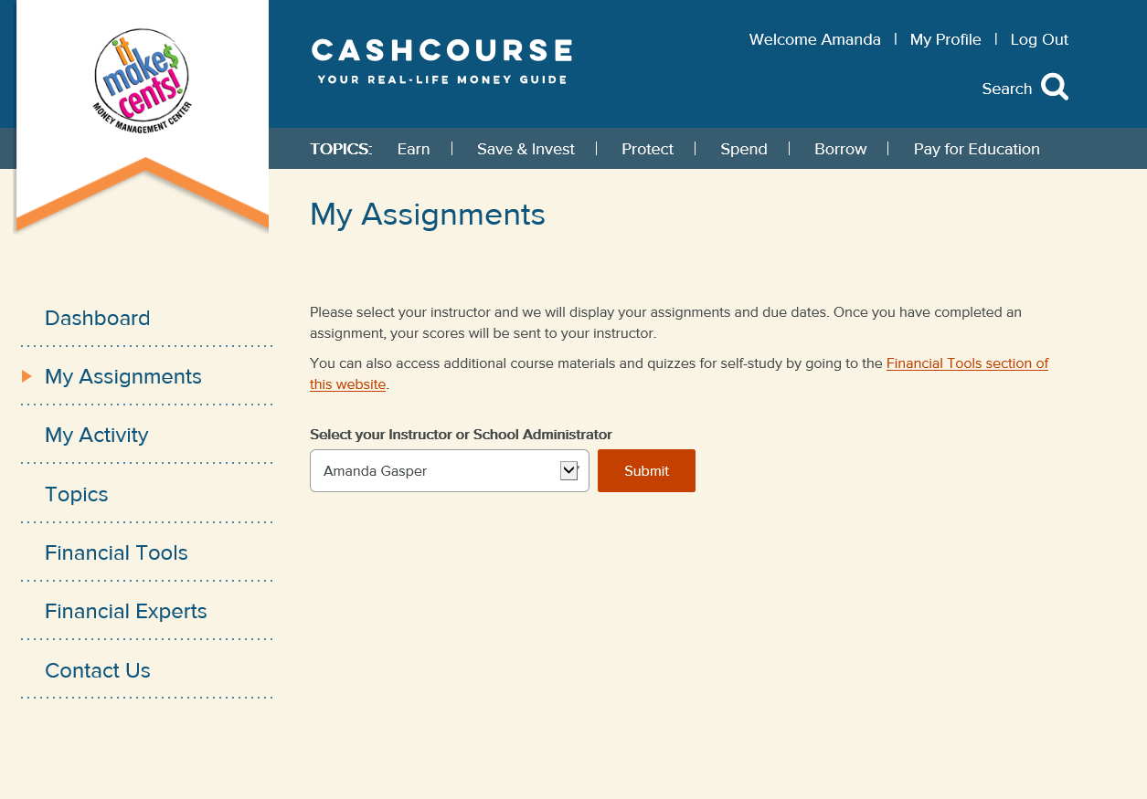

- Coursework Modules. Scroll down to see a list of coursework modules that you can choose from to replace or supplement your financial literacy requirement. The course topics include: Be Credit Savvy, Budgeting Basics, Paying Back Student Loans, Making the Most of Employee Benefits, Getting Started with Saving & Investing, Understanding & Managing Income Taxes, Protect Yourself with Insurance, and Fraud Protection.

- Click the “View Detail” button to get started.

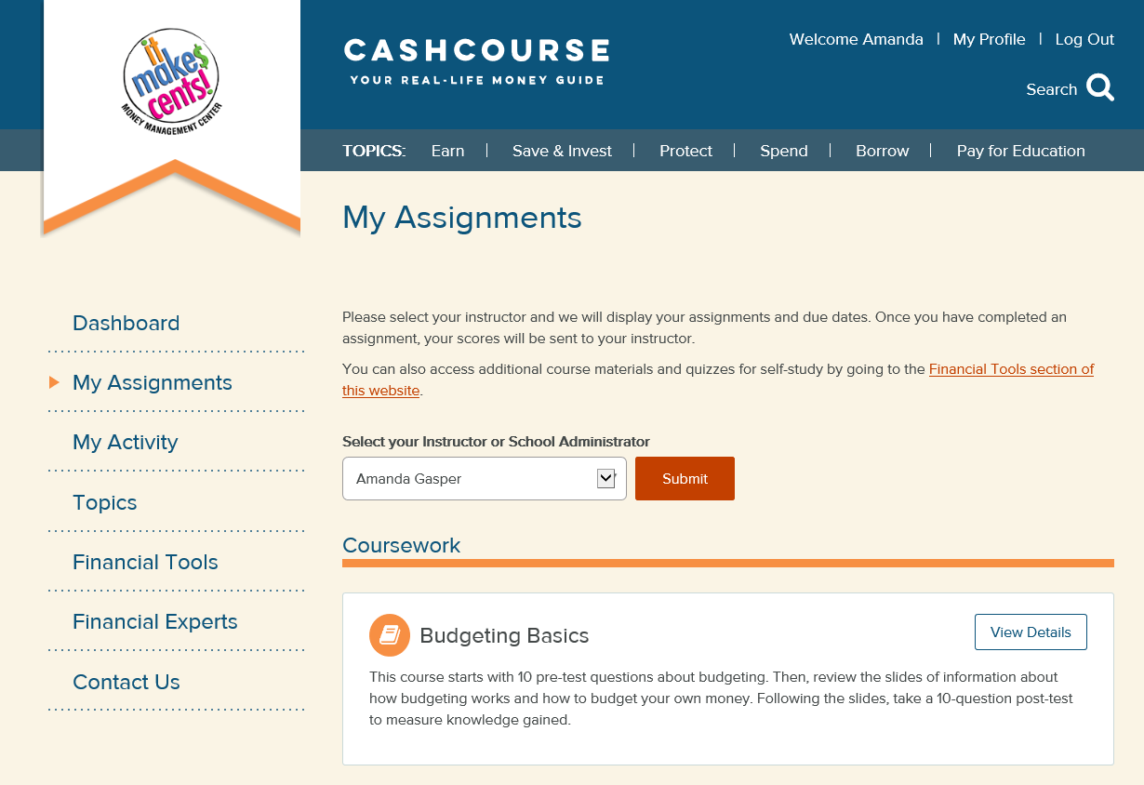
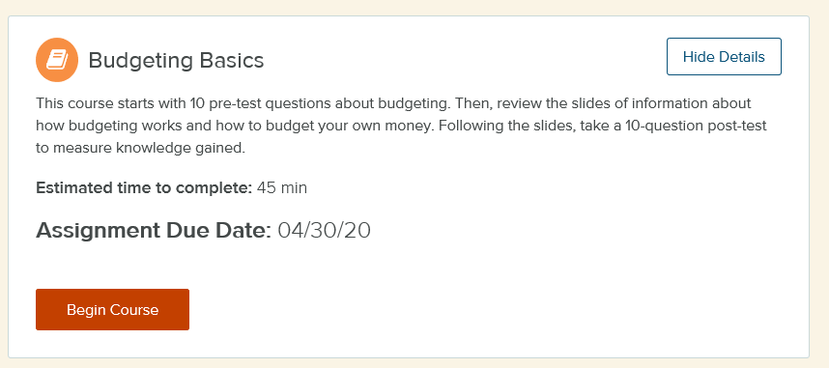

- Complete the pre-test, module and post-test. After completion your scores will be recorded. Your school administer will let your advisor and/or partner program aware of your participation module completion. Thank you for your time!

If you should have any questions, please email agasper@uwlax.edu

Warmest Regards Always,
- Your It Make$ Cents team

