April

SCHOLARSHIPS
Mattress Nerd's Scholarship Award: $1,000 Deadline: 4/1/26
https://www.mattressnerd.com/scholarship/

Janitorial Manager $1,000 Annual Scholarship
Award: $1,000 Deadline: 4/1/26 https://www.janitorialmanager.com/scholars hip/

Virginia Heinlein Memorial Scholarship Award: $1,000 Deadline: 4/1/26 https://heinleinsociety.org/scholarship-progr am/

The John T. Fields & Associates Scholarship Award: $1,000 Deadline: 4/4/26 https://www.johntfieldsdivorceattorney.com
/scholarship

CMP Carolyn Hines Memorial Scholarship Program
Award: $1,000 Deadline: 4/4/26 https://thecmp.org/cmp-scholarship-progra m/

CW4 Savidge Memorial Scholarship Award: $775 Deadline: 4/5/26 https://bold.org/scholarships/CW4-savidge- memorial-scholarship/
Wounded First Responders Scholarship Award: $1,000 Deadline: 4/6/26 https://www.pcbplaw.com/scholarship

BMO Capital Markets Lime Connect Equity Through Education Scholarship
Award: $1,000 Deadline: 4/7/26 https://limeconnect.com/awards/bmo_capit al/

O'Brien-Vrba Scholarship Trust Award: Varies Deadline: 4/8/26
https://learnmore.scholarsapply.org/obrien/

Navin Narayan Scholarship Award: $1,000 Deadline: 4/12/26
https://www.redcross.org/red-cross-youth/o pportunities/scholarships-and-awards/navin- narayan-college-scholarship.html

Natural Disaster Relief Scholarship Award: $1,000 Deadline: 4/13/26
https://www.ovcscholarshipnetwork.com/sc holarships/natural-disaster-relief-scholarship

The Create Real Impact Contest Award: Varies Deadline: 4/15/26 https://www.createrealimpact.com/

The Teresa Noelle Knabe Memorial Foundation
Award: $1,000-$4,000 Deadline: 4/15/26 https://teresanoelleknabefoundation.org/sc holarships

Surviving & Thriving With a Life-Altering Injury Scholarship
Award: $2,500 Deadline: 4/15/26 https://www.physicianlcp.com/company/sur viving-thriving-with-a-life-altering-injury-sch olarship/

The Penney Richards Memorial Scholarships Award: $1,000-$2,500 Deadline: 4/17/26 https://www.penneyrichards.com/schship.ht m

Crossroads Empowering Women Scholarship
Award: $1,000 Deadline: 4/18/26 https://crossroadsinsuranceadjusters.com/co mmunity-involvement

The Walker Williams Wilson Memorial Scholarship
Award: Varies Deadline: 4/21/26 https://www.svgsfoundation.org/scholarship
/

The Husband & Wife Law Team Scholarships Award: $2,000 Deadline: 4/27/26 https://husbandandwifelawteam.com/in-you r-community/scholarships

Dream Big Scholarship Fund Award: Varies Deadline: 4/29/26
https://dreambigscholarshipfund.org/scholar ship-application/

VFW's "Sport Clips Help a Hero Scholarship" Award: $5,000 Deadline: 4/30/26 https://www.vfw.org/1StudentVeteran

E-waste Scholarship
Award: $1,000 Deadline: 4/30/26 https://www.digitalresponsibility.org/ewaste
-scholarship

BrightSprout Crossword Scholarship Contest Award: $1,000 Deadline: 4/30/26 https://blog.brightsprout.com/brightsprout-c rossword-scholarship/

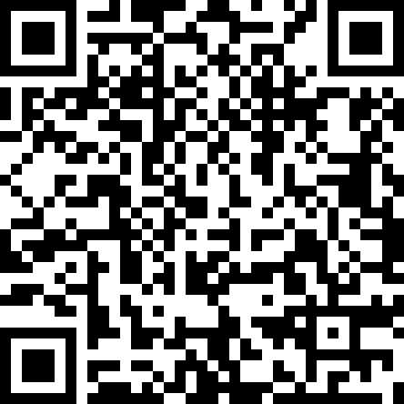
Schedule an appointment with us to get one-on-one assistance in finding scholarships, topic brainstorming, and essay review!
SNEAK PEAK INTO
MAY SCHOLARSHIPS
FutureDesigner Scholarship Award: $1,000 Deadline: 5/1/26
https://www.cardsdirect.com/scholarship.as px
Stand up to Distracted Driving Scholarship Award: $1,000 Deadline: 5/13/26 https://www.kanoski.com/community-involv ement/distracted-driving-scholarship
The MKFM Resilient Student Scholarship Award: $1,500 Deadline: 5/13/26 https://www.mkfmlaw.com/the-mkfm-resilie nt-student-scholarship
Lucas Law Legal Leaders Scholarship Award: $1,000 Deadline: 5/18/26 https://www.lucaslaw.com/scholarship
The Moving Forward Scholarship Award: $1,000 Deadline: 5/20/26 https://www.collinsrupp.law/scholarship
STEM To Flowers Scholarship Award: $500 Deadline: 5/31/26
https://www.scholarships.com/scholarships/ stem-to-flowers-scholarship

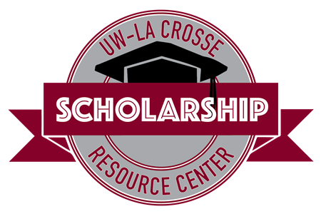
Student Union 0130
608-785-8852
uwlscholarships@uwlax.edu

Interested in receiving this each month? Sign up for our monthly
e-newsletter to receive the scholarship brochure and other scholarship updates!
