December SCHOLARSHIPS

ACF Visionary Scholarship Award: $5,000 Deadline: 12/1/25
https://americancollegefoundation.org/colle ge-planning-visionary-scholarship-details/

Gretchen Taylor Pousson Equal Rights Scholarship
Award: $500 Deadline: 12/1/25 https://vacrimlawyers.com/es/jay-p-mykytiu k/

Reducing Drunk Driving in Our Communities Scholarship
Award: $2,500 Deadline: 12/1/25 https://www.leekelaw.com/scholarship/

Bushnell Bioinformatic Scholarship Award: $500 Deadline: 12/1/25
https://bold.org/scholarships/bushnell-bioinf ormatic-scholarship/

The Stout Law Firm Family Matters Scholarship
Award: $1,000 Deadline: 12/1/25 https://www.divorcelawyerhouston.pro/the- stout-law-firm-family-matters-scholarship/
National Arts Competition Award: Varies Deadline: 12/1/25 https://youngarts.org/apply/

Descendants Truth & Reconciliation Foundation
Award: Varies Deadline: 12/1/25 https://tmcf.org/open-scholarships/descend ants-truth-reconciliation-foundation/

USBC ALBERTA E. CROWE STAR OF TOMORROW
Award: $6,000 Deadline: 12/1/25 https://bowl.com/youth/scholarships-and-a wards/usbc-youth-scholarships

The GoodDeedSeats Annual Scholarship Award: $500 Deadline: 12/1/25 https://gooddeedseats.com/our-scholarship/

Diversity Article Awards Award: $600 Deadline: 12/1/25
https://www.psichi.org/page/diversityinfo

Next Generation Healers Scholarship Award: $1,000 Deadline: 12/2/25 https://www.banyantreatmentcenter.com/re sources/student-scholarship/#apply

The Law Offices of Joseph. J Bogdan, LLC Healthcare Professional Scholarship Award: $1,000 Deadline: 12/3/25
https://www.jjblawoffice.com/healthcare-pr ofessional-scholarship

Illinois Association of Aggregate Producers Education Foundation Scholarship
Award: $2,000 Deadline: 12/4/25 https://www.iaap-aggregates.org/education- foundation-scholarship.html

SMART Scholarship Program
Award: Full Tuition Costs Deadline: 12/5/25 https://scholarshipamerica.org/scholarship/s mart-scholarship-program/

Kemper Human Rights Education Foundation Essay Contest
Award: $4,000 Deadline: 12/10/25 https://www.scholarships.com/scholarships/ kemper-human-rights-education-foundation- essay-contest#

Andrea Worden Scholarship for Tenacity and Timeless Grace
Award: $10,000 Deadline: 12/11/25 https://app.bold.org/scholarships/andrea-w orden-scholarship-for-tenacity-and-timeless- grace/

Foreclosure.com Scholarship Program Award: $4,000 Deadline: 12/15/25 https://www.foreclosure.com/scholarship

PEO International Peace Scholarship Award: Varies Deadline: 12/15/25
https://www.tun.com/scholarships/peo-inter national-peace-scholarships/

Dreams Without Borders
Award: $1,000 Deadline: 12/17/25 https://www.immigrationabogado.com/scho larship

2025 Autism Scholarship Contest Award: $1,000 Deadline:12/19/25
https://thescholarshipsystem.com/blog-for-s tudents-families/71-grants-and-scholarships- for-disabled-students/

North Spore Mycology Scholarship Award: $2,500 Deadline: 12/20/25
https://northspore.com/pages/north-spore-s cholarship

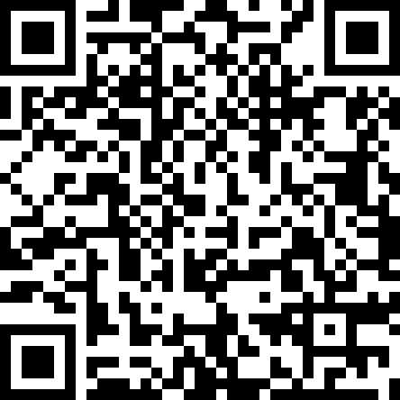
Schedule an appointment with us to get one-on-one assistance in finding scholarships, topic brainstorming, and essay review!
SNEAK PEAK INTO JANUARY SCHOLARSHIP

Abacus Life Scholarship
Award: $1,000 Deadline: 1/6/25 https://abacuslifesettlements.com/abacus-sc holarship/

The Jackie Robinson Foundation Scholarship 2025-2026
Award: Varies Deadline: 1/7/25 https://jackierobinson.org/apply/

Helen Diller Family Foundation Scholarship Award: Varies Deadline: 1/8/25 https://dillerteenawards.org/about-the-awar ds/

Pride Foundation Scholarship Award: Varies Deadline: 1/10/25
https://www.scholarships.com/scholarships/ pride-foundation-scholarships#

Profiles in Courage, John F. Kennedy Scholarship
Award: Varies Deadline: 1/12/25 https://www.jfklibrary.org/learn/education/ profile-in-courage-essay-contest/contest-topi c-and-information

DECEMBER SCHOLARSHIPS

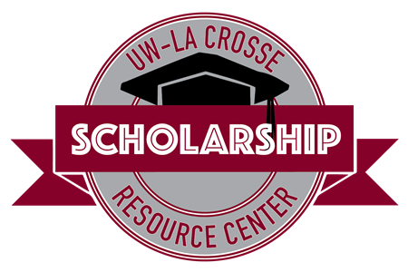
Student Union 0130
608-785-8852
uwlscholarships@uwlax.edu

Interested in receiving this each month? Sign up for our monthly
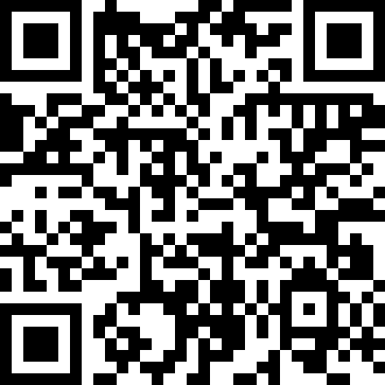
e-newsletter to receive the scholarship brochure and other scholarship updates!

