JANUARY

SCHOLARSHIPS

Abacus Life Scholarship
Award: $1000 Deadline: 1/6/26
https://abacuslifesettlements.com/abacus-scholarship/

The Jackie Robinson Foundation Scholarship 2026-2026
Award: Varies Deadline: 1/7/26
https://jackierobinson.org/apply/

Helen Diller Family Foundation Scholarship
Award: Varies Deadline: 1/8/26
https://dillerteenawards.org/about-the-awards/

Pride Foundation Scholarship
Award: Varies Deadline: 1/10/26
https://www.scholarships.com/scholarships/pride-foundation-scholarships#

Built Ford Tough Scholarship
Award: $1000 Deadline: 1/9/26
https://www.scholarships.com/scholarships/built-ford-tough-scholarship

The Gryphon Scholarship Program
Award: $2600 Deadline: 1/9/26
https://scholarshipamerica.org/scholarship/gryphon/

Garden Club of America Coastal Wetlands Studies Scholarship
Award: $5000 Deadline: 1/10/26
https://www.vims.edu/ccrm/outreach/gca/

PRINT IT Scholarship For Aspiring Content Creators
Award: $500 Deadline: 1/11/26
https://mmanuts.com/scholarships/

Profiles in Courage, John F. Kennedy Scholarship
Award: Varies Deadline: 1/12/26
https://www.jfklibrary.org/learn/education/profile-in-courage-essay-contest/contest-topic-and-information

Mark A. Jefferson Teaching Scholarship
Award: $1000 Deadline: 1/14/26
https://bold.org/scholarships/mark-jefferson-teaching-scholarship/

Leaders Save Lives Scholarship Program
Award: Varies Deadline: 1/15/26
https://www.redcrossblood.org/hosting-a-blood-drive/learn-about-hosting/why-host-a-blood-drive/leaders-save-lives.html

FFA Scholarship
Award: Varies Deadline: 1/15/26
https://www.ffa.org/participate/grants-and-scholarships/scholarships/

Bernt Anker Scholarship
Award: $3000 Deadline: 1/15/26
https://www.sofn.com/wp-content/uploads/2025/09/Bernt-Anker-Scholarship-2025.pdf

MSSA Scholarship Program
Award: $5000 Deadline: 1/15/26
https://www.scholarships.com/scholarships/mssa-scholarship-program#

Penguin Random House Creative Writing Awards
Award: $10000 Deadline: 1/15/26
https://social-impact.penguinrandomhouse.com/our-awards/u-s-creative-writing-awards/

Minnesota Mensa Scholarship
Award: $500 Deadline: 1/15/26
https://www.mensafoundation.org/what-we-do/scholarships/

Dolly Parton Songwriters Award
Award: $20000 Deadline: 1/15/26
https://www.scholarships.com/scholarships/dolly-parton-songwriters-award

American Red Cross - Leaders Save Lives Scholarship
Award: $2500 Deadline: 1/15/26
https://www.scholarships.com/scholarships/american-red-cross-leaders-save-lives-scholarship

The LAGRANT Foundation Scholarship
Award: $2500 Deadline: 1/20/26
https://www.lagrantfoundation.org/scholarship-application-process

Joy Cappel Scholarship
Award: $2500 Deadline: 1/20/26
https://www.scholarships.com/scholarships/joy-cappel-scholarship#

Jay Holstine Scholarship
Award: $1000 Deadline: 1/21/26
https://www.scholarships.com/scholarships/jay-holstine-scholarship#

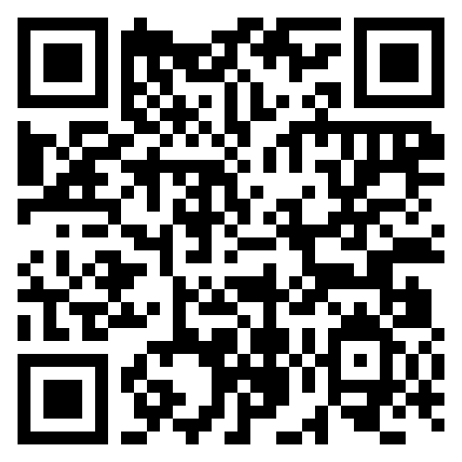

Schedule an appointment with us to get one-on-one assistance in finding scholarships, topic brainstorming, and essay review!
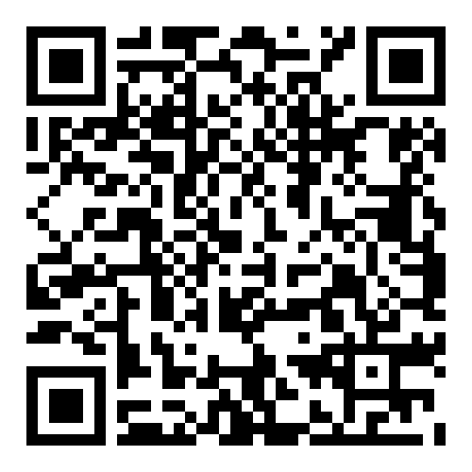

SNEAK PEAK INTO

FEBRUARY

SCHOLARSHIPS

AAUW-Racine Scholarship
Award: Varies Deadline: 2/2/26
https://racine-wi.aauw.net/scholarships/

The May Firm Scholarship Fund
Award: $1000 Deadline: 2/3/26
https://mayfirm.com/scholarship/

Helen Diller Family Foundation Scholarship
Award: Varies Deadline: 1/8/26
https://dillerteenawards.org/about-the-awards/

"The Hope for Healing" Scholarship
Award: $5000 Deadline: 2/5/26
https://fherehab.com/hope-for-healing-scholarship

Harris Injury Scholarship
Award: $1000 Deadline: 2/6/26
https://harrispersonalinjury.com/injury-scholarship/

Alltricity Scholarship Foundation Scholarship
Award: Varies Deadline: 2/7/26
https://www.scholarships.com/scholarships/alltricity-scholarship-foundation-scholarship#

JANUARY

SCHOLARSHIPS
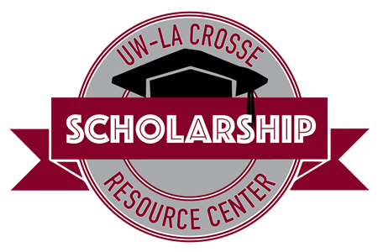
Student Union 0130
608-785-8852
uwlscholarships@uwlax.edu

Interested in receiving this each month? Sign up for our monthly e-newsletter to receive the scholarship brochure and other scholarship updates!

