March
SCHOLARSHIPS

Bill and Joyce Coborn Memorial Scholarship
Award: $1000 Deadline: 3/1/26
https://www.communitygiving.org/scholarship/bill-and-joyce-coborn-memorial-scholarship/

WATA Founding Fathers Leadership Scholarship
Award: $1000 Deadline: 3/1/26
https://watainc.org/Scholarships

Marine Corps Scholarship Foundation Children of the Fallen and Children of the Wounded Scholarships
Award: $30,000-$40,000 Deadline: 3/1/26
https://dillerteenawards.org/about-the-awards/

Tall Clubs International Student Scholarships
Award: $1000 Deadline: 3/1/26
https://www.scholarships.com/scholarships/tall-clubs-international-student-scholarships

The Lewis Scholarship
Award: $10000 Deadline: 3/1/26
https://www.pressclubinstitute.org/national-press-club-scholarship-opportunities/

The Devadoss Law Firm Civil Rights Scholarship
Award: $1000 Deadline: 3/2/26
https://www.fedemploymentlaw.com/the-devadoss-law-firm-civil-rights-scholarship/

Freshman Trailblazer Scholarship
Award: $1,000 Deadline: 3/4/26
https://www.moghullaw.com/scholarship

AAHD Scholarship Program
Award: $1000 D Deadline: 3/6/26
https://aahd.us/initiatives/scholarship/

Create-A-Greeting-Card Scholarship
Award: $10000 Deadline: 3/9/26
https://www.gallerycollection.com/ScholarshipOfficialRules.pdf

David A. Winston Health Policy Scholarship
Award: Varies Deadline: 3/13/26
https://winstonfellowship.org/health-policy-scholarship/

LeRoy C. Schmidt 150-Hour Scholarships
Award: $3000 Deadline: 3/13/26
https://www.wicpa.org/education/scholarships

Wisconsin State Telecommunications Foundation Scholarship
Award: $1500 Deadline: 3/15/26
https://bigfuture.collegeboard.org/scholarships/wisconsin-state-telecommunications-foundation-scholarship
Constellation Scholars Program
Award: $5000 Deadline: 3/16/26
https://learnmore.scholarsapply.org/constellation-scholars/

JCF Judy Kay Wendland-Young Scholarship
Award: $5000 Deadline: 3/16/26
https://www.scholarships.com/scholarships/jcf-judy-kay-wendland-young-scholarship

Justice For All Scholarship
Award: $1000 Deadline: 3/18/26
https://www.bettersworthlaw.com/scholarship

OCA Gold Mountain Scholarship
Award: $2000 Deadline: 3/18/26
https://www.scholarships.com/scholarships/oca-gold-mountain-scholarship

Aramark Scholarship Program
Award: $1000 Deadline: 3/20/26
https://learnmore.scholarsapply.org/aramark/

The VanRoss Foundation Scholarship
Award: $500 Deadline: 3/20/26
https://thevanrossfoundation.org/scholarship-application

Dylan's Journey Memorial Scholarship
Award: $1000 Deadline: 3/21/26
https://app.bold.org/scholarships/dylans-journey-memorial-scholarship/

Hedy Lamarr Achievement Award
Award: $10000 Deadline: 3/28/26
https://www.scholarships.com/scholarships/hedy-lamarr-achievement-award

EFWA Scholarships
Award: Varies Deadline: 3/30/26
https://www.scholarships.com/scholarships/efwa-scholarships

The First Generation College Student Scholarship
Award: $2500 Deadline: 3/30/26
https://www.kadzailawgroup.com/scholarship

Schedule an appointment with us to get one-on-one assistance in finding scholarships, topic brainstorming, and essay review!
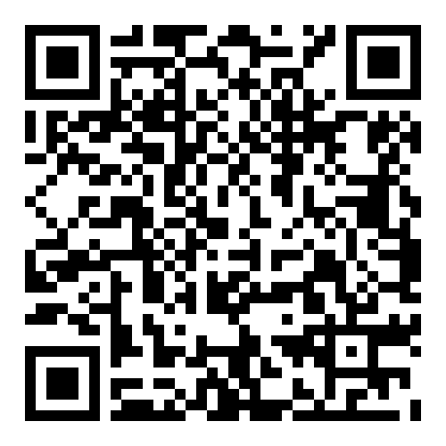

SNEAK PEAK INTO
April
SCHOLARSHIPS

Mattress Nerd's Scholarship
Award: $1000 Deadline: 4/1/26
https://www.mattressnerd.com/scholarship/

CW4 Savidge Memorial Scholarship
Award: $775 Deadline: 4/5/26
https://bold.org/scholarships/CW4-savidge-memorial-scholarship/

O'Brien-Vrba Scholarship Trust
Award: Varies Deadline: 4/8/26
https://learnmore.scholarsapply.org/obrien/

The Create Real Impact Contest
Award: Varies Deadline: 4/15/26
https://www.createrealimpact.com/

Surviving & Thriving With a Life-Altering Injury Scholarship
Award: $2500 Deadline: 4/15/26
https://www.physicianlcp.com/company/surviving-thriving-with-a-life-altering-injury-scholarship/

The Walker Williams Wilson Memorial Scholarship
Award: Varies Deadline: 4/21/26
https://www.svgsfoundation.org/scholarship/

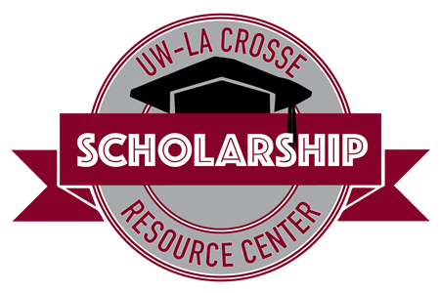
Student Union 0130
608-785-8852
uwlscholarships@uwlax.edu

Interested in receiving this each month? Sign up for our monthly e-newsletter to receive the scholarship brochure and other scholarship updates!

