October

SCHOLARSHIPS

Buckfire & Buckfire, P.C. Disability Scholarship Program
Award: $1,000 Deadline: 10/1/25 https://buckfirelaw.com/scholarships/disabi lity/

Spolin Law P.C. Civil Rights and Criminal Law Essay Competition & $1,000 Scholarship
Award: $1,000 Deadline: 10/1/25 https://www.spolinlaw.com/scholarship/

RodentPro.com® Animal Advocate Scholarship
Award: $1,000 Deadline: 10/1/25 https://www.rodentpro.com/pages/scholars hip
Students With Heart Foundation Award: $1,000 Deadline: 10/1/25
http://www.studentswithheart.org/scholars hips.html

The First Generation College Student Scholarship
Award: $2,500 Deadline: 10/1/25 https://www.kadzailawgroup.com/scholarsh ip

Anidjar & Levine Community Service Scholarship
Award: $2,500 Deadline: 10/1/25 https://www.anidjarlevine.com/about/schol arship/community-service-scholarship/

HealthArc Scholarship
Award: $2,000 Deadline: 10/1/25 https://www.healtharc.io/scholarship/

Price It Here Scholarship Program Award: $1,000 Deadline: 10/1/25 https://www.healtharc.io/scholarship/

The Fulbright Program
Award: Varies Deadline: 10/1/25 https://www.scholarships.com/scholarships
/the-fulbright-program#

Web Design Scholarship
Award: $1,000 Deadline: 10/2/25 https://www.loungelizard.com/scholarship/

Benjamin A. Gilman International Scholarship Program
Award: $5,000 Deadline: 10/3/25 https://www.scholarships.com/scholarships
/benjamin-a-gilman-international-scholarshi p-program#

Biederman & Burleson Champions of Justice Scholarship
Award: $1,000 Deadline: 10/6/25 https://www.biedermanandburleson.com/s cholarship
Conquering Cancer Scholarship Award: $1,000 Deadline: 10/6/25
https://www.thehoffmanfirm.net/scholarshi p

Steel Intern Scholarships
Award: $7,500 Deadline: 10/6/25 https://www.aist.org/students-faculty/schol arships/steel-intern-scholarships

AES Engineering Scholarship Award: $500 Deadline: 10/8/25
http://www.aesengineers.com/scholarships. htm

Breast Cancer Awareness Scholarship in Memory of Martha Dickinson
Award: $500 Deadline: 10/12/25 https://bold.org/scholarships/breast-cancer
-awareness-scholarship-in-memory-of-mart ha-dickinson/

Stantec Equity & Diversity Scholarship Award: $1,000 Deadline: 10/14/25 https://www.scholarships.com/scholarships
/stantec-equity-and-diversity-scholarship

The Ernest Varvoutis Scholarship for Accounting
Award: $1,000 Deadline: 10/15/25 https://ernestvarvoutisscholarship.com/ern est-varvoutis-scholarship/

Natural Disaster Relief Scholarship Award: $1,000 Deadline: 10/20/25
https://www.ovcscholarshipnetwork.com/sc holarships/natural-disaster-relief-scholarshi p

Delete Cyberbullying Beyond School Walls Scholarship
Award: $1,000 Deadline: 10/31/25 https://www.endcyberbullying.net/scholars hip-beyond-school-walls

Schedule an appointment with us to get one-on-one assistance in finding scholarships, topic brainstorming, and essay review!

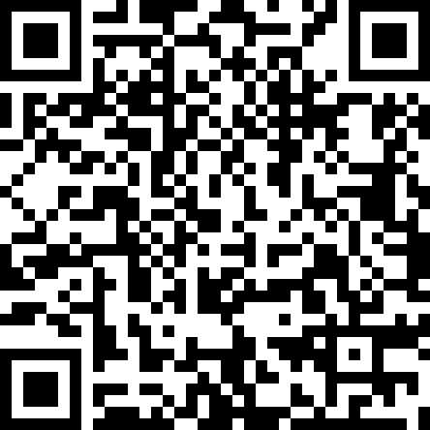

SNEAK PEAK INTO
November SCHOLARSHIPS

Mildred C. Hanson SIOR Memorial Scholarship
Award: $1,000 Deadline: 11/1/25 https://www.scholarships.com/scholarships
/mildred-c-hanson-sior-memorial-scholarshi p#

Band Directors International College Scholarships
Award: Varies Deadline: 11/1/25 https://www.scholarships.com/scholarships
/women-band-directors-international-colleg e-scholarships#

Waggle Human-Pet Bond Scholarship Opportunity
Award: $1,000 Deadline: 11/1/25 https://www.waggle.org/waggle-scholarshi p

The Whitlock Law Hope and Opportunity Scholarship
Award: $1,500 Deadline: 11/5/25 https://www.whitlocklawllc.com/scholarshi p

CPCU Society NextGen Scholarship Award: $5,000 Deadline: 11/6/25
https://www.scholarships.com/scholarships
/cpcu-society-nextgen-scholarship#

October SCHOLARSHIPS
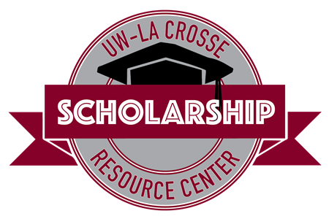
Student Union 0130
608-785-8852
uwlscholarships@uwlax.edu

Interested in receiving this each month? Sign up for our monthly
e-newsletter to receive the scholarship brochure and other scholarship updates!
