September SCHOLARSHIPS

Eric Dalius Muzicswipe Scholarship Award: $1,000 Deadline: 9/1/25
https://app.goingmerry.com/scholarships/e ric-dalius-muzicswipe-grant/20148

Finale Inventory Scholarship Award: $3,000 Deadline: 9/1/25
https://app.goingmerry.com/scholarships/fi nale-inventory-scholarship/20167

Paralyzed Veterans of America-WI Chapter: Family Scholarship Opportunity
Award: $1,000 Deadline: 9/1/25 https://forms.office.com/pages/responsepa ge.aspx?id=3tMR3NR2JUWpIjukeDI653AZ1A QGorhNr89q_6NK9uVUNk5CRlRJREtZRDdU WVlLQUY5QzEyS1BMWS4u

Cameron Impact Scholarship Award: $1,000 Deadline: 9/3/25
https://www.bryancameroneducationfound ation.org/scholarship

Marsala Law Group Lifelong Hobby Scholarship
Award: $1,000 Deadline: 9/3/25 https://www.maganavandyke.com/scholars hip

Chidubé Bobby Lee Green, Jr. Nkiruka Memorial Scholarship
Award: $500 Deadline: 9/8/25
https://app.bold.org/scholarships/chidube-bobb y-lee-green-jr-nkiruka-memorial-scholarship/

Love Your Career Scholarship Award: $1,000 Deadline: 9/10/25
https://www.jonestshirts.com/pages/schola rship

Digital Marketing Scholarship Award: $2,000 Deadline: 9/10/25
https://10xdigitalinc.com/scholarship/

Rising Stars Scholarship
Award: $1,000 Deadline: 9/10/25 https://www.knoxvillecriminaldefenselaw.c om/scholarship

Learner Math Lover Scholarship Award: $500 Deadline: 9/10/25
https://bold.org/scholarships/learner-math- lover-scholarship/

Award For Outstanding Work In Digital Archaeology
Award: $1,000 Deadline: 9/15/25 https://www.archaeological.org/grant/digit al-archaeology-award/

API’s Category Scholarships Award: $1,000 Deadline: 9/15/25
https://apiabroad.com/api-category-scholar ship-terms/
Schiffmann Injury Lawyers Scholarship Award: $1,000 Deadline: 9/15/25 https://schiffmannlaw.ca/scholarship/

Attorney Ambitions Scholarship Award: $1,000 Deadline: 9/15/25
https://www.callrobinson.com/scholarship

DDSRank Dental Scholarship Award: $500 Deadline: 9/20/25
https://www.ddsrank.com/scholarship/

Dr. Sami Shafiq-Barker Memorial Scholarship
Award: $1,000 Deadline: 9/22/25 https://bold.org/scholarships/dr-sami-shafi q-barker-memorial-scholarship/

Animal Rescue Scholarship Award: $2,500 Deadline: 9/30/25
https://thetexaslawdog.com/animal-rescue- scholarship/

Annie Pringle Memorial Scholarship Award: $500 Deadline: 9/30/25 https://bold.org/scholarships/annie-pringle- memorial-scholarship/#ref=great-scholarshi ps

Career Development Scholarship Award: $1,000 Deadline: 9/30/25
https://www.aauw.org/resources/programs
/career-development-grants/

Don't Text and Drive Scholarship Award: $1,000 Deadline: 9/30/25
https://www.digitalresponsibility.org/dont-t ext-and-drive-scholarship

Scholarship Zone
Award: $10,000 Deadline: 9/30/25 https://scholarshipzone.com/scholarship-ap plication

Schedule an appointment with us to get one-on-one assistance in finding scholarships, topic brainstorming, and essay review!

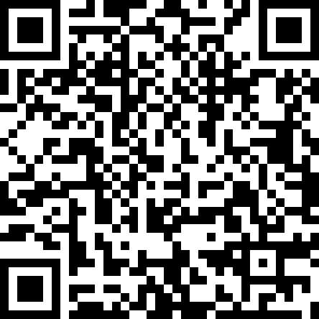

SNEAK PEAK INTO
October SCHOLARSHIPS

Buckfire & Buckfire, P.C. Disability Scholarship Program
Award: $1,000 Deadline: 10/1/25 https://buckfirelaw.com/scholarships/disabi lity/

Web Design Scholarship
Award: $1,000 Deadline: 10/2/25 https://www.loungelizard.com/scholarship/

Stantec Equity & Diversity Scholarship Award: $1,000 Deadline: 10/14/25 https://www.scholarships.com/scholarships
/stantec-equity-and-diversity-scholarship

The Ernest Varvoutis Scholarship for Accounting
Award: $1,000 Deadline: 10/15/25 https://ernestvarvoutisscholarship.com/ern est-varvoutis-scholarship/

Delete Cyberbullying Beyond School Walls Scholarship
Award: $1,000 Deadline: 10/31/25 https://www.endcyberbullying.net/scholars hip-beyond-school-walls

September SCHOLARSHIPS

Student Union 0130
608-785-8852
uwlscholarships@uwlax.edu

Interested in receiving this each month? Sign up for our monthly
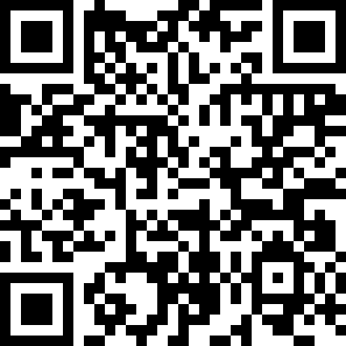
e-newsletter to receive the scholarship brochure and other scholarship updates!

