Records and Registration’s
QUICK GUIDE FOR CATALOG PAGE EDITORS

Logging in

- Go to the nextcatalog at https://uwlnextcat.courseleaf.com. You can use any type of internet browser to get to the catalog (we have found that Firefox works well).

- Log in using your UWL NetID and password.

- The landing page for the site will have the links to the catalog on the left-hand side.

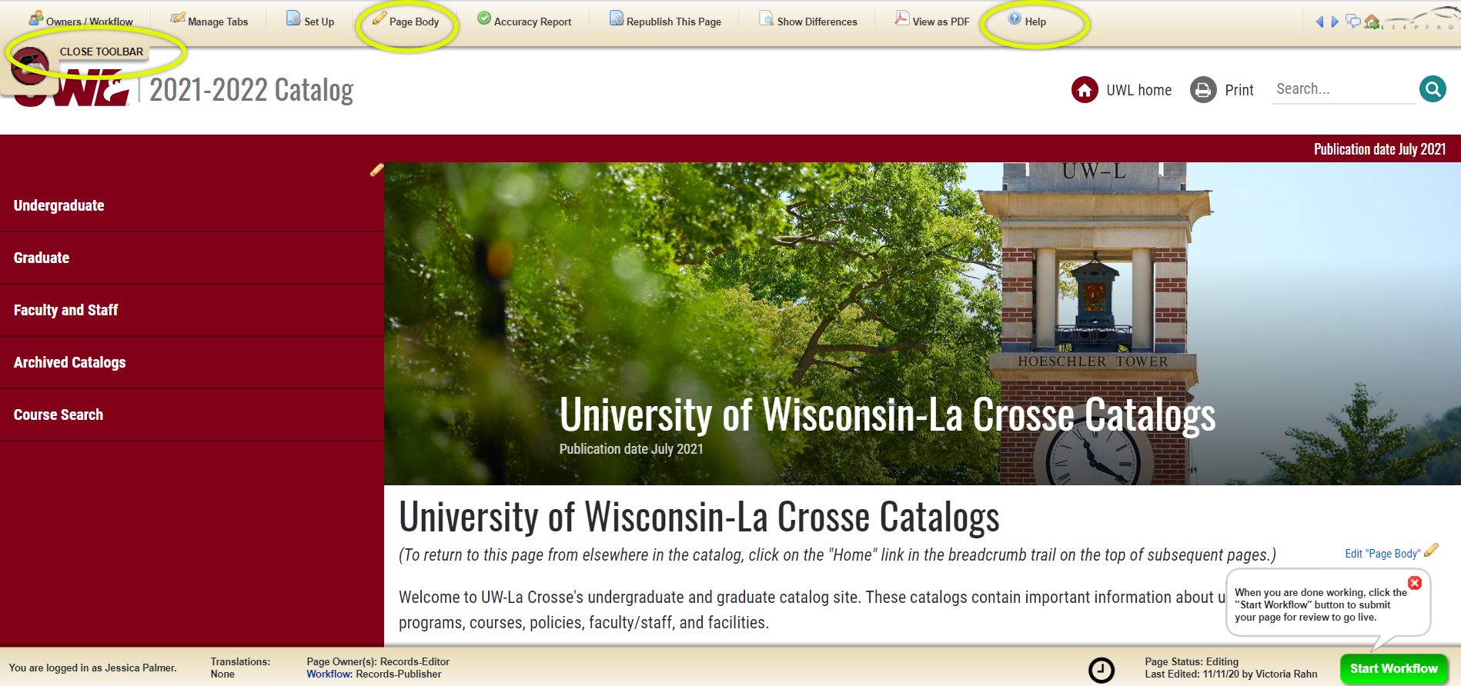

Editing

- Navigate to the page you are the editor for.
- Click “Edit Page” logo at top left to reveal the editor toolbar.
Click on “Close Toolbar” to close bar.
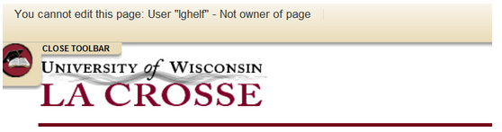
Note: If you are not the editor of a page, and you click on the Edit Page icon, you will receive the following error:

Click “Page Body” to edit any of the Overviews tabs and your 2021-2022 Faculty/Staff tab. If you would like an Overview tab added to a major/program, please contact us at catalog@uwlax.edu to request one.

- Enter or edit text in the body of the editor. Format it using the tools provided.

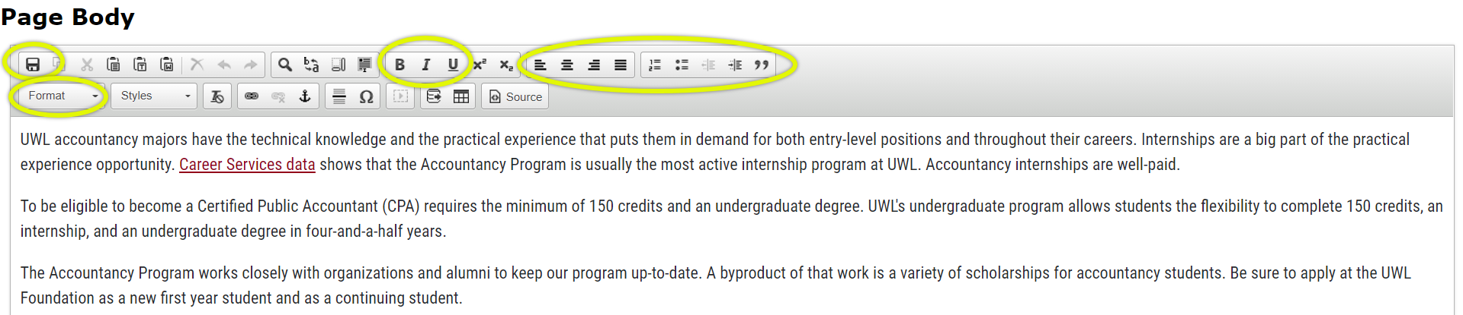

- Save by clicking the disc icon in the top row on the very left side OR save by clicking OK at the bottom of the page. Do not use the X in the top right corner to close the window or your changes will not be saved.

- If you are done editing and are ready to have your page published, click on the green “Start Workflow” button on the bottom right. You will need to click this button for each individual page you are the editor for. If you pushed any page into workflow, and need to make additional edits, send an email to catalog@uwlax.edu. We will roll back the page for you to finish editing.

- To log out: There is no logout button. However, you can still log out by closing all instances of the browser you are using. This means that if you have email up using the same type of browser, you will not be logged out of nextcatalog until that window is also closed. Also, if you have your browser set to remember passwords, you will not be logged out either.

For tips on how to edit, click on the “Help” button in the editing toolbar at the top.

You can also contact the catalog administrators in the Records and Registration office for help at catalog@uwlax.edu.

Jessica Palmer Victoria Rahn Amanda Koblitz
608.785.8954 608.785.8579 608.785.8577

