Quick Guide for Catalog Editors

Logging in & Navigating

- Login to the draft catalog using your UWL NetID and password.

- Links to different sections in the catalogs are on the left. Use the left navigation to find the page you want to edit.

  - Departments and undergraduate programs are listed under the appropriate college in the undergraduate catalog.
  - Graduate programs are listed under the Degrees & Program Requirements page in the graduate catalog.
  - A full list of all undergraduate and graduate degree programs is in the undergraduate catalog on the Majors, Minors, and Other Programs page.
  - Academic policies are below the program & college pages in both catalogs. Campus Resources and On-Campus Life sections are under the undergraduate catalog's Campus Organizations and Activities.

Editing

- Once you are on the right page, click “Edit Page” at top left to reveal the editor toolbar at the top and an informational ribbon at the bottom of the page. Click “Close Toolbar” in the same spot to close the toolbar.

- You may only edit a page if you have been assigned permission to edit.
If you are not the editor of a page and you click on Edit Page, you will receive an error similar to, "You cannot edit this page: user "example" – not owner of page."

- Click “Page Body” to edit the main overview tab for your department or section. If there are multiple tabs, use the arrows in the top right of the edit toolbar to find the edit option for the other tabs, such as the Faculty/Staff tab.

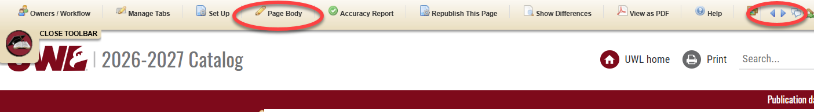

  - Please note, if you would like an introductory overview tab added to a major/program, you may email the Catalog Team to request one.
  - There is also an edit page or tab option on the page itself. It may be easier to navigate to the tab and select the edit option from the tab.
  - Please note that program requirement and other tabs are named differently from the overview, and therefore, the edit option name will be something other than "page body."

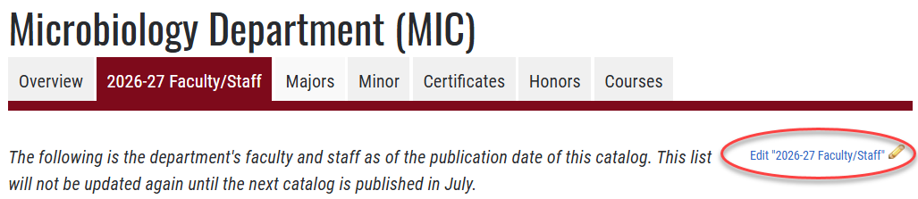

- Edit your text in the edit window and format as you would in other document editors. Please keep accessibility standards in mind. For example, when using a format option, use them like the headings in Microsoft Word and do not skip a level. If putting in a link, first enter a descriptive text and then embed the link in the text.

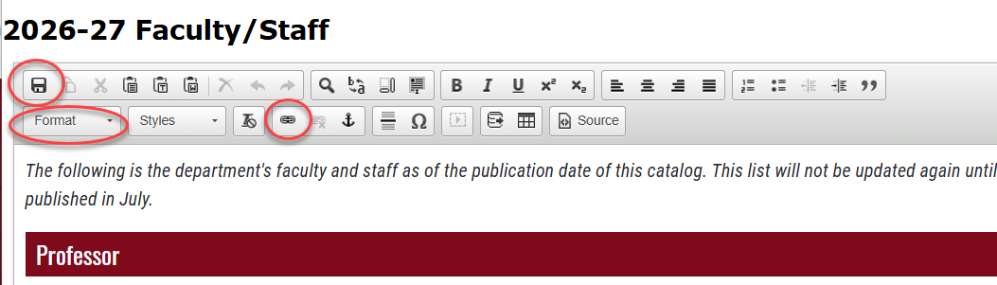

- Save by clicking the save icon in the top row, left side or save by clicking OK at the bottom of the window. Do not use the X in the top right corner to close the window or your changes will not be saved.

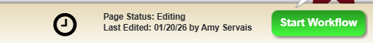
- When you have no more edits for this catalog and have saved your edits, click on the green “Start Workflow” button on the bottom right of the catalog page to submit it for final review by the Catalog Team. Start Workflow must be clicked on each individual page for which you are the editor, including for each major/minor/grad program in the department or program.

  - Once the page is submitted, if you need to make additional edits, please email the UWL Catalog Team. We can roll back the page for further editing as long as it is before the catalog editing deadline.
  - If the page has already been submitted to workflow, the page status in the bottom ribbon will either say "In Workflow" or "Done" and the Start Workflow button will be greyed out.

- To log out: There is no logout button. However, you can log out by closing all instances of the browser you are using, or the system will log you out after 30 minutes of inactivity.

For additional tips on how to edit:
- Click on the “Help” button in the editing toolbar at the top and navigate to the Courseleaf CAT section. You will have to select the University of Wisconsin-La Crosse first or type in UWLAX.
- Email the Catalog Team in Records and Registration for help or contact one of the individual team members below.

Amy Servais Jennifer Novak Victoria Rahn
608.785.8954 608.785.5046 608.785.8579

