Records and Registration’s
QUICK GUIDE FOR CATALOG PAGE EDITORS

Logging in and out

- Go to https://uwlnextcat.courseleaf.com. You can use any type of internet browser to get to the catalog.

- Log in using your UW-L network user id and password.

- The landing page for the site will have the links to the catalog on the left hand side.

- To log out: There is no logout button. However, you can still log out by closing all instances of the browser you are using. This means that if you have email up using the same type of browser, you won’t be logged out of nextcatalog until that window is also closed. Also, if you have your browser set to remember passwords, you will not be logged out either.

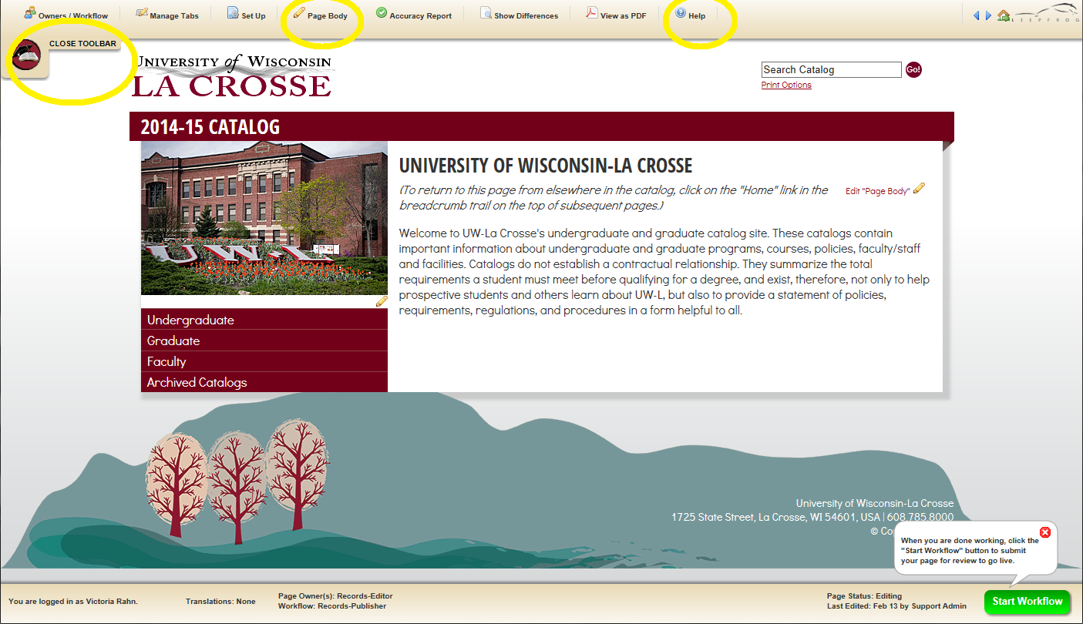

Editing

- Navigate to the page you are the editor for.

- Click “Edit Page” logo at top left to reveal the editor toolbar.
Click on “Close Toolbar” to close bar. 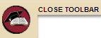

- Click “Page Body” to edit the Overview tab. The Overview tab does not appear if there is no text on it. For the majors/programs overview tab, we have entered sample text to make the tab appear. If your department/office decides not to provide any introductory text for that major/program, please delete the text by editing the page body. This will remove the Overview tab.

- Enter text into the body of the editor. Format it using the tools provided.

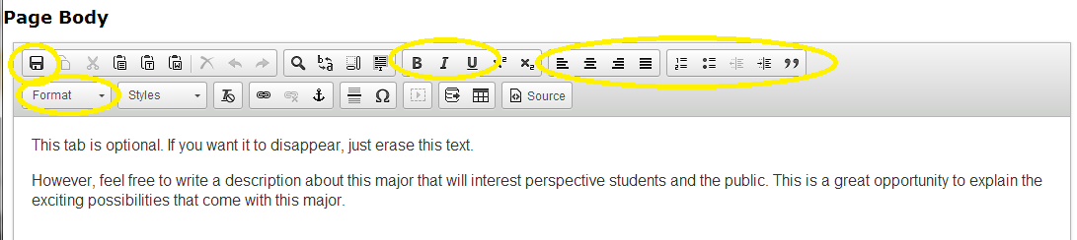

- Click Save using the disc icon in the top row, on the very left, OR save by clicking OK at the bottom of the page.

- If you are done editing and are ready to have your page published, click on the green “Start Workflow” button on the bottom right. You will need to click this button for each individual page you are the editor for.

For tips on how to edit, click on the “Help” button in the editing toolbar at the top.

You can also contact the catalog administrators in the Records and Registration office for help at:

catalog@uwlax.edu

Sue Knudson Victoria Rahn
608.785.8954 608.785.8577

