WI SMALL BUSINESS SUMMIT

Thursday, November 13, 2025
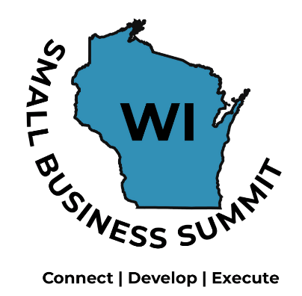

8:00 AM | Registration and Networking – Room 3115
1x1 Sessions with Experts and Resources
Signup and See Room Location Schedule
 | TRACK ONE  Room 3314  Facilitator: Mallory Pierce Follansbee, WWBIC | TRACK TWO  Room 3110  Facilitator: Kim Wagner, La Crosse Chamber of Commerce
8:30 AM | Financial Management: Cash Flow  Speaker: Mike Walker,  M.W. Business Consulting, LLC | New Strategies in Digital Marketing  Speaker: Sarah Arendt-Beyer, Marketing Consultant, Sarah Arendt-Beyer, LLC
9:30 AM | Taxes – State Sales and Use  Speaker: Tracey Mueller, Revenue Tax  Specialist, WI Department of Revenue | Organizational Thinking: Getting All Aboard  Speaker: Scott Dickmeyer  UWL Professor, Communications
10:30 AM | Taxes – Preparing for 2026 and Beyond  Speaker: Ed Jaekel, JRMCPA’s | Innovation: Fostering a Creative Mindset  Speaker: John Kruger, Incubation Studio
11:45 AM | CELEBRATE SMALL BUSINESS LUNCHEON  The Bluffs – Second Floor  Showcase of New Businesses  Small Business Needs Survey  Speakers: Colleen Merrill and Dan Brosman, UW Office of Business & Entrepreneurship  Small Business Persons in Western Wisconsin  Buffalo, Crawford, Jackson, Juneau,  Monroe, La Crosse, Trempealeau, Vernon  2025 Western WI Small Business Person of the Year  2025 WI Small Business Funder Recognition  2025 Small Business Champions
1:30 PM | Show Me the Money  Financial Panel:  Associated Bank – Toni Holter; MRRPC – Jon Bingol; and WWBIC – Kristine Shawley |  | People Power = Profit: Building a Business that Thrives from the Inside Out  Speaker: Sarah Fecht,  Best Self Leadership, LLC
2:30 PM | Defining an Exit Strategy  Speaker: Jim Kertis, Builders Flooring, Inc |  | AI: Impact and Trends in Business  Speaker: Greg Clark, SCORE
3:30 PM | Building a Scalable Business |  | Food Trends: “Buy Local” and  Specialty Foods  Speaker: Jen Barney, Meringue LLC
4:30 PM | SMALL BUSINESS CONFERENCE CONCLUDES

