Surety Small Business Scholarship
Amount: $3,000 Deadline: 4/12/2019
https://www.suretybonds.com/scholarships/

Linden Scholarship
Amount: $3,000 Deadline: 4/14/2019
https://salvationarmynorth.org/community-pages/linden-scholarship/

Build U. Scholarship
Amount: $2,500 Deadline: 4/15/2019
https://www.buildium.com/buildiums-build-u-scholarship/

BHW Women in STEM Scholarship
Amount: $3,000 Deadline: 4/15/2019
https://thebhwgroup.com/scholarship

Hydrocephalus Association
Amount: $1,000 Deadline: 4/15/2019
https://www.hydroassoc.org/scholarships/scholarship-instructions/

Jackie Spellman Scholarship Foundation
Amount: Varies Deadline: 4/15/2019
https://jackiespellmanbenefit.org/scholarships/#apply

Business Plan Scholarship for Students with Disabilities
Amount: $2,500 Deadline: 4/15/2019
https://fitsmallbusiness.com/learn-how-to-write-a-business-plan/

Masergy’s STEM Scholarship Program
Amount: $5,000 Deadline: 4/15/2019
https://www.masergy.com/stem-scholarship/

MyProjectorLamps Undergraduate Scholarship
Amount: $500 Deadline: 4/15/2019
https://www.myprojectorlamps.com/scholarships.html

***Check out this brochure online for easy access at https://www.uwlax.edu/scholarships/

Mythology Scholarship
Amount: $1,000 Deadline: 4/15/2019
https://mythology.net/mythology-scholarship/

Able Moving Scholarship
Amount: $500 Deadline: 4/15/2019
https://ablemoving.com/able-moving-scholarship-award/

League Foundation LGBTQ Scholarship
Amount: Varies Deadline: 4/15/2019
https://www.leaguefoundation.org/

EMPOWER Scholarship
Amount: $1,500 Deadline: 4/15/2019
https://www.allinahealth.org/Courage-Kenny-Rehabilitation-Institute/Programs-and-services/Volunteer-opportunities/EMPOWER-Scholarships/

Marathon Petroleum Youth Leadership Awards
Amount: $2,500 Deadline: 4/15/2019
https://nshssfoundation.org/scholarships/marathon-youth-leadership-awards/

College JumpStart Scholarship
Amount: $1,000 Deadline: 4/15/2019
http://www.jumpstart-scholarship.net/application-us/

NPG Essay Scholarship Contest
Amount: Varies Deadline: 4/19/2019
https://npg.org/2019-npg-essay-scholarship-contest.html

Ronald D. Weiss Scholarship
Amount: $2,500 Deadline: 4/21/2019
https://www.ny-bankruptcy.com/scholarship/

G2 Crowd Entrepreneurial Scholarship
Amount: $5,000 Deadline: 4/22/2019
https://learn.g2crowd.com/scholarship?utm_source=referral&utm_medium=email&utm_campaign=scholarship1

Sports Unlimited Scholarship
Amount: $1,000 Deadline: 4/25/2019
https://www.sportsunlimitedinc.com/scholarship.html

WIAWWA Scholarship
Amount: Varies Deadline: 4/26/2019
https://www.wiawwa.org/page/Scholarship

E-Waste Scholarship
Amount: $1,000 Deadline: 4/30/2019
http://www.digitalresponsibility.org/ewaste-scholarship

Brule River Sportsmen’s Club Scholarship
Amount: $5,000 Deadline: 4/30/2019
https://bruleriversportsmensclub.com/club-scholarship/information/

Teachers Make Teachers Scholarship
Amount: $1,000 Deadline: 4/30/2019
https://signatureschoolproducts.com/scholarship-application

Soliant’s Sunrise Scholarship
Amount: $1,000 Deadline: 4/30/2019
https://www.soliantconsulting.com/philanthropy/soliants-sunrise-scholarship

ABCS Home Care Scholarship
Amount: $1,000 Deadline: 4/30/2019
http://www.thehaef.org/scholarships-for-hmong-students.html

HAEF Scholarship- Female
Amount: $500 Deadline: 4/30/2019
http://www.thehaef.org/scholarships-for-hmong-students.html

HAEF Scholarship- Male
Amount: $1,000 Deadline: 4/30/2019
http://www.thehaef.org/scholarships-for-hmong-students.html

All About Education Scholarship
Amount: $3,000 Deadline: 4/30/2019
https://www.unigo.com/scholarships/our-scholarships/all-about-education-scholarship

Moss Adams Foundation Scholarship
Amount: $1,000 Deadline: 4/30/2019
http://www.efwa.org/scholarships_undergraduate.php

Michele L. McDonald Memorial Scholarship
Amount: $1,000 Deadline: 4/30/2019
http://www.efwa.org/scholarships_undergraduate.php

The PreJax Scholarship
Amount: $1,000 Deadline: 4/30/2019
http://www.theprejaxfoundation.com/apply/

Confident Writers Scholarship
Amount: $700 Deadline: 4/30/2019
https://www.confidentwriters.com/scholarship-essay-contest/

Randy Pausch Scholarship
Amount: $1,000 Deadline: 4/30/2019
https://aiasfoundation.wufoo.com/forms/z120qvlc0fux3w8/

WomenIn Scholarship
Amount: $1,000 Deadline: 4/30/2019
https://aiasfoundation.wufoo.com/forms/q5707ml1jdm4nw/

***Check out this brochure online for easy access at https://www.uwlax.edu/scholarships/
Sneak Peek into May!

Scholarship for Students who are Hard of Hearing or Deaf
Amount: $1,000 Deadline: 5/1/2019
http://www.nhbwinc.com/scholarship.htmlhttps://sertoma.org/what-we-do/scholarships/

Vivint Smart Home Scholarship
Amount: $1,000 Deadline: 5/1/2019
https://www.vivint.com/scholarship

$1000 Healthgrad.com Leadership 2019 Scholarship
Amount: $1,000 Deadline: 5/1/2019
https://www.healthgrad.com/scholarships/healthcare-leadership-scholarship/

Go! Overseas Study Abroad Scholarship
Amount: $500 Deadline: 5/6/2019
https://www.chegg.com/scholarships/go-overseas-study-abroad-scholarship-4791

Asia SiVon Cottom Memorial Scholarship
Amount: Varies Deadline: 5/6/2019
http://asiacottom.com/scholarship-fund/

Northland Vietnam Veterans Association Scholarship
Amount: $1,000 Deadline: 5/10/2019
http://www.nvva.us/scholarship

Against the Grain Artistic Scholarship
Amount: $1,000 Deadline: 5/7/2019
https://www.scholarships.com/financial-aid/college-scholarships/scholarships-by-major/liberal-arts-scholarships/against-the-grain-artistic-scholarship/

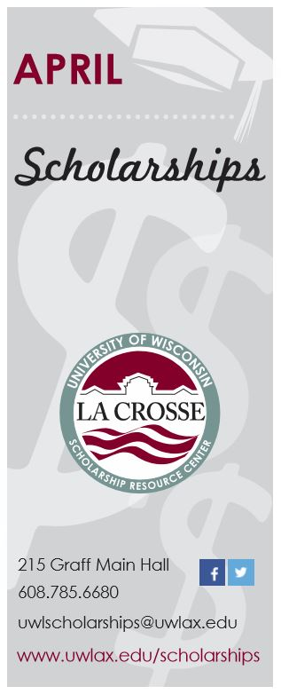

OVER $59,200 in available scholarships this month!!!

