Lucille Hobbs Education Scholarship
Amount: $500 Deadline: 4/3/2022
https://bold.org/scholarships/lucille-hobbs-education-scholarship/

Frame My Future Scholarship
Amount: Varies Deadline: 4/4/2022
https://www.diplomaframe.com/contests/frame-my-future-scholarship-contest-2022.aspx

NCAA Postgraduate Scholarship Program
Amount: $10,000 Deadline: 4/8/2022
https://www.ncaa.org/ncaa-postgraduate-scholarship-program

Anne DiSerafino Memorial Arts Scholarship
Amount: $1,483 Deadline: 4/10/2022
https://bold.org/scholarships/anne-diserafino-memorial-arts-scholarship/

Allegra Ford Thomas Scholarship
Amount: $5,000 Deadline: 4/10/2022
https://www.ncld.org/what-we-do/scholarships/allegra-ford-thomas-scholarship/

Rentec Direct Scholarship for Computer Science Students
Amount: $500 Deadline: 4/15/2022
https://www.rentecdirect.com/scholarship/

Interreligious Peace Scholarship
Amount: $1,500 Deadline: 4/15/2022
https://www.jessyjudaica.com/interreligious-peace-scholarship/

College JumpStart Scholarship
Amount: $1,000 Deadline: 4/15/2022
http://www.jumpstart-scholarship.net/application-us/

CJ Pony Parts Scholarship
Amount: $500 Deadline: 4/15/2022
https://www.cjponyparts.com/cj-pony-parts-scholarship-video-contest

Minnesota Association of Public Accountants Scholarships
Amount: $750 Deadline: 4/15/2022
https://mapa-mn.com/scholarship/

Gloria Barron Prize for Young Heros
Amount: $10,000 Deadline: 4/15/2022
https://barronprize.org/apply/

Milwaukee AFWA
Amount: $2,000 Deadline: 4/15/2022
https://www.milwaukeeafwa.org/scholarship

Crossroads Empowering Women Scholarship Application
Amount: $1,000 Deadline: 4/18/2022
https://crossroadsinsuranceadjusters.com/crossroads-empowering-women-scholarship/

NPG 2022 Essay Scholarship Contest
Amount: $5,000 Deadline: 4/18/2022
https://npg.org/2022-essay-scholarship-contest.html

Making a Difference For Autism Scholarship
Amount: $500 Deadline: 4/25/2022
https://kfmmakingadifference.org/scholarship-programs-for-adults-with-autism/

Bold Make Your Mark Scholarship
Amount: $500 Deadline: 4/27/2022
https://bold.org/scholarships/bold-make-your-mark-scholarship/

Bold Acts of Service Scholarship
Amount: $500 Deadline: 4/30/2022
https://bold.org/scholarships/bold-acts-of-service-scholarship/

Bold Listening Scholarship
Amount: $500 Deadline: 4/29/2022
https://bold.org/scholarships/bold-listening-scholarship/

Soliant's Sunrise Scholarship
Amount: $1,000 Deadline: 4/29/2022
https://www.soliantconsulting.com/philanthropy/sunrise-scholarship/

E-Waste Scholarship
Amount: $1,000 Deadline: 4/30/2022
http://www.digitalresponsibility.org/ewaste-scholarship

Active Life Scholarship for Political Expression
Amount: $1,000 Deadline: 4/30/2022
http://www.getupgetactive.org/active-life-political-awarenes/

Lighthouse Autism Center Scholarship
Amount: $1,000 Deadline: 4/30/2022
https://lighthouseautismcenter.com/scholarship/
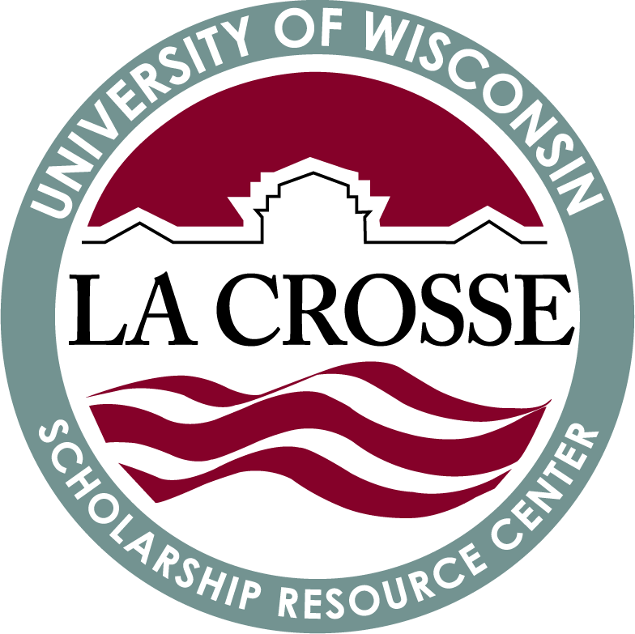

Conex Boxes, Inc. $1000 Scholarship Program
Amount: $1,000 Deadline: 4/30/2022
https://conexboxes.com/scholarship/

Moss Adams Foundation Scholarship
Amount: $1,000 Deadline: 4/30/2022
http://www.efwa.org/scholarships_undergraduate.php

RealtyHop Scholarship
Amount: $1,000 Deadline: 4/30/2022
https://www.realtyhop.com/resources/scholarship

Brule River Sportsmen's Club College Scholarship
Amount: $5,000 Deadline: 4/30/2022
https://bruleriversportsmensclub.com/club-scholarship/college-scholarship-information/

Let Grow Think for Yourself Scholarship
Amount: $5,000 Deadline: 4/30/2022
https://www.myscholarship.app/let-grow-think-for-yourself-scholarship

GMiS STEM Scholarship
Amount: $5,000 Deadline: 4/30/2022
https://greatmindsinstem.org/gmis-scholarship-application/

2022 Dr. Sydell Perlmutter Gold Memorial Scholarship
Amount: $5,000 Deadline: 4/30/2022
https://app.smarterselect.com/programs/78449

Charles R. Ullman & Associates Educational Support Scholarship
Amount: $1,166 Deadline: 4/30/2022
https://bold.org/scholarships/educational-support-scholarship/

Sneak Peek into May

I-Engage Scholarship
Amount: Varies Deadline: 5/1/2022
https://www.uwlax.edu/international-education/study-at-uwl/scholarships/

The Photographer.org Academic Scholarships
Amount: $1,000 Deadline: 5/1/2022
https://www.photographer.org/academic-scholarships/

Price It Here Annual Scholarship
Amount: $1,000 Deadline: 5/1/2022
https://priceithere.com/scholarship/

Faith Hope and Love Jesus, Inc. College Scholarship
Amount: $500 Deadline: 5/1/2022
https://faithhopeandlovejesus.org/college_scholarship

Earl Dedman Memorial Scholarship
Amount: Varies Deadline: 5/1/2022
https://endowment.org/afe-undergraduate-scholarship-application-form/

Ashoori Law Good Deeds Scholarship
Amount: $1,000 Deadline: 5/1/2022
https://www.ashoorilaw.com/scholarship/

New York Ramblers Scholarship
Amount: $2,500 Deadline: 5/1/2022
https://www.nyramblers.com/scholarship/

***Check out this brochure online for easy access at https://www.uwlax.edu/scholarships/
