Benjamin A. Gilman International Scholarship Program 2020-2021
Amount: $5,000 Deadline: 03/03/2020
https://www.gilmanscholarship.org/program/gilman-mccain-scholarships/#1565630427749-c2723aa6-3736

Udall Undergraduate Scholarship
Amount: up to $7,000 Deadline: 03/05/2020
https://udall.gov/OurPrograms/Scholarship/Scholarship.aspx

Wisconsin Sheriffs and Deputy Sheriffs Association Annual Scholarship
Amount: $500 Deadline: 03/06/2020
http://wsdsa.org/scholarships/

A-1 Auto Transport Scholarship
Amount: up to $1,000 Deadline: 03/10/2020
https://www.a1autotransport.com/a-1-auto-transport-scholarship/

Scott Sklenar Scholarship
Amount: up to $1,000 Deadline: 03/10/2020
https://forms.gle/o28c15nZ3F8Xv8Cn9

Never Drink and Drive Scholarship
Amount: $1,000 Deadline: 03/11/2020
https://californiainjuryaccidentlawyer.com/2020-scholarship/

Doodle 4 Google Scholarship (H.S. Seniors)
Amount: $30,000 Deadline: 03/13/2020
https://doodles.google.com/d4g/enter/

Morris J. & Betty Kaplun Essay Contest
(H.S. Seniors)
Amount: $1,800 Deadline: 03/13/2020
https://www.kaplunfoundation.org/essay-contest
Herbert Levy Memorial Scholarship
Amount: $2,000 Deadline: 03/15/2020
https://www.spsnational.org/scholarships/levy

Fontana Transport Inc. Scholars Program
Amount: up to $5,000 Deadline: 03/15/2020
http://www.fontanatransportincscholarsprogram.com/

Jean Downes Scholarship
Amount: $1,500 Deadline: 03/15/2020
https://form.jotform.us/usawsf2014/usa-wsf-2018-application-form---sch

The Randall Blair Isenberg Alcohol Addiction Awareness Scholarship
Amount: $500 Deadline: 03/15/2020
https://www.rbisenberg.com/alcohol-addiction-awareness-scholarship/

Greater Green Bay Community Scholarships
Amount: up to $40,000 Deadline: 03/15/2020
http://www.ggbcf.org/-Grant-Scholarship-Seekers/Scholarships-at-GGBCF

Smarter Health College Scholarship Program
Amount: $1,000 Deadline: 03/15/2020
https://www.cognitune.com/scholarship/

Scholarship for Women who want to be the boss
Amount: $2,000 Deadline: 03/15/2020
https://www.goskills.com/Scholarship

Beyond the Boroughs National Scholarship Fund for Students from Low-Income Households
Amount: up to $20,000 Deadline: 03/16/2020
http://www.beyondtheboroughs.org/the-scholarship/scholarship-requirements/
Create Real Impact Scholarship
Amount: $1,500 Deadline: 03/19/2020
https://createrealimpact.com/contestrules/

Try Mattress Scholarship Opportunity
Amount: $1,000 Deadline: 03/20/2020
https://www.trymattress.com/try-mattress-scholarship/

One Move Ahead Chess Scholarship
Amount: $1,000 Deadline: 03/23/2020
https://scholarships360.org/scholarship/one-move-ahead-chess-scholarship/

SmileTutor College Student Scholarship
Amount: $2,000 Deadline: 03/23/2020
https://smiletutor.sg/scholarship/

The Great Outdoors Wilderness Education Scholarship
Amount: $1,000 Deadline: 03/25/2020
https://scholarships360.org/scholarship/the-great-outdoors-wilderness-education-scholarship/

The Blades of Green Scholarship Fund
Amount: $1,000 Deadline: 03/27/2020
https://www.bladesofgreen.com/culture/blades-green-scholarship-fund

UPS Scholarship
Amount: $5,000 Deadline: 03/27/2020
https://www.unigo.com/scholarships/undergraduate-students/scholarships-for-college-freshmen/ups-scholarship/1002451

Mobile App Development Scholarship
Amount: $1,000 Deadline: 03/30/2020
https://mova.io/scholarship/

Mesothelioma Cancer Alliance Scholarship
Amount: $4,000 Deadline: 03/31/2020
https://www.mesothelioma.com/scholarship/

Active Life Scholarship for Financial Literacy
Amount: $1,000 Deadline: 03/31/2020
http://www.getupgetactive.org/scholarship/

Montem Health and Wellness Scholarship
Amount: $1,500 Deadline: 03/31/2020
https://montemlife.com/scholarship/

$1,000 St. Patrick’s Day Scholarship
Amount: $1,000 Deadline: 03/31/2020
https://www.moneysolver.org/scholarships/st-patricks-day-scholarship/

HSF Cancer Survivor Scholarship
Amount: $1,000 Deadline: 03/31/2020
https://hsflawfirm.com/the-cancer-survivor-scholarship/

Driver Education Initiative Scholarship
Amount: $500 Deadline: 03/31/2020
https://www.dmvedu.org/scholarship/

Vowelor Scholarship
Amount: $1,000 Deadline: 03/31/2020
https://www.vowelor.com/scholarship/

Child Safety Scholarship
Amount: $1,000 Deadline: 03/31/2020
https://www.hartlawyers.com/child-safety-scholarship/

Sneak Peek into April

Inspire Our Future Scholarship for Students Pursuing Teaching
Amount: $500 Deadline: 04/01/2020
http://www.teacher.org/scholarship-entry-rules/

Computer Science and Engineering Scholarship
Amount: $1,000 Deadline: 04/01/2020
http://study.com/pages/Computer_Science_Academic_Scholarship.html

The Kristina Flores Overcoming Odds Scholarship
Amount: $1,000 Deadline: 04/01/2020
https://www.sandiegoaddictions.com/overcoming-all-odds-scholarship/

Women in STEM
Amount: $2,500 Deadline: 04/01/2020
https://www.avomeen.com/scholarships/#apply

Scholarship for Growing the Future
Amount: up to $4,000 Deadline: 04/01/2020
https://www.iddba.org/professional-resources/scholarships-grants/scholarship-for-growing-the-future

AACT John Kitt Memorial Scholarship
Amount: $5,000 Deadline: 04/03/2020
http://www.aactcandy.org/aactscholarship.asp

***Check out this brochure online for easy access at https://www.uwlax.edu/scholarships/

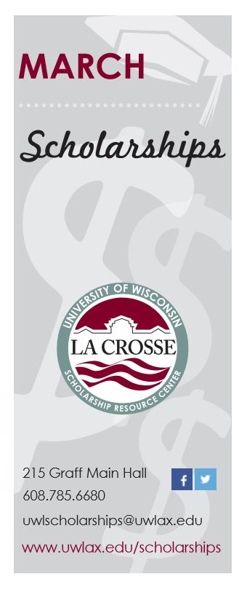
OVER $150,000 in available scholarships this month!!!

