View Your Unofficial Transcript

A transcript is a copy of your academic record at UWL, listing all courses, credits, grades, academic standing, GPA, honors, and degrees in one report. An official copy has the school seal, Registrar's signature, and other securities to prevent tampering. An unofficial copy does not have signatures or many of the other securities, although it is still secured from being released without permission

      - In the Academics section of your Student Center, select Transcript: View Unofficial from the drop-down mention. Click the double arrow button.

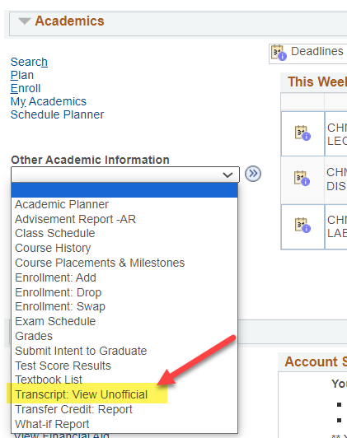

      - On the next screen, click Unofficial Enrollment (Both) for Report Type. Do not leave this blank or the transcript will not come up.

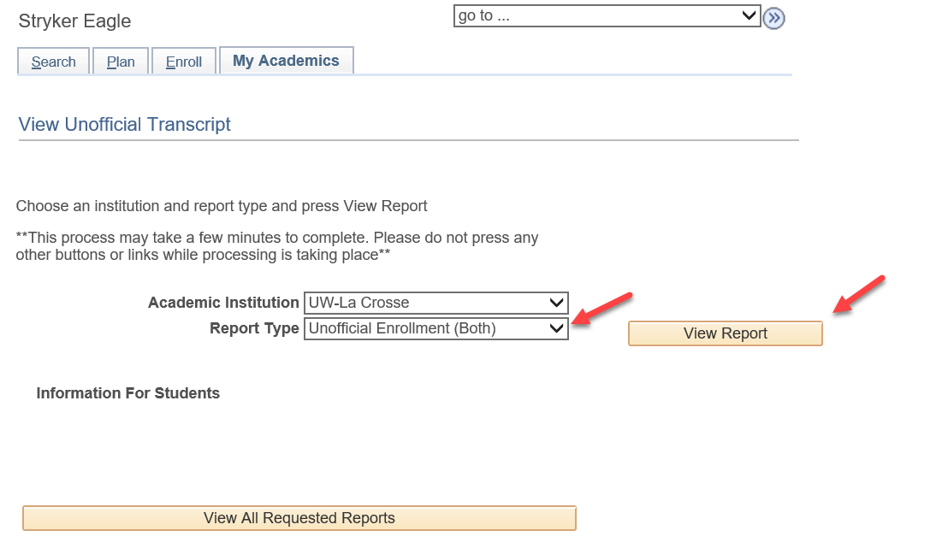

      - Click View Report.
      - A new window or tab should pop up displaying the transcript.

Tip: If a new window or tab does not come up, you might have a popup blocker on in your browser. Go to your browser options and turn off the blocker or add wings.uwlax.edu to the list of acceptable sites.

      - You may save the unofficial transcript as a PDF file to your computer or print it. On your WINGS window, you will see the history of the times when you have requested to view this report.
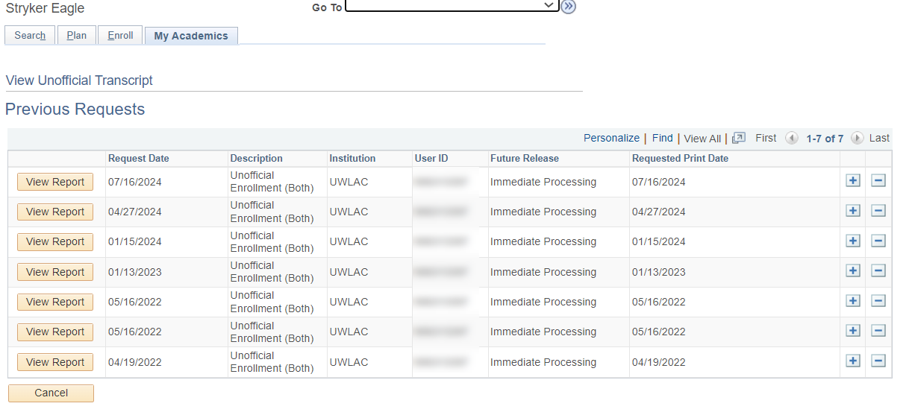

To order an official transcript, there are two places in your WINGS you can click on.
        - Go to the Enrollment Resources section in the bottom right of your Student Center homepage and click on Official Transcript. A new window or tab will pop up with the start of the official transcript form.

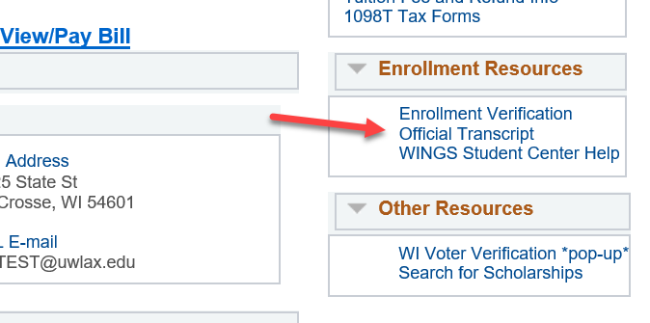

OR
        - Click on the Official Transcript link in the left-hand menu, then click on Official Transcript again. A new window or tab will pop up with the start of the official transcript form. Select either electronic (PDF) delivery through secure email or paper (hard copy) delivery through US Postal Service.

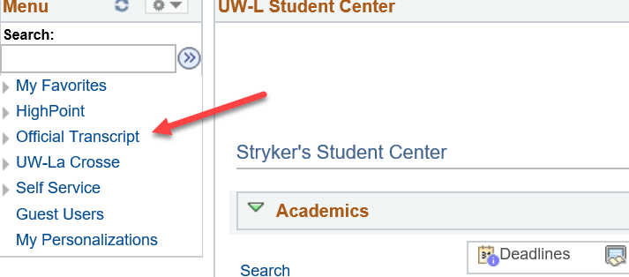

There is a fee for each official copy sent. You can pay with a credit or debit card.

More information about ordering an official transcript is on the Records & Registration office's transcript webpage.

