Campus Child Center Annual Report 2017-18
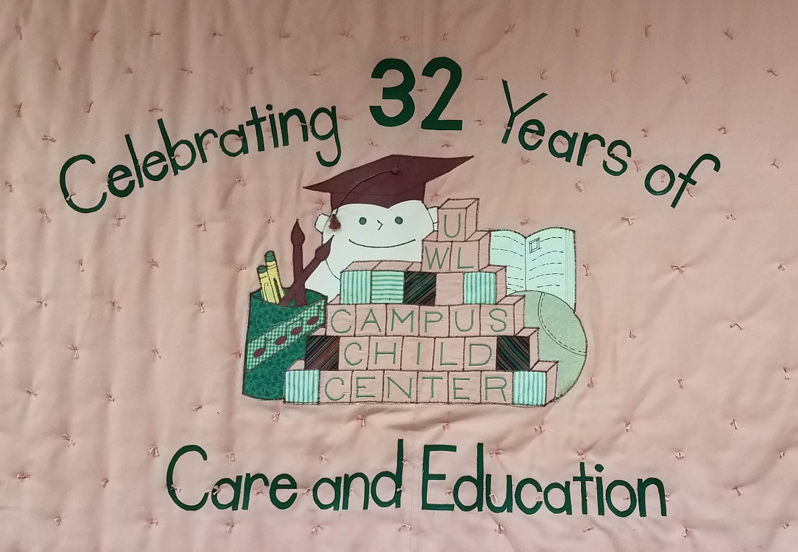

Submitted by Dawn Hays
Director of Campus Child Center

Our Mission:
The Campus Child Center provides quality care and education in an environment where all are valued for their unique abilities and ideas. Appreciation and respect for individuals, relationships, and the community are the foundation of our practice.
Our Vision:
Campus Child Center, a place

…where children are valued for their sense of wonder, their genuine curiosity and need to explore, and their natural desire to learn.

…where staff are valued for their ability to work together for the benefit of the children, for their commitment to continual program evaluation and improvement, for their energy and enthusiasm, for their ability to design and implement well-planned curriculum, and for their capacity to build relationships with and make use of resources within the community.

…where families are valued for the support they provide their children, for the partnerships they build with our staff, for their eagerness to help and for their willingness to entrust their children into our care.

…where all are valued for their unique abilities and ideas, for their ability to play, for their love of laughter, for the respect they give one another, and for their capacity to trust, lean on and learn from one another.

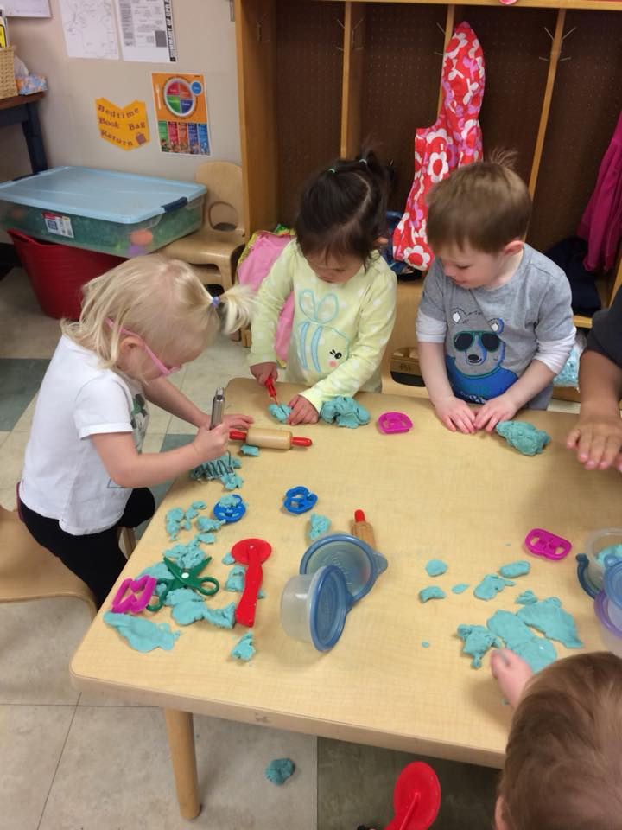

Our History:
The Campus Child Center was established in 1985 to provide quality care for the children of University of Wisconsin-La Crosse students and employees. Our program was first housed in what is currently the Mississippi Valley Archeology Lab. In 1997 we doubled our capacity when we moved to the new child center adjacent to the Recreational Eagle Center.

.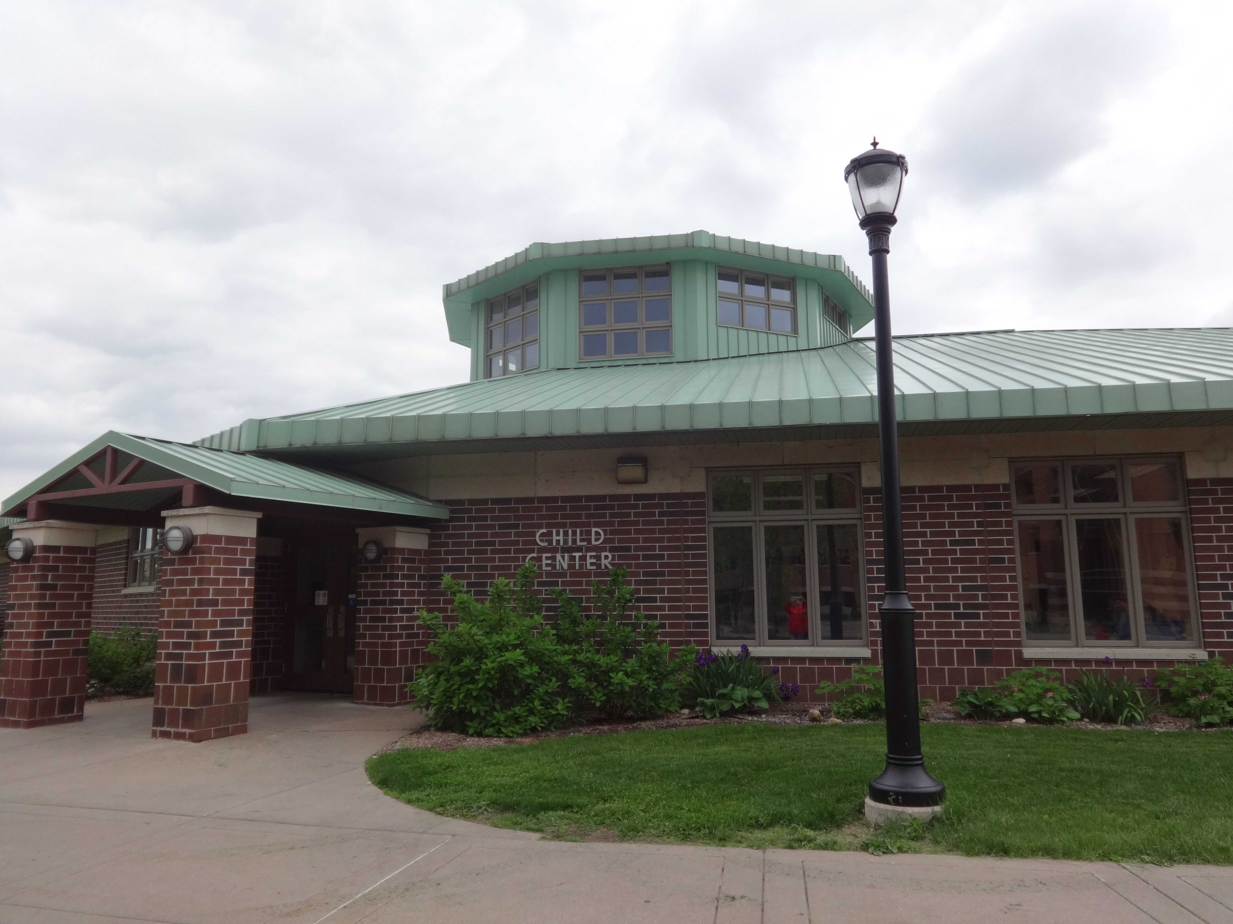

Established as a program to provide high quality care to the children it served, the center believed that attaining high quality involved attention to the following: providing age-appropriate activities that stimulate both exploration and discovery; viewing play and socialization as essential to young children; celebrating each child's unique needs and capabilities; providing a well-balanced mix of large and small group activities, indoor and outdoor activities, and restful and active play times; and by building strong connections and partnerships with the families we serve. These beliefs still guide the center as we continue to provide high quality care for our children.
Included in the vision of high quality was the commitment to recruiting and maintaining a staff whose knowledge base was firmly planted in sound early childhood practice. As the staff grew from two full-time employees to six full-time employees, a team evolved that has proven itself in its commitment to young children. We take pride in a staff turnover rate that is virtually non-existent.
From its inception, Campus Child Center built and maintained strong ties within the University setting. From its beginnings, the staff and children participated with other programs on campus. This practice continues to this day, as Campus Child Center describes itself as an active member and participant of our university community. Our center is used as a field site for programs in education, psychology, occupational therapy, physical therapy and more. Reciprocating arrangements are valued as a source of expanding ideas and activities for the children, our staff, and the college students involved.
2017-2018 Goals:
Goal 1: Establish and maintain a safe and healthy environment for the children as well as partnerships with families while providing links to community resources.
Goal 2: Encourage children to explore, manipulate, and use the tools and toys around them, think critically, solve problems, gain confidence, and build friendships.
Goal 3: To support children’s need for creative expression, increased independence, closeness, warmth and compassion.
Goal 4: Extend children’s knowledge through books, field trips, classroom visitors, meaningful conversations and discussions and a variety of activities and experiences.
Goal 5: Weave into the program a sense of respect for others and the world around us, opportunities to express kindness and cooperation, and an appreciation for nature and the arts.
Goal 6: Assure adequate funding for future needs.
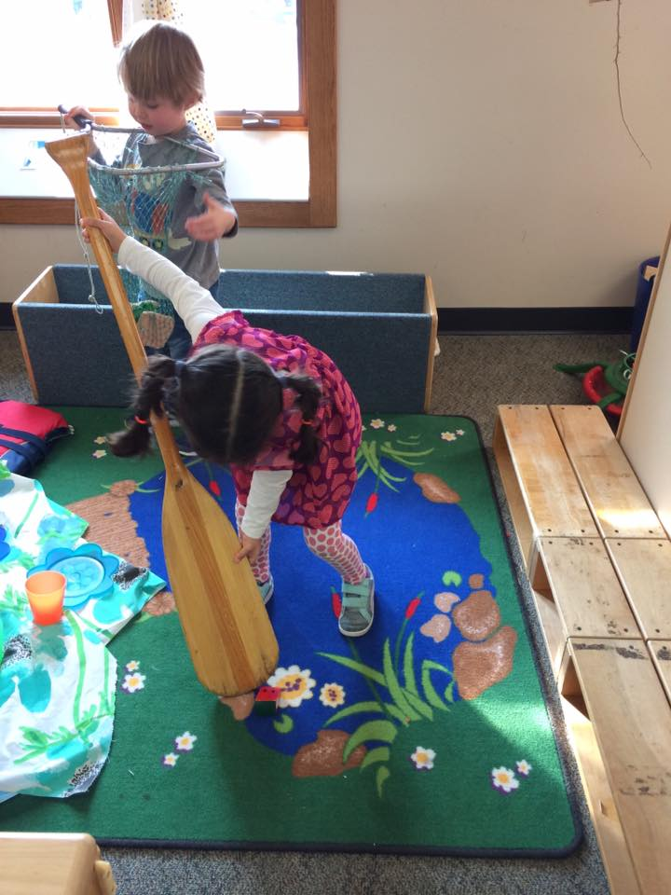
Points of Pride/Accomplishments
- Our Staff:
Campus Child Center maintains a low staff turnover rate, a point of pride for any early childhood program. Our full-time staff is comprised of the director and 5 lead teachers, with a total of 148 years of service in the field of early childhood education and 129 years of service to the University of Wisconsin-La Crosse. Our full-time staff is supported by our Associate Teacher and a group of student employees who work as teacher assistants. In 2017-18, we employed 67 students over the course of the year.
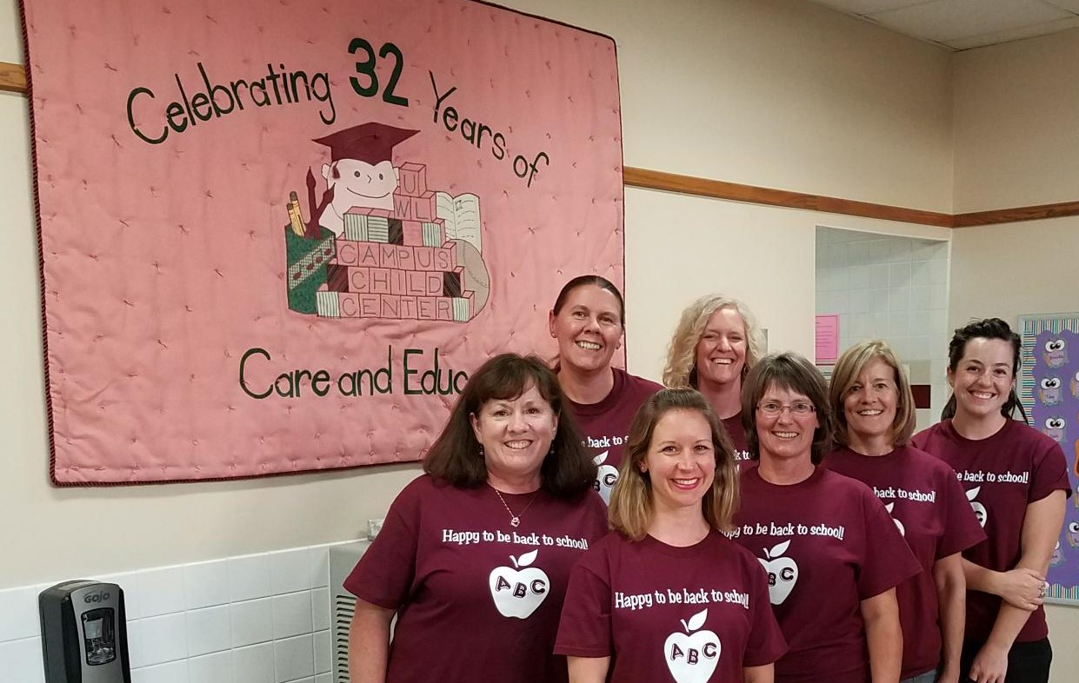
From our student staff:
“Learning about children’s vast developments in class was fascinating to see hands-on at my own place of work. I was able to share stories in class and have a better idea of the content I was learning, because I see it every day. I made better connections in class, with the children, my co-workers, and lead teachers.” – Dana
“When I was taking Developmental Psychology we learned about how individuals develop over years. The coolest thing to see at the Child Center is how accurate these behaviors and growth patterns are for children at specific ages. I have learned so much over the past two years from working at the Child Center that will assist me in my future as an elementary teacher. The Campus Child Center is an amazing place to work as a student at UWL.” – Annie

- National Accreditation Earned
Campus Child Center has earned accreditation through September, 2023 from the National Association for the Education of Young Children (NAEYC) – the world’s largest organization working on behalf of young children. NAEYC Accreditation is a rigorous and transformative quality-improvement system that uses a set of 10 research-based standards to collaborate with early education programs to recognize and drive quality-improvement in high-quality early learning environments.
To earn NAEYC Accreditation, Campus Child Center went through an extensive self-study and quality-improvement process, followed by a May 1, 2018 on-site visit by an NAEYC Assessor to verify and ensure that the program met each of the ten program standards, and hundreds of corresponding individual criteria.
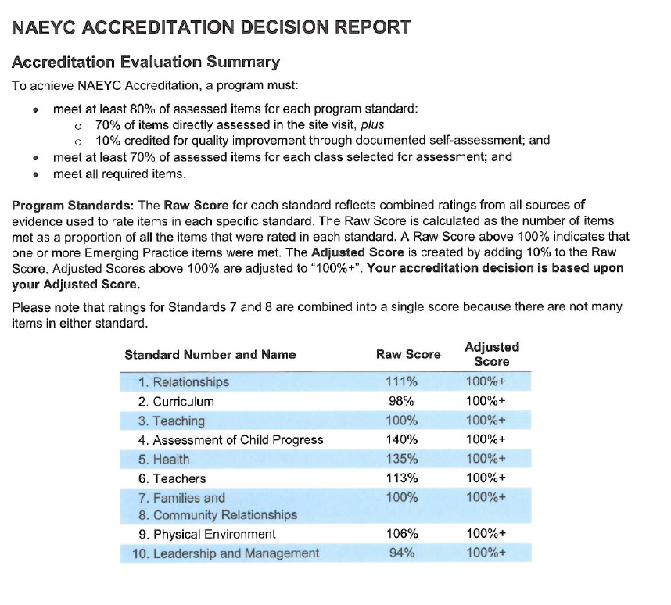In the 30 years since NAEYC Accreditation was established, it has become a widely recognized sign of high-quality early childhood education. More than 7,000 programs are currently accredited by NAEYC – less than 10 percent of all child care centers, preschools, and kindergartens nationally achieve this recognition. Campus Child Center is proud to have maintained this achievement continually since 1994.

- University Collaboration:
This year Campus Child Center provided care and early education to the children of 25 University of Wisconsin-La Crosse student parents and children of 49 UWL staff/faculty members, enrolling a total of 82 different children over the course of the year.
From a parent:
“Having my son enrolled at the Campus Child Center was a great experience for both of us and enabled me to continue and focus on my studies as a student parent. The staff is always warm and welcoming, and I was able to visit my son at any time of the day in between classes. Not only is the atmosphere positive, the program for his age group is excellent. The age two and under children were constantly engaged in fun and developmentally appropriate play and learning. The Campus Child Center is full of genuinely caring staff who are invested in providing the best care for our children and is an absolute asset to the UW-L Campus!” - Stacey

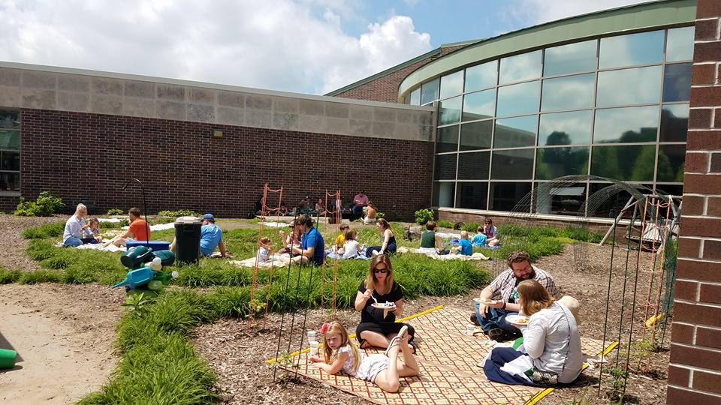

Campus Child Center has continued its rich history of collaboration with the University of Wisconsin – La Crosse. During the 2017-18 school year, Campus Child Center provided UWL students with over 3100 hours of fieldwork, observations, and volunteer work. Students from the departments of Education, Health Education, Physical Therapy, Occupational Therapy, Psychology, Nutrition, Art and Music Education visited our center in relation to their coursework to gain knowledge about the growth and development of young children, to complete research, and to meet their student teaching requirements.
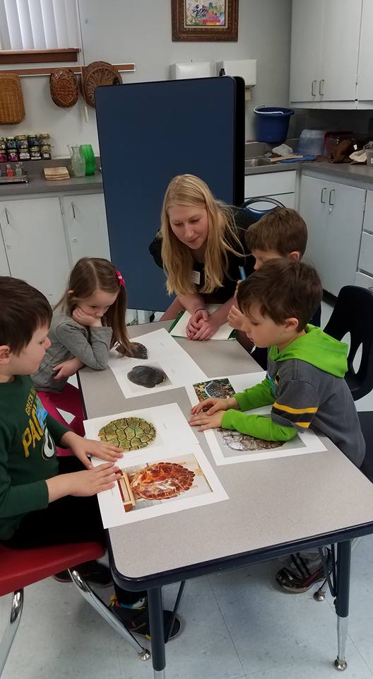
Children from Campus Child Center visited an Early Childhood Education Course for a week each semester to provide UWL students with opportunities to plan and implement age appropriate lesson plans for preschoolers.

Along with serving as a site for UWL students to enrich their studies, Campus Child Center also collaborated with the University in other ways. Our director continues to serve on the Early Childhood Education Department Advisory Board, children from Campus Child Center joined the Organization for Campus Women to sing at their Holiday Social, and our staff served as guest speakers in Early Childhood Education courses. We worked with campus groups to provide an opportunity for visiting students from Japan and China to experience child care and education in the United States.
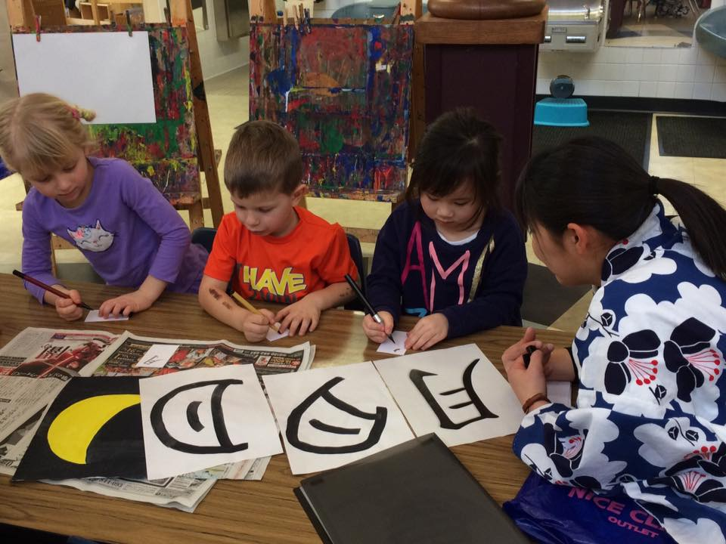
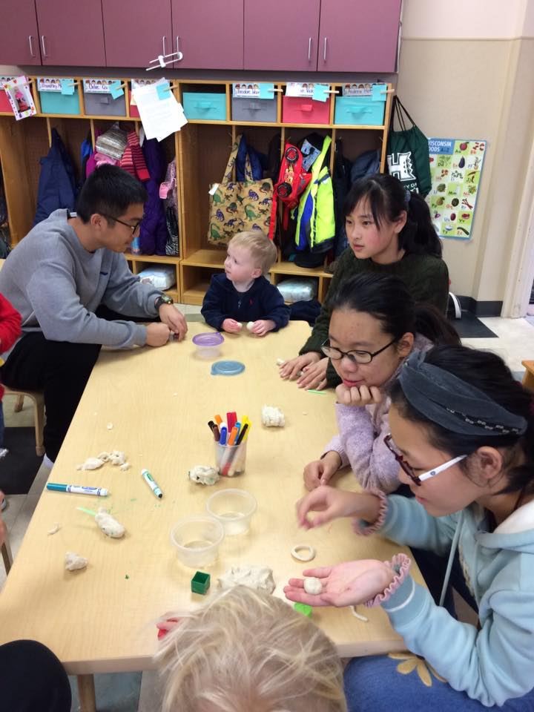
We truly appreciate the many opportunities provided by our UWL partners in bringing unique experiences to the children of Campus Child Center.
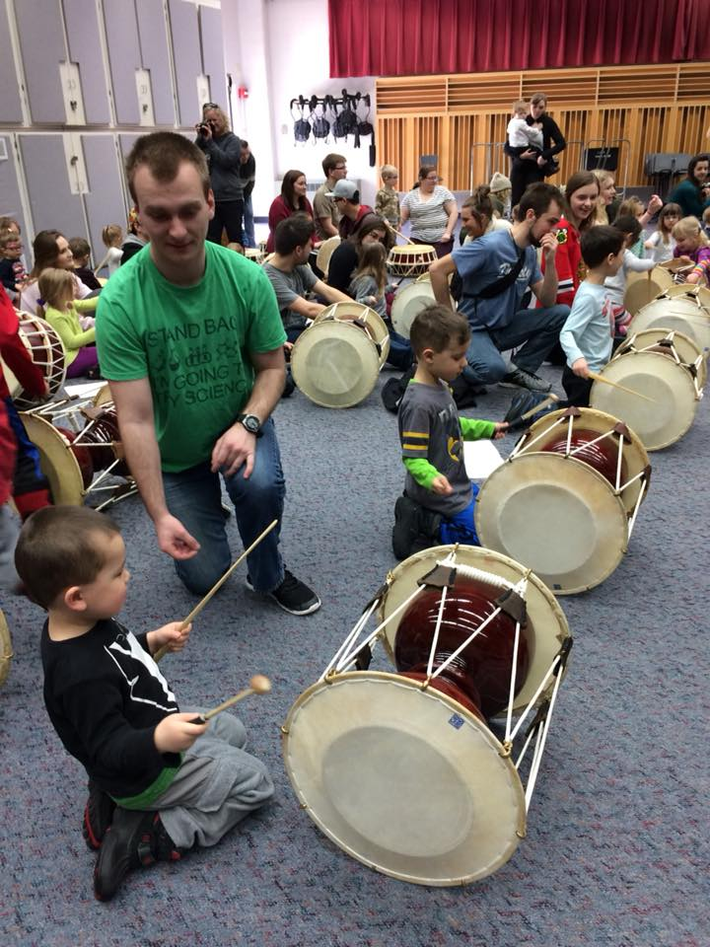
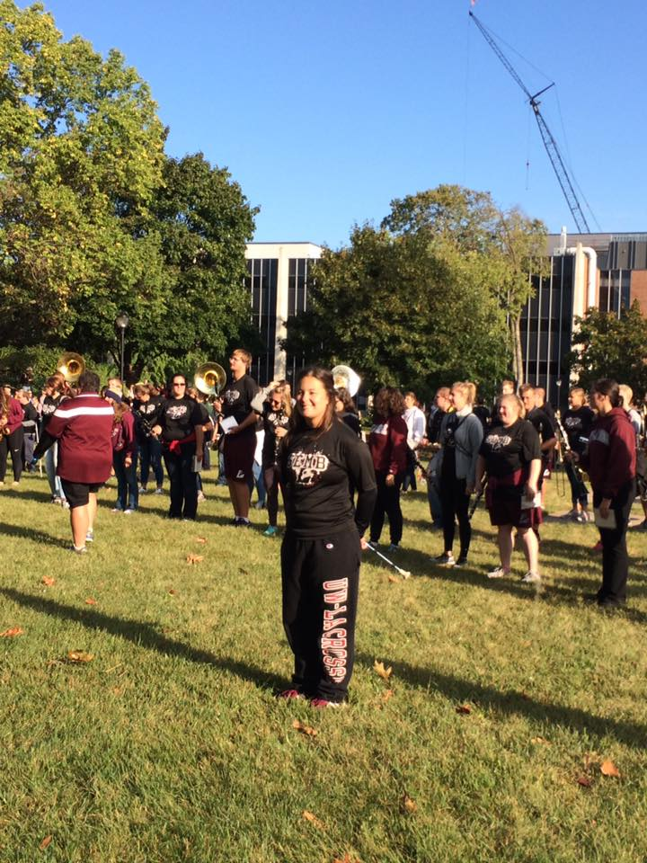
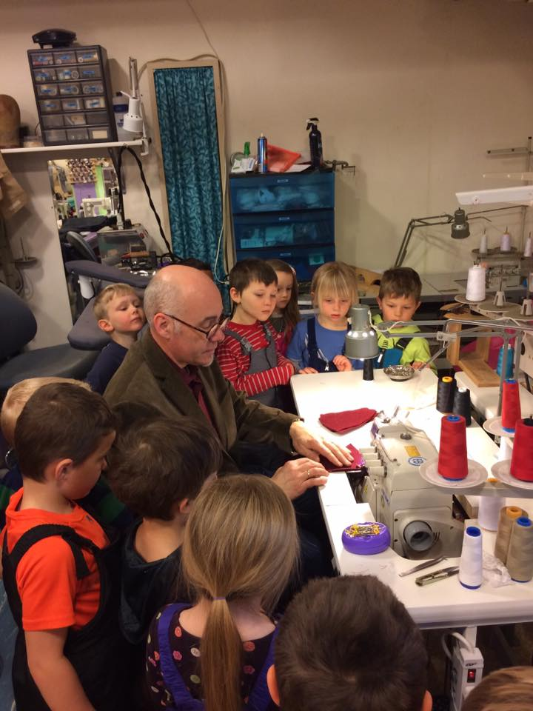

- Community Collaboration
For the first time, Campus Child Center partnered with Western Technical College to provide 500 hours of student teacher placements during the spring semester of 2018. We look forward to continuing this partnership.

We also continued our tradition of inviting local Oktoberfest Royalty to campus to help us celebrate Oktoberfest with our annual parade. It’s a tradition the campus looks forward to every year.

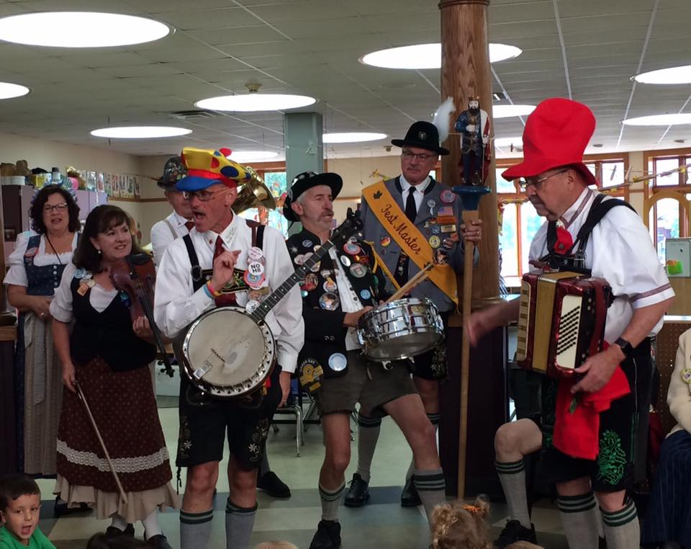

Challenges during 2017-2018:
Successfully operating a licensed and accredited group child care setting to provide quality care and education to young children continues to have its challenges. This year we found ourselves in need of additional student staff to maintain our licensing ratios. We felt the time constraints of preparing for our national accreditation renewal and we worked to overcome barriers in effective communication with the families we serve, particularly with the families of the oldest children.
Goals for 2018-2019
- Put five new communication tools into place during the year.
- Invest in our people by creating three new training initiatives.
- Increase the diversity of our staff members by 10%.

