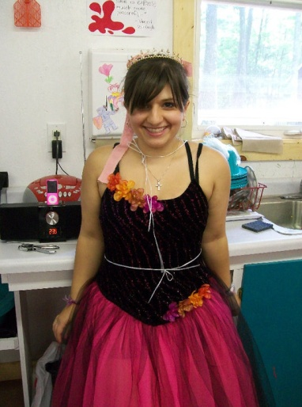
http://www.uwlax.edu/tesol (2011)
Summer Fun
By Dani Pellicane
University of Wisconsin – La Crosse
TESOL graduate, December 2011

Summer camp is full of memories: campfires under the stars, s’mores and pudgy pies for dinner, jumping in the lake, and counting all your mosquito bites. For me, going to summer camp was a learning experience. I spent two summers at a wonderful summer camp, working with all kinds of girls. I worked at a camp in Northern Wisconsin, on Barker Lake, which was part of the Chippewa flowage. Nestled under large white pines, for two years, I was cabin counselor to girls from the ages of 7 to 12, from the States and as far away as France.
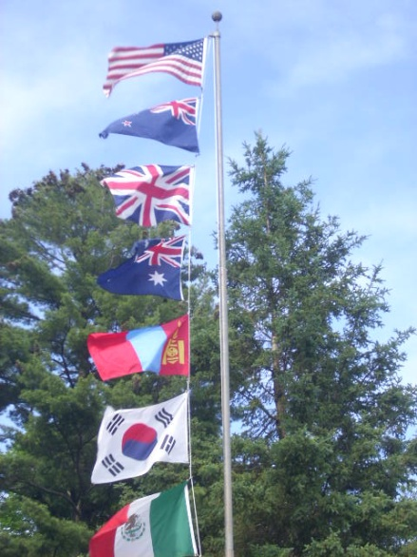
Summer camp is about meeting new people. I worked with many different staff members. We had staff from the United Kingdom, New Zealand, Mexico, Australia, South Korea and Mongolia. There were campers from France, Mexico, Columbia, Guatemala, South Korea, Russia, and Japan. There were visitors from England and a doctor from Puerto Rico. Every Sunday at camp, we would have a flag ceremony where we would raise the flag of each country represented and then sing that country’s national anthem. In those two years, I learned a lot about different cultures just from working at summer camp.
I taught dance, painting, theatre, knitting, and pottery. It was through knitting that I practiced my Spanish and started learning French; but mostly, when campers were looking for me, they would find me in the pottery barn. It was through the pottery barn that I worked with all of the girls who came to camp. It was through the pottery barn that I taught girls how to work with their hands, how to mold the clay to get the design they were hoping for, how to guide the clay while it is on the wheel, and how to carry a finished piece so it can dry without breaking. It was through pottery that I helped English language learners practice their English, but it was through my cabin life that I had the most international experiences.
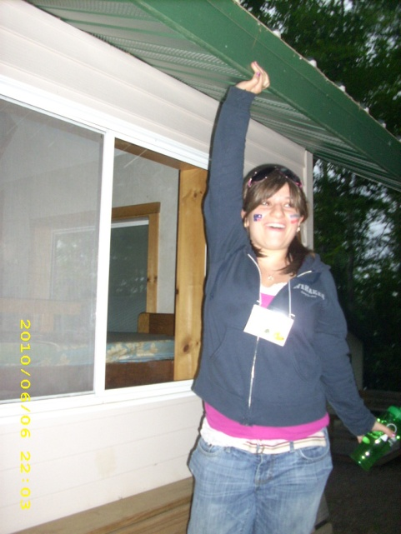
I have been in a cabin with girls or staff from Mexico, France and Australia. I have worked with girls whose English skills were not the greatest; and I have worked with girls whose English skills were so good that, listening past the accent, it would be hard to tell that English was their second (or third!) language. Sometimes we had girls who spoke English, French and Spanish in the same cabin. One might think the language differences could cause problems, and sometimes this was the case; but mainly, the girls wanted to learn from each other. From my girls who spoke French, I started learning some French (although they told me that I spoke French with an accent they’d expect to hear from someone from Spain). I practiced my Spanish with some of the girls who spoke Spanish; I read the book Green Eggs and Ham in Spanish. Learning different languages was not all that my co-counselor and I did in the cabins, of course. My co-counselor was fortunate to have studied French, and I had studied Spanish. To know if something was going on, we learned to listen with a fine ear while the girls weren’t speaking in English. We learned how to tell when there were arguments in the cabin between girls from the same country. We learned slang in Spanish and French from our listening. I learned even more when the girls were speaking English. The girls shared information about their countries with us, which was a great learning experience. The girls shared how hard it is to pronounce some of the sounds they hear in English, and the girls, of course, talked about English slang.
Slang was common for the counselors to share. I learned that being called a “fruit loop” in Australia means you did something silly or stupid. “That’s so pants” in England means it was dirty (in a “that’s what she said” kind of way). People who lived in New Zealand call themselves Kiwis. I tasted Vegemite and had honey toast. Yet, I learned so much more. Through my experiences at summer camp, I saw girls from all different walks of life come together and bond, whether it was over getting a horse to trot or standing up on the windsurf board. I saw how little girls, no matter what country they are from, love to play pretend games such as house, or have their stuffed animals get married. I learned from my campers how to wish someone happy birthday in their language and whether or not the tooth fairy is a fairy or a rat.
My summer camp experiences were awesome. I would love to share more information about what camp I went to, what type of camp it is, and any other questions one may have. I learned more about kids and languages from my camp experience than I ever did in my college classes. I would recommend taking a trip to a camp sometime in your life to see the simple beauty of summer.
