For the screenshots in this example, we will be booking an appointment for Stryker Eagle on September 2 at 11 AM.
- Go to the Textbook Rental Services booking page
(http://uwlax.edu/go/textbook-appt ).
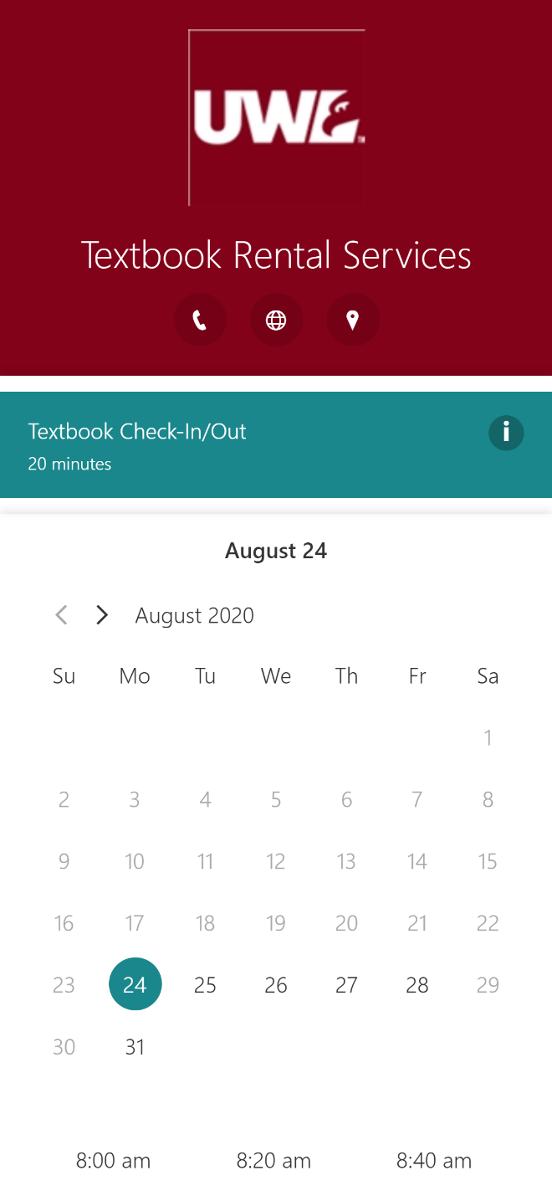
- Select a date. Use the left and right arrows above the calendar to view previous or future months. Once you have selected a date, it will be highlighted in teal.
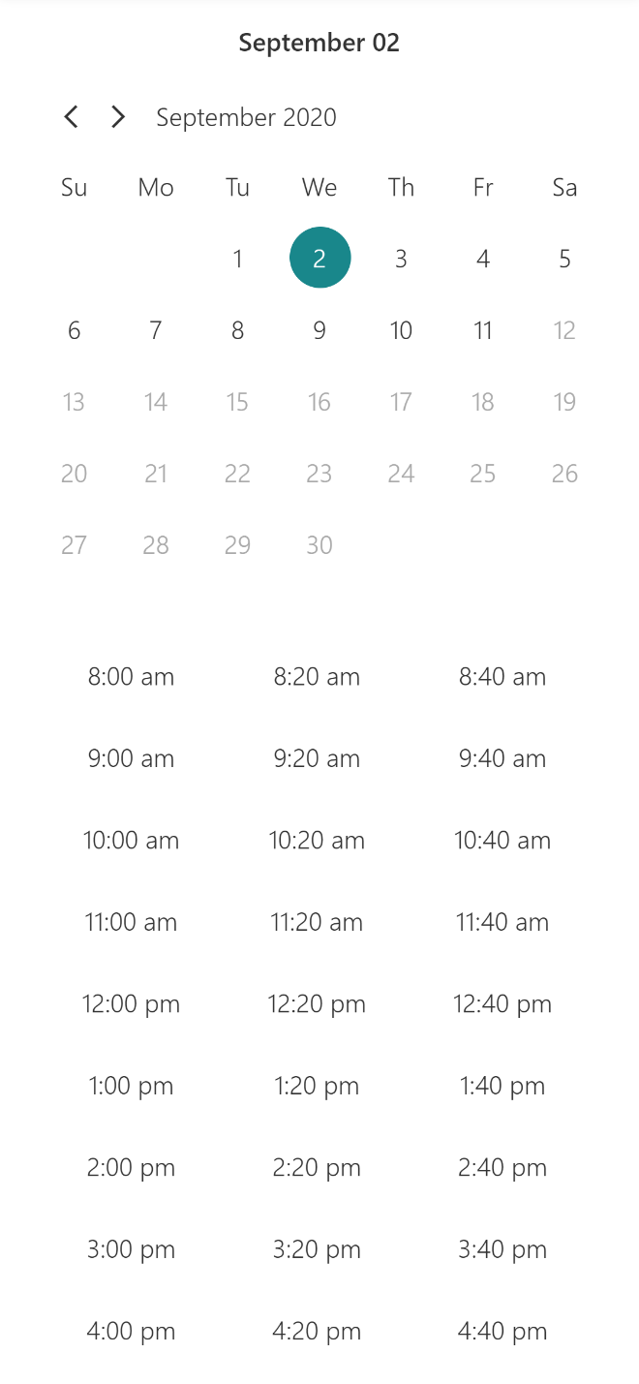
- Select a time. A list of available times on the date you selected is shown. If a time is not in this list, then it is no longer available. Once you have selected a time, it will be highlighted in teal. Your full date and time selection will be shown above the calendar.
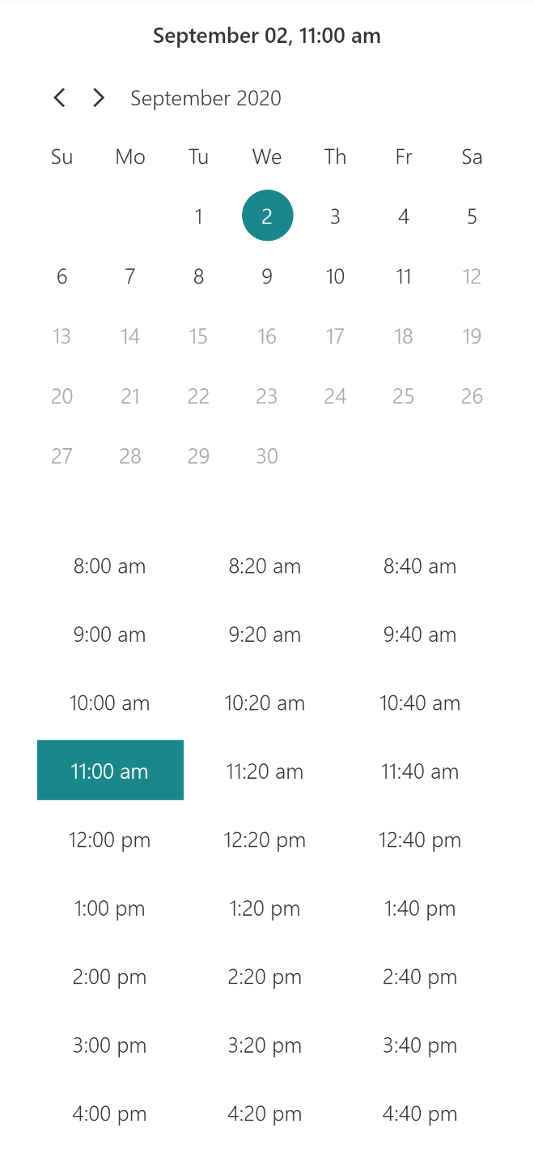
- Enter your details. You must enter your full name and UWL email address (ending with @uwlax.edu). If you would like to receive text reminders, enter your ten-digit phone number and check the “Get booking confirmation and reminder via text message” box.
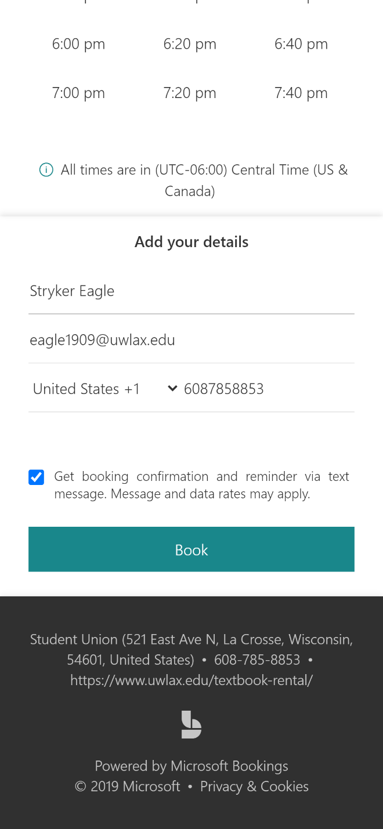
- Once you have confirmed that everything is correct, click Book. You will receive an email confirmation shortly with more details about your appointment. You will also receive email reminders forty-eight hours, twenty-four hours, and two hours before your appointment. If you opted to receive texts, then you will receive this information as texts as well.
