Electronic Overrides (Adds), 6th-10th Day

# Also known as "Class Permissions"

## *To use during the second week of the semester (prorated for shorter classes)*

Before you begin, please note these policies:

* Classes shorter than a full semester class have prorated add/drop deadlines. Check with the ADA or the Records office if you aren't sure what the deadline is.
* Once permission is added, student must go into their own account and enroll. If class is closed, it will still look closed to the student. He/she will still be able to enroll if the class permission was placed correctly. Students must enroll before the expiration date expires.
* All students adding a class will require instructor permission during the second week of classes, even if the class is open. This is the "add with permission" period.

## **Directions**

1. In WINGS, follow this menu navigation:**Records and Enrollment > Term Processing > Class Permissions > Class Permissions**
2. In the search fields, enter:
   1. **Academic Institution:** UWLAC
   2. **Term:** 
      1. Each term has a 4-digit numeric code. Some examples are below.
         1. 2261 (Summer 2025) or 2264 (Fall 2025) or 2266 (Winter 2026) or 2267 (Spring 2026)
      2. If you don't know the code, click on the "Look Up" icon (magnifying glass) next to the Term field. 
   3. **Subject:** prefix of course you are teaching
   4. **Catalog Nbr:** course number of course you are teaching
   5. **The rest of the search fields can remain blank.**

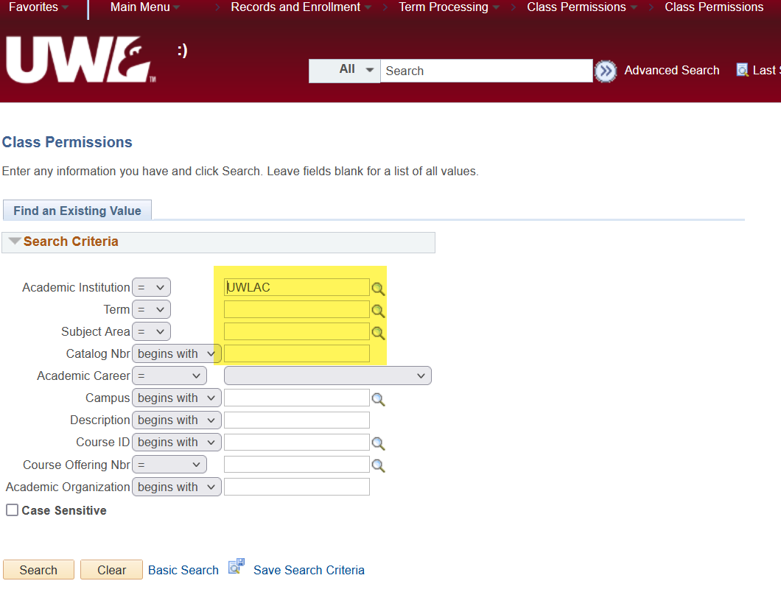

1. Click **Search.** On the next page, you should already be on the **Permission to Add** tab at the top.

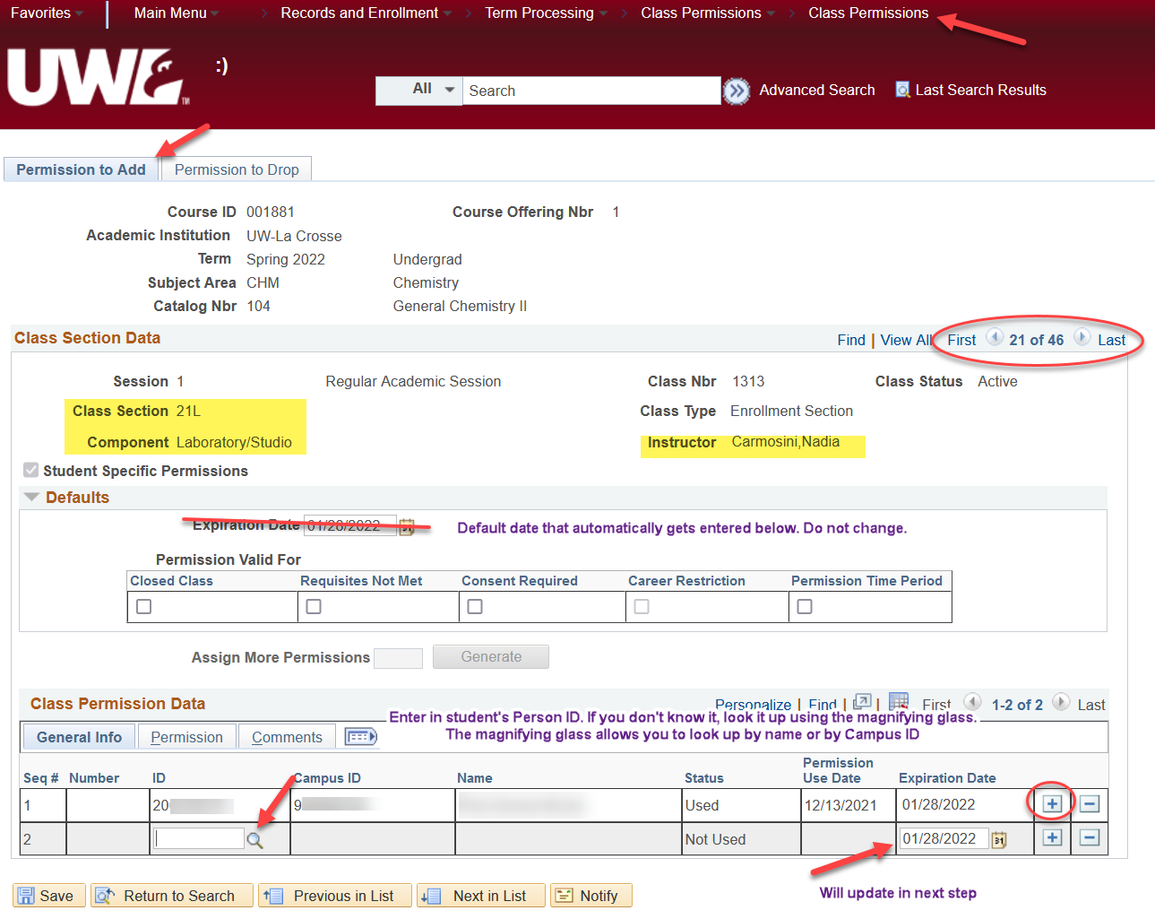

1. Verify you are on the correct **section** of the class using the Class Section Data. If more than one section of a class is offered you will see "1 of ? " on the right side of the top bar. Click the arrow until you find the correct section. Verify you are the instructor of the course.
   1. **For courses with lab components,** the ***lab*** that controls the overall enrollment. Make sure you put the override permission on the correct lab section, especially when overriding prerequisites and/or if the lab is closed.
   2. However, if the **lecture** section is closed, put the permission on **both the lecture and lab** component
2. Skip over the Defaults Section.
3. Go to the **Class Permission Data** at the bottom of the page and enter the student's Person ID (the number starting with 1 or 2) in the **ID** field under the General Info tab. If you don't know it or only have the student's Campus ID, you can look up their Person ID by using the "Look Up" icon (magnifying glass) next to the field. Enter their name or their campus ID, click Look Up, and click on the correct name in the results.

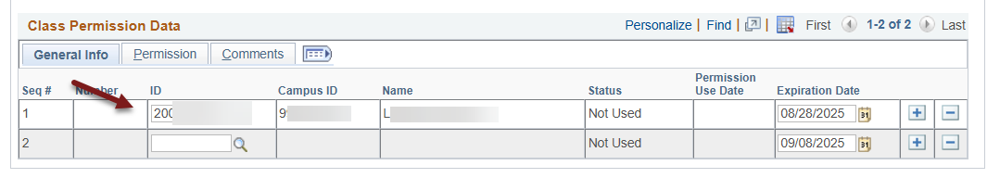

1. On the same tab, the **Expiration Date** field is on the far right. Change the date to something after the 5th day but no later than the 10th day of class**.** The Records office recommends using the 10th day of class to give students the most amount of time to use register. When changing the date, remember:
   1. The date must be after the 5th day of class; otherwise, you're not extending the permission any farther than normal.
   2. The date must be at least today's date; otherwise, the date is in the past and can't be used.
   3. **At the latest, the date can be the 10th day for a full semester class. After the 10th day of class, the Add Permissions do not work.** Students who request late adds after the 10th day will need instructor, department, and dean's office permission and will have to be added in the Records Office.

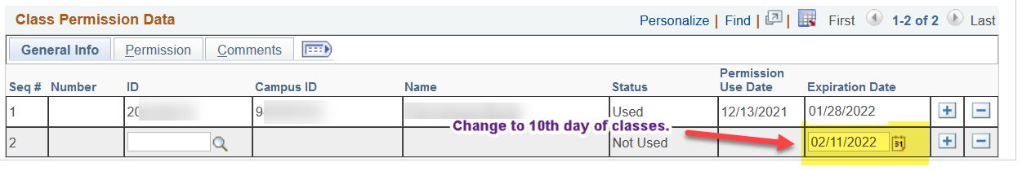

1. **Do not click Save yet!** If you click save here, you will get an error reminding you about checking an override box first.
2. Go to the **Permission** tab, and you will see options that can be overridden. Options used at UWL are "Closed Class," "Requisites Not Met," "Consent Required," and "Permission Time Period."

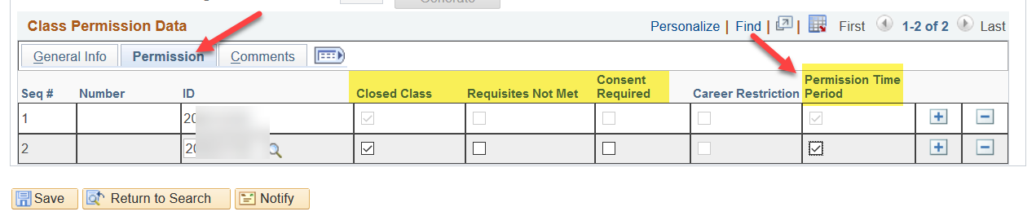

1. Check the **Permission Time Period** box. This overrides the default expiration date and allows you to save the new expiration date entered in step 7.
2. As needed, check one or more of the other boxes to override additional restrictions.
   1. Closed Class - if the class capacity is full
   2. Requisites Not Met - if student has not met some or all of the prerequisites, but you are approving them to enroll anyway.
   3. Consent Required is used when all students are required to get formal permission to register in the class. That permission may be given by the instructor or the department. **Most classes do not require consent to enroll.**
   4. The Career Restriction option is not used at UWL.
3. . **Please note the "Requisites Not Met" permission will override all course restrictions.**
   1. Overriding admission to a specific program or class standing (sophomore standing, etc) must be given by the dean's office. Do not check that box unless you know the student is admitted to your program or has the necessary class standing. If a student does not have those prereqs, they will need to contact their Dean's office for permission.
   2. Students will need separate overrides for audits, time conflicts, and/or overriding more than 18 credits. The blue paper override form can be used, or
      1. Audits - instructor sends approval by email to [records@uwlax.edu](mailto:records@uwlax.edu)
      2. Time Conflicts - student initiate the request using [Time Conflict Form](https://www.uwlax.edu/records/forms/#tm-299672). This form is preferred over the blue paper form.
      3. Overload Max Credit Load - contact the Dean's office for permission.
4. Click Save at the bottom left.
5. Inform the student that they may finish registering. A class permission **does not register** the student; it only gives them permission to register.
6. To give permission to another student, click the plus sign on the bottom right to add another row. 
7. You can return to the Class Permissions page to monitor the overrides given to see when the student used the override or if they dropped the class after they initially added it.
   1. If the student used the permission, there will be a date under the Permission Use Date on the General Info tab.
   2. The status of "Not Used" does not necessarily mean the student is not enrolled. It may mean the student didn't need the override to get in. For example, if the class was closed when the student got the override, but another student dropped it before your student registered, the class status may have been "open" and allowed them to register without using the override.

**Questions? Contact the Records Office at** [records@uwlax.edu](mailto:records@uwlax.edu) **or 608-785-8591.**