Electronic Overrides (Adds) thru 5th Day

# Also known as "Class Permissions"

## *To use from start of registration through 1st week of semester (prorated for shorter classes)*

Before you begin, please note these policies:

* Classes shorter than a full semester class have prorated add/drop deadlines. Check with the ADA or the Records office if you aren't sure what the deadline is.
* Once permission is added, student must go into their own account and enroll. If class is closed, it will still look closed to the student. He/she will still be able to enroll if the class permission was placed correctly. Students must enroll before the expiration date expires.

## **Directions**

1. In WINGS, follow this menu navigation:**Records and Enrollment > Term Processing > Class Permissions > Class Permissions**
2. In the search fields, enter:
   1. **Academic Institution:** UWLAC
   2. **Term:** 
      1. Each term has a 4-digit numeric code. Some examples are below.
         * 2261 (Summer 2025) or 2264 (Fall 2025) or 2266 (Winter 2026) or 2267 (Spring 2026)
      2. If you don't know the code, click on the "Look Up" icon (magnifying glass) next to the Term field. 
   3. **Subject:** prefix of course you are teaching
   4. **Catalog Nbr:** course number of course you are teaching
   5. **The rest of the search fields can remain blank.**

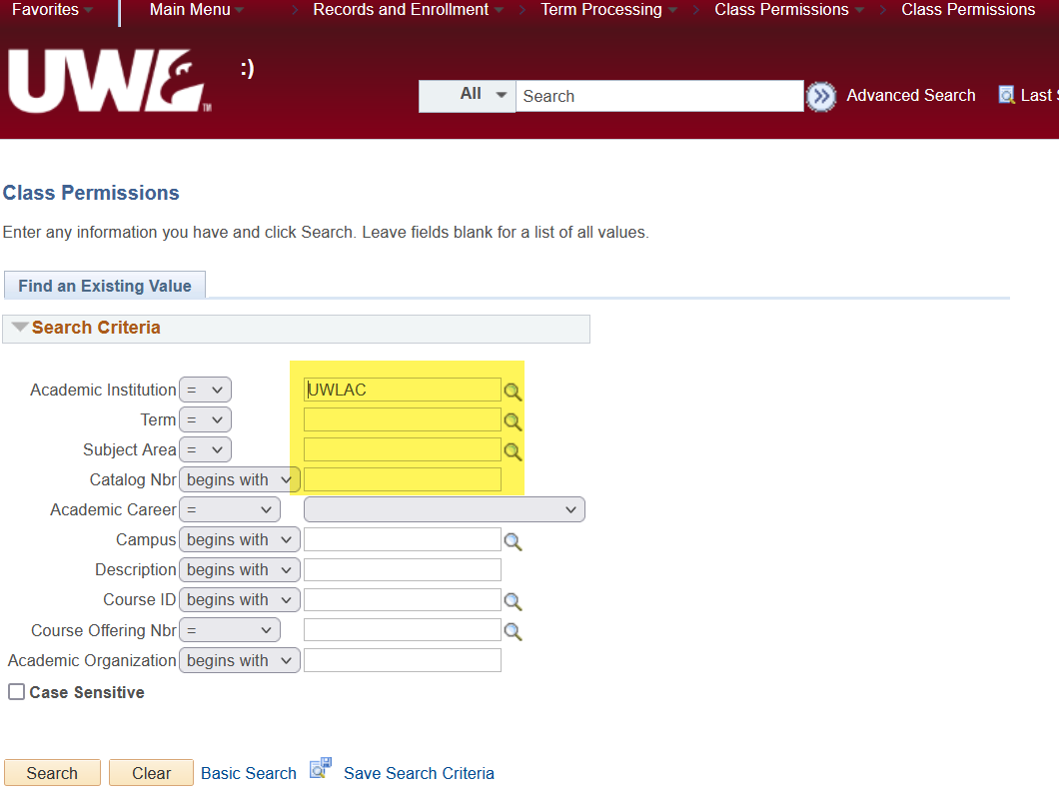

1. Click **Search.** On the next page, you should already be on the **Permission to Add** tab at the top.

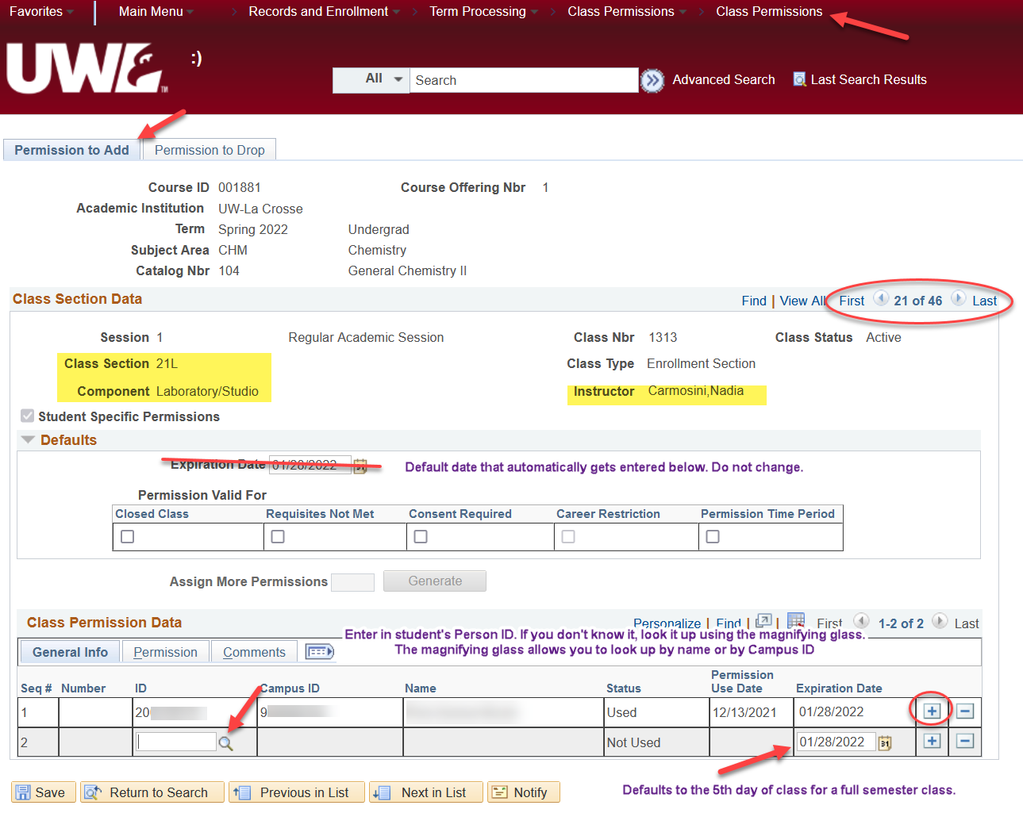

1. Verify you are on the correct **section** of the class using the Class Section Data. If more than one section of a class is offered you will see "1 of ? " on the right side of the top bar. Click the arrow until you find the correct section. Verify you are the instructor of the course.
   1. **For courses with lab components,** the ***lab*** that controls the overall enrollment. Make sure you put the override permission on the correct lab section, especially when overriding prerequisites and/or if the lab is closed.
   2. However, if the **lecture** section is closed, put the permission on **both the lecture and lab** component
2. Skip over the Defaults section.
3. Go to the **Class Permission Data** at the bottom of the page and enter the student's Person ID (the number starting with 1 or 2) in the **ID** field under the General Info tab. If you don't know it or only have the student's Campus ID, you can look up their Person ID by using the "Look Up" icon (magnifying glass) next to the field. Enter their name or their campus ID, click Look Up, and click on the correct name in the results.

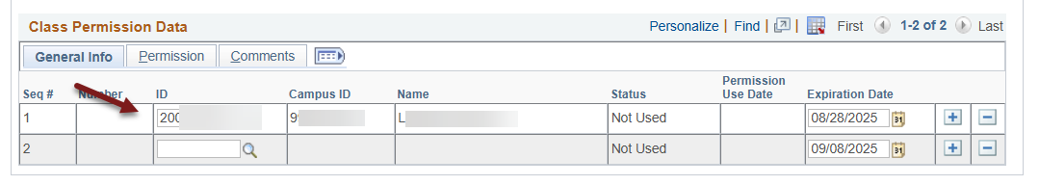

1. **Do not click Save yet!** If you click save here, you will get an error reminding you about checking an override box first.
2. Note the **Expiration Date** of the override. It automatically defaults to the 5th day of class for a full semester course, which is the last day students can add classes without permission, if a seat is open. If you so choose, you can change it to limit how long the student has to use it.
   1. Changing the expiration date is not required. But if you choose to do so, please remember to give the student a reasonable amount of time to register.
   2. IMPORTANT: during the first weeks of registration, remember that students have registration appointments with start times that vary. Please be sure not to change the expiration date to a date before the student can register.

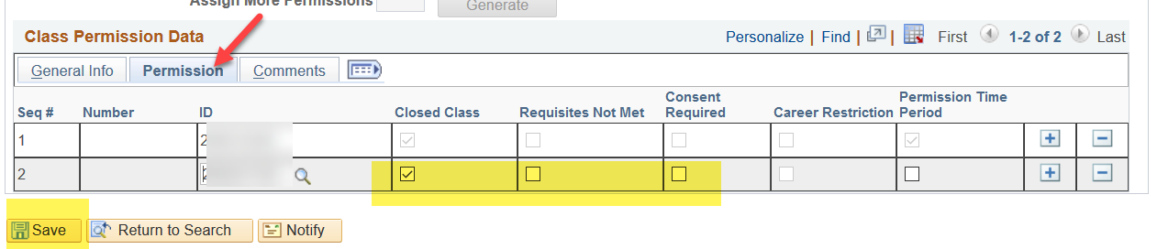

1. Go to the **Permission** tab, and you will see options that can be overridden. Options used at UWL are "Closed Class," "Requisites Not Met," "Consent Required," and "Permission Time Period."
   1. Consent Required is used when all students are required to get formal permission to register in the class. That permission may be given by the instructor or the department. **Most classes do not require consent to enroll.**
   2. The Career Restriction option is not used at UWL.
   3. The Permission Time Period is only used in the 2nd week of classes (see the 6th-10th day directions).
2. Select one or more of Closed Class, Requisites Not Met, and Consent Required. **Please note the "Requisites Not Met" permission will override all course restrictions.**
   1. Overriding admission to a specific program or class standing (sophomore standing, etc) must be given by the dean's office. Do not check that box unless you know the student is admitted to your program or has the necessary class standing. If a student does not have those prereqs, they will need to contact their Dean's office for permission.
   2. Students will need separate overrides for audits, time conflicts, and/or overriding more than 18 credits. The blue paper override form can be used, or
      1. Audits - instructor sends approval by email to [records@uwlax.edu](mailto:records@uwlax.edu)
      2. Time Conflicts - student initiate the request using [Time Conflict Form](https://www.uwlax.edu/records/forms/#tm-299672). This form is preferred over the blue paper form.
      3. Overload Max Credit Load - contact the Dean's office for permission.
3. If you would like to add a comment to track why an override was given, you can click the Comments tab and make an entry. Entering a comment is not required.
4. Click Save at the bottom left.
5. Inform the student that they may finish registering. A class permission **does not register** the student; it only gives them permission to register.
6. To give permission to another student, click the plus sign on the bottom right to add another row. 
7. You can return to the Class Permissions page to monitor the overrides given to see when the student used the override or if they dropped the class after they initially added it.
   1. If the student used the permission, there will be a date under the Permission Use Date on the General Info tab.
   2. The status of "Not Used" does not necessarily mean the student is not enrolled. It may mean the student didn't need the override to get in. For example, if the class was closed when the student got the override, but another student dropped it before your student registered, the class status may have been "open" and allowed them to register without using the override.

**Questions? Contact the Records Office at** [records@uwlax.edu](mailto:records@uwlax.edu) **or 608-785-8591.**