Drop with Permission

# *Electronic permission to drop is required after the 10th day of class and to the last day to drop with a "W" deadline.*

Before you begin, please note these policies:

* Classes shorter than a full semester class have prorated add/drop deadlines. Check with the ADA or the Records office if you aren't sure what the deadline is.
* Once permission is added, student must go into their own account and drop. Students must drop before the expiration date expires.
* Only advisors and instructors can approve drops. ADAs can put the permission if requested, but only if they've received the OK from the instructor/advisor.

## **Directions**

1. In WINGS, follow this menu navigation:**Records and Enrollment > Term Processing > Class Permissions > Class Permissions**
2. In the search fields, enter:
   1. **Academic Institution:** UWLAC
   2. **Term:** 
      1. Each term has a 4-digit numeric code. Some examples are below.
         1. 2261 (Summer 2025) or 2264 (Fall 2025) or 2266 (Winter 2026) or 2267 (Spring 2026)
      2. If you don't know the code, click on the "Look Up" icon (magnifying glass) next to the Term field. 
   3. **Subject:** prefix of course you are teaching
   4. **Catalog Nbr:** course number of course you are teaching
   5. **The rest of the search fields can remain blank.**

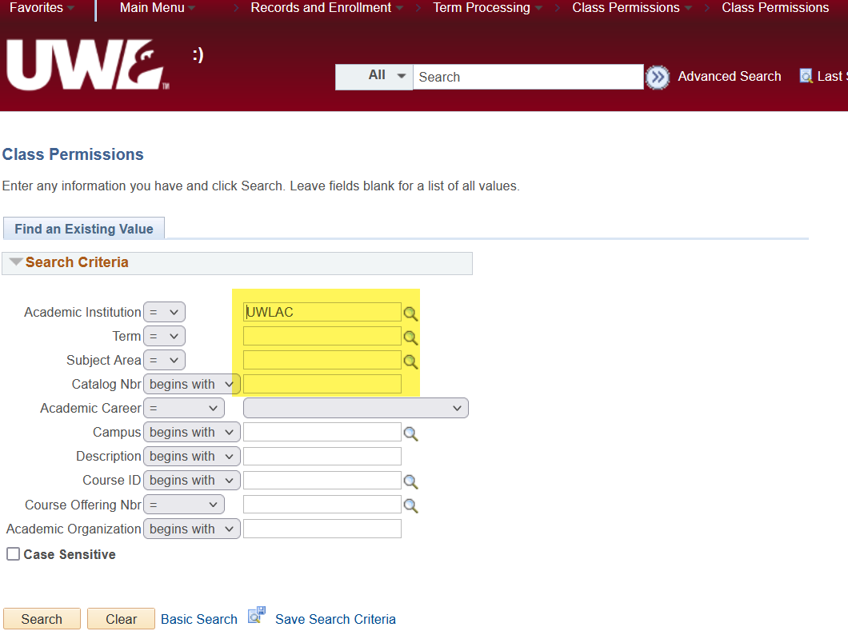

1. Click **Search.** On the next page, select the **Permission to Drop** tab at the top.

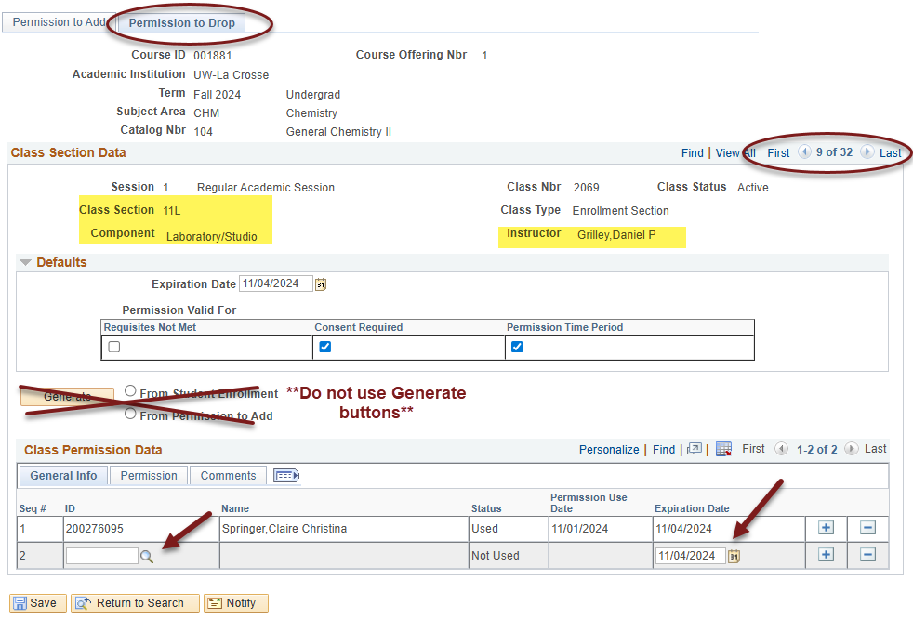

1. Verify you are on the correct **section** of the class using the Class Section Data. If more than one section of a class is offered you will see "1 of ? " on the right side of the top bar. Click the arrow until you find the correct section. Verify you are the instructor of the course.
   1. **For courses with lab components,** the ***lab*** that controls the overall enrollment. Make sure you put the override permission on the correct lab section. If permission is put on the lecture instead of the lab, the student won't be able to drop.
2. Skip over the Default section and the Generate button and options.These sections are restricted to Records Office use only. Do not use.
3. Go to the **Class Permission Data** at the bottom of the page and enter the student's Person ID (the number starting with 1 or 2) in the **ID** field under the General Info tab. If you don't know it or only have the student's Campus ID, you can look up their Person ID by using the "Look Up" icon (magnifying glass) next to the field. Enter their name or their campus ID, click Look Up, and click on the correct name in the results.
4. The **Expiration Date** at the bottom is the last day the last day to drop the course with permission. Do not change this date. Students will receive a "W" for the course upon dropping.
5. Click Save at the bottom left. **If you receive an error when saving, please see end of the directions.**
6. Inform the student they may now drop the class through their WINGS Student Center. A permission to drop **does not drop** the student; it only gives them permission to drop.
7. Students who use the permission to drop will receive a 'W' on their academic record.
8. To give permission to another student, click the plus sign on the bottom right on the Permission to Drop tab. This will add another line to be completed. 

## **Error message that might appear & what to do:**

Upon saving, you may get a message that says "At least one override must be selected." There are no overrides to check for a drop permission, so this indicates that **WINGS did not saving correctly.** The system can be slow to save, and if you click away from the page before its finished saving, WINGS won't let you continue.

If you get this message, click OK. Then navigate to another page in WINGS (such as your Faculty Center). If it asks you if you want to save, say no. Then go back into Class Permissions, find the section, and re-enter the drop permission. Make sure you see the **Saved** message in the top right or another indication the page is fully saved before moving on.

If this method doesn't work, please contact the Records Office.

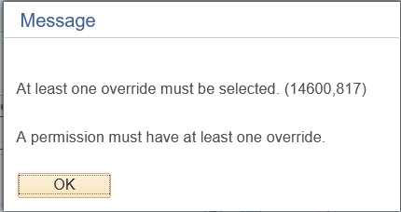

**Questions? Contact the Records Office at** [records@uwlax.edu](mailto:records@uwlax.edu) **or 608-785-8591.**