Academic Deadlines for Your Classes
The upcoming academic deadlines for the semester are listed on the Records & Registration's Dates and Deadlines page. You can also find them in your class schedule in the WINGS Student Center as shown below.

Deadlines are prorated for shorter classes, meaning the deadlines will also be shorter. If your class is not the normal semester length, use the below method for finding the exact drop dates.

Please note that tuition refund dates are not always the same as the academic deadline to drop a course. The Cashiers Office lists the refund deadlines in each refund schedule for the term.

Finding the deadlines from your schedule
- Login to WINGS. A list of your enrolled classes for the current or upcoming term show on your home page, in the Academics area.

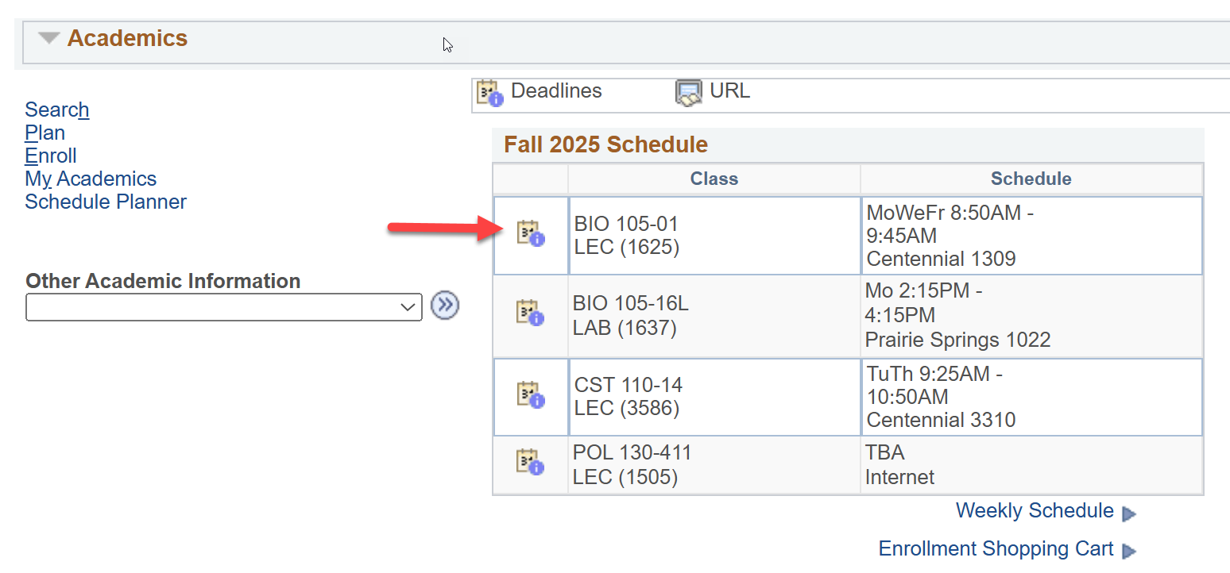

- The Academic Calendar Deadlines icon is the number 31 inside a box with a small circle with an "i" in the corner, and it is meant to represent a calendar page. Select the icon next to the class you are checking.

  - If you are registered into two terms and want to look at the dates for a class in a future term, click on the Other Academic Information drop down in the Academics area.
  - Select Class Schedule.
  - On the next page, select the correct term.
  - There will be a Deadlines icon in the line above each class listed.

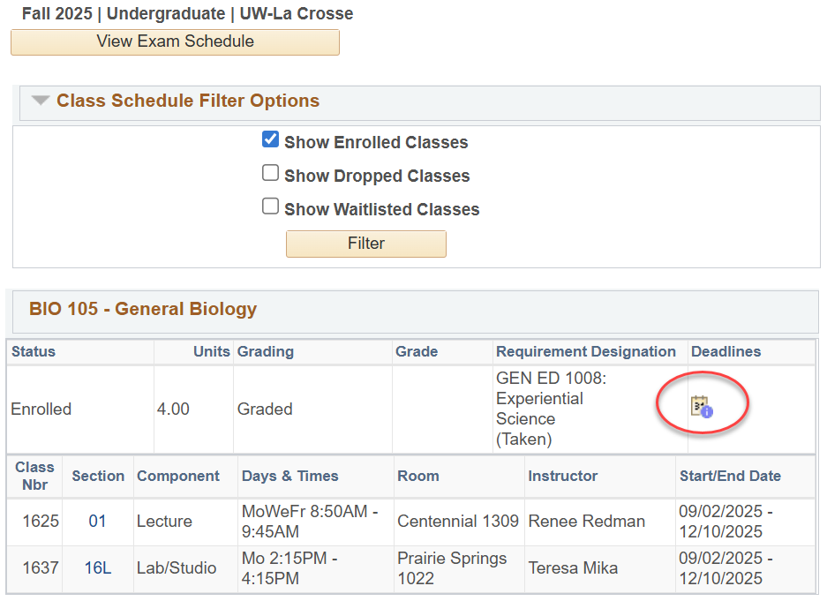

- After clicking on the Deadlines icon, a page will come up with a list of applicable academic deadlines for that specific class. The definitions of each deadline are listed below.

Definition of deadlines
- Drop Calendar section
  - Drop – Retain Record:
    - Last day to drop without a "W" grade.
    - A class dropped on or before this date will not appear on your transcript.
  - Drop with Penalty:
    - Last day to drop with a "W" grade.
    - A class dropped after the Drop-Retain Record date and on or before this date will appear on your transcript with a grade of "W."
- Cancel & Withdrawal Calendar section
  - Cancel:
    - Day before the class starts.
    - If it is the last course in your schedule, the last day to drop the course without officially withdrawing from UWL.
  - Withdraw without Penalty:
    - Last day to drop without a "W" grade and same date as the Drop-Retain Record.
    - A class dropped on or before this date will not appear on your transcript.
    - The official date of withdrawal will be recorded on your transcript if you withdraw from all classes at UWL after the term starts.
  - Withdraw with Penalty:
    - Last day to drop with a "W" and same date as Drop with Penalty.
    - Your instructor or advisor's permission is required to withdraw after the Withdraw without Penalty date (a.k.a. after the change of schedule period).
    - A class dropped after the Withdraw without Penalty date and on or before this date will appear on your transcript with a grade of "W."
    - The official date of withdrawal will be recorded on your transcript if you withdraw from all classes at UWL after the term starts.
  - Withdraw with Greater Penalty:
    - Last day to withdraw from all classes at UWL without a medical reason or military orders.
    - Withdrawal from the university is not allowed after the three-quarter point of the term, except for documented medical reasons or active-duty military orders.
    - A grade of "WP" or "WF" will appear if the withdrawal falls after the last day to drop with a "W" date. A grade of "WF" is calculated as an "F" in the GPA.
    - The official date of withdrawal will be recorded on your transcript if you withdraw from all classes at UWL after the term starts.

Considerations when withdrawing from a class

Offices that can assist
- Office of Student Life
  - When to contact
    - Withdrawing from all spring/fall classes
    - Withdrawing from Winter class and not coming back in Spring
    - Withdrawing from your last Summer class and not coming back in the Fall
  - Contact information
    - studentlife@uwlax.edu
    - 608.785.8062
    - 149 Graff Main Hall
- Office of Records and Registration
  - When to contact
    - Withdrawing from Winter class but coming back in Spring
    - Withdrawing from last Summer class but coming back in Fall
    - Any questions about dropping a course
  - Contact information
    - records@uwlax.edu
    - 608.785.8951
    - 117 Graff Main Hall

