Register With a Permission Number in WINGS
  - (for students in collaborative programs)

Directions

- Click the Search for Classes button in the top right-hand corner of Student Center.

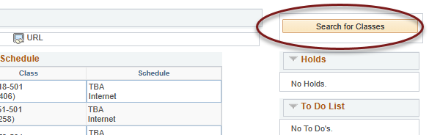

- Make sure you are on the correct term and enter the appropriate search criteria.
  - If you know the course subject and number, you can enter them in the fields.
  - If you just know the course subject, enter that in the subject field and change the Course Career to Graduate or Undergraduate.
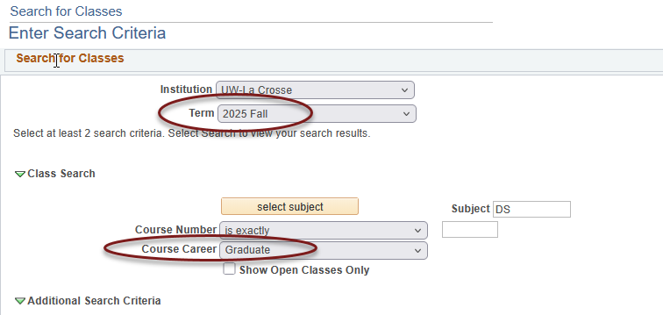

  - Scroll down and click Search

- In the Search Results, locate the section you are looking for. You can click on the blue section link to find more details. Or if you are ready to add it to your shopping cart, click Select.

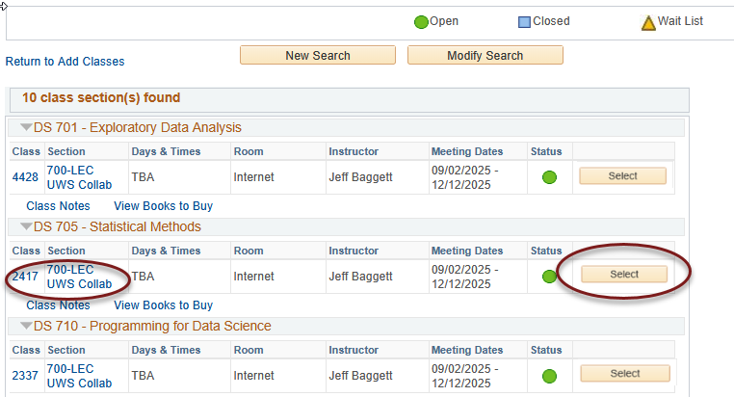

- The next screen is the Add to Shopping Cart - Enrollment Preferences screen. Locate the permission number given to you by UW System. Enter that number in the Permission Nbr field at the top right. Make sure the number entered is correct and click Next.
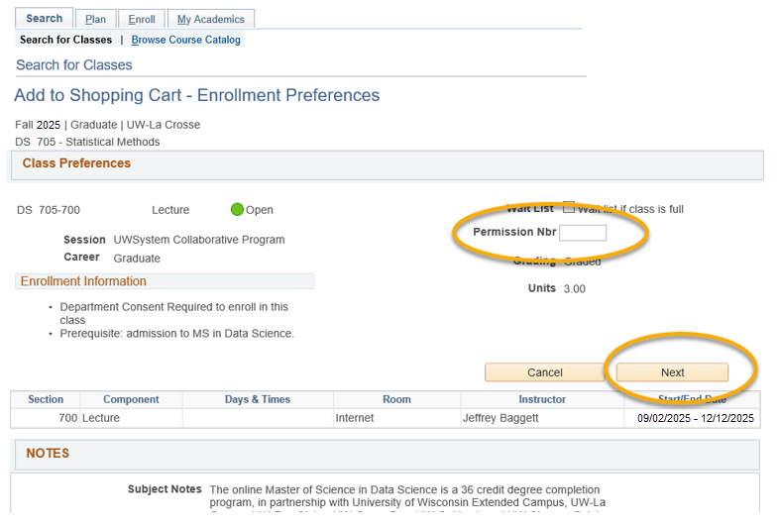

- You will see a success message if the course was successfully added to your cart:

- Repeat the above steps to add any other courses you need to your shopping cart. Do not forget to add the permission number after selecting the class. If the number is not put in at this time, you will need to drop the course from your shopping cart and then re-add it in order to put in the permission number.

- If all the correct courses are in your shopping cart and you are ready to register, go to the Enroll tab at the top.


- You should now be on the Add screen with your shopping cart shown below. Review the list to make sure it is correct. Click on Proceed to Step 2 of 3.
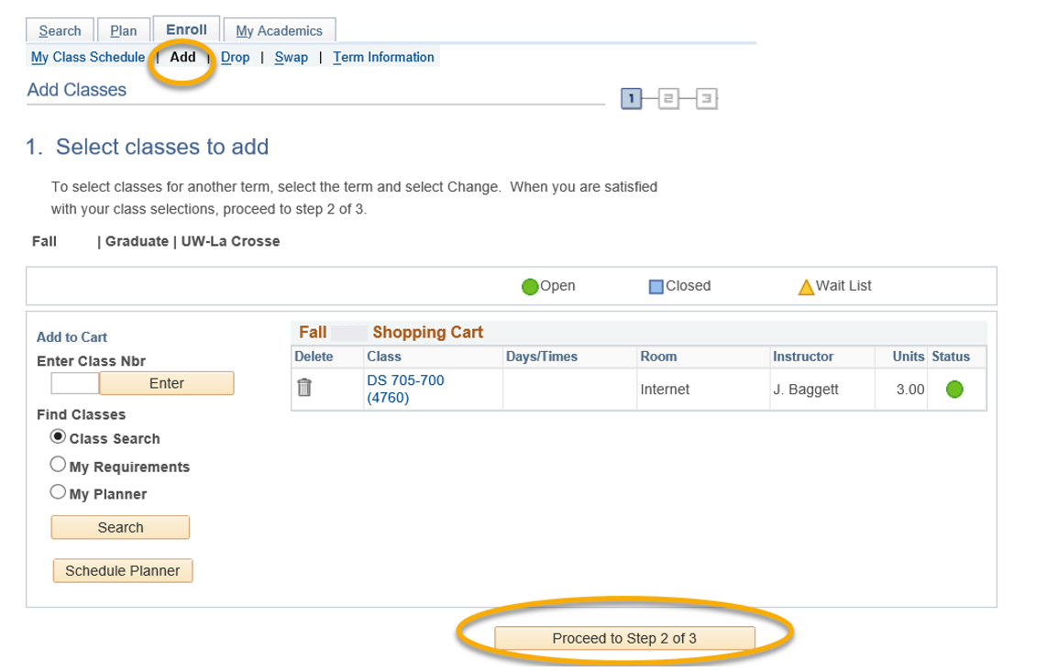

- On the Confirm Classes screen, click Finish Enrolling. This is not the final step!

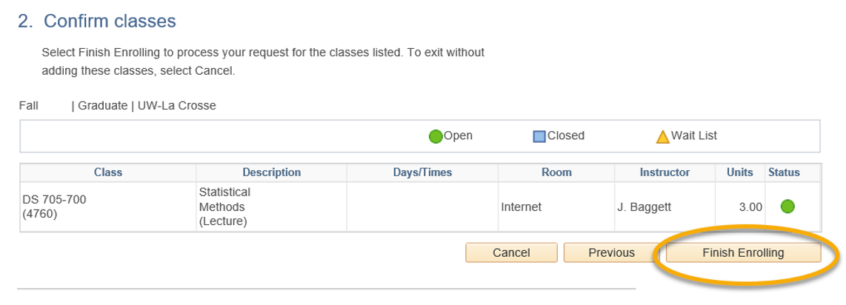

- Next, read the Terms and Conditions of Financial Responsibility by clicking the Terms and Conditions link on the next screen.

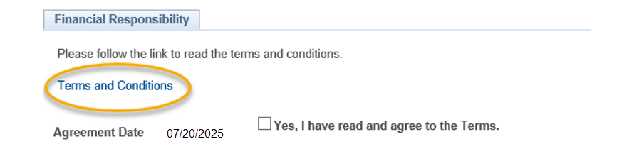

- Another window will open up with the full agreement posted on the Cashier's website. When you are finished reading this document, check the box next to "Yes, I have read and agree to the Terms" in order to agree to the terms and continue. Then click the link titled "Continue. You will have to click Finish Enrolling again."

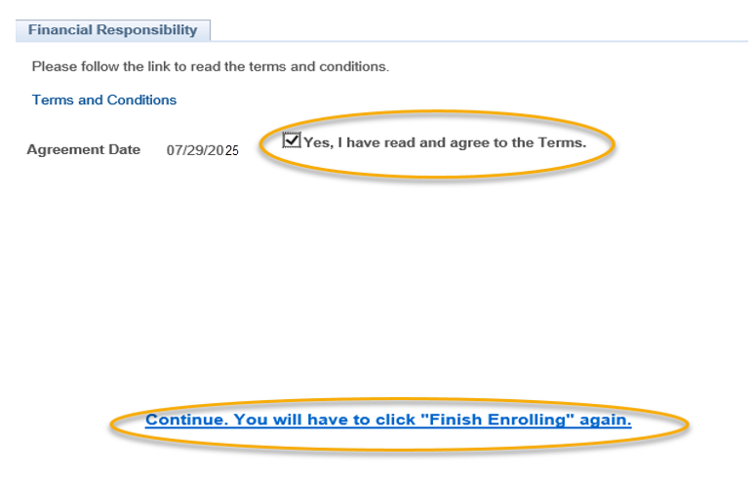

- Step 2 will appear again. Click on Finish Enrolling again.

- View your results.
  - A green check mark in the status field indicates that you have successfully enrolled in a course.
  - A red indicates that you have not successfully added a course. Click Add Another Class to be taken back to your Shopping Cart.

- View your course schedule after you register to ensure you have successfully enrolled in all your desired courses.

Possible error messages:

- If the error says Department Consent Required, the permission number was not entered correctly in the Permission Nbr field when the class was added to the shopping cart. Click Add Another Class to be taken back to your Shopping Cart.

Click the trash can icon next to the course to remove it. Then click on Search to re-add the course.
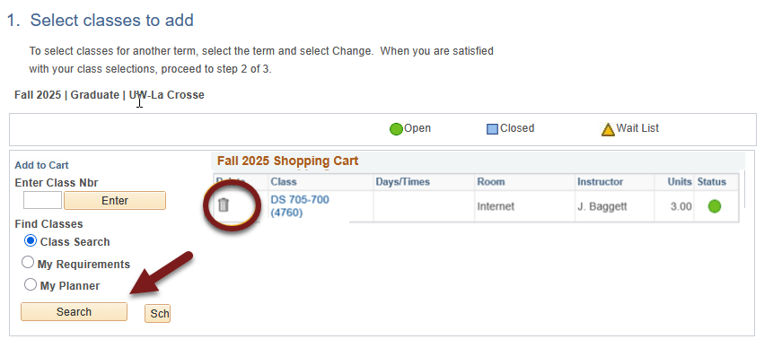
Follow steps 8-13 again. Remember to add in the permission number on the Select Classes to Add page.

- If you get an error about not meeting the prerequisites, please contact the program director for your program. The instructor listed on the class is the program director. You don't need to remove the course from your shopping cart.

If the program director give you a prerequisite override, you may log back into your WINGS and finish registering by clicking on the Enroll link on your WINGS main page and following the Add steps.



- If you get an error other than the department consent error or the prerequisite error, please contact the UWL Records and Registration Office at 608-785-8951 or records@uwlax.edu.

Please note:
- If you have not registered after the fifth day for Fall & Spring semesters, contact the program director or Records and Registration for help. Your electronic permission can be extended another week.
  - After the tenth day, you will need your college dean's office approval to add a course. You will need to bring all the approvals to the Records and Registration office to be registered.
  - Winter and Summer terms have shorter deadlines.
  - Permission numbers must be gotten from the UW Extended Campus Office. Their email is learn@uwlex.edu. Phone is 1-877-895-3276 or 608-262-2011.
  - If you have questions about what courses to sign up for, please contact the UW Extended Campus at the above address/phone.
  - If you have a question about an error you are getting or you have trouble registering, contact your program director or the Records and Registration Office for assistance at records@uwlax.edu for assistance

