Drop a Class in Schedule Planner

- Click on the Schedule Planner link from your WINGS Student Center.



- Go to the Current Schedule in the top tab in Schedule Planner and click on Drop Classes.

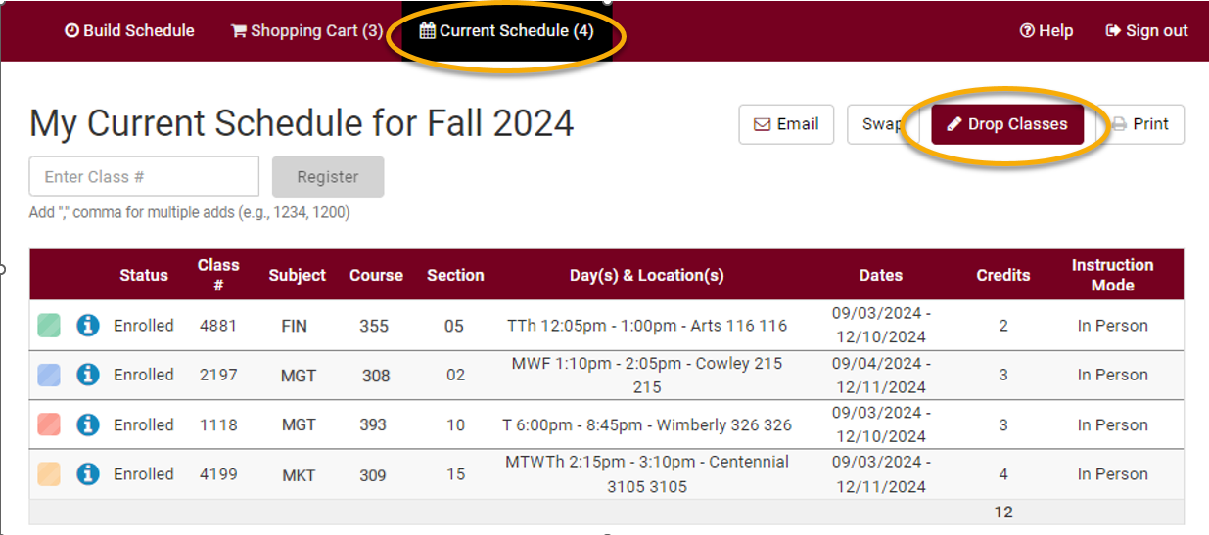

- Check Drop next to the course and click Save.

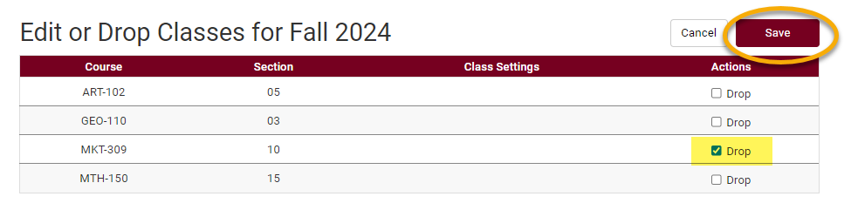

- Messages will pop up with important notifications and warnings.
  - Textbooks must be returned within 24 hours if course is dropped within the first 5 class days or you will incur a fine.
  - If you drop all of your classes, you will still be required to pay the non-refundable $25 fee which is assessed once per term.
  - Withdrawing from a course may change your situation in other ways. Review the considerations for withdrawing from a course before continuing.

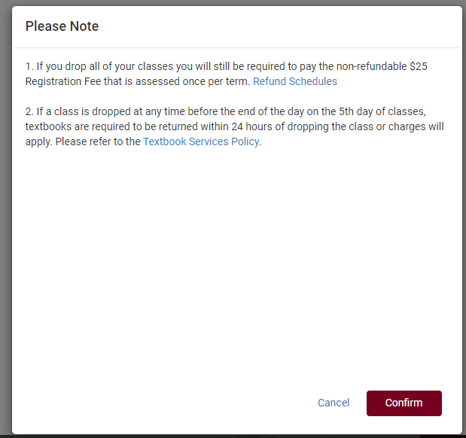

- If you still want to drop the class(es), click Confirm.
- On the next window, click Save.
- Review your course schedule on the Current Schedule page to make sure everything is correct.

Please note:

- If you receive an error when trying to drop, read the error message to find out why.
  - You cannot drop below 1 credit on your own. For example, if you are taking one class over the summer, you cannot drop it without help.
  - If you want to drop all classes for a Fall or Spring term after the term has started, this is considered withdrawing from the University. In that case, please contact the Student Life office at studentlife@uwlax.edu. If you are dropping all classes in Summer or Winter, please contact the Records and Registration office.
- After the first 10 days of a semester (deadline is shorter for shorter classes & Winter/Summer), you will receive a "W" grade if you drop a class. "W"s indicate a withdrawal and do not affect GPA.
- The academic deadlines for your classes can be found by clicking on the calendar icon next to the course in your schedule in WINGS, or on the Records and Registration Dates and Deadlines page.
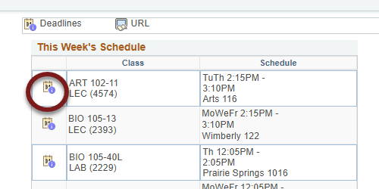

- Refund dates are set by the Cashier's office and are often different than the academic drop deadlines. Tuition for 12-18 credits remains the same in the fall/spring terms. Check the Cashier's website for the dates.
- Questions? If you have questions about what courses to sign up for, please contact your advisor or the Academic Advising Center in 1209 Centennial Hall or at advising@uwlax.edu. If you have a question about an error you are getting or you have trouble registering, contact the Records and Registration Office for assistance at records@uwlax.edu or 117 Graff Main Hall.

