Drop a Class in WINGS
      - Click the Enroll link in the Academics section at the top of the page


      - Select the Drop tab.
      - Select the appropriate term and click the Continue button. (This step will not be necessary if there is only one active term.)
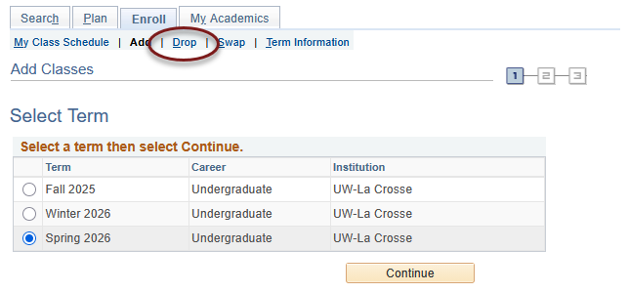

      - Read the caution at the top in red and consider your options.
- Textbooks must be returned within 24 hours if course is dropped within the first 5 class days or you will incur a fine.
- If you drop all of your classes, you will still be required to pay the non-refundable $25 fee which is assessed once per term.
- Withdrawing from a course may change your situation in other ways. Review the considerations for withdrawing from a course before continuing.

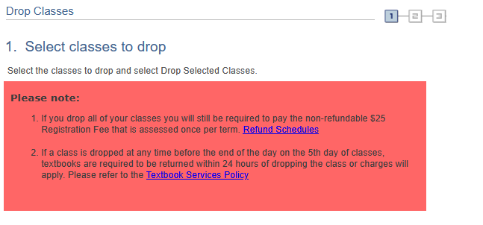
- If you still want to drop the class(es), select the course(s) you wish to drop and click Drop Selected Classes.

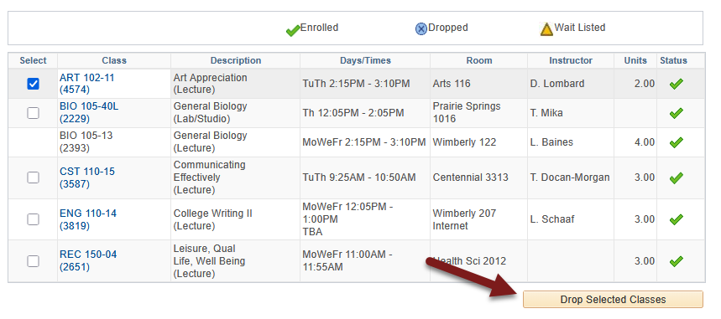

- On the next screen, confirm that the course is correct and click Finish Dropping.
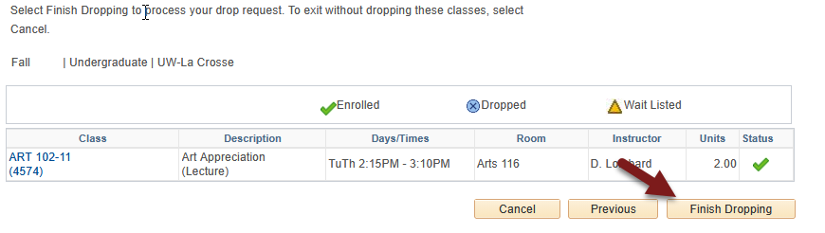

- View your results.
  - A green check mark in the status field indicates that you have successfully dropped that course.
  - A red indicates that you have not successfully dropped the course. If you received a , you no longer have permission to drop the course on your own. Read the error text to find out why. If you have further questions about why you could not drop, contact the Records and Registration Office.

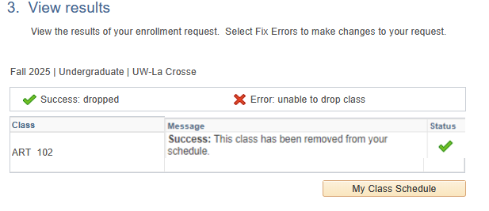

- View your course schedule after this step to ensure that you have successfully dropped all desired courses. Click on the My Class Schedule button underneath the results table.

Please note:

- If you receive an error when trying to drop, read the error message to find out why.
  - You cannot drop below 1 credit on your own. For example, if you are taking one class over the summer, you cannot drop it without help.
  - If you want to drop all classes for a Fall or Spring term after the term has started, this is considered withdrawing from the University. In that case, please contact the Student Life office at studentlife@uwlax.edu. If you are dropping all classes in Summer or Winter, please contact the Records and Registration office.
- After the first 10 days of a semester (deadline is shorter for shorter classes & Winter/Summer), you will receive a "W" grade if you drop a class. "W"s indicate a withdrawal and do not affect GPA.
- The academic deadlines for your classes can be found by clicking on the calendar icon next to the course in your schedule in WINGS, or by checking the Dates and Deadlines page on the Records & Registration website.
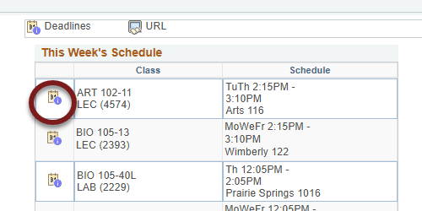

- Refund dates are set by the Cashier's office and are often different than the academic drop deadlines. Tuition for 12-18 credits remains the same in the fall/spring terms. Check the Cashier's website for the dates.
Questions? If you have questions about what courses to sign up for, please contact your advisor or the Academic Advising Center in 1209 Centennial Hall or at advising@uwlax.edu. If you have a question about an error you are getting or you have trouble registering, contact the Records and Registration Office for assistance at records@uwlax.edu or 117 Graff Main Hall.

