Creating Favorite Schedules in Schedule Planner

Creating Favorite schedules allows students to save multiple schedules as options to be ready for their registration appointment. This makes it easy to see whether seats are still available in your preferred schedules and saves time if you need to make changes because you won't need to drop classes out of the shopping cart first to generate new schedules.

- In Schedule Planner, pull up the correct term. Use the +Add Courses button to find courses you are interested in.

- Click Generate Schedules to find all possible options based on the courses added. Click View next to one of them to see the details. You can then scroll through the possible schedules using the arrows on the next screen. (More details on finding classes is in the "Search for Classes/Creating a Schedule in Schedule Planner" directions.

- When you find a schedule to save, click on the "Favorites" heart icon at the top to save it.

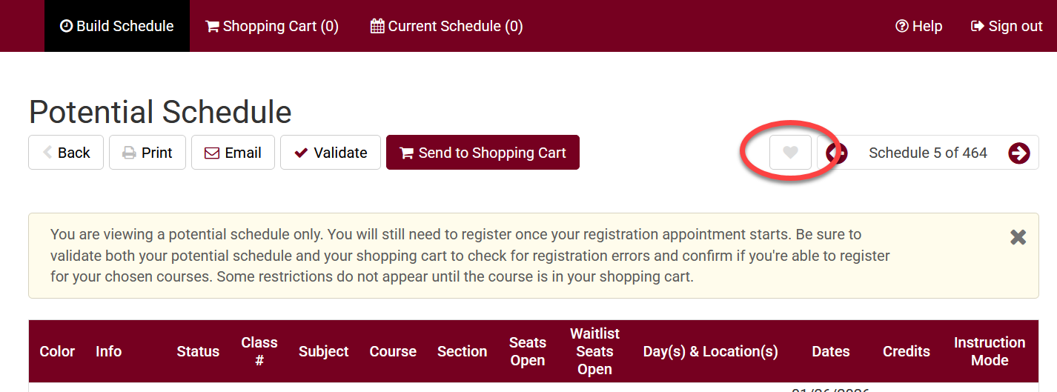

- Enter a name in the pop up to help identify which saved schedule is which. Click OK when done.

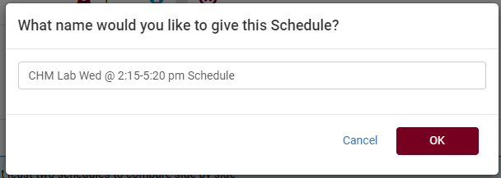

- You may click through more schedule options using the arrows at the top.
  - If you find another possibility, follow the same steps to make it a Favorite but give it a different label.
  - You can have as many favorites as you want. To edit them further, go to the Plan Schedule page and scroll down to find the Schedules section.
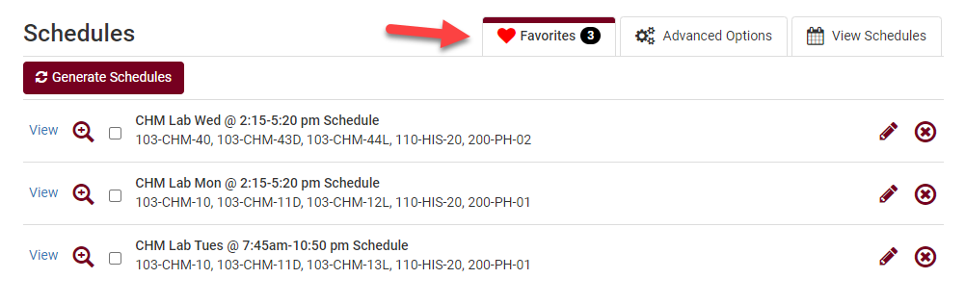

  - Important: Saving a Favorite schedule does not reserve you a seat in the class.

- Once your registration appointment starts, review the schedule and see if there are still open seats.
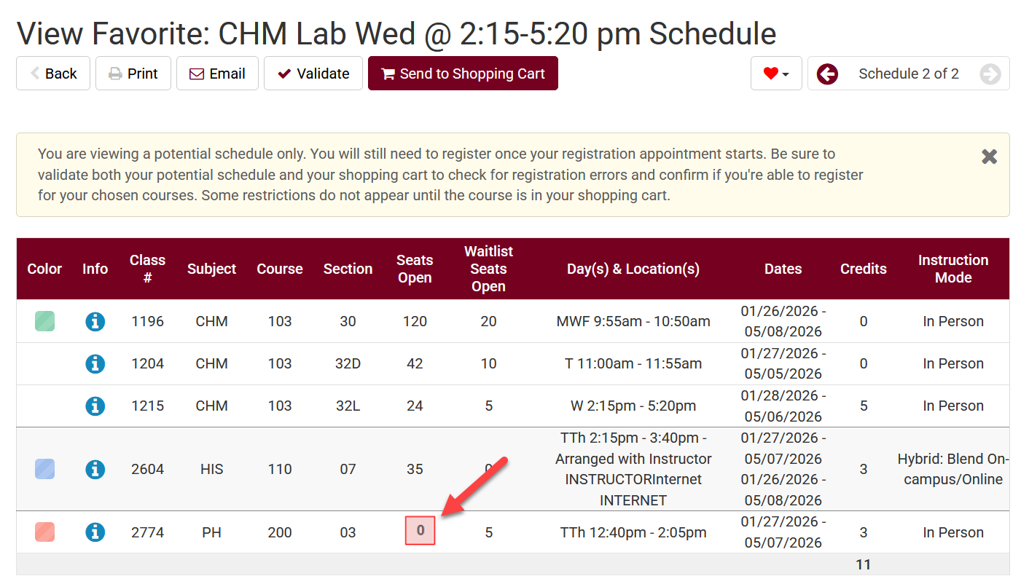

- If one of your Favorites has a class that is full, you can move onto the next Favorite schedule and check if that schedule will work.

- Once your registration appointment starts and you have a schedule that you think will work (i.e. no time conflicts, an available seat, not more than 18 credits, and you meet the prerequisites), pull up the schedule details and click Send to Shopping Cart.

- From the Shopping Cart, click Register and follow the prompts to finish registering.

