Privacy Settings/FERPA Restrictions

FERPA stands for Federal Education Rights and Privacy Act, and it governs the privacy of student educational records. The below shows how and which directory information can be restricted by the student in their WINGS Student Center.

# Directions

1. In the **Personal Information** section of your Student Center, select **Privacy Settings** from the drop-down menu. Click the double arrow **Go** button.

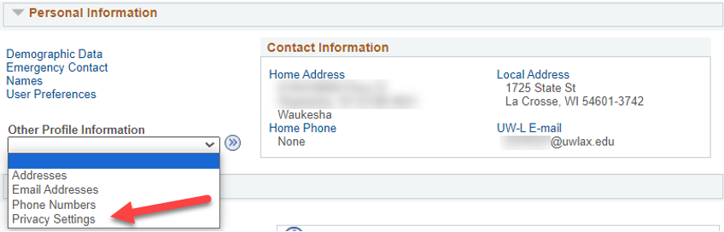

1. If you already have some data restricted, that category will be listed. To restrict or unrestrict categories of data, click the **Edit FERPA/Director Restrictions** button.

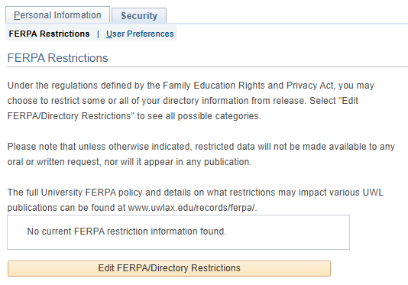

1. On the next screen, you may restrict all, some, or none of the categories. To restrict all, click the Restrict All at the top of the page. To restrict some, go to each category and individually check what you want to restrict. Important: you may come back at any time and change the restrictions.
2. A Release to Publication link will come up if a category is restricted; however, it cannot be used to release information temporarily or partially. If a category is restricted, it is restricted from all publications.
3. Click save when done.

# Considerations when restricting:

## The online directory & Outlook

Your street addresses and phone numbers are not published in the online directory. Only your name in use, class standing, primary major, and UWL campus email are published.

Restricting your primary name keeps all your information out of the online directory. However, it also means you can't be searched for in the Outlook directory or in Microsoft Teams. Also, blocking your name keeps it out of other publications, such as the Deans List, and prevents UWL from providing verifications for insurance and/or employment.

There is currently no way to block just your campus email from the online directory. You can block your name and email so they don't show, but that means they will also not be searchable in Outlook. To make sure your name is searchable in Outlook, we recommend not restricting any categories.

## Commencement

Both your primary/legal and degree names must be unrestricted for your name to be printed in the commencement program. The Degree Candidacy, Degree/Credential Earned, and Honors and Awards categories must also be unchecked. This must be done before April 1st for May Commencement, and November 1st for December Commencement to make it in time for printing. Commencement programs cannot be updated after they are printed.

In addition, if you'd prefer your Name in Use to be printed in the program, please add a Degree name.

## Hometown newspapers, Deans Lists, & graduation announcements

Both your primary/legal name and home address must be unchecked for your information to be published in your hometown newspaper or to be published on UWL's website for the Deans List. The Honors and Awards category must also be unchecked for the Deans List publications. This should be done within two weeks after final grades are due to be included in these publications. Please note that most lists cannot be updated after being published.

## Insurance, loan, and potential employer verifications

Your primary name and the related academic information categories must be unchecked for the information to be released to a third party. Academic information that is sometimes requested by these parties includes Attendance or Enrollment Dates, Enrollment Status, Programs of Study (a.k.a. your major), Degree Candidacy, Honors and Awards, and Degrees earned.

## Having everything restricted

Any third party who calls, aside from exceptions within the law, will not be able to obtain any information about you, including whether you attended UWL.

No information will be included in publications such as online directories, newspapers, or the commencement program. No information will be released to potential employes, loan or insurance companies.

For current students, their names will not be searchable in Outlook or Teams, although their email will still be active, usable email addresses.

## Having nothing restricted

Your campus email and major are published in the online directory and may be released upon request, along with any other [directory information](https://www.uwlax.edu/records/ferpa/#tm-18626) requested. Your photograph may be used in publications. Your name will be published in Deans' List and graduation lists, if applicable.

## What will never be released without your consent

Your grades, academic standing, GPA, probations and/or ineligibilities, applications, tuition and billing, financial aid, non-academic disciplinary actions, and medical (HIPAA) information will never be released without your official authorization, except for specific exceptions required by law.

## Authorizations to release restricted information

If you would like to keep categories restricted but also want UWL to release them for a specific situation, provide written authorization is required to release it. The written authorization or release should specify who the information can be released to, the date the release was signed, and what information exactly may be released. Written authorizations are treated as one-time authorizations This permission to release should be sent to the Records and Registration Office.

To make a release of information permanent, go into your WINGS Student Center and uncheck the category. If you are no longer a student at UWL, contact Records and Registration.

# [UWL's FERPA policy](https://www.uwlax.edu/records/ferpa/)

# FERPA restriction categories

1. Addresses
   1. Campus
   2. Home
   3. Local
   4. Permanent
2. Email Addresses
   1. Campus
   2. Personal
3. Names
   1. Degree
   2. Former
   3. Primary
4. Phones
   1. Campus
   2. Cell
   3. Home
   4. Local
5. Photograph
6. Academic Information
   1. Attendance Dates
   2. Degree Candidacy
   3. Degree/Credentials Earned and Date Awarded
   4. Enrollment Dates
   5. Enrollment Status – full time or part time
   6. Honors and Awards – Deans List and graduation honors
   7. Official UWL Sports/Activities participation information
   8. Previous Institutions attended
   9. Program(s) of Study – your major/minor or graduate program
   10. Student Athlete Physical Factors

