Setting up a FERPA Secure PIN
Your student records are confidential and protected under the Family Educational Rights and Privacy Act (FERPA). To comply with FERPA, students must verify their identity when contacting UWL offices and discussing personal and confidential information. Students visiting UWL offices may be required to provide a photo ID. Students contacting UWL offices remotely, such as through a phone call, will need to provide their student ID number and a six-digit FERPA Secure PIN number which is available in the student's WINGS account.

In addition, UWL staff cannot release your student records and financial account information to your parent, guardian, sponsor, or third-party designee without your prior formal consent. However, you may set a FERPA Secure PIN to allow UWL staff to release your personal information to a third-party designee, i.e., anyone who has your name and can provide the FERPA Secure PIN assigned to them. Please note that campus offices are not required to release your personal information to a person providing the PIN, but they may do so. This FERPA Secure PIN system protects your student records and complies with FERPA.

The FERPA Secure PIN does not grant the guest access to:
- View or discuss course grades
- View or discuss the student's current schedule of classes
- Sign documents or forms on behalf of the student

Tuition payments: Students may provide parents or guests a way to pay tuition through CashNet without accessing WINGS. The UWL Cashiers office has posted directions on how to create guest access to CashNet.

Important: Please be careful with whom you give a Secure PIN as you are choosing to release confidential information about your personal records.

Your Personal FERPA PIN

Creating your first PIN
- Login to your WINGS Student Center.
- Select UW-La Crosse from the left-hand menu.
- Select FERPA Secure Pin.
- Select Set/Update FERPA Secure PIN.
- The Terms and Conditions statement for the FERPA Secure Student PIN are:

I understand and agree that by providing my FERPA Secure Student PIN and student ID number to staff at UWL, I am verifying that I am the student assigned this FERPA Secure Student PIN and student ID number. Anytime I wish to change my FERPA Secure Student PIN, I can do so by logging into my WINGS account and manually changing my FERPA Secure Student PIN.

- Check the box next to I Accept These Terms if you agree to this statement. If you do not agree, stop here and do not create a PIN.
- A new section will appear with your name and Campus ID number. Click Set PIN.
- A 6-digit number will generate and appear next to the PIN label.

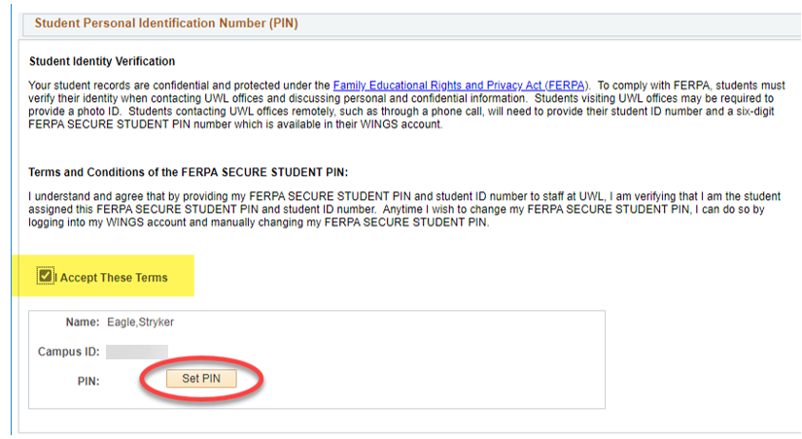

- Scroll down to the bottom of the page and click save.

Updating your PIN
If you feel your number is no longer secure (e.g. someone else may be using the number), you can generate a new PIN. Login into your WINGS Student Center and navigate to the Set/Update FERPA Secure PIN page. Click Set PIN again and then save. The old PIN will no longer be accepted by UWL offices.

Additional info
The FERPA Secure PIN can be changed at any time by current students. Students should not share their personal FERPA Secure PIN with anyone. This is used to authenticate the individual student's identity only.

Along with your campus ID and name, your FERPA Secure PIN will help identify you to staff members and allow them to release information to you. If you do not create a PIN for yourself, when you contact those offices, they will instead ask 1) for your campus ID and name; and 2) two or more other pieces of personally identifiable information such as classes you are or were enrolled in and other information from your record that will help identify you. If you come in person, they will ask to see a photo ID instead.

Former students
After you have graduated or left UWL, your FERPA Secure PIN is no longer available, and you must verify your identity using your campus ID and other pieces of information.

To create a PIN for another person to use, see the directions on FERPA PIN for Guest.

FERPA PIN for Guest/Parent

Creating a Guest PIN
- If you are already on the FERPA Secure PIN page in WINGS, scroll down to the Guest Personal Identification Number section. If you are not in WINGS yet,
  - Login to your WINGS Student Center.
  - Select UW-La Crosse from the left-hand menu.
  - Select FERPA Secure Pin.
  - Select Set/Update FERPA Secure PIN.
  - Scroll down to the Guest Personal Identification Number section
- The Terms and Conditions statement for a guest FERPA Secure PIN are:

I understand and agree that when my FERPA Secure PIN and name are provided to staff at UWL, it indicates the following:
- That I have granted permission for staff at UWL to share one or more of the following information with the holder of this FERPA Secure PIN:
  - Information about my tuition, fees and financial aid
  - Information found in my academic record, with the exception of current schedule of classes and all course grades.
- That this action will not permanently remove any FERPA block I may have for other purposes; however, it does indicate my desire for UWL staff to override the FERPA block and communicate with the holder of my FERPA Secure PIN each time contact is made.
- That anytime I wish to rescind this permission, I can do so by logging into my WINGS account and manually change my FERPA Secure PIN.
- That after changing my FERPA Secure PIN, I must provide my new FERPA Secure PIN to anyone with whom I wish to grant access to the information described above.

- Check the box next to I Accept These Terms if you agree to this statement. If you do not agree, stop here and do not create a PIN.
- A new section will appear with the option of creating PINs for up to three individuals. Enter your guest's name in the box next to Name.
- Click Set PIN. A 6-digit number will be generated and appear next to the PIN label.
- Check one or both boxes labeled Finances and/or Academic Records.

  - Finances: May discuss account charges and payments, financial aid disbursements, and enrollment status as it relates to your financial obligations to UWL.
  - Academic Records, with the exception of current schedule of classes and all course grades: May discuss application status, placement information, transcript status, test score status, enrollment, progress toward degree, academic standing, etc.
  - IMPORTANT: The FERPA Secure PIN does not grant access to:
    - Course grades and current schedule of classes
    - The holder party to sign documents or make decisions/changes on a student behalf

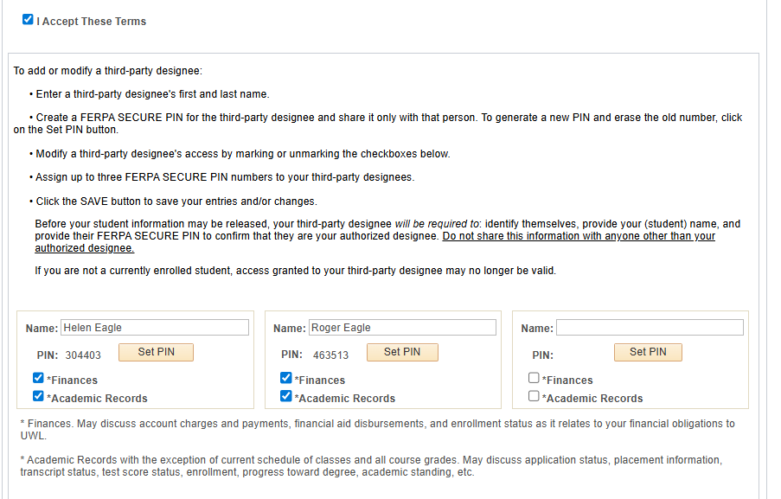

- If more than one person needs a PIN, repeat steps with the next Name field.
- Scroll down to the bottom of the page and click save.
- Contact your guest(s) and give them the FERPA Secure PIN generated. Before your student information may be released or discussed, your guest will be required to: identify themselves, provide your (student) name, and provide their FERPA Secure PIN to confirm they are your authorized designee. Do not sure the PIN with anyone other than your authorized designee.

Updating Guest PINs
You may change the FERPA Secure PIN any time while still a current student. Examples of reasons to change or remove the PIN are:
- You feel the PIN is no longer secure (e.g. someone else may be using the number)
- You no longer want the guest's to have access to discuss your records/account.

Generate a new PIN by coming back to the Set/Update FERPA Secure PIN, selecting Set PIN again next to the name that you would like to update, and click Save. The old PIN will no longer be accepted by UWL offices. To deny access, you may also remove the person's name. Always remember to click Save.

If you are no longer a student at UWL, access granted to your guest may no longer be valid.

Directory information restrictions vs FERPA secure PIN access
When a student gives a FERPA Secure PIN to a parent or other third party, that permission overrides any directory information restrictions that already exist. Directory information is information designated as public by the university, and it can be released by the institution for any purpose, at its discretion. For directions on how to restrict directory information, please see Privacy Settings/FERPA Restrictions on the WINGS Help page.

Please note that UWL offices are not required to release information to the third party providing the FERPA Secure PIN, but may do so.

