Final Exam Schedules

Your individual Final Exam Schedule will be available in WINGS mid-way through the semester. Each class should also list when your final exam is in the syllabus.

- Log into WINGS and open the drop-down menu in the Academics section. Select Exam Schedule and click on the arrow button.

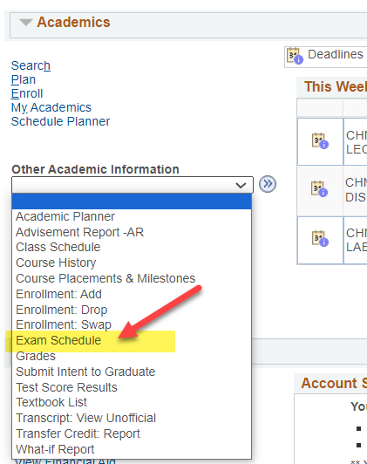

Alternate way to find it: There is also a link to your final exam schedule from your normal Weekly Schedule page. Your normal class schedule and final exam schedule have to be viewed in separate calendars.
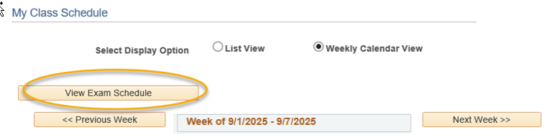

- If the schedule has not been entered yet, the message will say "an exam schedule is not available for this term."

- If the schedule has been entered, your courses will be listed with the dates, times, and assigned rooms for the final.

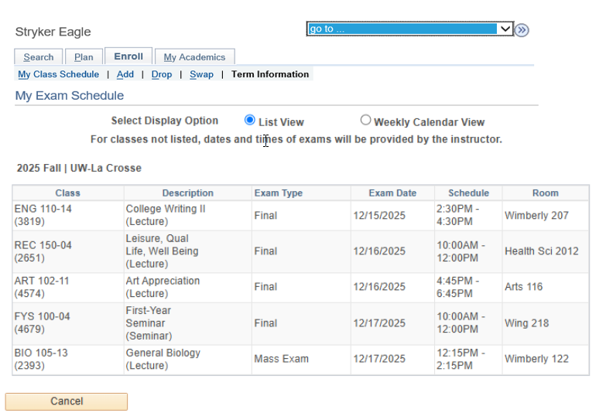

Important: For classes not listed, dates and times of exams will be provide by the instructor. Check your syllabus or with your instructor to be sure.

- Click on the Weekly Calendar view option at the top to see the times in a calendar grid. Remember, the calendar grid goes by weeks.

Important: In the Fall, finals week starts in one week and ends in the next. Use the Next Week/Previous Week buttons to change weeks.
