How to Submit Your Intent to Graduate

Submitting your intent to graduate indicates you want to be notified about Commencement information, that your degree requirements are almost completed and a credit check on your record is needed, and that you want to be notified about other important information for soon-to-be graduates.

You should notify UWL of when you expect to graduate graduate when it is within the next calendar year. Please submit your expected term of graduation by the start of your final term at the latest.

The deadline for your name to be printed in the Commencement program is November 1st in the Fall (for the December ceremony) and April 1st in the Spring (for the May ceremony). Students graduating in the summer participate in the May ceremony and Winter graduates participate in the December ceremony.

# Directions

1. In the **Academics** area of your Student Center, select **Submit Intent to Graduate** from the Other Academic Information drop-down menu. Click the double arrow Go button.

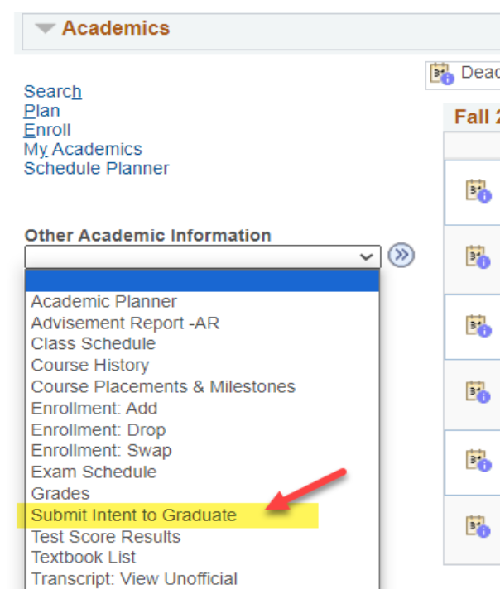

1. Review the degree program, major and minor to make sure they are correct. If they are not, contact your College Dean's office for assistance or submit a [Change of Major](https://www.uwlax.edu/records/student-resources/faqs/#tm-70834) form.

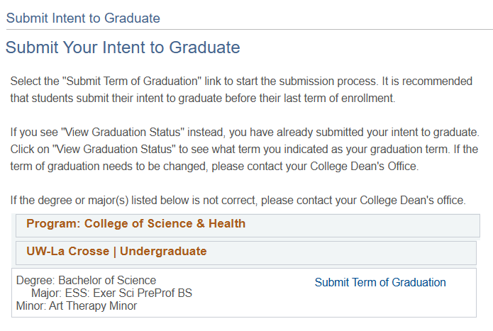

1. Click on the **Submit Term of Graduation** link next to the degree program from which you are graduating.

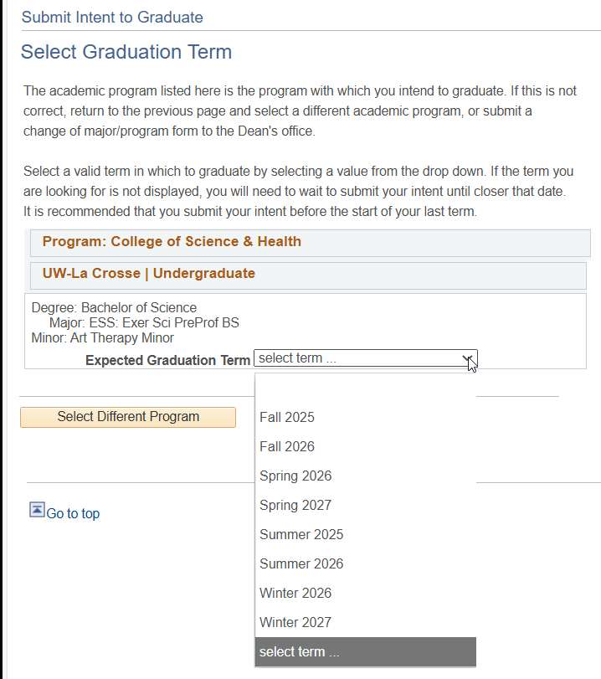

1. Select your expected graduation term and click **Continue**. Please note that the terms are listed alphabetically, so be careful to select the correct term. If the future term you are searching for is not available, return in a semester and see if it is available then.
2. Another section will appear with information about Commencement, your diploma, and what will happen to your netID and email after graduation. The full information provided is listed at the end of these directions.
3. Read the information and then click **Continue** at the bottom.
4. Confirm the term you selected.

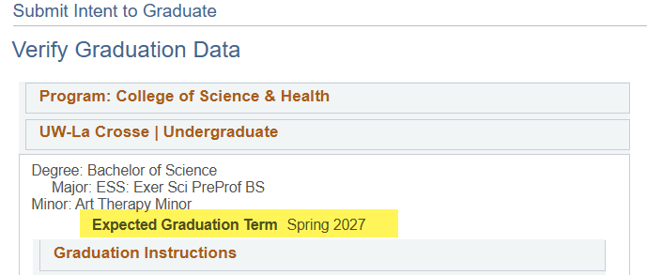

1. Click **Submit Application** at the bottom of the screen.
2. A message should appear that says, "Submit Confirmation: you have successful submitted your intent to graduate." This indicates you are done.

You can also verify that term was submitted correctly by clicking on the My Academics tab at the top of the page. Select **View my graduation** status at the bottom of the list of links. The status will say "Submitted Intent to Graduate" if you have already completed this. Note the expected graduation term listed. If that term is incorrect, contact your College Dean's office.

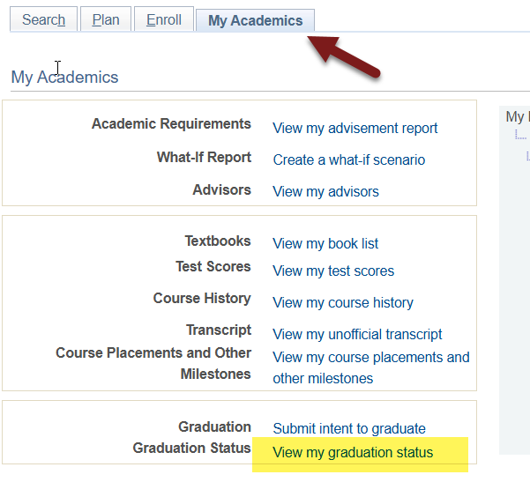

# Graduation Instructions:

Read the below information to learn more about Commencement, diplomas, and your net ID and email after graduation. This information is shown in WINGS when you are submitted your intended term of graduation.

If you need to change your graduation term to a different term, you must contact your dean's office.

Information regarding the upcoming Commencement ceremony is available on UWL's [Commencement website](https://www.uwlax.edu/commencement/). The ceremony will be held at the La Crosse Center. Summer graduates participate in the May ceremony, and Winter Intersession graduates participate in the December ceremony.

Your diploma will be mailed to your Home address. Please verify/update that information before the end of your last term at UWL.

Please also update your "personal" Email Address in WINGS to a non-UWL email before the end of your last term at UWL. Your digital diploma will be sent to your personal email address. To have access after graduation, your personal email address must be a non-UWL email.

**Important: Your UW-La Crosse Net ID will be deactivated approximately 6 months after graduation. This will remove your access to WINGS, UWL email account, personal files, data on OneDrive, and other resources accessed with your Net ID account. The data will be deleted and will not be retrievable. You will receive notice of the pending deletion two to four weeks prior to the process. Please note that Canvas access ends when your last class is finished.

Besides updating your addresses, please take the actions below that apply to you to ensure a smooth transition after graduation:

1. Use your last term of enrollment to start transitioning to a personal email address for job and graduate school applications.
2. Update any non-UWL accounts created with your UWL email address to a personal email. For example, if you have used Parchment Transcript Services to order an official transcript, make sure your email address on that account has been changed to a personal, non-UWL email. Another common example is to check that your Google account is using a non-UWL email.
3. Copy and save the data you would like to save from your OneDrive, email (messages and contacts), and other UWL systems to your own personal computer or storage device before you leave UWL. Copy and save any data from Canvas you need now, before the end of your last term of enrollment.
4. Within a few months of your degree being posted, download a copy of your unofficial transcript from WINGS for future use.
5. (Undergraduates only) Make note of your major GPA from your Advisement Report as this may be requested when applying for graduate school.

Your legal name will be printed on your diploma and in the Commencement program unless a Degree Name is submitted. If you wish your name to appear differently, go to the "Personal Information" area of the Student Center and click on the "Names" link. Click the "Add a New Name" button. Choose the name type of "Degree." Enter the name as you wish it to appear on your diploma. Save. Please submit this change by April 1st for Spring graduation and November 1st for Fall graduation to have that name reflected in the Commencement program. International students and other students intending to work or study in another country must use their legal name (as it appears on the transcript/VISA) to avoid complications with proof of degree.