Using My Planner

My Planner allows students to map out what courses to take, term by term, using the requirements from the Advisement Report. It also connects to Schedule Planner so that students can add a planned course into their schedule during the appropriate term.

Important: the Advisement Report in My Planner closes requirement sections once a course has been added to your plan. However, the regular Advisement Report does not close that section until after you have actually registered into the course. It also shows the most up to date information about grades and credit totals. Thus, to avoid forgetting to register into the course and make sure you know what requirements are left, check your regular Advisement Report every semester as well. Directions on using the regular Advisement Report are separate.

Add Courses to My Planner

- To get to the Planner, click the Plan link in their Student Center. Or select Academic Planner from the dropdown.
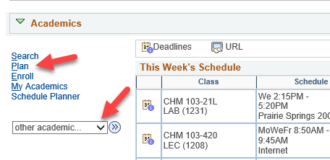

- Click the Plan By My Requirements. This is the My Planner Advisement Report, a copy of your regular Advisement Report where you can select courses from what requirements still need to be met.

Tip: Remember to remove courses from My Planner after enrolling or completing the class to avoid the course showing in the report twice, which can throw off credit totals.

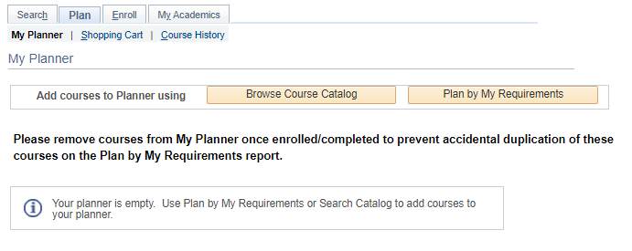

- Scroll through the Advisement Report to find the sections marked Not Satisfied. A list of courses will be displayed that will go toward that requirement. Click on the course title that you want to use to complete the requirement.

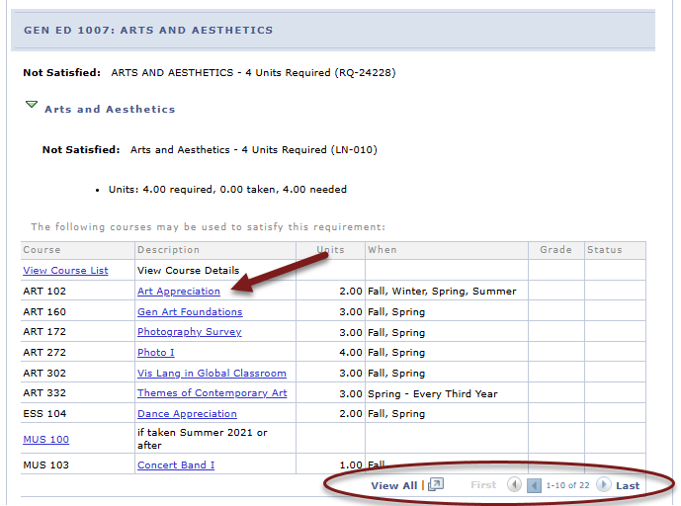

- Review the Course Details, including the Enrollment Information which will include prerequisites if any and the course description.
  - Click on View Class Sections to find out if any sections are being offered in the upcoming term. A section will open up below.

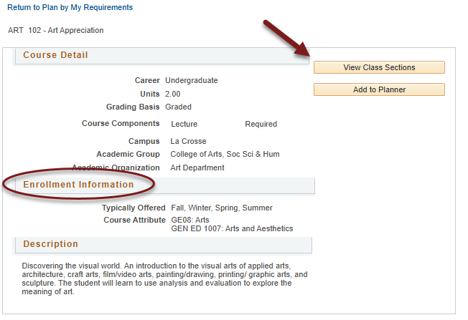

  - Be sure to look at the Terms Offered menu to see what terms are available. You can change terms by selecting another one and clicking Show Sections.

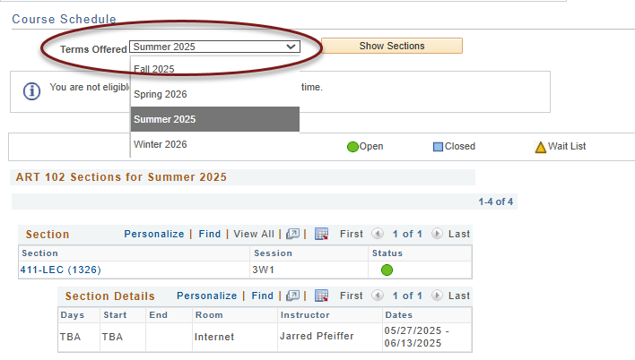

  - To estimate whether a class will be offered in a future term not available yet, review the Typically Offered information. Please note that the typically offered information is an estimate from the department on the next time the course will be offered, but it is not guaranteed.

- Scroll back to top of page and click Add to Planner if you'd to add that course to your plan.

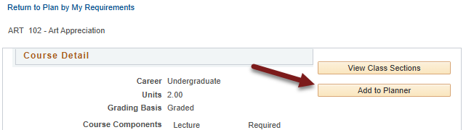

- A confirmation message will display at the top saying the course was added to your planner

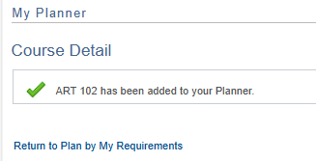

- To add additional courses, select Return to Plan by My Requirements and repeat the steps.

- To move courses to specific term, return to the My Planner screen using the My Planner tab at the top.

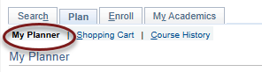

- After being added to the planner, courses are listed as Unassigned. Select the course using the checkbox, and then select the appropriate term from the "move selected courses to Term" dropdown menu. Click Move.

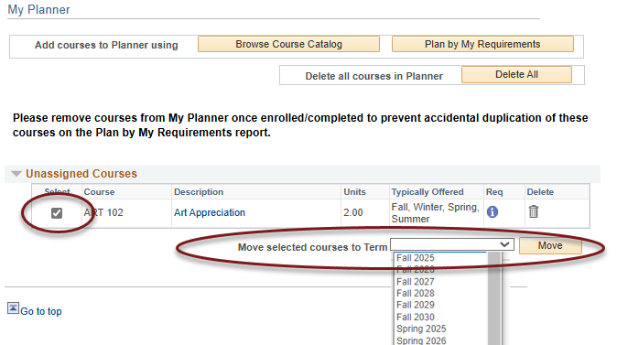

- You'll see a confirmation message that your move was successful and the course listed underneath the term.

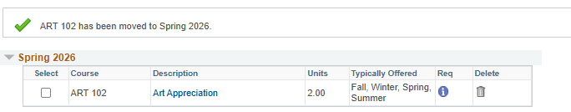

- After adding all the courses to your Planner, click the Plan By My Requirements to see the My Planner Advisement Report with these courses added. If the course satisfies the requirement, that section will now be closed. Click on the arrow to expand the section and review. The course will display with a star in the Status and act as a marker to satisfy a requirement even though the course has not been taken yet. If the course has been assigned to a term, the planned term will display in the When column.

Important: Your regular Advisement Report does not show your planned courses (courses with a blue star). Only the Plan By My Requirements/My Planner Advisement Report will include them.

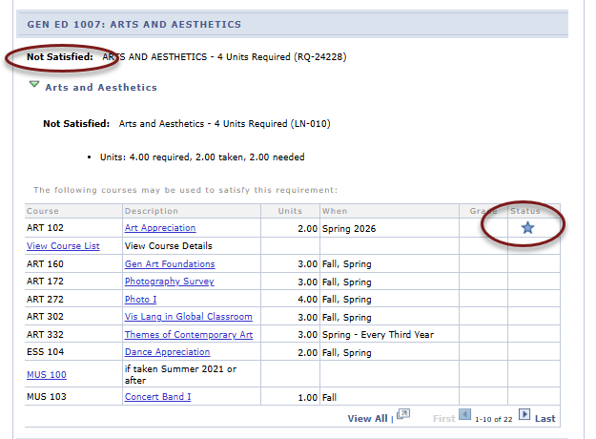

Registering in Planned Courses

Schedule Planner
Only planned courses assigned a term in WINGS are available in Schedule Planner. Unassigned courses are not available.

- Click on the link to Schedule Planner in your WINGS Student Center and select the correct term.

- Click +Add Course to add courses from My Planner to your schedule.

- Select the My Planner tab and review the courses listed. Only courses that you have assigned to that term in WINGS will appear as an option. Select the course and click +Add.
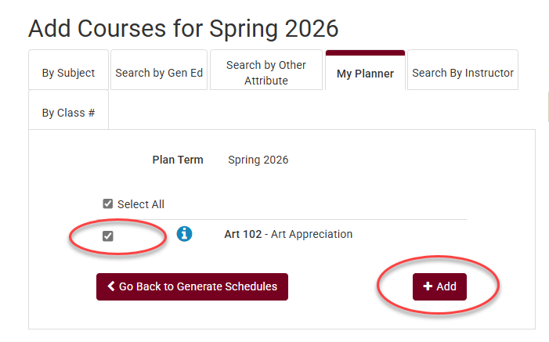

- Add more courses to your list or click Go back to Generate Schedules.

- Click Generate Schedules to view possible schedules.
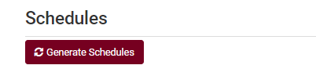
- From the generated schedules, click View to see a schedule in the weekly calendar grid and to move to the next step.
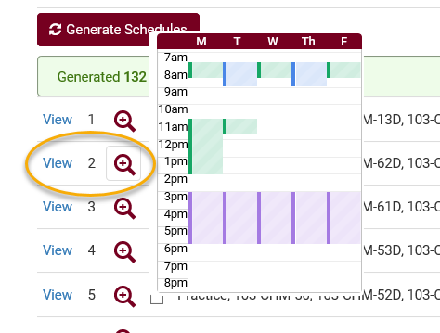

- On the potential schedule page, when you are ready to add to shopping cart, click Send to Shopping Cart near the top of the page. Once it is in the shopping cart, you can register as soon as your appointment starts. More directions on how to generate schedules and register can be found on the WINGS help page.
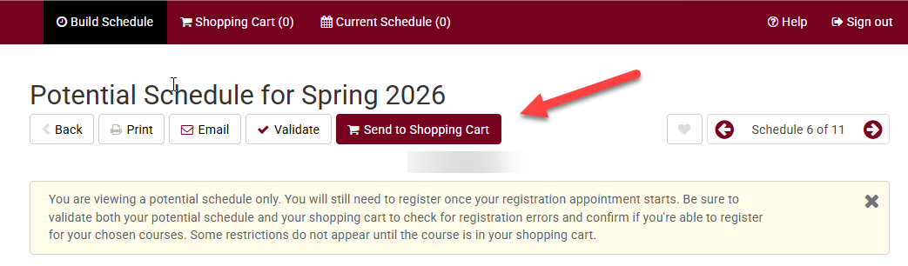

WINGS
In WINGS, courses both assigned to that specific term and unassigned can be added to the shopping cart.

- Log into WINGS and select Plan in the Academics section. Or select Academic Planner from the Other Academic Information drop-down menu in the Academics section.
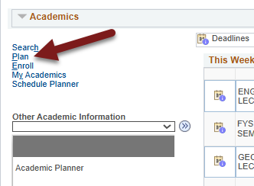

- Navigate to the shopping cart using the tab at the top.
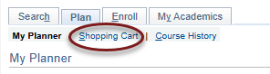

- Select the correct term and then select My Planner in the left options and click Search.

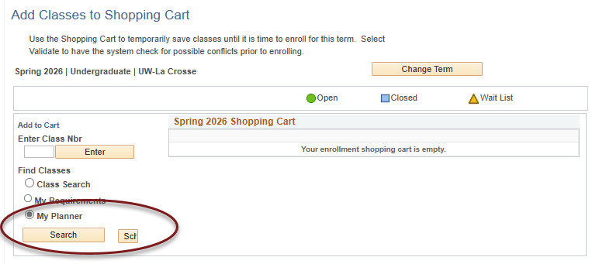

- Courses that are available for that term will display and can be added by clicking Select at the right.

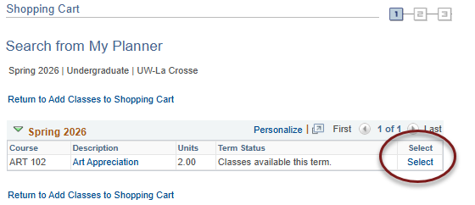

Tip: If an error message comes up saying "You are unable to enroll at this time, the time period for enrolling in that term has passed," recheck what term you are in and click on Shopping Cart at the top to select a different term.

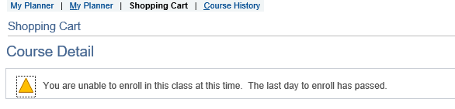

- Review the Course Details for the selected class. Scroll down to view the sections that are available and look at the Status to see if they are open, closed, or wait listed. Click the Select button to choose a section.
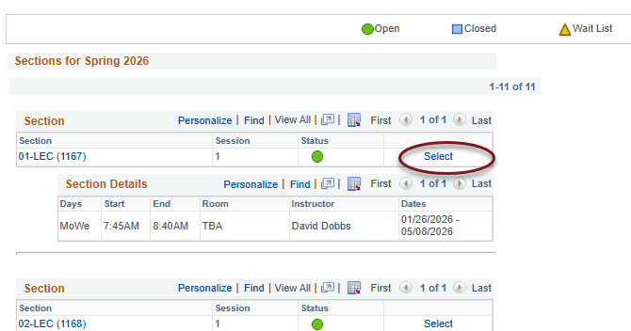

- If the class is full but has a wait list (yellow triangle icon), select the Wait List if Class is Full box. You don't need to check it if the class is open.

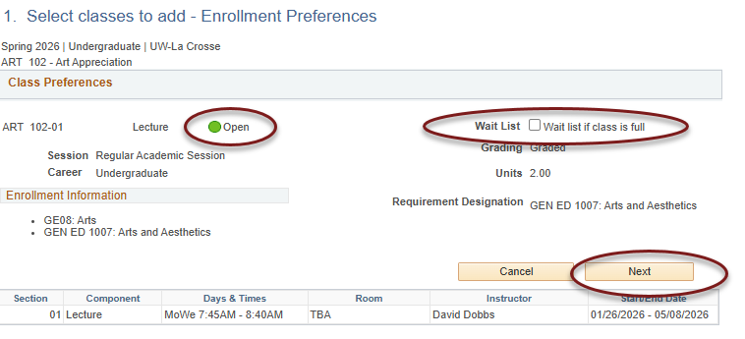

- Click Next. The course has now been added to your cart. The shopping cart in Schedule Planner has also been updated.

- To finish registering in WINGS, checking the box next to the class and clicking Enroll. Or you may click on Schedule Planner to continue registering through that application.

