Register for a Class using
Schedule Planner

- Click the Schedule Planner link under the Academic section of your Student Center.
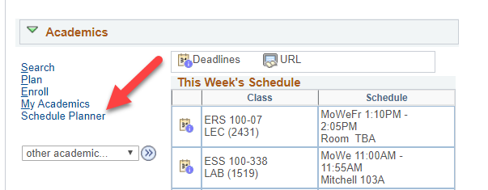

- Select the term that you are registering for and click Save and Continue.

- Search and add courses to your potential schedules by following the steps in the Search for Classes/Creating a Schedule using Schedule Planner" directions.

- Check the courses you'd like to generate a schedule for from your Course list and then click Generate Schedules.

- Review schedules to find the one you like best and click View to see more details.

  - If you have already developed a schedule and saved as a Favorite, go to the Favorites tab to find the schedule, and click View. (More details on how to create a Favorite schedule are in the "Favorite Schedules in Schedule Planner" directions.)
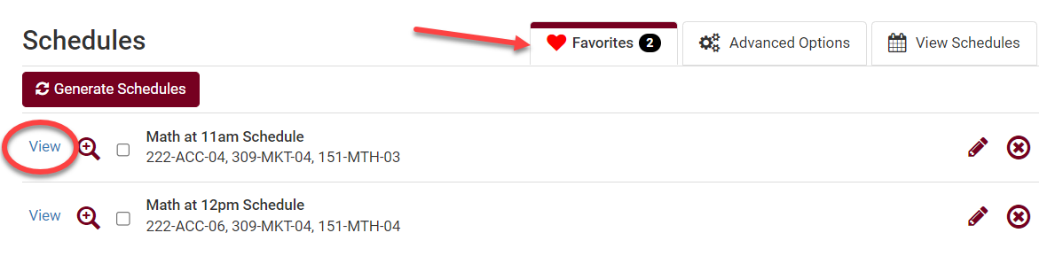
  - When reviewing potential schedules, keep an eye out for sections that are closed with no seats in the class and no seats on the waitlist. You will not be able to get into these classes without an override.
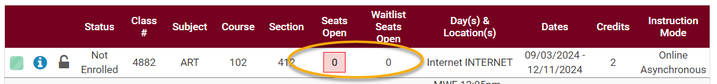
- If you are ready to register into the selected class schedule, click Send to Shopping Cart.
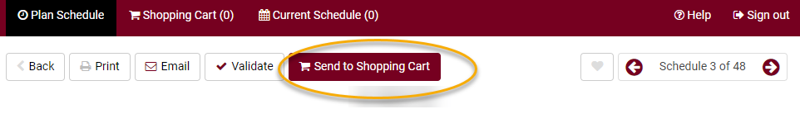

- Review & validate the courses in your Shopping Cart.
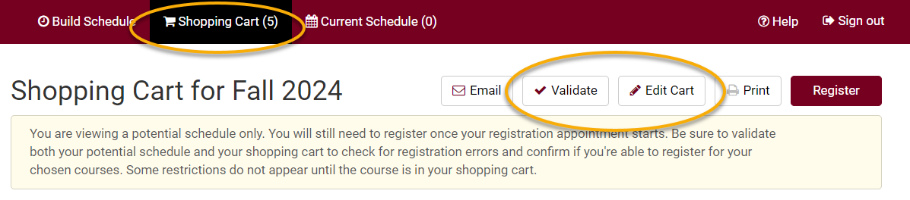
  - Click Validate to verify that you meet the prerequisites before registering.
  - Review your results.
    - A green check mark indicates there should not be a problem registering for those courses, as long as nothing on your record changes.
    - A red warning icon indicates that there is a prerequisite, time conflict, or instructor permission issue. Read the message for further information on the error and how to resolve it.

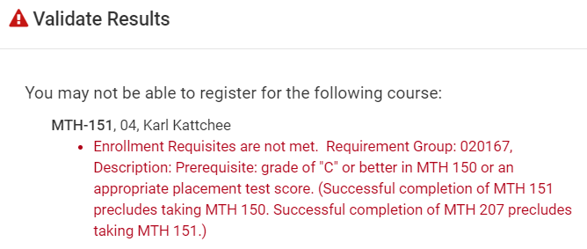
  - Before registering, drop any courses you do not want from your shopping cart, as the system will attempt to register you into all courses in your shopping cart.
    - Click Edit Cart.
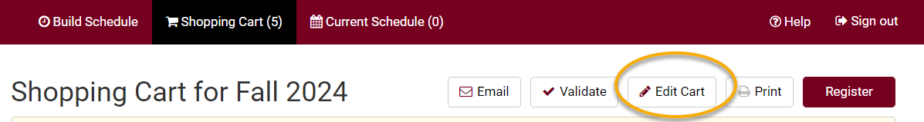

    - Check the Remove from Cart box next to the course and click Save.
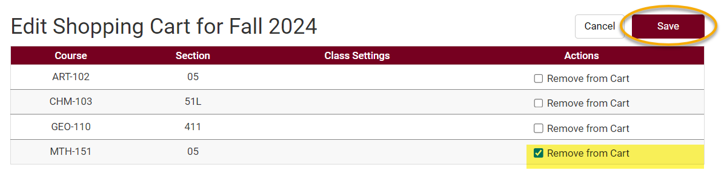
  - To add another course, go back to the Build Schedule page, add another course to your list, and generate a new schedule.

- If your shopping cart is ready and your registration appointment has started, go to your Shopping Cart and click Register.
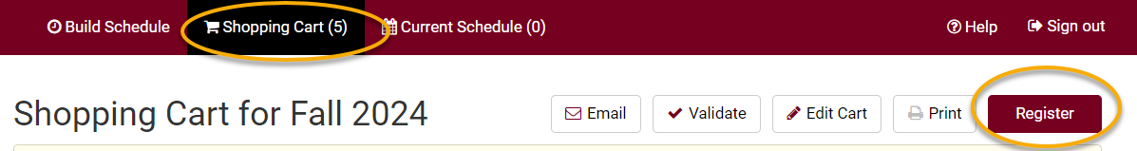

- The Terms and Conditions notification and agreement will appear, which relate to your financial obligations to the university. Click the link to read the terms and conditions. When ready, click Agree and Continue.
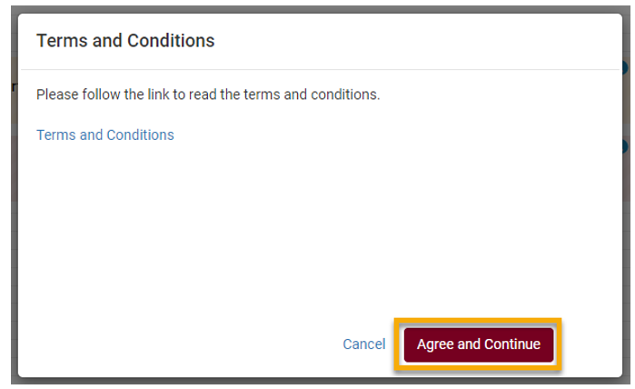

- Next, click Continue to confirm that you want to register for this schedule.
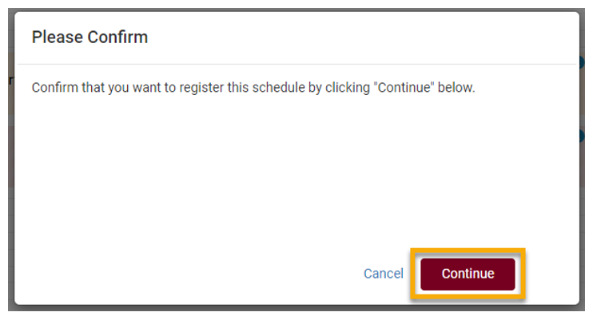

- Review your Registration Results.
  - A green check mark means you successfully registered in the course.

  - A red warning sign means you have not been registered in the course. Read the full message to understand why. If you have questions about the error you received, contact the Records and Registration Office for assistance.
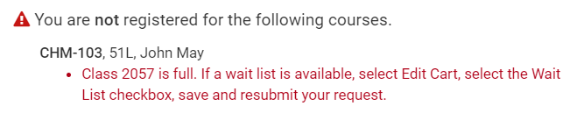
- View your registered schedule to ensure your schedule is as expected. This is found on the Current Schedule tab in Schedule Planner or by looking up your Class Schedule in WINGS.
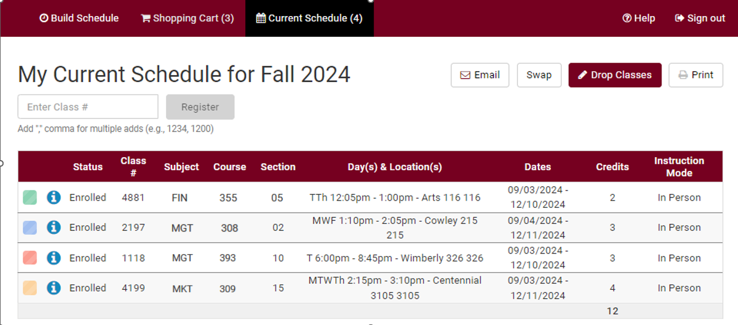
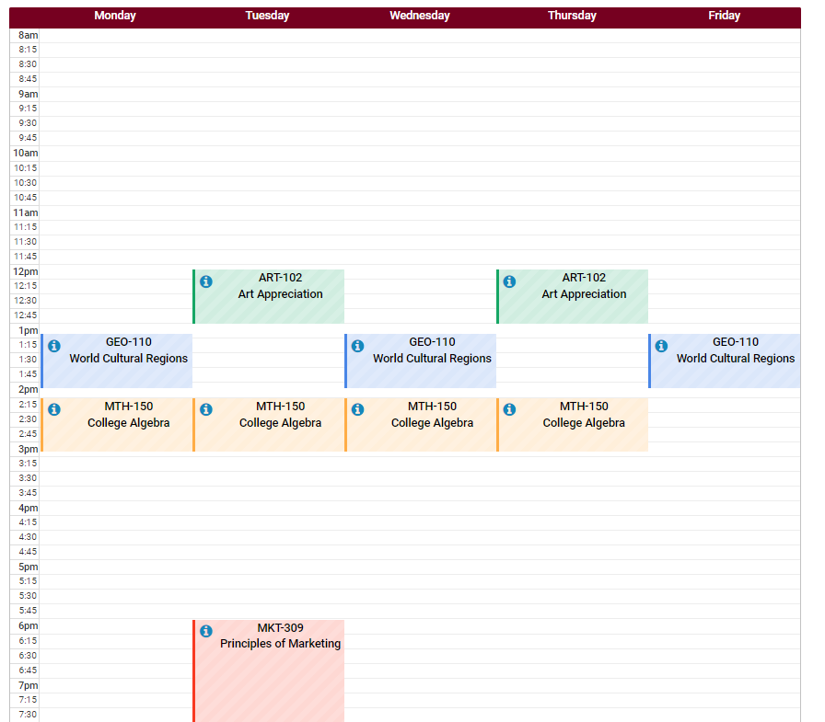

- After registering, you may change your schedule through the start of the term. Deadlines are determined by the length of the class.
  - To drop enrolled classes:
    - Click on Current Schedule tab in Schedule Planner. Click Drop Classes.
    - Check the Drop box next to the course or courses you wish to drop.
    - A message will pop up about the non-refundable registration fee and a reminder to return your textbooks within 24 hours.
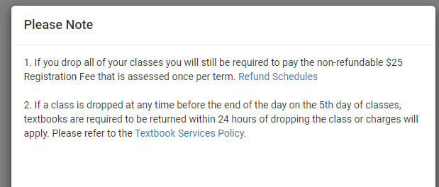
    - Click Confirm.
    - Save.
    - Please note, you can also drop courses through your WINGS by clicking on the Enroll link, selecting the Drop tab, and following the directions.
    - More detailed directions on swapping can be found in the "Dropping in Schedule Planner" directions.

  - To swap enrolled classes:
    - Use the Swap button found on the Current Schedule tab.
    - Select a class already in your schedule.
    - Search for the class you want to switch into using the By Subject, Shopping Cart, or By Class # options.

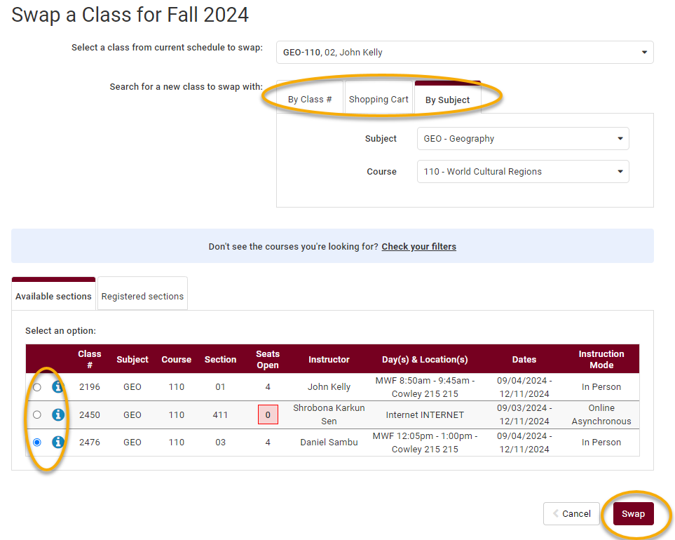
    - If the results provide multiple sections, select the one that will work in your schedule, keeping an eye on whether there are open seats in that section or not. To see if there is a waitlist option, click the blue information icon next to the section and look for Waitlist Seats Open.
    - Review the swap and click Swap if it looks good. Confirm that you want to keep swapping and click Swap again.
    - Review messages. If it was successful, you will see a green checkmark. If was not successful, you will see a red warning icon. Review the error before attempting to swap again.
    - More detailed directions on swapping can be found in the "Swap a Class Using Schedule Planner" and "Swapping onto a Waitlist in Schedule Planner" directions.

- View your course schedule after you register to ensure you have successfully enrolled in your desired courses. In Schedule Planner, that is the Current Schedule tab. In WINGS, that is Class Schedule in the drop-down menu.

Please note:
- After the fifth day for Fall & Spring semesters, you need instructor permission to add their class, even if it has a seat available. The last day to add with permission for a full semester class is the 10th day of classes.
- Winter and Summer terms have shorter deadlines. Classes shorter than full semester also have shorter deadlines.
- Swapping: Swapping into a course with an open seat will automatically drop you from the first course. Swapping onto a waitlist seat means you will stay in the class you intend to drop unless you get into the waitlisted class.
- Overrides: Classes that are closed or have prerequisites that are not satisfied can only be enrolled in with permission from the instructor, department, and/or dean's office, depending on what is being overridden.
    - Overrides can be given electronically up through the 10th day. Students must login to Schedule Planner and register themselves before the deadline after obtaining an override.
    - Closed classes will still appear closed; if you have an override, you will be able to register anyway.
- If a class is dropped any time before the end of the day of the 5th day of classes, textbooks are required to be returned within 24 hours or charges will apply.

Questions?
- Questions about what courses to sign up for, contact your advisor or the Academic Advising Center in 1209 Centennial Hall or at advising@uwlax.edu.
- Questions about an error or have trouble registering, contact the Records and Registration Office for assistance at records@uwlax.edu or 117 Graff Main Hall.

