Register for a Class using WINGS

- Login to WINGS and click Enroll in the Academic section.
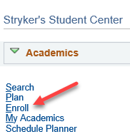

- Make sure you are on the Enroll tab and the Add subtab.
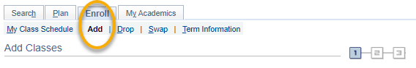
- Select the term that you are registering for and click Continue.
- On the Select Classes to Add screen, the Shopping Cart is the section next to the blue box in the middle. If you have registered in some classes already, they will be in the Class Schedule section.
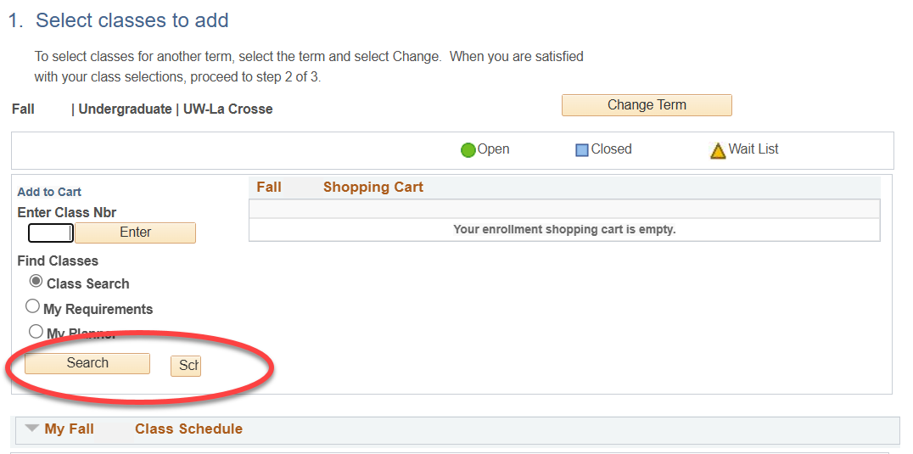

- If you haven't yet, add the desired courses to your Shopping Cart following the steps in the "Search for Classes/Using the Shopping Cart in WINGS Student Center" directions. The course must be in your Shopping Cart before you can register.

- Once you have your courses in the shopping cart, review course shopping cart. The system will attempt to register you for everything in your cart. You may want to remove any classes you aren't sure about or which conflict with another class clicking on the garbage can icon.
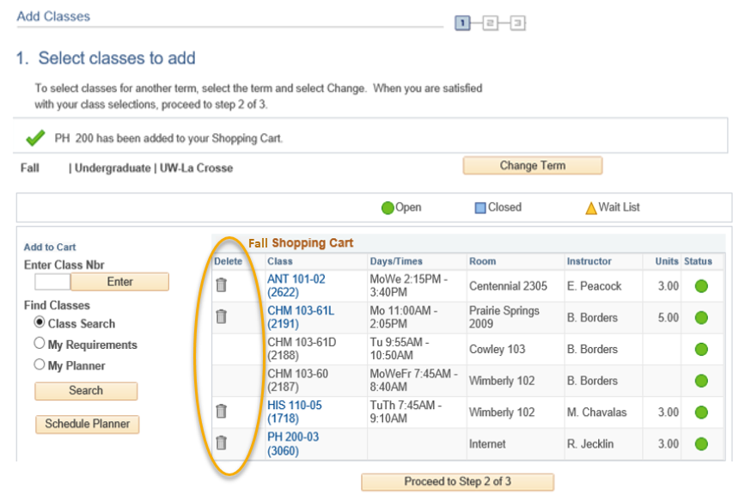

- When your shopping cart is ready, click Proceed to Step 2 of 3.
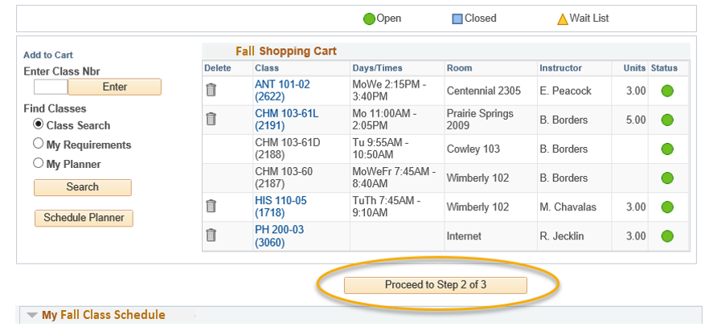

- Review the courses that you wish to add.
  - If you attempt to enroll in courses that conflict with each other, WINGS will automatically enroll you in the one that appears first in the Cart. You will receive a time conflict error for the other one.
- Confirm the list is correct and click Finish Enrolling. Important: this is not the final step!
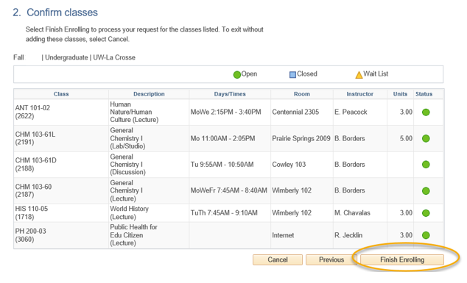
- Next, the Terms and Conditions agreement will appear, which relate to your financial obligations to the university. Click the link to read the terms and conditions. You will be taken to the full agreement listed on the Cashier's website.

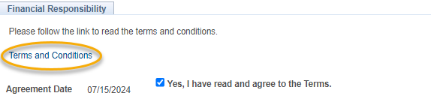
- When ready, check the box next to "Yes, I have read and agree to the Terms" to agree to the terms and continue. Then click the link titled "Continue. You will have to click Finish Enrolling again."
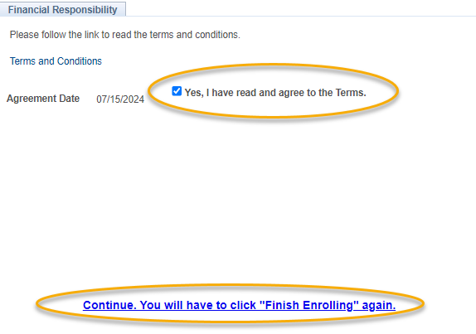

- The Confirm Classes (step 2) page will appear again. Click Finish Enrolling.
- View your results.
  - A green check mark means you successfully registered in the course.
  - A red X indicates that you have not been registered in the course. Read the full message to understand why. If you have questions about the error you received, contact the Records and Registration Office for assistance.
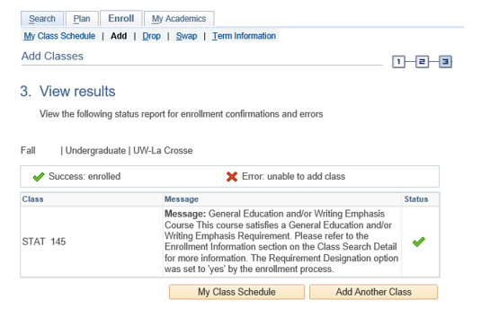

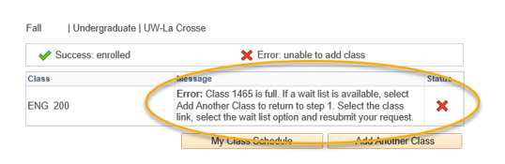

- View your registered schedule to ensure your schedule is as expected. Click on My Class Schedule underneath the results table.

- After registering, you may change your schedule through the start of the term. Deadlines are determined by the length of the class.
  - Review the "Dropping in WINGS" directions for more info on dropping an enrolled class.
  - Review the "Swapping A Class in WING"S or the "Swapping onto a Waitlist in WINGS" for more information on swapping.

Please note:
- After the fifth day for Fall & Spring semesters, you need instructor permission to add their class, even if it has a seat available. The last day to add with permission for a full semester class is the 10th day of classes.
- Winter and Summer terms have shorter deadlines. Classes shorter than full semester also have shorter deadlines.
- Swapping: Swapping into a course with an open seat will automatically drop you from the first course. Swapping onto a waitlist seat means you will stay in the class you intend to drop unless you get into the waitlisted class.
- Overrides: Classes that are closed or have prerequisites that are not satisfied can only be enrolled in with permission from the instructor, department, and/or dean's office, depending on what is being overridden.
- Overrides can be given electronically up through the 10th day. Students must login to Schedule Planner and register themselves before the deadline after obtaining an override.
- Closed classes will still appear closed; if you have an override, you will be able to register anyway.
- If a class is dropped any time before the end of the day of the 5th day of classes, textbooks are required to be returned within 24 hours or charges will apply.

Questions?
- Questions about what courses to sign up for, contact your advisor or the Academic Advising Center in 1209 Centennial Hall or at advising@uwlax.edu.
- Questions about an error or have trouble registering, contact the Records and Registration Office for assistance at records@uwlax.edu or 117 Graff Main Hall.

