Search for Classes/Using the Shopping Cart in Your WINGS Student Center

You may start searching for classes as soon as the next term's schedule is made public. However, shopping carts and validation appointments are not immediately available. Shopping carts must be activated before you can save courses to them. They will be activated 1-2 days after the schedule comes out. A shopping cart appointment will show up in your WINGS in the Enrollment Dates section.

- Click the Search for Classes button in the top right-hand corner of your Student Center.

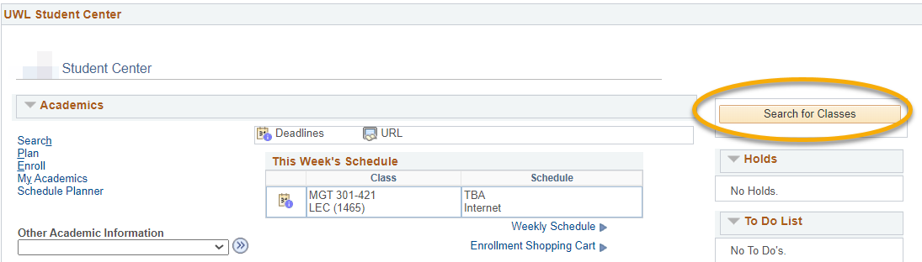

- On the next page, the Search and Search for Classes tabs are selected.
  - Note the other tabs for future reference. You can use them when managing your Shopping Cart and planning your courses (Plan); enrolling, dropping, and swapping classes (Enroll); and looking at other details of your academic record (My Academics).
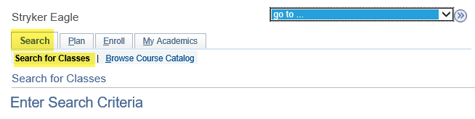
- The search defaults to a term. To search another term, click the drop-down list, and select another term.
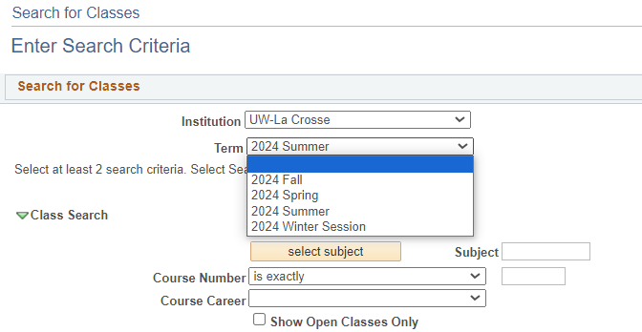

- Click the Select Subject button in the Class Search section. If you already know the course prefix, type the prefix in the Subject field and skip ahead to step 8.

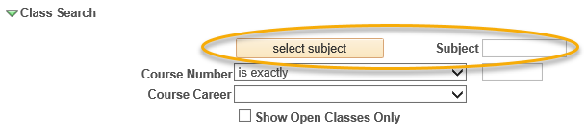

- In the A-Z list, click the first letter of the subject you would like to search.
- Click the Select link next to the subject you would like to search. Do not select a subject without a description; those are prefixes that are no longer active.
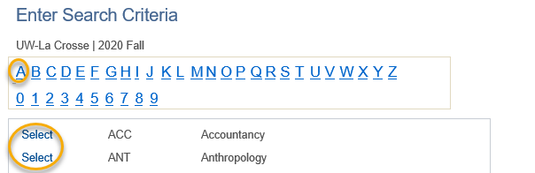

- The subject you select from the A-Z list should now appear in the Subject field under the Class Search section.
- If you know the exact course number you are searching for, enter it into the corresponding box and skip ahead to step 14. Otherwise, go to step 9.
- Select either Graduate or Undergraduate for Course Career.
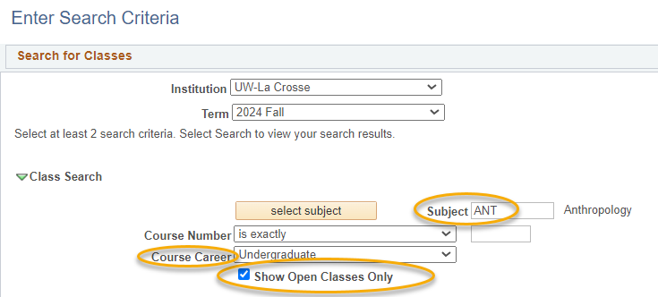

- The box marked Show Open Classes Only might be checked. Classes closed but which have open seats on a waitlist only show up if this is unchecked.

- To narrow down search results, select additional search criteria such as: meeting time, day of the week, instructor last name, class number, course title keyword, minimum or maximum units, session, mode of instruction, or requirement designation.

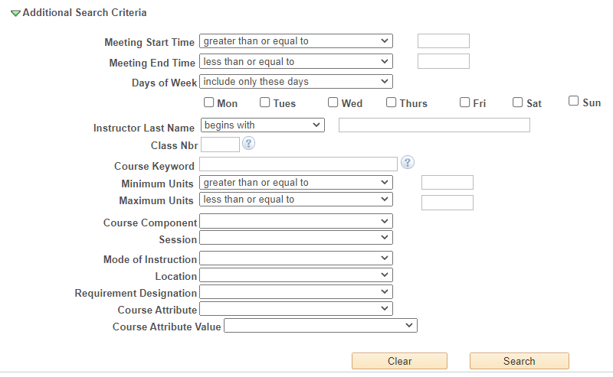

- Definitions of criteria:
  - Class Nbr - is the 4-digit number assigned to each individual section of the course (not the same number as the 3-digit Course Number) to identify a specific section. Students sometimes get this from an instructor or advisor to direct you to the exact section you need, but it is also listed in the section details.
  - Minimum/Maximum Units - number of credits the course should be
  - Session – to find a course scheduled for a certain length of time
    - For half-semester courses, select either First Session - Seven Week or Second Session - Seven Week.
    - For summer courses, the 3 four-week sessions are most commonly use. However, there are also many other lengths of classes including twelve-week, three-week, six-week, eight-week sessions, and many Dynamically Dated courses. Dynamic Dates are dates that don’t conform to the other session dates in the term. These classes can be much longer or much shorter than average.
  - Mode of Instruction –
    - In-Person (or On-Campus or Face-to-Face): Course takes place in a physical classroom.
    - Hybrid (both In Person & Online), a.k.a. Blended: Course takes place in both a physical classroom and online. This combination of online and in-person elements is based on meaningful learning strategies that best serve an instructor’s pedagogical goals and objectives. While a percentage is not mandated, hybrid courses are traditionally 30% to 50% of seat time replaced with online components.
    - Online Asynchronous: Students do not meet in person at a physical site. All content and course activities take place online. Although there are deadlines for students by which they need to complete work, there are no requirements for a specific date/time when the student must be available.
    - Online Synchronous: Students do not meet in person at a physical site. All content and course activities take place online. Some or all of the class occurs in real time. Online elements can be required (e.g., a lecture or exam) or optional (e.g., office hours or discussion times). The course is listed as online in the timetable and a meeting date/time will be scheduled or in the notes. Enrolled students should schedule other classes/activities around that time.
    - Independent Study: Students work out with their instructor when they meet and what topic they will study. This type of course always requires instructor approval to register. First years and sophomores vary rarely have this type of course.
  - Course Attribute and Course Attribute Value - to narrow down results to a specific type of attribute. UWL has attributes indicating if the course is in a General Education category, a Community Engaged Learning course, or a sustainability related theme or topic. Once you choose an attribute, narrow down the results further by selecting a related Attribute Value.
Important: students who started at UWL in the Summer of 2025 or later follow the 2025 General Education Categories. These new categories begin with GEN ED 1001, GEN ED 1002, etc. Students who started at UWL in Spring of 2025 or earlier follow the General Education Categories that start with GE01, GE02, etc. Please refer to your Advisement Report to see which categories you need to satisfy.

- Click the Search button when you are ready to see the results.
- If notified that the search will return over 50 classes, click Cancel to modify your search criteria or click OK to see them all.

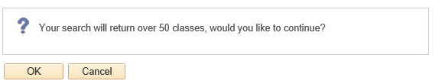

- Review search results:
  - If you did not enter the exact number of the course you are looking for, all courses that meet your criteria will appear on this page.
  - Open courses have a status marked with a green circle, while closed courses are marked with a blue box. The yellow triangle is on closed courses that have open waitlist seats. Remember, waitlisted courses only appear if Show Open Classes Only is unchecked.

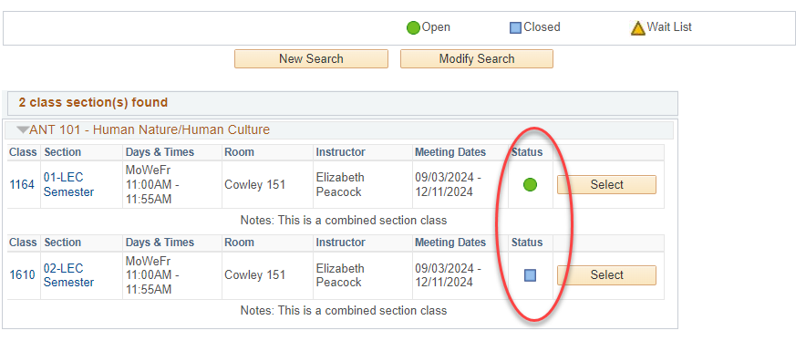

- To view more information on a particular course, click the linked Section number. Or you can add the class to your Shopping Cart right away by clicking Select.

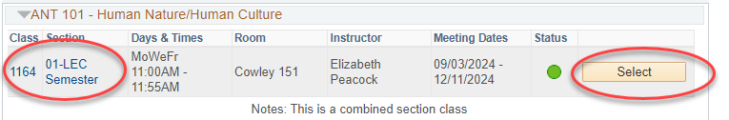

- Clicking on the linked section number shows the Class Detail page. Information includes number of credits (units), class capacity, available seats left, waitlist information, enrollment requirements (prerequisites), and the course description.
- A course's prerequisites will display in the Enrollment Information section as Enrollment Requirements. If there are no enrollment requirements, the section does not have prerequisites.
- Class Attributes are often the general education category that the course satisfied.
- If the section is part of a combined section, it shows the combined sections' capacity and available seats in all sections. Which sections are combined are also shown. Combined classes normally do not have waitlists.

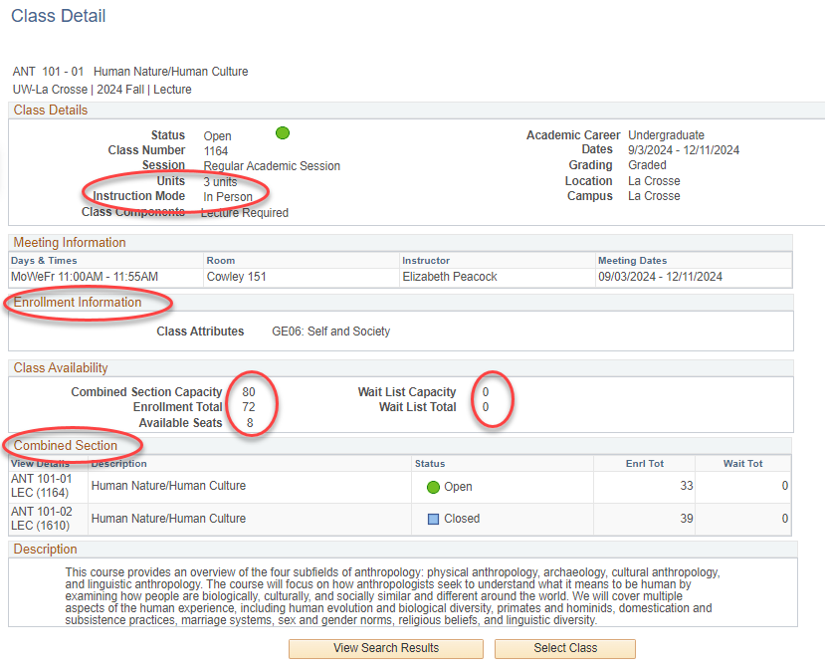

- Links to Class Notes and textbooks are on both the Search Results page and the Class Details page.
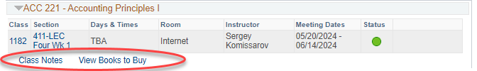

    - Class Notes explain anything else the student may need to know about the class, including additional fees that may not be refundable.
    - The View Books to Buy link takes you out of WINGS. The booklist does not appear until two weeks before the term starts. The complete textbook list for your registered classes is also available from the drop down list in the Academics section of your Student Center at that time. If there is no Textbook List link, the booklist is not available yet for the term.
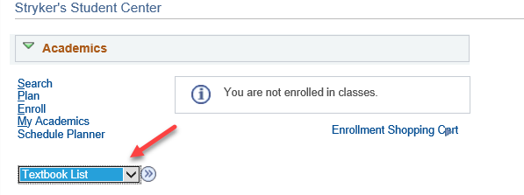
- Return to the previous page by clicking the View Search Results button.
- Click the Select button to add the section to your shopping cart.
Important: putting a class in your shopping cart does not reserve you a seat in the class. There are additional steps to registration after the courses are added to your cart. The additional steps only be completed once your registration appointment starts. There are separate directions on "How to Register for a Course using WINGS."
  - For classes with multiple component options such as CHM 103 and CHM 104, you must first select the lab and then select the related section on the Related Class Sections screen. For CHM 103 and 104, the lecture will automatically be added depending on what lab you selected. A small number of other classes offer similar choices in their registration.

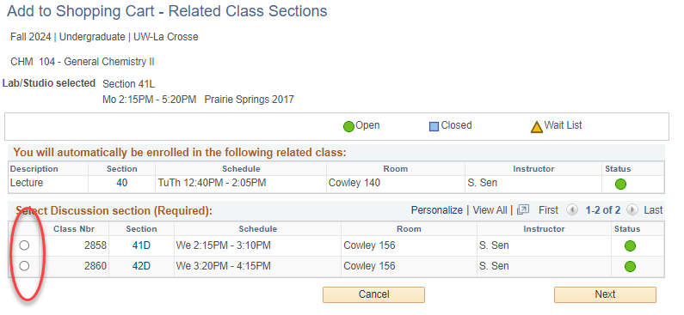

  - If the class is full, you may add yourself to a waitlist by clicking Waitlist if class is full. If there is no option, there is no waitlist set up for this class.
Important: If the class is already in your shopping cart but you didn't check the waitlist box, you will have to drop it out of the cart and add it back in so that you can check the waitlist box. Open waitlist seats are not available for every section. The section will have an orange triangle if it has available waitlist seats.

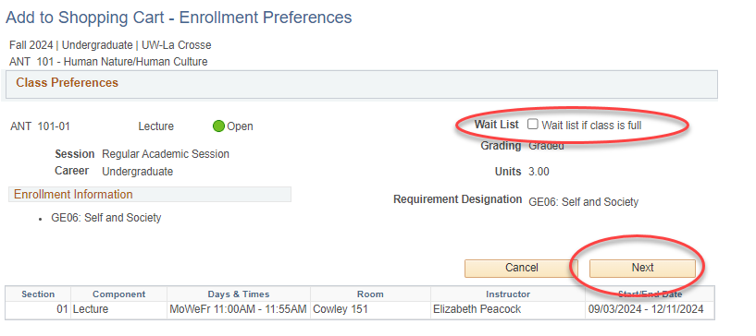

- Click Next. A green check mark and message at the top means you successfully added the course to your cart.
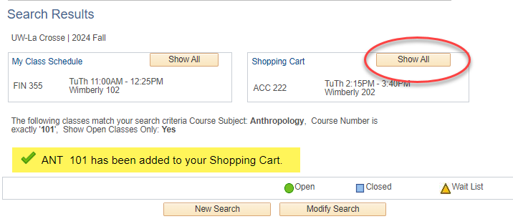

- To add additional courses, click the New Search or Modify Search buttons and repeat steps.
- To return to your WINGS shopping cart later, use the enrollment shopping cart link on the WINGS home screen. You can also get to it while you are searching for classes by clicking on the Plan tab, and then the Shopping Cart subtab.

