Swap a Class in WINGS

*See also Swapping onto a Waitlist in WINGS.

- In your WINGS, click the Enroll link under the Academics section.
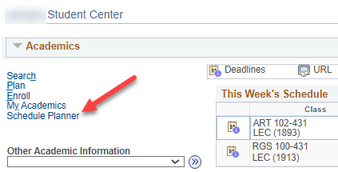

- Select the term and click the yellow Continue button.

- Select the Swap tab. Then choose the course from your schedule that you would like to swap out from the select from your schedule drop-down menu.

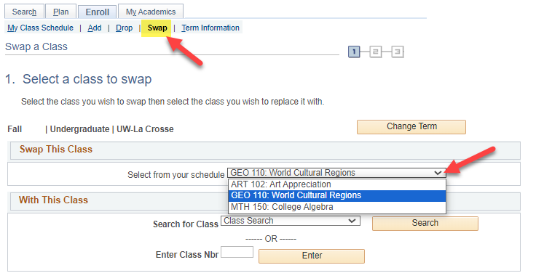

- Search for the course that you would like to swap it with by clicking Search or by entering the four-digit Class Nbr that is assigned by WINGS to individual sections.

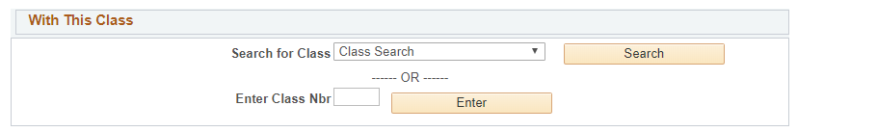

- If you entered the Class Nbr, click Enter. If you found the section in the search, click Select next to the section you want.

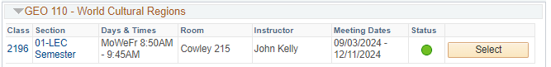

- Review the section to see which one of the following applies:
  - If it is open, it has a green circle. Click Next to continue.
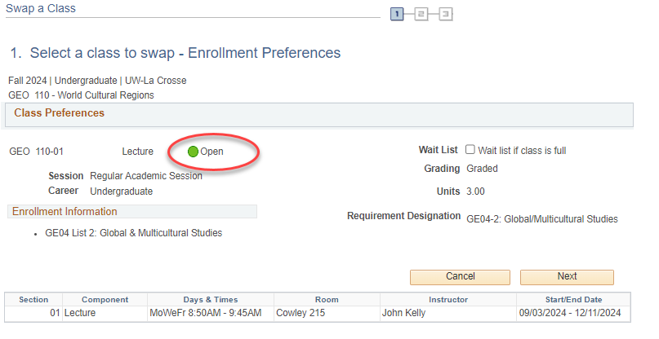

  - If the section is closed (no seats available), there will be a blue box at the top. You will not be able to swap with this class unless you have an electronic class permission (a.k.a. override). If you have an override, click Next to continue.
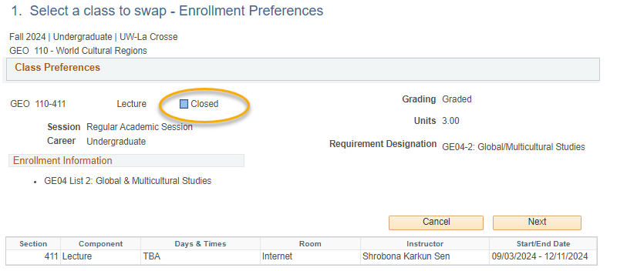

  - If it is closed but has a waitlist, it will have a yellow triangle. To get on the waitlist for a class with a yellow triangle during the swap, select the waitlist if class is full option. Click Next to continue.
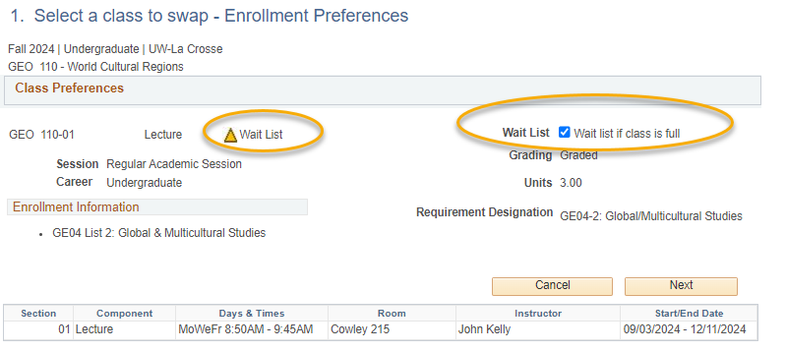

- Review the swap and then click the Finish Swapping button if you are ready to continue. Or click Cancel to start over.

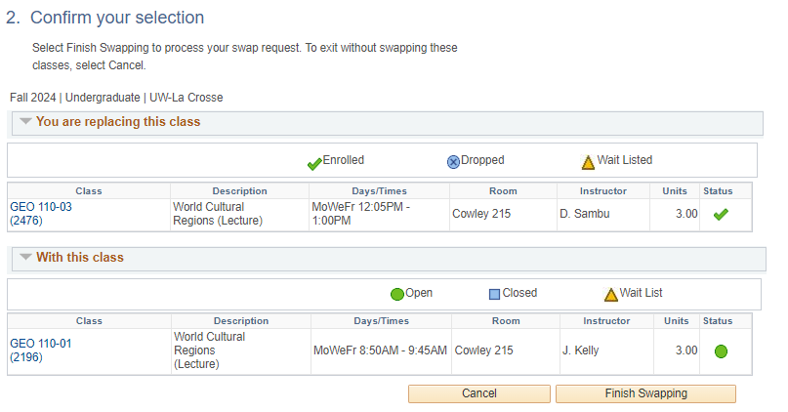

- View results.
  - A green check mark in the status field indicates that you have successfully swapped courses.
  - A red indicates that you have not successfully swapped. If you received an , review the error text to understand why. If you need help understanding why the error, contact the Records and Registration Office.

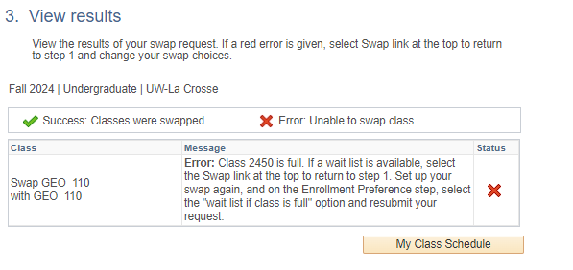

- Review your class schedule to ensure that you have successfully swapped your courses.
- Some reasons why it might not swap:
  - There is a time conflict in your schedule with the class you are swapping into.
  - The class is full, or the waitlist is full.
  - The class you are swapping out of or into has linked sections such as a discussion or lab that are causing conflicts or don't have a seat, even though there is a seat in the lecture.

Please note:
- Swapping is most useful when you don't want to drop a class unless you can get into another class at the same time.

- Waitlists end at the start of the term, but you can still swap into open classes through the 10th day of classes for a full semester course.

- If you have any questions about the waitlist or swapping, contact your advisor or the Records and Registration Office at records@uwlax.edu or 117 Graff Main Hall.

