Swap a Class Using

Schedule Planner

  - See also "Swapping onto a Waitlist in Schedule Planner."

- Click the Schedule Planner link under the Academic section of your WINGS Student Center. A new window/tab will come up. If you are taken to a page with a green button that says Open Schedule Planner, click on that button.

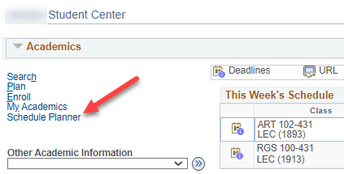

- Select the correct term for your current schedule and click Save and Continue.

- Select and register into your 2nd choice class, if you haven't already, following the Register for a Class in Schedule Planner directions.

Tip: How to figure out if class has a waitlist on the Build Schedule page
- Go to Add Course section and search for course. If you know all sections are full, you will need to first change the Course Status filter to Open & Full to find the course in the search.
- In your Course list, click on Sections.
- There will be a column called Waitlist Seats Open indicating the number of waitlisted seats available. If the course has no waitlist seats left or doesn't have a waitlist at all, it will say 0.
- Click on the blue circle with an 'i' (Section Details) next to the subject to see more information on that section. If there is a waitlist with students on it, there will be a Waitlist Enrollment line. You can also see the Waitlist Seats Open number in the Section Details.
- If there is no Waitlist Enrollment in the details and the Waitlist Seats Open column is at 0, the section does not have a waitlist.

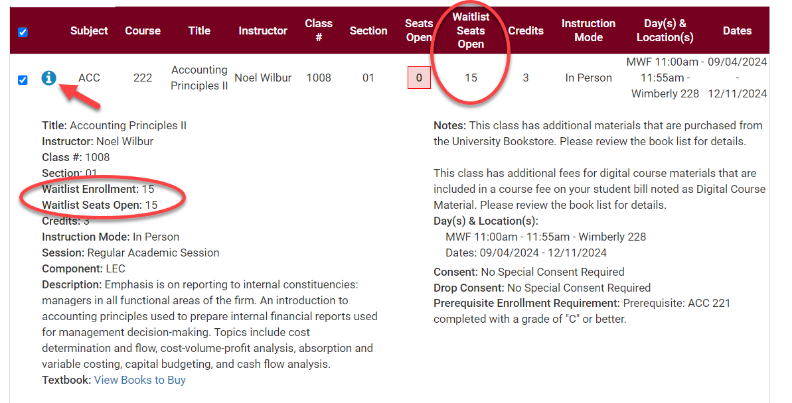

- Go to Current Schedule at the top.

- Click on the Swap button on the Current Schedule page. This will take you to the Swap page.

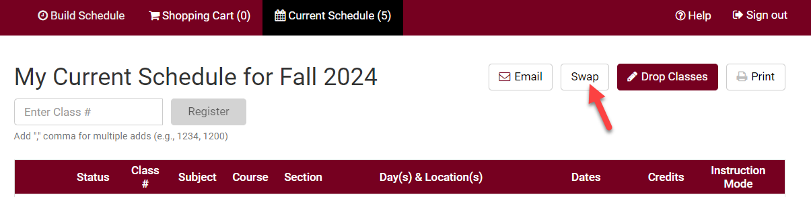

- From the drop down, select the class to be dropped from your current schedule.

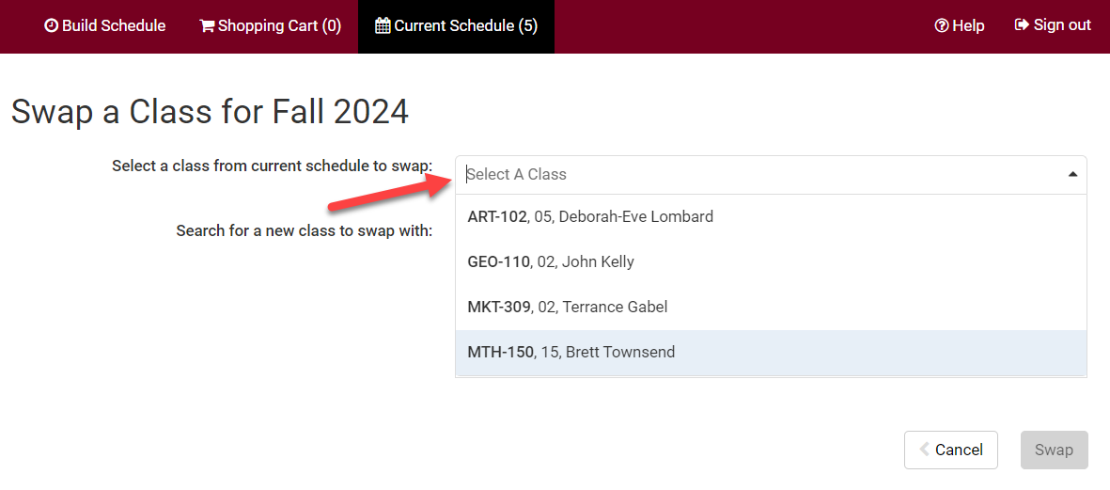

- Search for the class to be added using class number, what's in your shopping cart, or by subject.

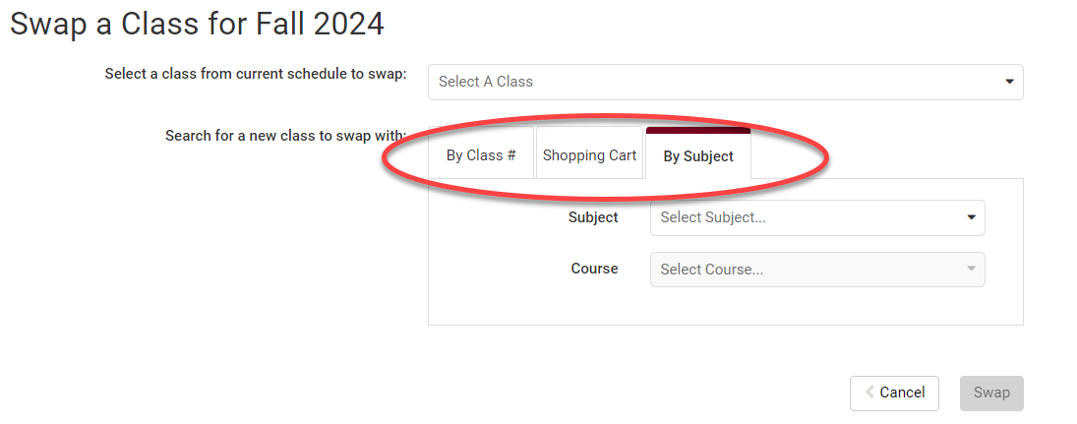

- Review your results. Click on the blue information icon to see if the section has a wait list. Waitlist Enrollment appears if there are students on the waitlist. Waitlist Seats Open appears if there are open waitlist seats. If there is no Waitlist Enrollment and no Waitlist Seats Open, the section does not have a waitlist.

- Select the section you want to add and click Swap.

  - If the Swap button is greyed out instead of red, check that you've selected a course in the "select a class from current schedule to swap" question above.
  - If you can't find the section or course you are looking for, check the Session filter at the top of the Build Schedule page.
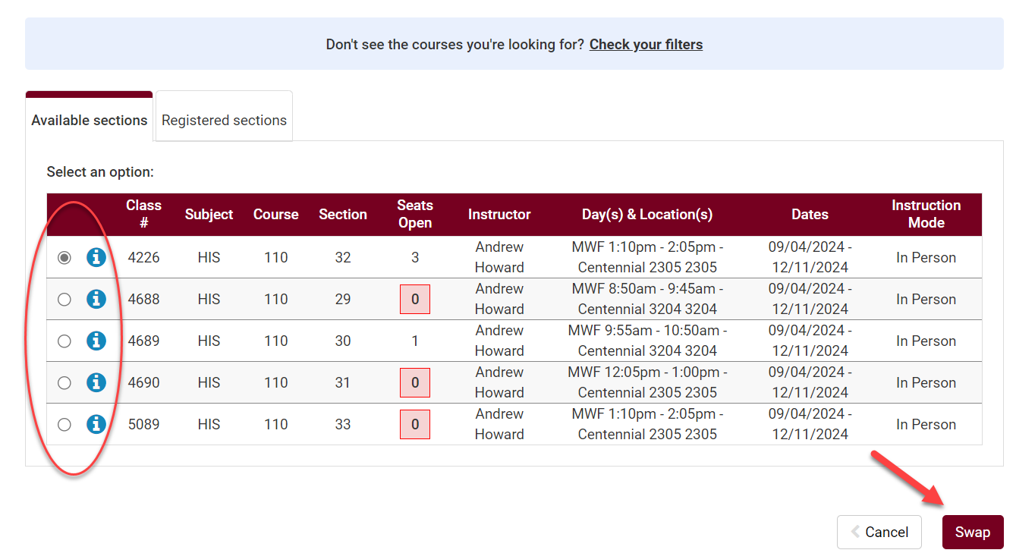

- A message will pop up asking you to confirm. Click Swap to confirm your swap or click Cancel to start over.

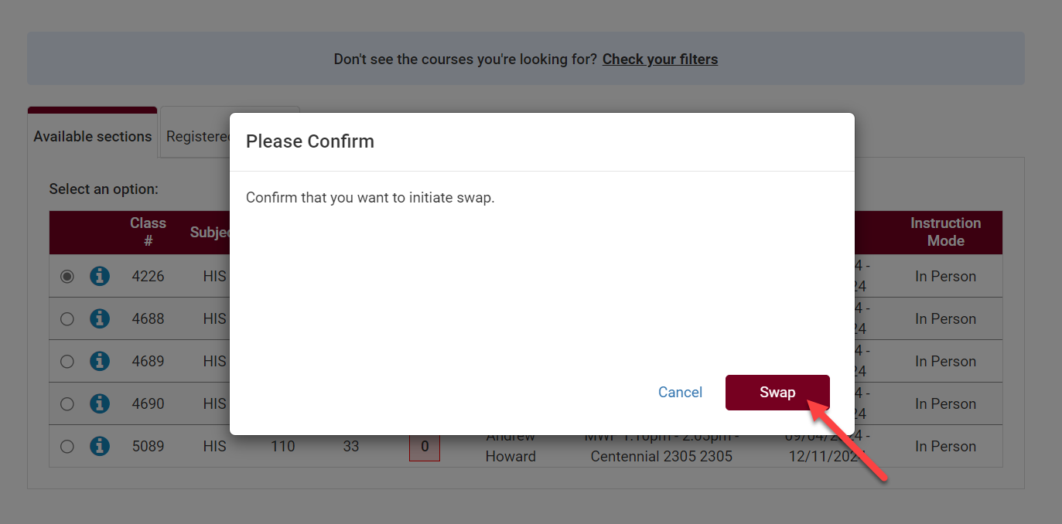

- Review messages:
  - If you are successful in swapping a course, you will get a green checkmark and a success message. Click OK.

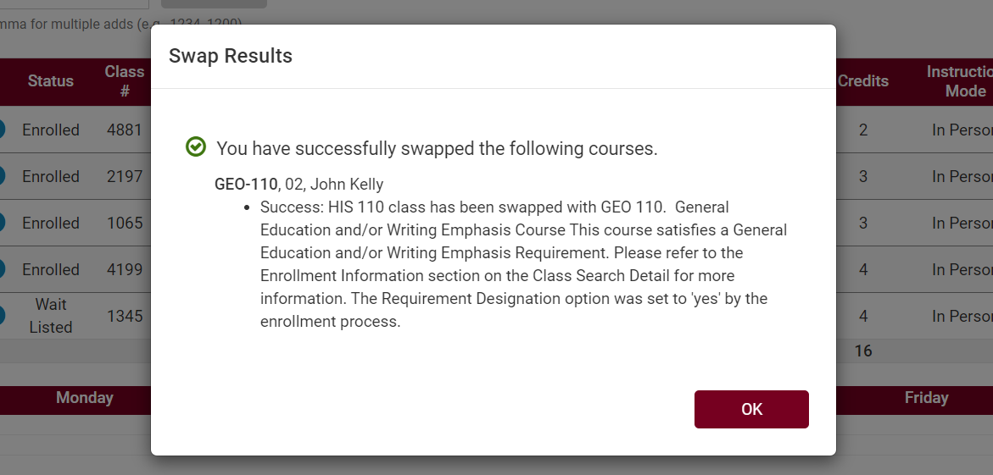

  - If there is an issue, an error message will explain why the swap cannot occur.

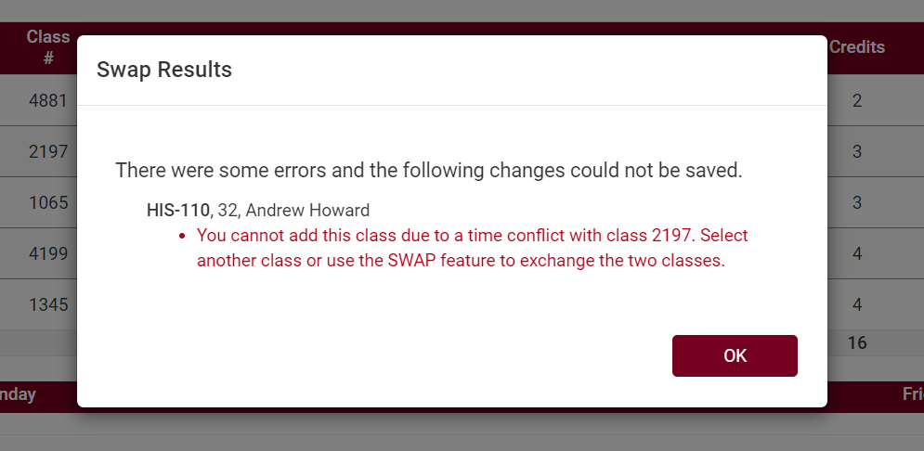

  - If there are no open seats in a class and the wait list wasn't selected, you will get a message that the course is full.

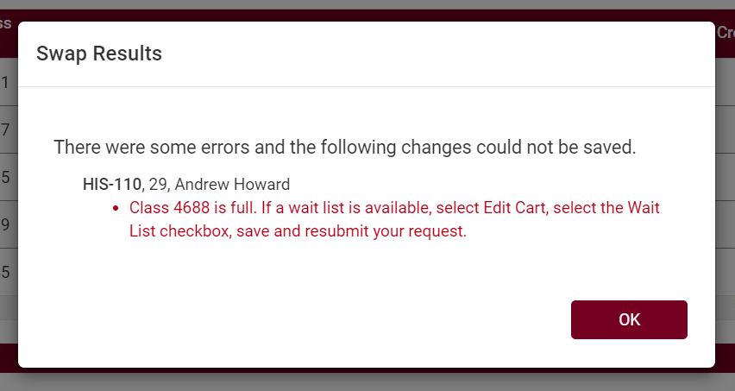

    - If the course does not have a wait list, you will need to find a different section. Or you check with the instructor to see if they are allowing any overrides.
    - If the course has a wait list, you can try the swap using these methods:
      - If the course is in your shopping cart, go to the Shopping Cart, select Edit Cart, and click Wait List?. Then try swapping again.
      - If the course was not in your shopping cart, try the swap again and be sure to select the box next to Wait List? on the next page that comes up after clicking Swap.
    - See Swapping onto a Waitlist in Schedule Planner directions for more info.

Please note:
- Swapping is most useful when you don't want to drop a class unless you can get into another class at the same time.

- Waitlists end at the start of the term, but you can still swap into open classes through the 10th day of classes for a full semester course.

- If you have any questions about the waitlist or swapping, contact your advisor or the Records and Registration Office at records@uwlax.edu or 117 Graff Main Hall.

