Swapping onto a Waitlist in WINGS

The class you want is closed but has a waitlist. You don't want to drop your 2nd choice unless you get into your 1st choice. What do you do?

Enroll using Swap - this puts you on the waitlist of your 1st choice and identifies which class to drop if you get in. If a seat becomes available and you are enrolled in the class successfully, WINGS will drop your backup class at the same time. If you never get enrolled into your 1st choice, you remain enrolled in your 2nd choice.

Directions:
- Register into your back up course if you haven't already.

- To swap, navigate to the Enroll link or the Enrollment: Swap option in the drop-down menu of the Academics section of your homepage. Navigate to the Swap tab of the enrollment area.

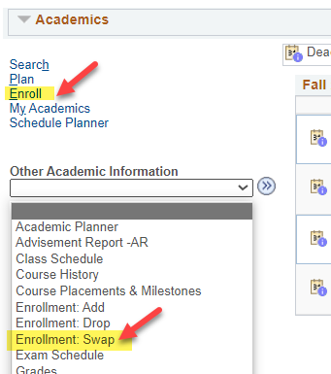

- Select the correct term.

- Choose the class to drop from the Swap This Class drop down. This is the class to be dropped.

- Find your first choice using the Class Search, select it from your shopping cart (course must be added to shopping cart first), or enter the 4-digit Class Nbr in the With This Class section. This is your preferred class with the waitlist. If entering the Class Nbr, click Enter when done.

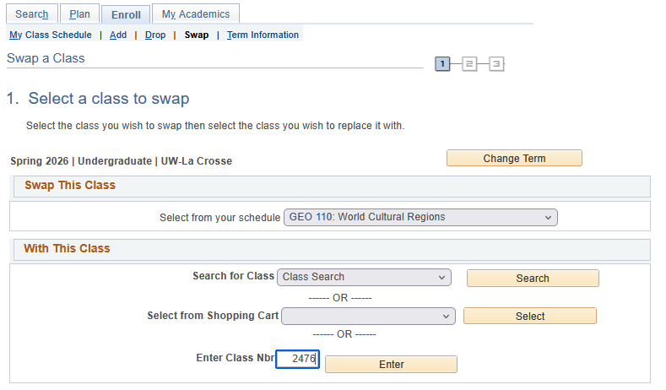

- If the class has linked lecture/lab, choose your preferred section or review the information and click Next.

- Click the box Waitlist if class is full. Then click Next.

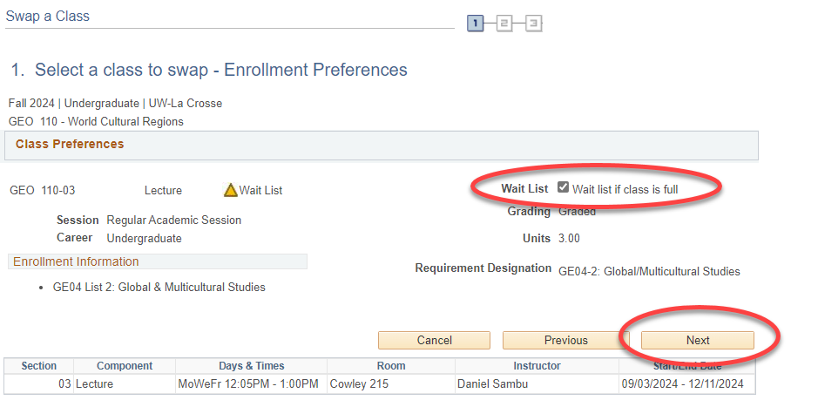

- Review the swap. When ready, click Finish Swapping.

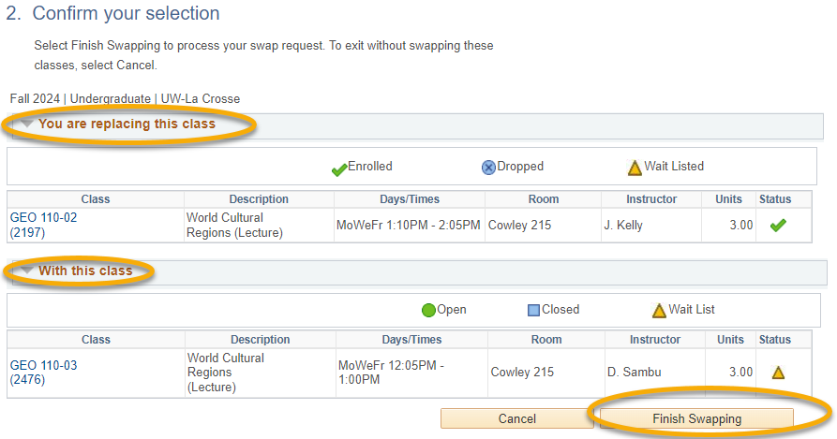

- Read the message reporting your spot on the waitlist.

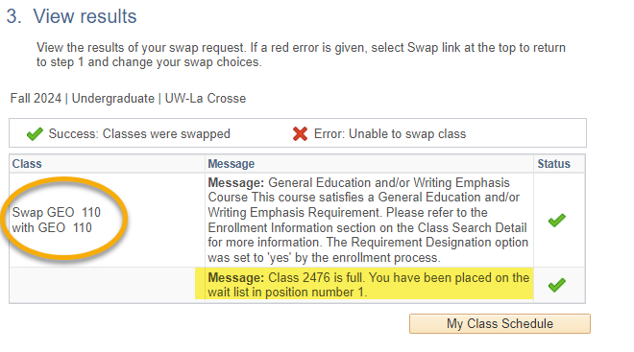
- If you are successfully enrolled later from the waitlist, a notification email will be sent. If WINGS tries to register you later but is not able to, a notification email will be sent letting you know about the error. The email will include what the error was.

Please note:
- Swapping is most useful when you don't want to drop a class unless you can get into another class at the same time.

- Remember, the system allows you onto the wait list as long as there is a seat and you meet prerequisites. However, the system will not register you if you have a time conflict, you are missing prerequisites, or the course will put you over the 18 credit maximum. Always check your schedule before adding yourself to a waitlist.

- Waitlists end at the start of the term, but you can still swap into open classes through the 10th day of classes for a full semester course.

- If you put yourself on the waitlist without using the swap and want to use it after, you'll have to drop yourself off the waitlist first and then re-add using the swap.

- You cannot swap onto a waitlist if the section does not have a waitlist.
- See the Waitlist FAQs for more information about how waitlists work.

- If you have questions about or need assistance swapping, contact the Records and Registration Office at records@uwlax.edu or 117 Graff Main Hall.

