View Transfer Credit Report

- In the Academics section of your Student Center, select Transfer Credit: Report from the drop-down menu. Click the double arrow Go button.
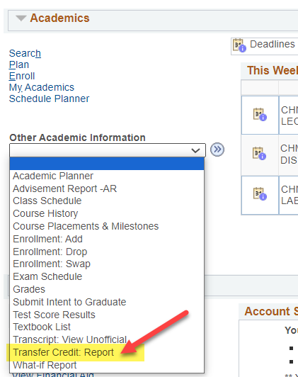

- View your report.
  - The example below shows credits transferred in from Southwest Minnesota State University and North Dakota State University under the Course Credits section.
    - Grades that start with 'T' are transfer grades.
    - Incoming Course is the course name/number from your prior school.
    - The Equivalent Course is the name of which UWL course will be awarded. If the course is labeled GEL, that is a general, non-departmental elective. If the course has a subject code followed by 0's (e.g. ECO 000C or MUS 0001NL), the course is an elective in that particular subject/department. The letter(s) at the end indicate whether the credit counts toward a General Education category.
  - The example below shows no test credits, such as departmental exam credit, AP, IB, or CLEP. If you had any of these credits it would be in the Test Credits section.
  - The example below shows no other kinds of transfer credits, such as retroactive credit. If you had any of these credits, they would be in the Other Credits section.
